Popular Democratic Republic of Algeria   
Ministry of Higher Education and Scientifc Research   
University of Science and Technology Houari Boumediene



Computer Sience Faculty

Bureautique & Web  
(TIC)

Information & Communication Technologies

* Work prsented to :
* Hariz Soumia
* Keteb Yousra
* Hiba Tébani
* Nadir Manel
* Beddai Yakoub Abdallah

### CONTENT :

|  |  |
| --- | --- |
| PAGE: | TOPIC: |
| 3 | INFORMATION & COMMUNICATION TECHNOLOGIES. |
| 5 | GOOGLE SERVICES. |
| 8 | MICROSOFT TOOLS. |
| 11 | LATEX. |
| 13 | GIT AND GITHUB . |
| 18 | DIFFERENCE BETWEEN GIT &GITHUB. |

### 

### 

Information & Communication Technologies

Information and communications technology (ICT) is an extensional term for information technology (IT) that stresses the role of unified communications and the integration of telecommunications (telephone lines and wireless signals) and computers, as well as necessary enterprise software, middleware, storage and audiovisual, that enable users to access, store, transmit, understand and manipulate information.

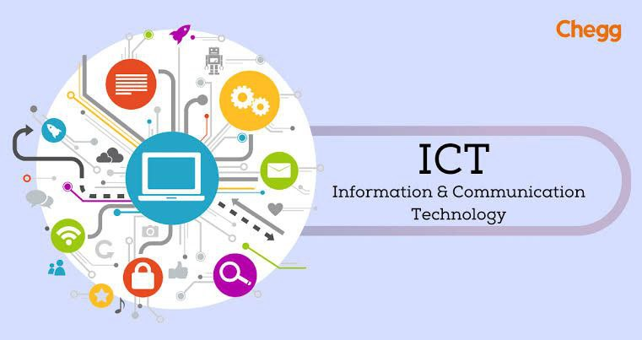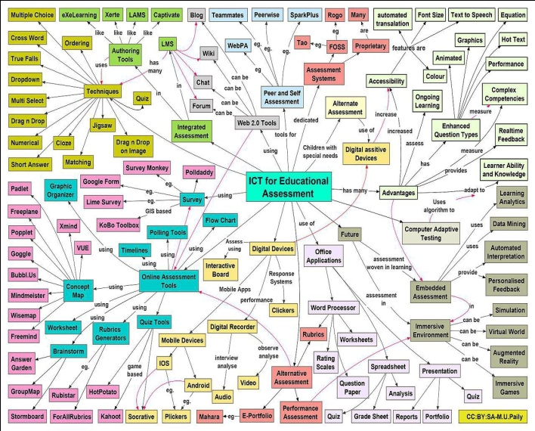

A Concept Map on the Use of Information and Communication Technology (Information) in Educational Assessment as per the International Federation of ICT (the IFGICT).

ICT is also used to refer to the convergence of audiovisuals and telephone networks with computer networks through a single cabling or link system. There are large economic incentives to merge the telephone networks with the computer network system using a single unified system of cabling

signal distribution, and management. ICT is an umbrella term that includes any communication device, encompassing radio, television, cell phones, computer and network hardware, satellite systems and so on, as well as the various services and appliances with them such as video conferencing and distance learning. ICT also includes analog technology, such as paper communication, and any mode that transmits communication.

ICT is a broad subject and the concepts are evolving.It covers any product that will store, retrieve, manipulate, transmit, or receive information electronically in a digital form (e.g., personal computers including smartphones, digital television, email, or robots). Skills Framework for the Information Age is one of many models for describing and managing competencies for ICT professionals in the 21st century for example:

GOOGLE WORKSPACE APPS.

GOOGLE CLOUD STORAGE.

GOOGLE CLOUD AI PLATFORM.

GOOGLE CLOUD COMPUTER ENGINE.

G

GOOGLE CLOUD VISION API.

FIREBASE.

* GOOGLE SERVICES
* Google services encompass a suite of applications and tools provided by Google, playing a crucial role in the realm of Information and Communications Technology (ICT). Here’s an overview of some key Google services and their connection to ICT:
* 1. Google Search

- Facilitates precise web search, serving as a fundamental tool for accessing information in the digital space.

* 2. Gmail:

- Google’s email service, contributing to communication and information exchange.

* 3. Google Maps:

- Offers mapping and navigation services, utilizing geospatial technology to provide location-based information.

* 4. Google Drive:

- Cloud storage service, enabling users to store, share, and collaborate on documents and files over the internet.

* 5. YouTube:

- A video-sharing platform, illustrating the multimedia dimension of ICT.

* 6. Google Calendar:

- A time-management tool aiding in organizing schedules and events, showcasing the integration of technology in planning.

* 7. Google Photos:

- Cloud-based photo and video storage, demonstrating the intersection of ICT with personal media management.

* 8. Google Translate:

- Utilizes language processing algorithms for text translation, showcasing the role of technology in breaking language barriers.

* 9. Google Chrome:

- A web browser that forms a fundamental part of the ICT ecosystem, facilitating internet access and interactions.

* 10. Google Play Store:

- An online marketplace for Android applications, showcasing the role of platforms in the distribution of software.

* 11. Google Assistant:

- An artificial intelligence-powered virtual assistant, highlighting advancements in voice recognition and natural language processing within ICT.

* These services collectively exemplify how Google leverages ICT to provide users with a seamless digital experience, emphasizing connectivity, accessibility, and efficiency in information management and communication.

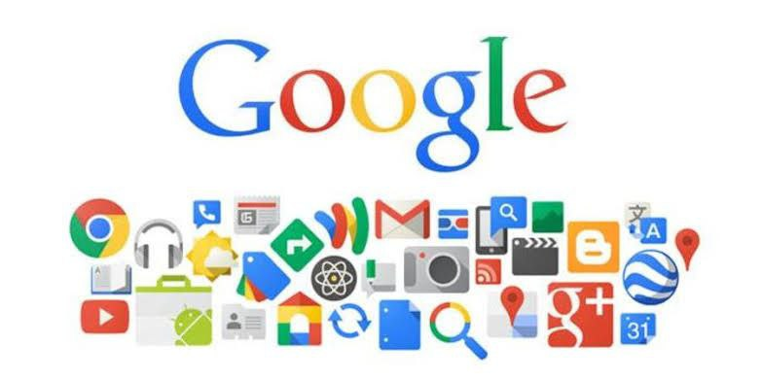

* MICROSOFT TOOLS:
* Microsoft provides a diverse range of tools that cater to different aspects of computing and productivity. Here are some key Microsoft tools:
* 1. Microsoft Office Suite:

- Includes applications like Word, Excel, PowerPoint, and Outlook for document creation, spreadsheet analysis, presentations, and email communication.

* 2. Microsoft Azure:

- A cloud computing platform offering services such as virtual machines, databases, and AI, enabling businesses to build, deploy, and manage applications in the cloud.

* 3. Windows Operating System:

- Microsoft’s flagship operating system used on personal computers, laptops, and servers.

* 4. Visual Studio:

- An integrated development environment (IDE) for software development, supporting a variety of programming languages.

* 5. Microsoft Teams:
* - A collaboration platform that integrates chat, video conferencing, file storage, and application integration to facilitate teamwork.
* 6. Power BI:

- A business analytics tool that helps visualize and share insights from data, making it easier to analyze trends and make informed decisions.

* 7. SQL Server:

- A relational database management system used for storing and retrieving data. It’s widely used in business applications.

* 8. PowerShell:

- A task automation framework and scripting language primarily used for system administration and configuration management.

* 9. Microsoft Edge:

- A web browser developed by Microsoft, known for its integration with Windows and compatibility with web standards.

* 10. OneDrive

- A cloud storage service that allows users to store and share files securely.

* These tools collectively contribute to various aspects of computing, from software development and collaboration to data analysis and cloud computing. They play a crucial role in enhancing productivity, communication, and overall efficiency in both personal and professional computing environments.

* LATEX:
* LaTeX is a document preparation system widely used in scientific and academic publishing. Here’s an explanation of LaTeX and how it works:
* 1. Programming Language:

- LaTeX is not a regular word processor; it’s a document preparation system based on a programming language. It uses programming-like commands to specify the format of the document and its various elements.

* 2. Document Formatting:

- LaTeX excels in handling complex document structures. It allows users to focus on content creation while taking care of formatting automatically. This is particularly beneficial for academic papers, research articles, and other documents with intricate layouts.

* 3. Packages and Libraries:

- LaTeX offers a rich set of packages and libraries that extend its functionality. These can be used to include mathematical symbols, manage references, create tables, and more.

* 4. Cross-Referencing:

- One of LaTeX’s strengths is its robust cross-referencing system. It automates the numbering of sections, figures, and equations, ensuring consistency throughout the document. When changes are made, LaTeX automatically updates the references.

* 5. Mathematical Typesetting:

- LaTeX is widely known for its excellent support for mathematical typesetting. It provides a comprehensive set of tools for creating and formatting mathematical equations and expressions.

* 6. Portability and Stability:

- LaTeX documents are plain text files, making them portable and easy to share. Additionally, LaTeX provides stability and consistency across different platforms, ensuring that documents look the same regardless of the operating system.

* 7. Version Control:

- LaTeX integrates well with version control systems like Git. This is particularly advantageous for collaborative writing and managing changes in large documents.

* In summary, LaTeX is a powerful typesetting system that enables the creation of well-formatted and structured documents, especially in fields where complex mathematical notation and precise formatting are essential.



* GIT AND GITHUB:
* Git is a distributed version control system used for tracking changes in source code during software development. Here’s an overview of Git:
* 1. Version Control System (VCS):

- Git is a VCS that allows multiple developers to collaborate on a project. It keeps track of changes to source code, making it easier to manage and merge modifications from different contributors.

* 2. Distributed System:

- Git is a distributed version control system, meaning each user has a complete copy of the repository, including its history. This decentralization allows for offline work and provides redundancy.

* 3. Repository:

- A Git repository is a collection of files and their revision history. It can be local (on your machine) or remote (on a server). Developers clone repositories to get a copy on their local machines.

* 4. Commit:

- A commit is a snapshot of changes to the repository. Developers make commits to save their changes along with a commit message describing the modifications.

* 5. Branch:

- Git uses branches to isolate work. Developers can create branches to work on features or bug fixes independently. Branches can later be merged back into the main branch.

* 6. Merge:

- Merging is the process of combining changes from different branches. Git automatically merges changes when possible, but conflicts may need manual resolution.

* 7. Pull Request (GitHub/GitLab):

- In platforms like GitHub or GitLab, developers propose changes through pull requests. This is a way to review, discuss, and merge code changes collaboratively.

* 8. Push and Pull:

- Developers use “push” to upload local changes to a remote repository, and “pull” to download changes from a remote repository to their local machine.

* 9. Fork:
* - Forking is the process of creating a personal copy of someone else’s repository. This allows contributors to make changes without affecting the original project until they are ready to propose their modifications.
* 10. Gitignore:

- The .gitignore file specifies intentionally untracked files that Git should ignore. It helps avoid including unnecessary files, like temporary files or compiled binaries, in the version control system.

* Git is widely used in the software development industry due to its efficiency, flexibility, and ability to handle collaborative projects with ease. It provides a powerful and reliable mechanism for tracking changes and managing code repositories.
* GitHub is a web-based platform that uses Git for version control and facilitates collaborative software development. Here are key aspects of GitHub:
* 1. Repository Hosting:

- GitHub provides a platform for hosting Git repositories. Developers can create repositories to store and manage their code.

* 2. Collaboration:

- GitHub enhances collaboration by allowing multiple developers to work on the same project simultaneously. It provides tools for issue tracking, code review, and discussions.

* 3. Pull Requests:

- Developers propose changes to a project by creating a pull request. This is a way to submit contributions, have them reviewed, and eventually merge them into the main codebase.

* 4. Issues:

- GitHub’s issue tracker helps manage tasks, enhancements, and bugs. Developers can create, assign, and comment on issues, providing a central hub for project-related discussions.

* 5. Branch Protection:

- GitHub allows administrators to protect branches, ensuring that changes go through a code review process before being merged. This helps maintain code quality and stability.

* 6. GitHub Actions:

- GitHub Actions automate workflows, allowing developers to define custom CI/CD (Continuous Integration/Continuous Deployment) processes. This automates tasks like testing and deployment.

* 7. GitHub Pages:
* - GitHub Pages enables users to host static websites directly from their GitHub repositories. It’s commonly used for project documentation, personal blogs, or simple websites.
* 8. Gists:

- Gists are a way to share snippets or small portions of code. They can be public or private and are often used for quick sharing or collaboration.

* 9. GitHub Desktop:

- GitHub Desktop is a desktop application that provides a graphical interface for working with Git repositories. It simplifies common Git tasks and is suitable for users less familiar with the command line.

* 10. Social Coding :

- GitHub encourages social coding by allowing users to follow each other, star repositories, and contribute to open-source projects. It has become a hub for collaboration and community-driven development.

* GitHub plays a central role in modern software development, providing a platform that combines version control with collaboration tools. It has become a standard for hosting and sharing code, fostering open-source contributions and collaborative projects.

# photo_5803419210209148613_x.jpg DIFFERENCE BETWEEN GIT &GITHUB :

* GIT:

   - Git is a distributed version control system that enables developers to track changes in their project files. It allows developers to create local copies (repositories) of their projects and records changes at different stages, facilitating collaboration and change management.

* GitHub:

   - GitHub is an online platform that provides hosting services for Git projects. Developers use GitHub to upload (push) their projects (repositories) to the cloud, allowing for better collaboration. GitHub offers a graphical user interface for project management and displays changes, providing a platform for developers to work together.

* In summary, Git is the system that controls changes and allows for the creation of local copies, while GitHub is the place where developers can share and improve their projects online using Git.

