**Project code**

<https://github.com/hibik07/SI507f23_proj>

**Data sources**

* The document of the API is:

<https://developers.google.com/maps/documentation/places/web-service/search-text?hl=zh-cn#maps_http_places_textsearch_incomplete_address-txt>

* And use this URL given by the service:

[https://maps.googleapis.com/maps/api/place/textsearch/*output*?*parameters*](https://maps.googleapis.com/maps/api/place/textsearch/output?parameters)

* Format: JSON
* To get this data, add parameters to the url and call it with a request. (the screenshot of the code shows below:

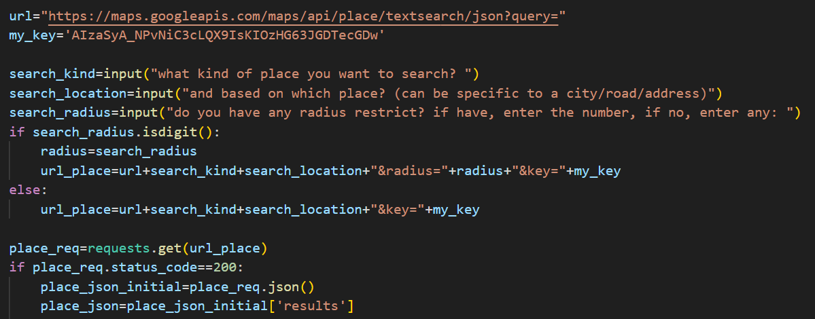

* Use cache to store each returned json file, in checkpoint can already store and read cache.

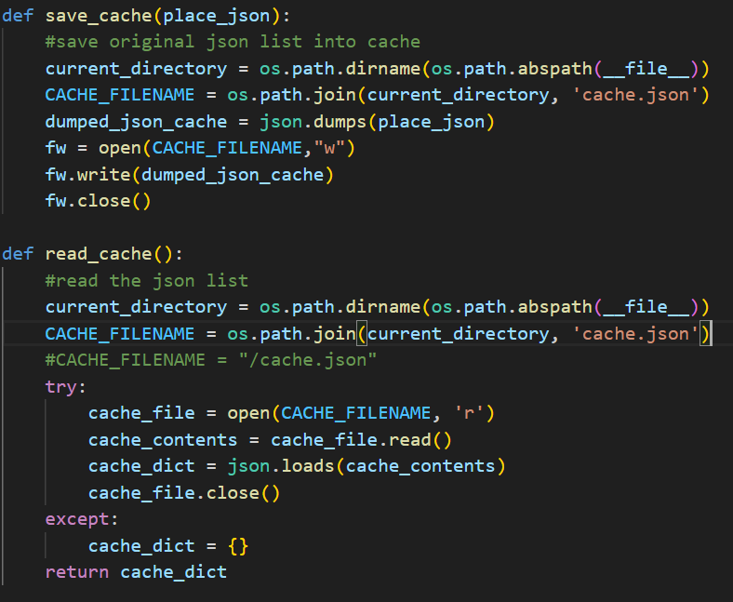

* The records available and retrieved will based on what users input. It is possible that this API will have a return limit, which has not yet been observed and handled.
* Important fields in the results include POI name, global code, text address, latitude and longitude coordinates, icon related information, rating information, etc.

**Data Structure**

* Plan: Since it was not possible to determine the relationship between every two POIs and built a graph, I plan to organize all the data into a tree in the subsequent work. The data will be sorted and built into tree based on the rating values for each POI (if POIs with no rating data, the rating value will be set to 0).
* Progress: created the ResNode class for each result, which has a attribute named rating, and completed the function that sorts all results by their rating value. No formal tree building function has been done yet

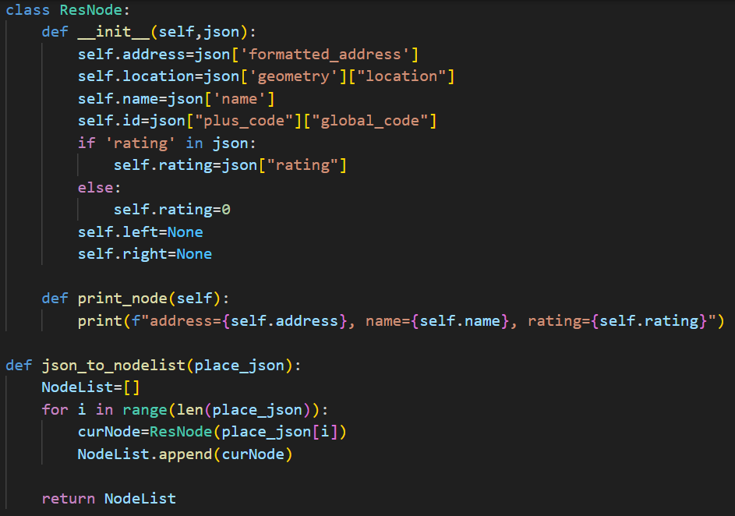

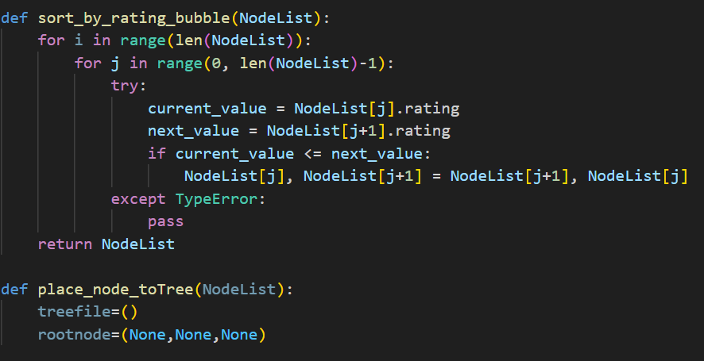

**Interaction and Presentation Plans**

Since I'm not familiar with web framework, my design for the interactive presentation is divided into two parts. The first is about the sentences that allows the user to interact in the command line, and ways to display the search results. The second is about charts that can be displayed on a web panel, if I can display some visualization using Panel, Flask or other python frameworks

1. **Command line interaction:**
2. The user is allowed to make inputs such as:

* What kind of POI they want (eg. Café, hospital hotel)
* Which place are their POI based on (eg. the specific address, or just the name of city)
* Do they have a radius restriction
* The condition of their selection (eg. Rating under 4.0)

1. The project will give users:

* The result of selection in text (in the terminal)
* visualization charts of the result (in a pop-up figure)

1. **In HTML page**
2. The user is allowed to make inputs such as:

* What kind of POI they want (eg. Café, hospital hotel)
* Which place are their POI based on (eg. the specific address, or just the name of city)
* Do they have a radius restriction
* The condition of their selection (eg. Rating under 4.0)

All of above will be input in HTML forms.

* If possible, the item of selection can be in a drop-down box
* And the number restriction can be in a slide bar

1. The project will give users:

* The result of selection in text (in the terminal)
* visualization chart of the result (in a pop-up figure)

the page will be designed as:

