SPH-PIO-PoC
Stage 03 研究记录
保守动态 neural-SPH：实现验证、拓扑事件与多步梯度边界
Dynamic Route Closure, Evidence Synthesis and Publication Boundary
终端边界 Stage 03C implementation verified；Stage 03D multistep gradient NOT QUALIFIED；Stage 03D-R mixed or unresolved；topology component qualified；Stage 03E authorization=false。
证据冻结日期：2026-08-05 | 非计算性闭包 | 训练与 rollout 均未执行

目录
1. Stage 03 新假设 3
2. Stage 02 边界 4
3. 动态控制方程 4
4. D0-D3 架构 5
5. RK2 / history / graph semantics 5
6. 动态参考体系 6
7. Stage 03B trajectory qualification 6
8. Stage 03C implementation 7
9. Zero correction 7
10. Conservation / equivariance 8
11. Checkpoint / resume 8
12. One-step autograd 8
13. Stage 03D multistep AD/FD 9
14. TE1 topology qualification 10
15. Stage 03D-R failure attribution 10
16. Supported / unsupported claims 12
17. Publication boundary 13
18. Future new hypotheses 15
19. Artifact / hash index 15
目录条目包含内部链接；页码由最终渲染后的静态索引生成。

摘要
Stage 03 以“动态、因果、守恒的 particle interaction correction 可否在严格 V&V 合同下实现并进入训练”为新假设。路线获得了强实现证据：独立 RK2、bitwise zero correction、结构守恒/等变、checkpoint/resume 与 one-step autograd 全部通过；同时，冻结的 360-probe 多步 AD/FD 合同仅有216个 stable windows，144个 failure，故完整梯度资格化失败。Stage 03D-R 进一步表明 failure 来源混合且部分未决，不能覆盖 Stage 03D 的 NOT_QUALIFIED。TE1 拓扑事件分量独立通过，但 cutoff edge existence 本身仍为离散、不可微事件。
闭包结论 动态学习路线暂停于多步梯度边界。训练、solver-in-the-loop、rollout 性能和长期稳定性均未授权或未测试；不得写为“训练失败”或“Transformer 求解器全部失败”。
图 1 Stage 03 verification-first 路线与关闭边界
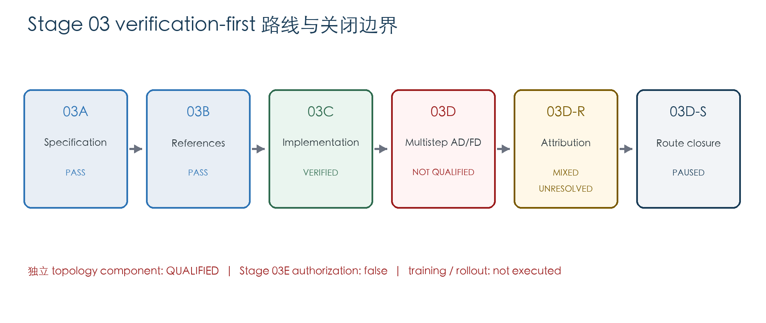

1. Stage 03 新假设
Stage 03 的新假设不是“Transformer 必然改进 SPH”，而是：在 baseline WCSPH 完整保留的条件下，新增的因果、局部、互易 pair-force correction 能否首先满足可审计的控制方程、时间积分、历史因果性、图拓扑、守恒/等变、checkpoint 与 differentiability 合同，然后才具备进入训练和 rollout 的资格。
该假设被拆成可证伪的层级：specification → reference → implementation → multistep gradient/topology → dataset/training。Stage 03D 的失败触发了路线暂停，而不是把前层级已获得的实现证据一并否定。

2. Stage 02 边界
Stage 02 静态学习路线已以 STAGE02_ROUTE_CLOSED_PUBLICATION_BOUNDARY_COMPLETE 关闭。Stage 02M 与 Stage 02M-Q 两个冻结静态拟合协议均未资格化；Stage 02 的 consumed test、selected checkpoints 和 K2 结果只能作为历史静态诊断。Stage 03 不复用其权重，不把静态 v0.2 延伸为 v0.3，也不以 rollout 隐藏静态 failure。
历史边界 Stage 01 仍为 V2_QUALIFICATION_FAIL；Stage 01H 仍为 FINITE_RESOLUTION_DOMINANT；viscosity operator form 仍为 NOT_CONFIRMED。Stage 03 未恢复或改写这些状态。

3. 动态控制方程
冻结的 Stage 03 v0.1 半离散系统保留 baseline WCSPH 的连续性、压力、EOS、图和时间步选择；网络只提供加性 acceleration correction。
dx_i/dt = v_i (1)
dρ_i/dt = C_SPH,i(S) (2)
dv_i/dt = a_SPH,i(S) + a_θ,i(S_history, H_history, G_history) (3)
p_i = c_s²(ρ_i − ρ₀) (4)
a_θ,i = (1/m_i) Σ_{j:{i,j}∈G} f_θ,ij (5)
f_θ,ij = F⁰_ij[α_ij r̂_ij + β_ij t_ij], α_ij=α_ji, β_ij=β_ji (6)
由于 r̂_ji=−r̂_ij、t_ji=−t_ij 且标量系数对称，pair force 满足 f_θ,ji=−f_θ,ij。该构造建立结构守恒，不建立 correction 的准确性或必要性。

4. D0-D3 架构
图 2 D0-D3 architecture 与共同守恒边界
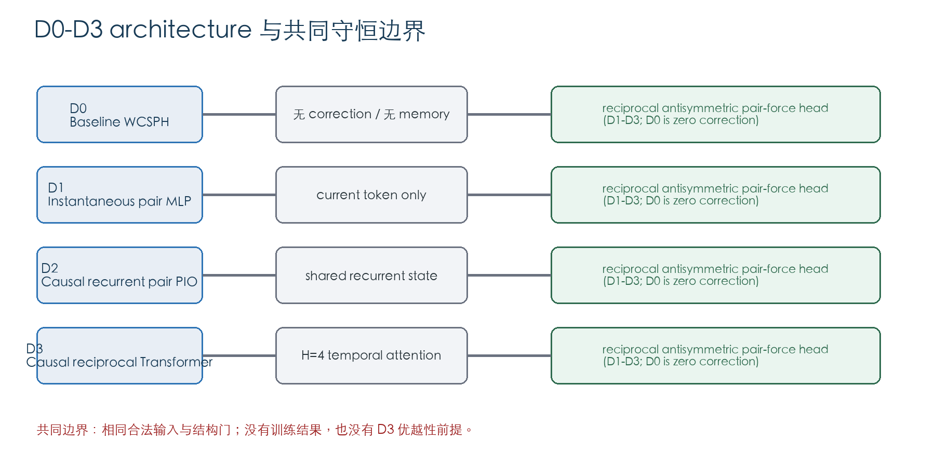
Arm | 角色 | 时间机制 | Pair-force head | 证据边界
D0 | Baseline WCSPH | none | correction disabled | zero/cost baseline
D1 | Instantaneous conservative pair MLP | current token | shared antisymmetric basis | memory necessity control
D2 | Causal recurrent pair PIO | recurrent state | shared antisymmetric basis | non-attention temporal control
D3 | Causal temporal reciprocal Transformer PIO | H=4 causal Transformer | shared antisymmetric basis | candidate, not presumed winner

5. RK2 / history / graph semantics

5.1 Explicit midpoint/RK2
k₁ = F(Sⁿ, historyⁿ) (7)
Sⁿ⁺¹ᐟ² = Sⁿ + (Δt/2)k₁ (8)
k₂ = F(Sⁿ⁺¹ᐟ², historyⁿ + ephemeral token) (9)
Sⁿ⁺¹ = Sⁿ + Δt k₂ (10)
start 与 midpoint 是两个独立 RHS evaluation；每次都重算 EOS 并从相应 state 重建 reciprocal graph。固定 whole-step topology 被禁止。

5.2 Transactional history
start/midpoint 只读 committed snapshot。midpoint token 为 ephemeral，不得 append、evict 或覆盖 accepted history。只有 Sⁿ⁺¹ 通过 finite/safety checks 后，才在物理时刻 tₙ₊₁ 构造一个 accepted token 并原子 commit；失败步同时回滚 state 与 cache。

5.3 Topology boundary
Graph construction 由 baseline solver 控制。网络不得预测、剪枝或改变 edge membership。edge birth/death 由 cutoff crossing 离散触发；事件两侧可讨论固定拓扑路径的梯度，事件本身不被声明可微。

6. 动态参考体系
Class | 作用 | 本阶段状态 | 禁止越界
D-R1 | analytic/MMS verification | two families PASS | MMS ≠ physical validation
D-R2 | same-semidiscrete high-accuracy time reference | six cases PASS | time reference ≠ spatial truth
D-R3 | source-free analytic/independent validation | oblique shear PASS | never training/normalization/threshold source
D-R4 | external V&V-qualified reference | NOT_AVAILABLE | higher-resolution SPH alone ≠ D-R4

7. Stage 03B trajectory qualification
Stage 03B 在 deterministic CPU float64 下完成参考资格化。D-R1 Lagrangian compression 与 coupled deformation 通过解析闭包；D-R2 对六个同半离散算子 case 完成 DOP853 time-reference sensitivity；D-R3 oblique shear A/B 通过 source-free exact audit。最终形成18条 canonical trajectories。
Evidence | Result | Boundary
D-R1 | 2 families; 6 exact trajectories; PASS | verification/MMS only
D-R2 | 6/6 time-reference cases PASS | not spatial truth
D-R3 oblique shear | 2 families; 6 exact trajectories; PASS | independent validation only
Acoustic | linear-regime conditional | not unrestricted exact D-R3
Periodic vortex | rejected as exact source-free | possible separate MMS role only
Topology events | 0 in Stage 03B trajectories | TE1 handled later

17 frames constitute one trajectory rather than IID samples。Stage 03B 未建立 dataset split、normalization、optimizer 或 neural rollout；其53.49 s wall time、348,471,296-byte peak RSS 和4302 RHS/rebuilds仅为资格化资源记录。

8. Stage 03C implementation
Stage 03C 以 Stage 03B 为唯一授权，完成 D0-D3 frozen implementation contract。其 final status 为 DYNAMIC_RK2_HYBRID_IMPLEMENTATION_VERIFIED。该状态表示实现及指定 smoke/structural gates 通过，不表示 multistep gradient、training 或 performance 通过。
Gate | Frozen result | Interpretation
Independent RK2 | 48/48 PASS | state/time/graph semantics
Zero correction | 288/288 bitwise PASS | D1-D3 zero head equals D0
History | PASS | single accepted commit; no midpoint contamination
Structure | PASS | antisymmetry/conservation/equivariance
Checkpoint/resume | 6/6 PASS | state/graph/history/RNG identity
One-step autograd | 6/6 PASS | plumbing only
Resources/safety | PASS | not performance benchmark

9. Zero correction
Zero correction 使用两种冻结 mode：Mode A 完全 bypass neural correction；Mode B 执行网络但将 correction head 置零。D1-D3、多个参考 case 与 horizons 上的 accepted state、density、pressure、velocity、wrapped/unwrapped position、graph hashes、source count 和 step/time 均与 D0 bitwise 一致，合计288/288。
允许主张 zero-correction equivalence is bitwise established。不得外推为 nonzero learned correction accurate 或 dynamic solver improved。

10. Conservation / equivariance
Stage 03C structural smoke 对 pair exchange、force antisymmetry、normalized correction-force residual、deterministic repeat、edge reorder、particle permutation、translation、periodic representative shift、Galilean boost、SO(2) rotation 与 reflection 进行检查并通过。Stage 03D 的多步审计进一步记录540/540 per-stage conservation PASS。
这些结果说明 reciprocal pair-force 结构在多个 RK stages 中保持预期不变量；它们不是 long-time stability、accuracy 或 learned improvement 的替代证据。

11. Checkpoint / resume
D0、D1 zero-head、D2 zero-head、D3 zero-head、D2 fixed-seed 与 D3 fixed-seed 六个 configuration 在 save/load 后均复现 physical state、accepted time/step、parameter hash、history order/hash、hidden state、RNG identity 与 graph hash sequence。Stage 03C 没有训练 checkpoint；这里验证的是 deterministic continuation plumbing。

12. One-step autograd
Stage 03C 对 D1-D3 × 两个 family 共6个 one-step runs 检查 expected parameter、initial state 与 history-related gradients；全部 finite、nonzero 且 deterministic repeat PASS。没有 edge-index gradient、optimizer object 或 parameter update，也没有 finite difference。
层级边界 one-step autograd verified ≠ complete multistep differentiability qualified。后者由 Stage 03D 的冻结 AD/FD 合同单独判定。

13. Stage 03D multistep AD/FD
图 3 360-probe 多步 AD/FD 完整结果与失败归因
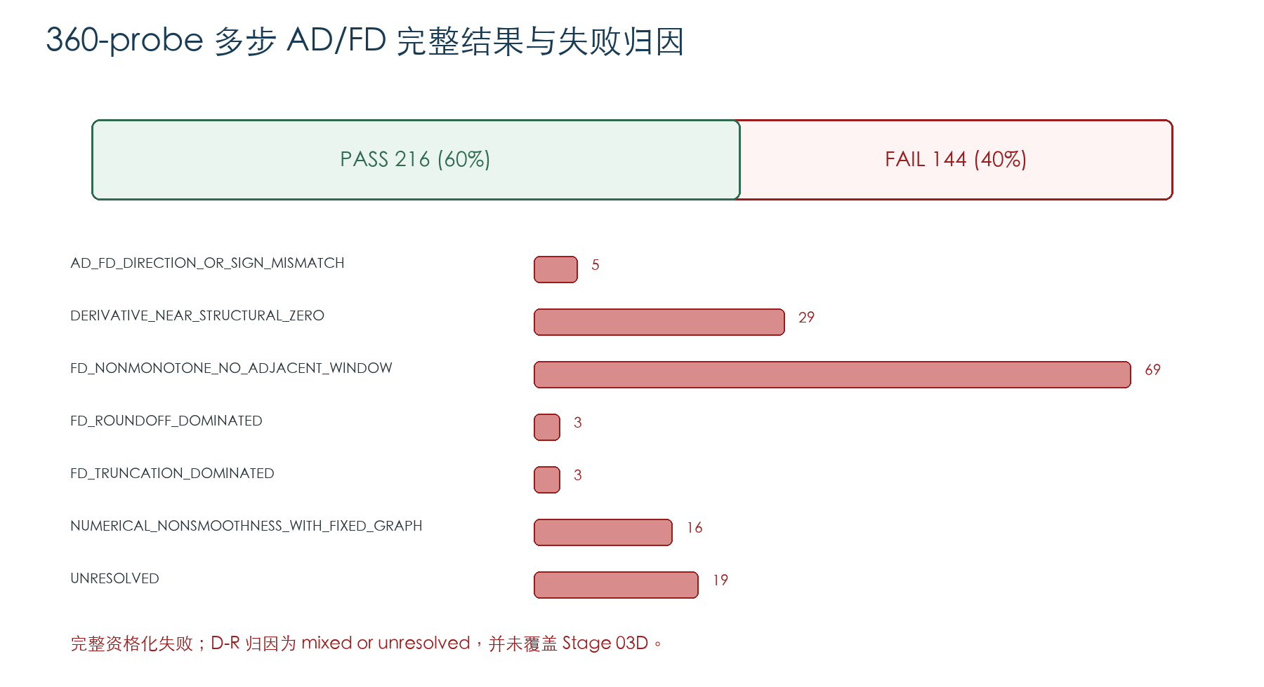
冻结 matrix 覆盖 D1-D3、四个 case roles、三个 seeds、horizons 1/2/4/8 与参数/初值/history probes，共360 rows、2880 AD/FD comparisons。216 rows 获得 stable adjacent epsilon window，144 rows failure；没有 topology-changing epsilon 被排除。
Arm | PASS | FAIL | Total
D1 | 65 | 31 | 96
D2 | 75 | 45 | 120
D3 | 76 | 68 | 144
All | 216 | 144 | 360

Primary reason | Count
AD_FD_DIRECTION_OR_SIGN_MISMATCH | 5
DERIVATIVE_NEAR_STRUCTURAL_ZERO | 29
FD_NONMONOTONE_NO_ADJACENT_WINDOW | 69
FD_ROUNDOFF_DOMINATED | 3
FD_TRUNCATION_DOMINATED | 3
NUMERICAL_NONSMOOTHNESS_WITH_FIXED_GRAPH | 16
UNRESOLVED | 19

Stage 03D verdict DYNAMIC_MULTISTEP_ADFD_AND_TOPOLOGY_NOT_QUALIFIED。不得只展示216个PASS，不得隐藏144个failure。

14. TE1 topology qualification
TE1 对 cutoff crossing 建立独立 component contract：记录一个 edge birth 与一个 death，6/6 stage replay PASS，12/12 event-side AD/FD PASS，并确认 force jump finite/bounded 与 empty graph deterministic semantics。
Topology gate | Result | Boundary
Birth/death | 1 / 1 | deterministic event semantics
Replay | 6/6 PASS | frozen TE1 only
Fixed-side gradients | 12/12 PASS | not through membership change
Force jump | finite/bounded | no global smoothness claim
Empty graph | deterministic | no correction edges

Component verdict TOPOLOGY_EVENT_COMPONENT_QUALIFIED。该 PASS 不把 Stage 03D 总体状态改成 PASS，也不证明 arbitrary topology families 或 cutoff existence differentiable。

15. Stage 03D-R failure attribution
Stage 03D-R 不修改 Stage 03D contract、epsilon、probe、backend 或 architecture。它首先重建 complete 360-row matrix，再对冻结 selected rows 执行 same-math reverse/JVP、extended FD、objective decomposition、history path 与 horizon scaling。
Diagnostic | Frozen result | Interpretation
Same-math reverse/JVP | 60/60 PASS | AD implementation consistency
Historical backend vs math JVP | 48/60 match | 12 selected D3 mismatches; backend sensitivity
Extended FD | 30/60 stable; 2640 paths | conditioning contributes to some failures
History traces | 1 conditioning-limited; 5 below FD resolution | strong rollout attenuation
Horizon scaling | 90 bounded/nonmonotone | no systematic vanish/explode detected
Unresolved | 19/144 | no complete single-root-cause attribution

Temporal-module-only paths generally exhibited stable reverse/JVP/FD behavior, while full-rollout history influence was attenuated to ratios approximately 1.54×10⁻⁴–4.91×10⁻³。No detach/cache/object mismatch was identified。该证据支持 mixed contributors，而不支持“全部 failure 都是 FD artifact”或“D3 intrinsically non-differentiable”。
D-R verdict DYNAMIC_GRADIENT_FAILURE_MIXED_OR_UNRESOLVED。D-R 不覆盖、不修复 Stage 03D failure。

16. Supported / unsupported claims
图 4 Stage 03 证据—主张边界
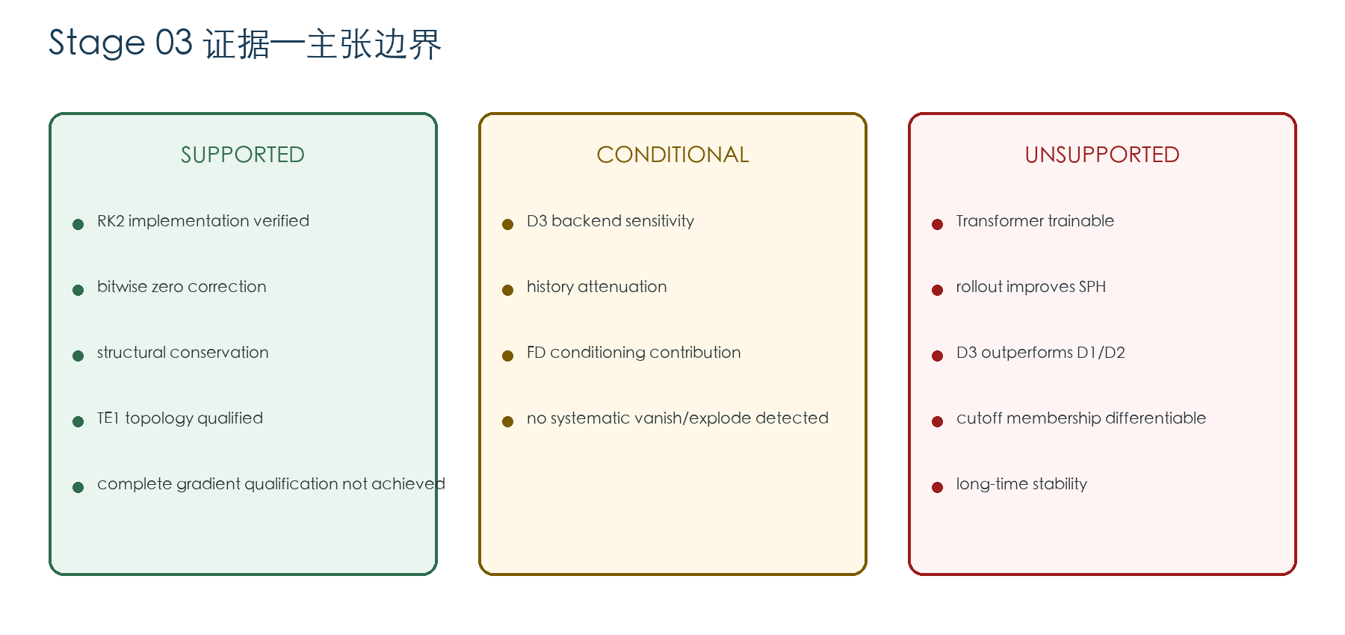

16.1 Supported claims
允许：动态 RK2 hybrid solver 的冻结实现合同已通过 Stage 03C。 禁止：dynamic solver performance is verified
允许：zero correction 在 288/288 检查中与 D0 bitwise 等价。 禁止：nonzero learned correction is accurate
允许：冻结多步审计的 540/540 stage conservation checks 通过。 禁止：long-time conservation and stability are proven
允许：TE1 的 birth/death、replay 和 fixed-side gradients 已资格化。 禁止：cutoff membership is differentiable
允许：360 个冻结 probes 中 216 个获得 stable AD/FD window。 禁止：all multistep gradients are valid
允许：Stage 03D 保持 NOT_QUALIFIED，D-R 保持 MIXED_OR_UNRESOLVED。 禁止：Stage 03D-R repaired the Stage 03D failure

16.2 Conditional claims
条件性允许：在冻结的 selected diagnostics 内，D3 的部分梯度显示 backend sensitivity。 禁止：D3 is intrinsically non-differentiable
条件性允许：当前 reference-prehistory paths 显示 rollout 中 history influence 强烈衰减。 禁止：temporal memory is useless
条件性允许：extended FD 支持 conditioning 对部分 failure 的贡献。 禁止：all failures are finite-difference artifacts
条件性允许：冻结 horizon diagnostics 未检测到系统性 vanish/explode。 禁止：gradient health is proven for training

16.3 Unsupported claims
Unsupported claim | Allowed wording | Prohibited wording
dynamic Transformer is trainable | 动态训练尚未授权或执行。 | the dynamic Transformer is trainable
solver-in-the-loop training is valid | solver-in-the-loop 为 NOT AUTHORIZED / NOT EXECUTED。 | solver-in-the-loop training is valid
rollout improves SPH | 未进行 rollout 性能评价。 | rollout improves SPH
Transformer outperforms recurrent/instantaneous baselines | D1/D2/D3 未训练、未比较。 | Transformer outperforms D1/D2
cutoff edge existence is differentiable | 只能主张 event 两侧的 piecewise-smooth gradients。 | edge membership is differentiable
Stage 01 V2 is restored | Stage 01 仍为 V2_QUALIFICATION_FAIL。 | Stage 03 restores Stage 01 V2
viscosity operator is confirmed | viscosity operator form 仍为 NOT_CONFIRMED。 | viscosity operator is confirmed
long-time stability is established | 未执行 long-time rollout/stability qualification。 | long-time stability is established

语义守卫 未执行动态训练只能写 NOT AUTHORIZED / NOT EXECUTED，不能写“动态训练失败”；Stage 03D NOT_QUALIFIED 不能写“Transformer 求解器全部失败”。

17. Publication boundary
当前不能形成以完整动态 solver 性能为中心的论文，因为没有训练、受控/自主 rollout、独立性能比较或 long-time stability evidence。当前最可辩护的主线是 verification-first conservative dynamic neural-SPH coupling：把分层合同、bitwise zero correction、结构守恒、TE1 event boundary 和完整负梯度证据作为方法贡献。
Paper | 方向 | Readiness | 判断
A | 完整动态 SPH-Transformer hybrid solver | NOT_READY | 缺少训练、rollout 与独立性能验证；不能形成完整 solver-performance 论文。
B | verification-first conservative dynamic neural-SPH coupling | MOST_DEFENSIBLE_BUT_INCOMPLETE | 创新点可放在 verification-first 分层、bitwise zero correction、结构守恒、TE1 事件边界和透明负梯度证据；必须把 multistep limitation 置于主文。
C | limits of multistep differentiability verification in dynamic graph particle solvers | POTENTIAL_METHODS_NOTE | 可围绕 backend sensitivity、FD conditioning、history attenuation、piecewise topology 与 negative-result value；需证明诊断框架超出单个 PoC。

CMAME 的官方 scope 包括 meshless discretization、fluid mechanics 和 physically based machine learning，因此主题层面相符；但该刊强调具有显著发展的原创 computational methods。当前证据不足以支撑 full-solver claim，Paper B 仍需更强的通用方法深度与独立验证，Paper C 则需证明诊断框架超出单个 PoC。
官方 scope：Computer Methods in Applied Mechanics and Engineering — Aims & Scope

17.1 三项核心缺失证据
- 冻结训练协议下的正式动态训练资格
- 受控与自主 rollout 的独立性能/稳定性证据
- 新且独立的 D-R4 或等价外部验证与跨问题泛化证据

17.2 主文、补充材料与内部证据
主文：V&V pipeline and contracts；D0-D3 architecture and RK2/history/graph semantics；Stage 03B reference qualification；Stage 03C zero/structural/checkpoint/one-step evidence；complete 360-probe outcomes including 144 failures；TE1 topology component boundary；D-R mixed/unresolved attribution；claim boundary。
补充材料：complete hash ledger；360-row matrix；extended FD paths；reverse/JVP tables；history traces；horizon scaling；topology replay and event-side rows；resource audits。
内部证据：machine-specific RSS/timing except reproducibility context；individual debug traces without preregistered interpretive role；any unqualified post-hoc backend comparison beyond the frozen diagnostic。

18. Future new hypotheses
以下仅为新假设设计，Stage 03D-S 不执行。所有分支都必须作为全新 Stage 04 建立新的 hypothesis、implementation/topology/AD-FD contract 与 success gates；不得称为 Stage 03E 直接继续。
ID | Future hypothesis | Required stage | Executed
H1 | 不依赖长链 reverse-mode 的局部 one-step/短窗目标可获得可资格化训练信号。 | new Stage 04 | No
H2 | 显式可微邻域近似或连续邻接权重可重定义拓扑可微边界。 | new Stage 04 with a new topology contract | No
H3 | 离散伴随、自定义 JVP 或统一 math-attention backend 可改善多步梯度资格。 | new Stage 04 with new implementation and AD/FD contracts | No
H4 | 非学习或解析型动态保守修正可在不依赖端到端训练时建立动态证据。 | new Stage 04 | No

19. Artifact / hash index
Stage 03D-S input freeze 在综合前记录 1976 个历史文件。完整逐文件 SHA-256 位于 10_manifests/stage03ds_input_freeze_manifest.json；本节列出关键索引。
Artifact | Path | SHA-256 prefix
stage03a_final_manifest.json | stage_03_Dynamic_SPH_Transformer_Hybrid/10_manifests/stage03a_final_manifest.json | sha256:d4ed848abd0ab4b48449228…
stage03b_final_manifest.json | stage_03_Dynamic_SPH_Transformer_Hybrid/10_manifests/stage03b_final_manifest.json | sha256:c3bef0df24f373fe2eff33b…
stage03c_final_manifest.json | stage_03_Dynamic_SPH_Transformer_Hybrid/10_manifests/stage03c_final_manifest.json | sha256:bf5e0e3f1ac68e4b2df8ed8…
stage03d_final_manifest.json | stage_03_Dynamic_SPH_Transformer_Hybrid/10_manifests/stage03d_final_manifest.json | sha256:c0862a16d0a43e283e80df2…
stage03dr_final_manifest.json | stage_03_Dynamic_SPH_Transformer_Hybrid/10_manifests/stage03dr_final_manifest.json | sha256:ad5ef80137ec6aa2e27b22c…
fixed_topology_adfd_results.json | stage_03_Dynamic_SPH_Transformer_Hybrid/05_dynamic_solver_implementation/stage03d/results/fixed_topology_adfd_results.json | sha256:bd864c0ce1bd2beaf51d1e7…

19.1 Artifact / hash index（续）
Artifact | Path | SHA-256 prefix
stage03d_complete_360_row_matrix.json | stage_03_Dynamic_SPH_Transformer_Hybrid/05_dynamic_solver_implementation/stage03dr/failure_matrix/stage03d_complete_360_row_matrix.json | sha256:a0b925593f3cda97be68266…
reverse_vs_jvp.json | stage_03_Dynamic_SPH_Transformer_Hybrid/05_dynamic_solver_implementation/stage03dr/ad_crosscheck/reverse_vs_jvp.json | sha256:853b224aac8543ef1f473a4…
extended_fd_results.json | stage_03_Dynamic_SPH_Transformer_Hybrid/05_dynamic_solver_implementation/stage03dr/fd_conditioning/extended_fd_results.json | sha256:a4d11212be2583a6146e835…
reference_prehistory_trace.json | stage_03_Dynamic_SPH_Transformer_Hybrid/05_dynamic_solver_implementation/stage03dr/history_path/reference_prehistory_trace.json | sha256:fed16b4b4919ca83308482c…
topology_component_status.json | stage_03_Dynamic_SPH_Transformer_Hybrid/05_dynamic_solver_implementation/stage03dr/topology_preservation/topology_component_status.json | sha256:a0436c35e9ee1fb15685f7e…

19.2 Stage 03 状态账本
Stage | Unique status | Exec | Steps | Runs | Performance
Stage 03A | DYNAMIC_HYBRID_SOLVER_SPECIFICATION_COMPLETE | 0 | 0 | 0 | 0
Stage 03B | DYNAMIC_REFERENCE_TRAJECTORY_QUALIFICATION_COMPLETE | 1 | 0 | 0 | 0
Stage 03C | DYNAMIC_RK2_HYBRID_IMPLEMENTATION_VERIFIED | 1 | 0 | 0 | 0
Stage 03D | DYNAMIC_MULTISTEP_ADFD_AND_TOPOLOGY_NOT_QUALIFIED | 1 | 0 | 0 | 0
Stage 03D-R | DYNAMIC_GRADIENT_FAILURE_MIXED_OR_UNRESOLVED | 1 | 0 | 0 | 0

附录 A：动态证据矩阵
ID | Category | Item | Status | Boundary
A01 | A SPECIFICATION | governing equations | PASS | 合同证据；无性能含义。
A02 | A SPECIFICATION | causal Transformer contract | PASS | 候选架构，不证明必要或优越。
A03 | A SPECIFICATION | D0-D3 arm matrix | PASS | 未训练、未比较性能。
A04 | A SPECIFICATION | RK2/history/graph semantics | PASS | 语义合同与实现证据分层。
A05 | A SPECIFICATION | reference hierarchy | PASS | D-R4 remains NOT_AVAILABLE.
B01 | B REFERENCE | D-R1 analytic/MMS closure | PASS | MMS verifies equations/code, not physical validation.
B02 | B REFERENCE | D-R2 time-reference sensitivity | PASS | Isolates time error; not spatial truth.
B03 | B REFERENCE | D-R3 source-free exact reference | PASS | Independent validation only; forbidden for training/threshold selection.
B04 | B REFERENCE | acoustic boundary | DIAGNOSTIC | Not an unrestricted exact D-R3 family.
B05 | B REFERENCE | periodic vortex boundary | NOT_QUALIFIED | May only support a separately sourced MMS role.
C01 | C IMPLEMENTATION | independent RK2 | PASS | Implementation verification only.
C02 | C IMPLEMENTATION | zero correction | PASS | Does not prove nonzero correction accuracy.
C03 | C IMPLEMENTATION | conservation/equivariance | PASS | Structural property, not learned performance.
C04 | C IMPLEMENTATION | checkpoint/resume | PASS | No trained checkpoint exists.
C05 | C IMPLEMENTATION | one-step autograd | PASS | No finite difference and no multistep qualification in Stage 03C.

附录 A.1：动态证据矩阵（续）
ID | Category | Item | Status | Boundary
C06 | C IMPLEMENTATION | resources | PASS | Resource record is not a speed or cost comparison.
D01 | D MULTISTEP GRADIENT | 360 frozen probes | NOT_QUALIFIED | Complete gradient qualification failed.
D02 | D MULTISTEP GRADIENT | stable epsilon windows | DIAGNOSTIC | Cannot report only the passing subset.
D03 | D MULTISTEP GRADIENT | reverse/JVP crosscheck | PASS | Supports AD implementation consistency, not complete AD/FD validity.
D04 | D MULTISTEP GRADIENT | extended finite difference | DIAGNOSTIC | Conditioning contribution remains path dependent.
D05 | D MULTISTEP GRADIENT | history influence | UNRESOLVED | Strong rollout attenuation is observed; long-chain trainability is not established.
D06 | D MULTISTEP GRADIENT | backend sensitivity | DIAGNOSTIC | Conditional diagnostic; no backend switch or requalification authorized.
D07 | D MULTISTEP GRADIENT | failure attribution | UNRESOLVED | Mixed contributors; no single complete root cause.
D08 | D MULTISTEP GRADIENT | horizon scaling | DIAGNOSTIC | No systematic vanishing/exploding detected, not proof of healthy training gradients.
D09 | D MULTISTEP GRADIENT | dynamic training | NOT_EXECUTED | Must not be called training failure.
E01 | E TOPOLOGY | TE1 birth/death | PASS | Discrete edge existence is not differentiable.
E02 | E TOPOLOGY | replay | PASS | Qualification is for TE1 semantics.
E03 | E TOPOLOGY | event-side gradients | PASS | Gradients are within a fixed event side, not through cutoff membership.
E04 | E TOPOLOGY | piecewise-smooth boundary | PASS | Topology map remains piecewise smooth with discrete events.

附录 B：图表发表计划
Fig. | Title | Form | Integrity rule
1 | Stage 03 V&V pipeline | workflow | Show A-D-R chronology and independent topology branch.
2 | D0-D3 dynamic architecture | architecture schematic | No superiority encoding.
3 | RK2 graph rebuild and history commit | state-transition schematic | Show start/midpoint rebuilds and one accepted commit.
4 | D-R1/D-R2/D-R3 reference hierarchy | evidence hierarchy | Keep role and disallowed-use labels.
5 | Zero-correction and structural qualification matrix | status matrix | Separate bitwise/structural from performance.
6 | 360-probe multistep AD/FD outcome matrix | complete matrix | Show all 216 PASS and 144 failures.
7 | History-gradient attenuation and backend sensitivity | diagnostic panels | Use conditional language; no trainability claim.
8 | TE1 birth/death and piecewise-smooth boundary | event schematic | Do not depict edge existence as differentiable.
9 | Supported versus unsupported claim map | claim map | Include training/rollout NOT EXECUTED.

计划表格：Stage 03 status ledger；trajectory inventory；implementation gates；AD/FD failure taxonomy；topology-event results；final evidence matrix。不得生成虚构训练或性能图。

记录闭包声明
Stage 03D-S 本研究记录不授权新 AD/FD contract、epsilon、probe、backend、architecture、dataset、training protocol、optimizer、training、rollout 或 solver-in-the-loop。最终闭包状态须以渲染审计与 final manifest 为准。

