Steven Bolt

Lab 1 Report

CPET 461 – Real Time Operating Systems

Screenshot 1



Screenshot 2

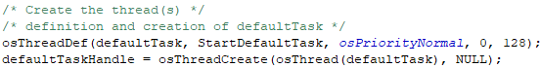

Screenshot 3

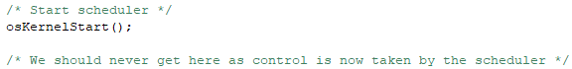

Signoff Sheet

