Screenshot 1



Screenshot 2

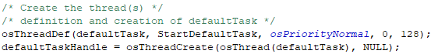

Screenshot 3

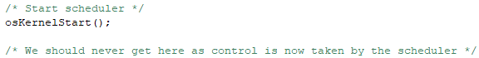

Signoff Sheet