LUGAR | GEOLOCALIZACION | FOTOS
SAN PEDRO | 23.920906, -110.264564 | 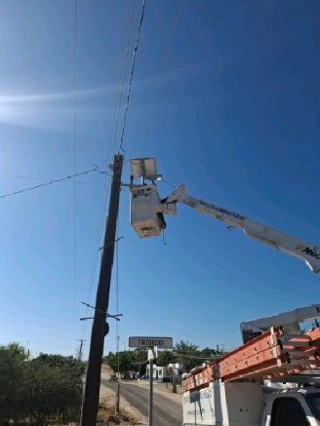
SARGENTO | 24.082526, -109.993033 | 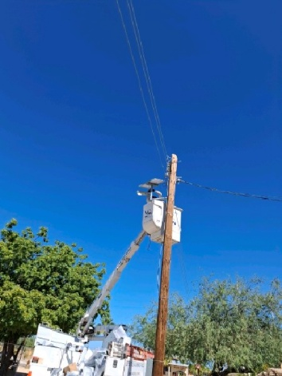
SARGENTO | 24.083834, -109.993126 | 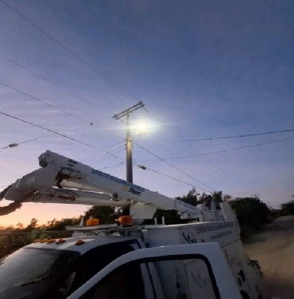
SARGENTO | 24.083898, -109.993788 | 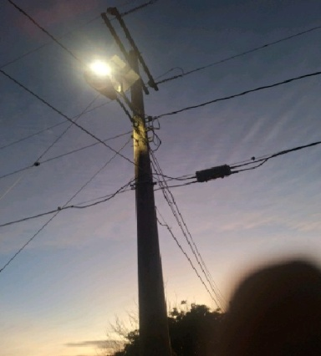
SARGENTO | 24.084451, -109.994061 | 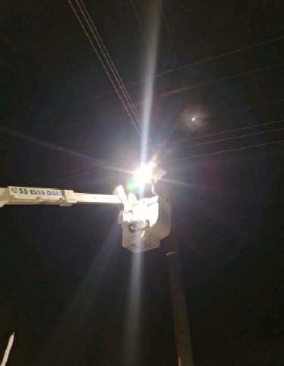
SARGENTO | 24.087357, -109.995435 | 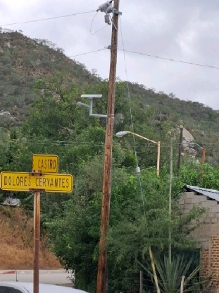
SARGENTO | 24.085748, -109.996506 | 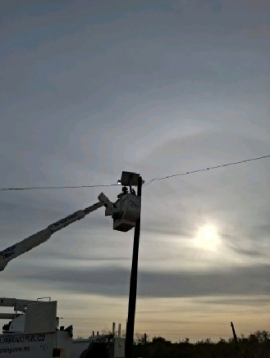
SARGENTO | 24.085423, -109.996640 | 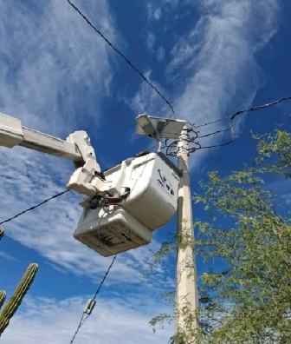
SARGENTO | 24.087622, -109.996782 | 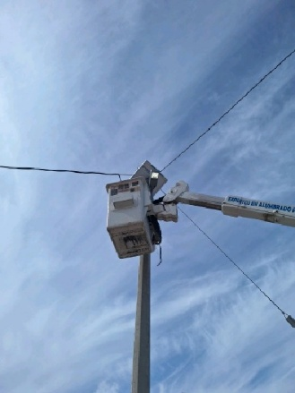
SARGENTO | 24.086197, -109.997982 | 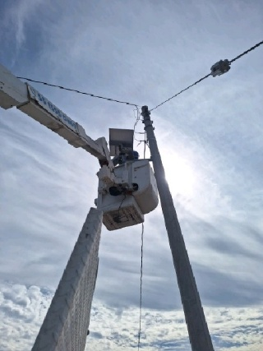
SARGENTO | 24.085769, -109.998268 | 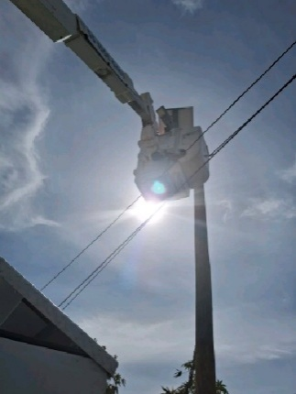
SARGENTO | 24.085384, -109.997933 | 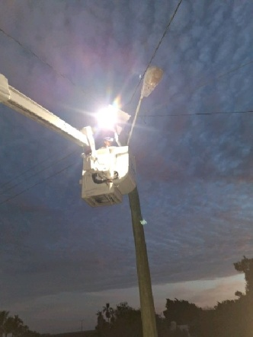
SARGENTO | 24.084192, -109.997802 | 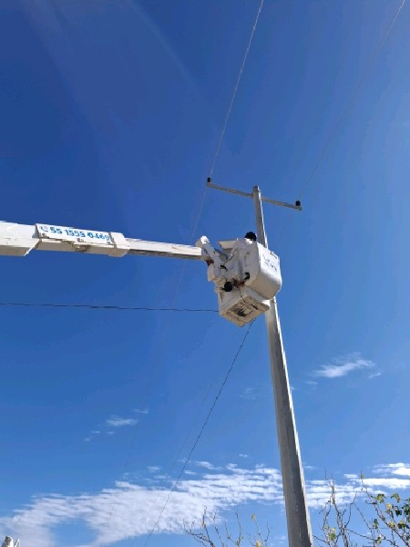
SARGENTO | 24.080288, -109.997255 | 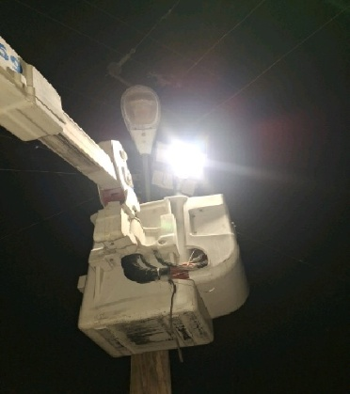
SARGENTO | 24.079367, -109.997146 | 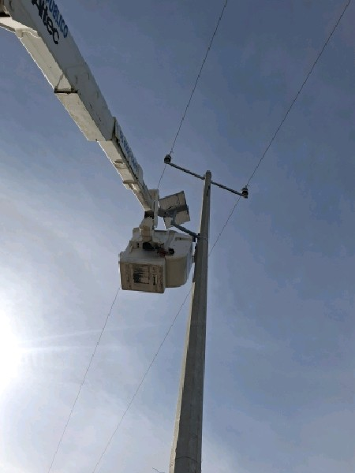
SARGENTO | 24.078820, -109.997031 | 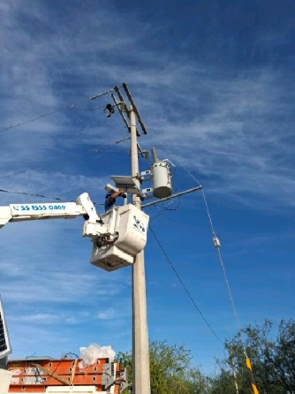
SARGENTO | 24.078324, -109.996978 | 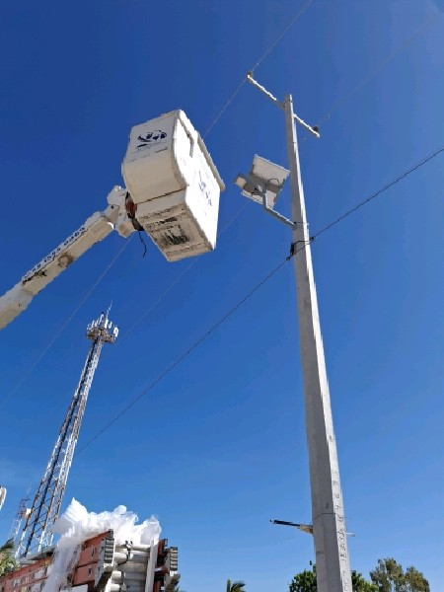
SARGENTO | 24.077720, -109.997015 | 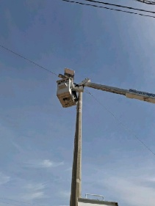
SARGENTO | 24.077460, -109.998353 | 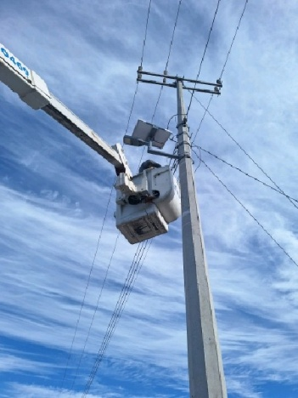
SARGENTO | 24.078738, -109.997988 | 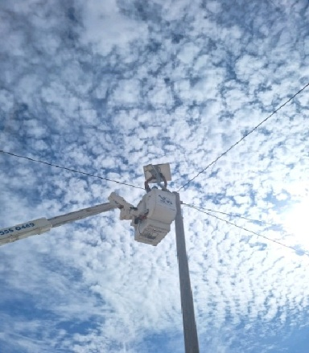
SARGENTO | 24.079027, -109.996324 | 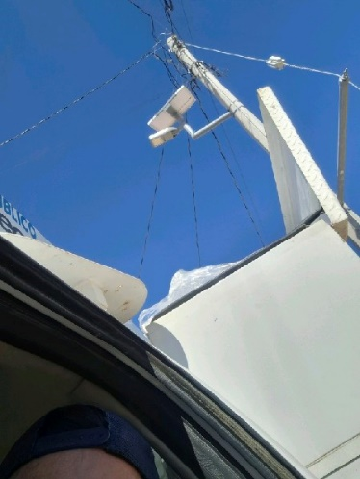
SARGENTO | 24.078506, -109.995925 | 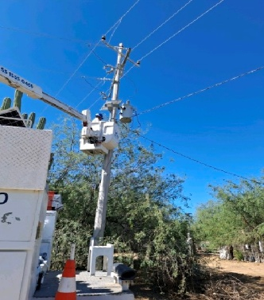
SARGENTO | 24.077989, -109.995036 | 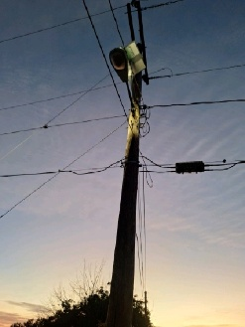
SARGENTO | 24.076817, -109.994799 | 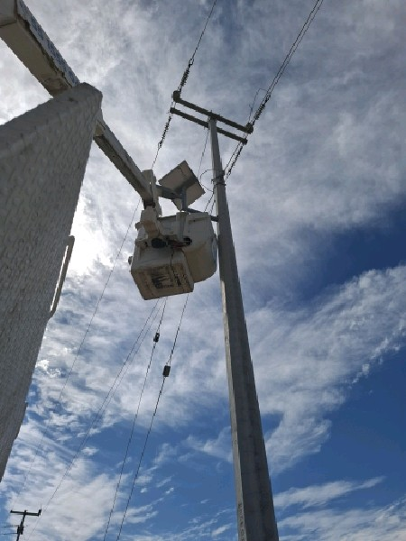
SARGENTO | 24.076902, -109.994020 | 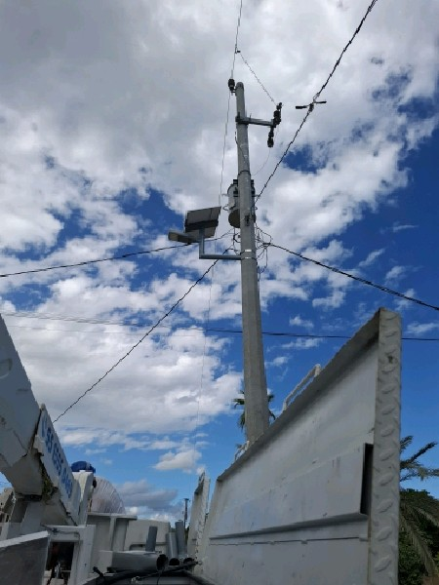
LA VENTANA | 24.056053, -109.989364 | 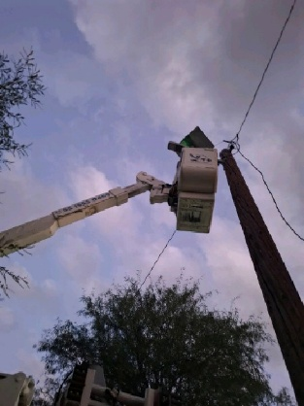
LA VENTANA | 24.052067, -109.991165 | 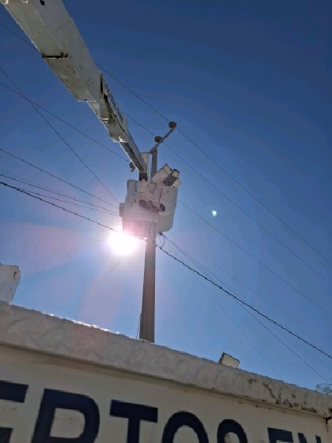
LA VENTANA | 24.049364, -109.991133 | 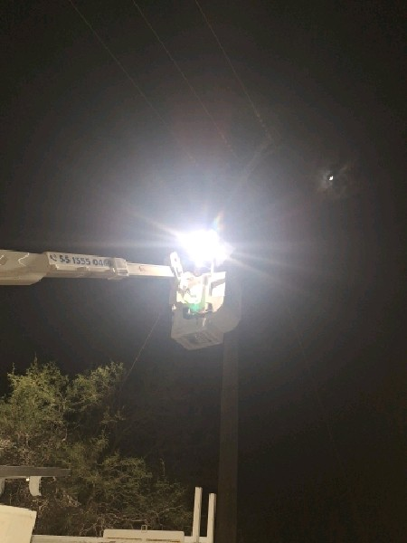
LA VENTANA | 24.048324, -109.989810 | 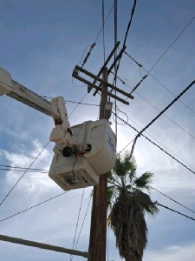
LA VENTANA | 24.048256, -109.990577 | 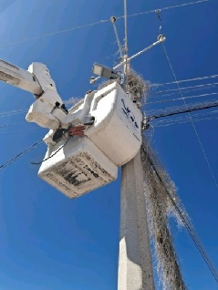
LA VENTANA | 24.045969, -109.989120 | 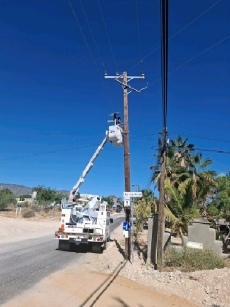
JUAN DOMINGUEZ COTA | 23.968273, -109.952253 | 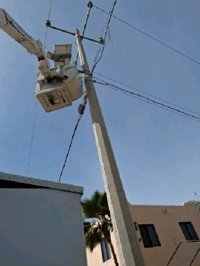
JUAN DOMINGUEZ COTA | 23.969179, -109.951256 | 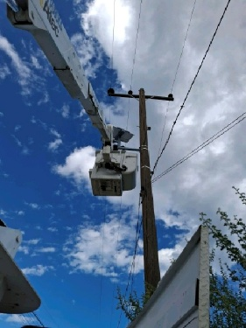
JUAN DOMINGUEZ COTA | 23.969521, -109.951948 | 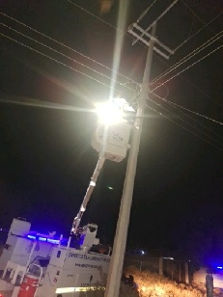
JUAN DOMINGUEZ COTA | 23.970359, -109.954923 | 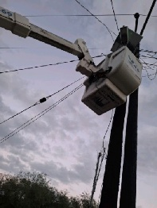
JUAN DOMINGUEZ COTA | 23.969906, -109.955002 | 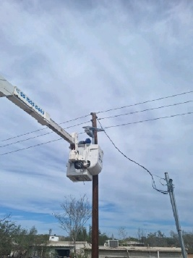
JUAN DOMINGUEZ COTA | 23.970340, -109.955975 | 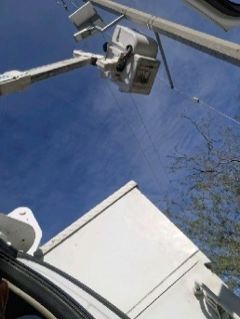
JUAN DOMINGUEZ COTA | 23.970446, -109.956447 | 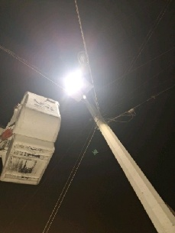
JUAN DOMINGUEZ COTA | 23.970516, -109.957032 | 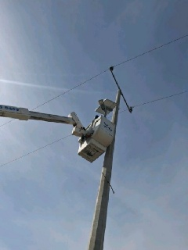
JUAN DOMINGUEZ COTA | 23.969673, -109.957303 | 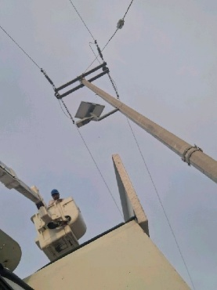
JUAN DOMINGUEZ COTA | 23.968308, -109.955268 | 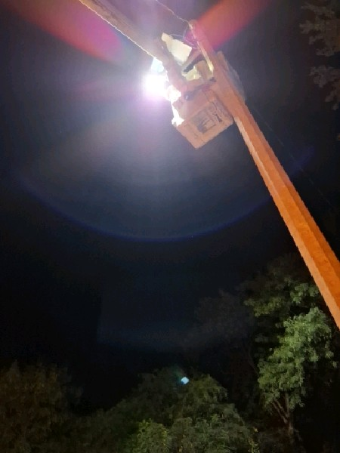
JUAN DOMINGUEZ COTA | 23.968933, -109.957212 | 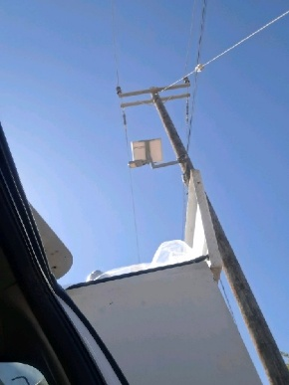
JUAN DOMINGUEZ COTA | 23.968865, -109.958609 | 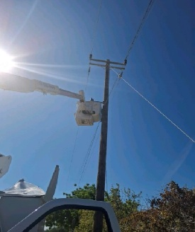
JUAN DOMINGUEZ COTA | 23.969368, -109.958399 | 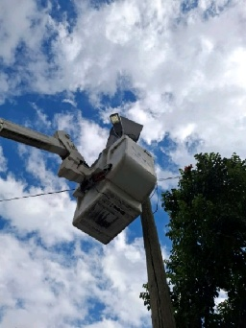
JUAN DOMINGUEZ COTA | 23.969901, -109.958216 | 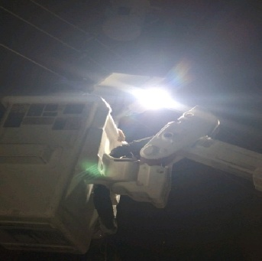
JUAN DOMINGUEZ COTA | 23.970223, -109.958117 | 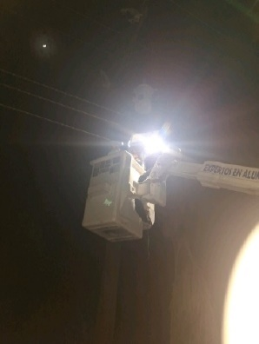
JUAN DOMINGUEZ COTA | 23.971184, -109.957801 | 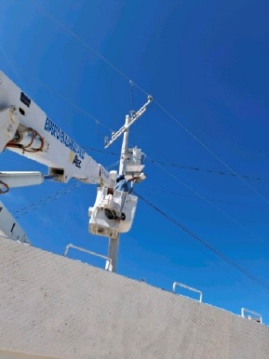
JUAN DOMINGUEZ COTA | 23.971750, -109.957603 | 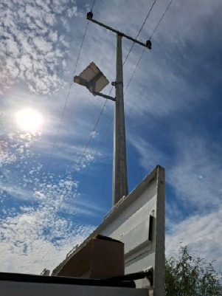
JUAN DOMINGUEZ COTA | 23.970948, -109.958990 | 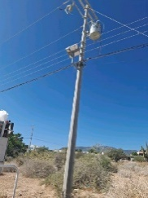
JUAN DOMINGUEZ COTA | 23.968853, -109.959660 | 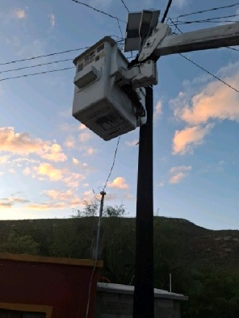
JUAN DOMINGUEZ COTA | 23.968345, -109.959831 | 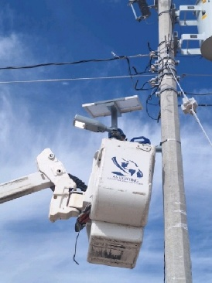
El CARDONAL | 23.842481, -109.751555 | 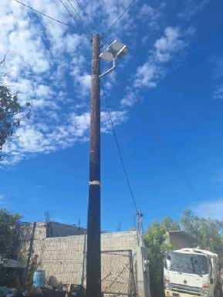
El CARDONAL | 23.843354, -109.748952 | 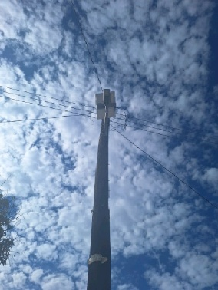
El CARDONAL | 23.841935, -109.747947 | 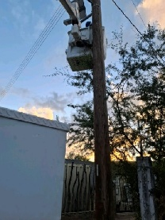
El CARDONAL | 23.840981, -109.747863 | 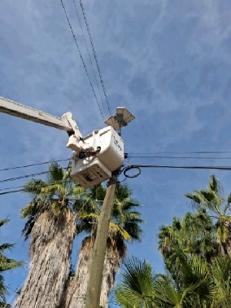
El CARDONAL | 23.841497, -109.749329 | 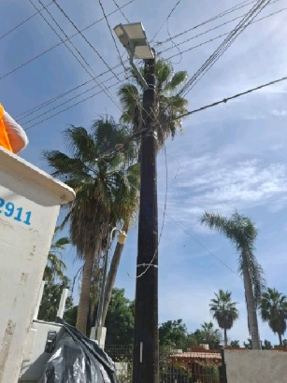
El CARDONAL | 23.843705, -109.747276 | 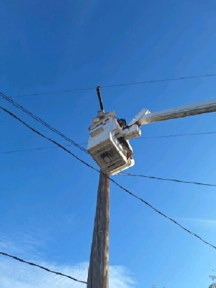
LOS BARRILES | 23.696609, -109.702834 | 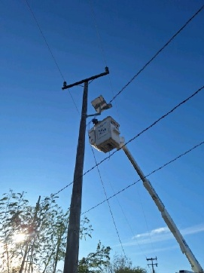
LOS BARRILES | 23.686859, -109.702636 | 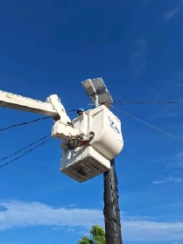
LOS BARRILES | 23.686458, -109.702477 | 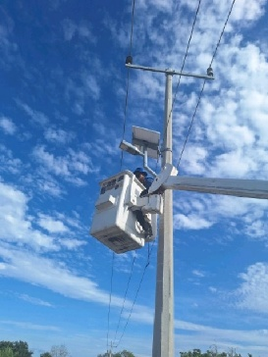
LOS BARRILES | 23.686479, -109.702061 | 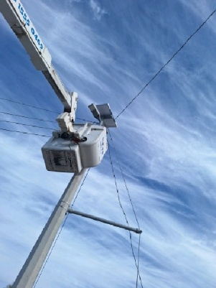
LOS BARRILES | 23.679822, -109.700482 | 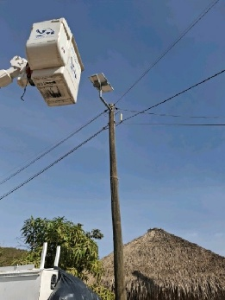
LOS BARRILES | 23.679295, -109.706500 | 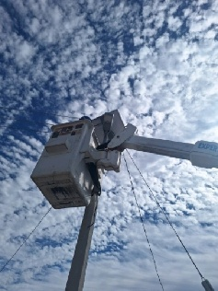
LOS BARRILES | 23.679468, -109.707311 | 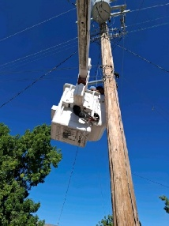
LOS BARRILES | 23.682499, -109.718119 | 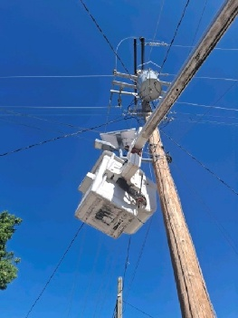
SAN BARTOLO | 23.738562, -109.838622 | 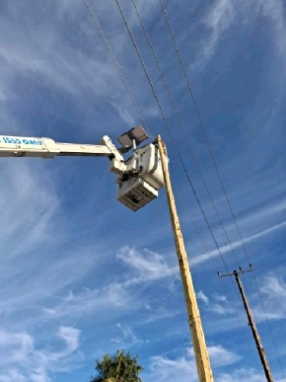
SAN BARTOLO | 23.738613, -109.838319 | 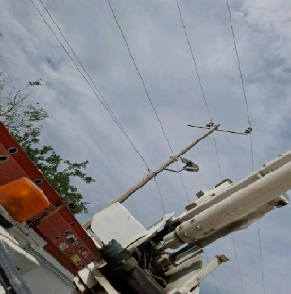
SAN BARTOLO | 23.738775, -109.837997 | 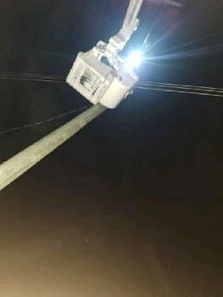
SAN BARTOLO | 23.738233, -109.841490 | 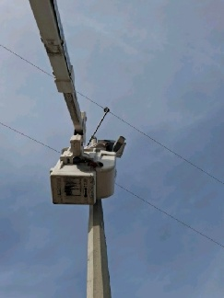
SAN BARTOLO | 23.738260, -109.841735 | 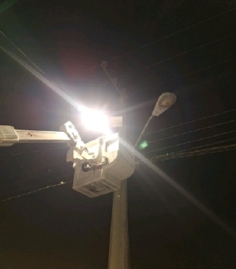
SAN BARTOLO | 23.738060, -109.847737 | 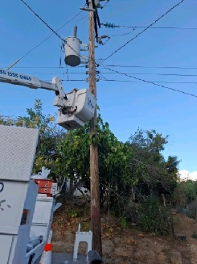
EL TRIUNFO | 23.802158, -110.110120 | 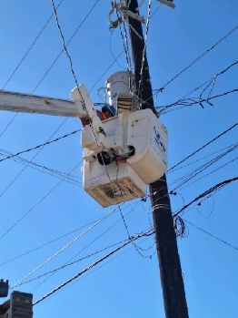
EL TRIUNFO | 23.802637, -110.110379 | 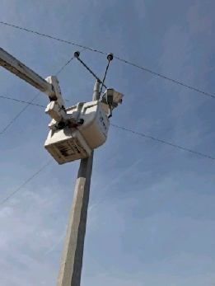
EL TRIUNFO | 23.803461, -110.110974 | 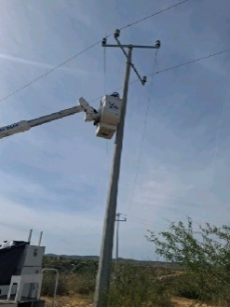
EL TRIUNFO | 23.803709, -110.110022 | 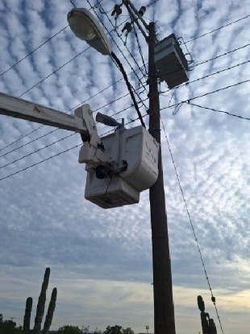
EL TRIUNFO | 23.804191, -110.109857 | 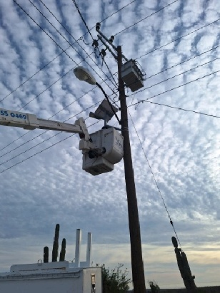
EL TRIUNFO | 23.805412, -110.109193 | 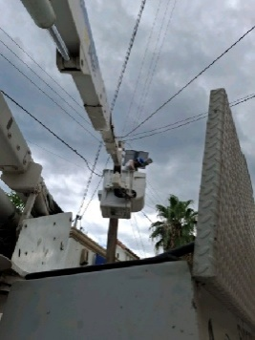
EL TRIUNFO | 23.806301, -110.107619 | 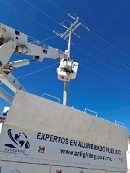
EL TRIUNFO | 23.806753, -110.107481 | 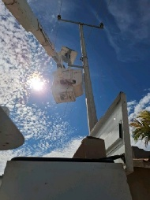
EL TRIUNFO | 23.807192, -110.106718 | 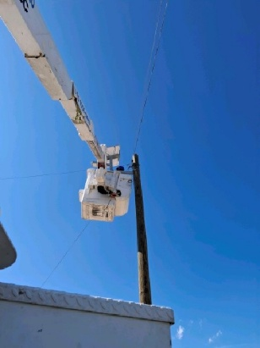
EL TRIUNFO | 23.807050, -110.106148 | 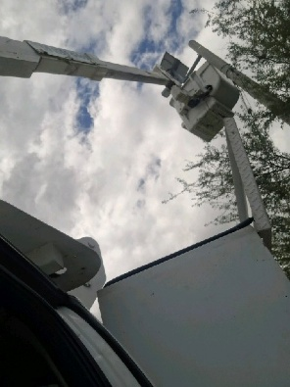
EL TRIUNFO | 23.802697, -110.108414 | 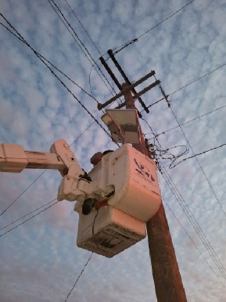
EL TRIUNFO | 23.801654, -110.108827 | 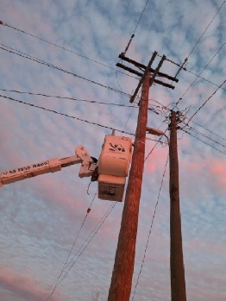
EL TRIUNFO | 23.798768, -110.110549 | 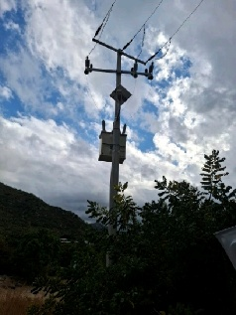
EL TRIUNFO | 23.798195, -110.110067 | 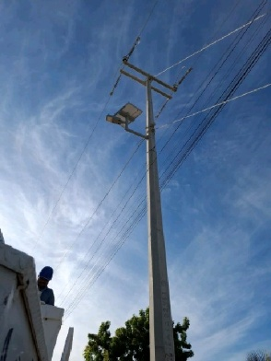
EL TRIUNFO | 23.798211, -110.109507 | 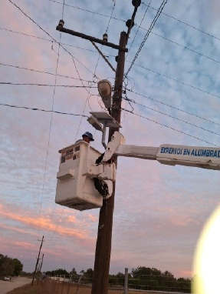
EL TRIUNFO | 23.797735, -110.109217 | 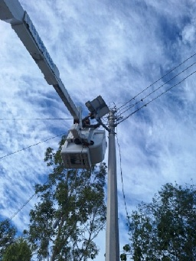
EL TRIUNFO | 23.802305, -110.110556 | 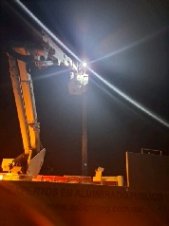
TODOS SANTOS | 23.447450, -110.218419 | 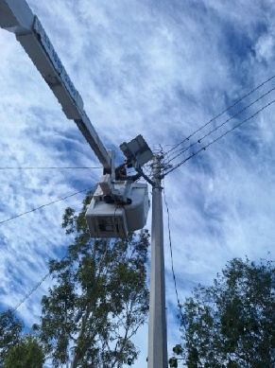
TODOS SANTOS | 23.362433, -110.166682 | 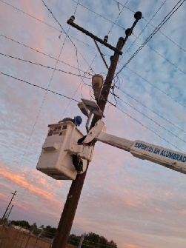
TODOS SANTOS | 23.446685, -110.219049 | 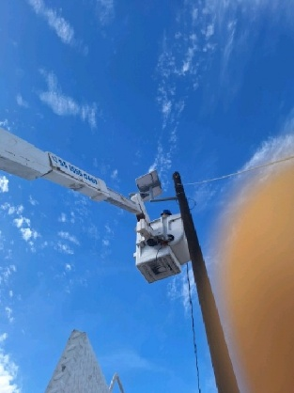
TODOS SANTOS | 23.363776, -110.165133 | 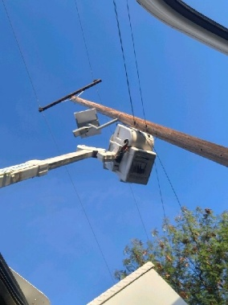
TODOS SANTOS | 23.450352, -110.215993 | 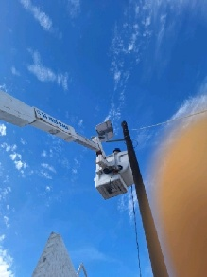
TODOS SANTOS | 23.447936, -110.218395 | 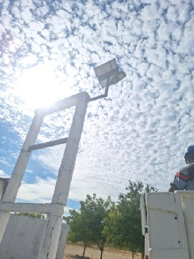
TODOS SANTOS | 23.445791, -110.223759 | 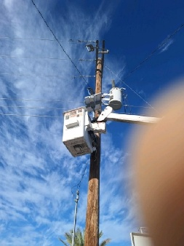
TODOS SANTOS | 23.448284, -110.221226 | 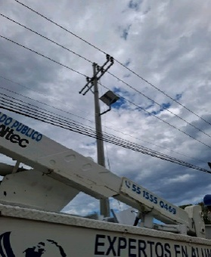
TODOS SANTOS | 23.447383, -110.225843 | 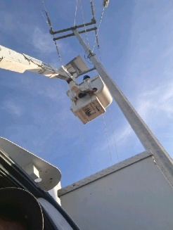
PESCADERO | 23.363549, -110.165677 | 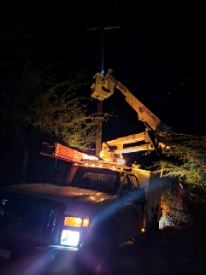
TODOS SANTOS | 23.460737, -110.227673 | 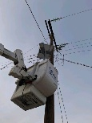
TODOS SANTOS | 23.456603, -110.233536 | 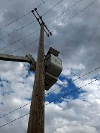
TODOS SANTOS | 23.449893, -110.226224 | 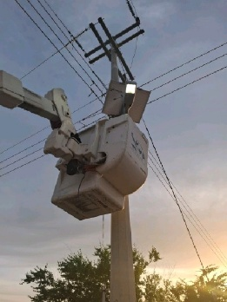
TODOS SANTOS | 23.449227, -110.226410 | 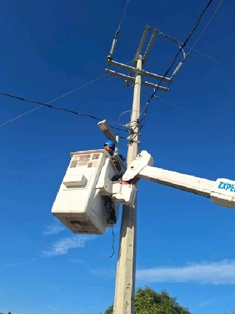
PESCADERO | 23.367558, -110.171711 | 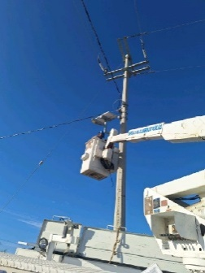
PESCADERO | 23.369657, -110.172528 | 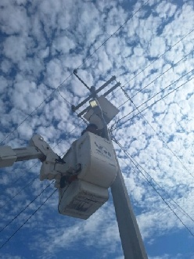
PESCADERO | 23.374394, -110.168827 | 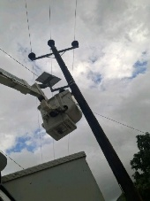
PESCADERO | 23.374107, -110.169767 | 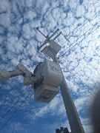
PESCADERO | 23.372518, -110.173723 | 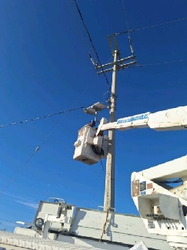
LA MATANZA | 23.638689, -110.278343 | 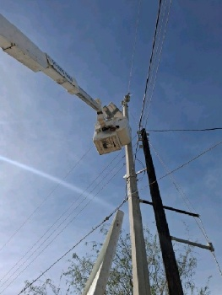
LA MATANZA | 23.637576, -110.278091 | 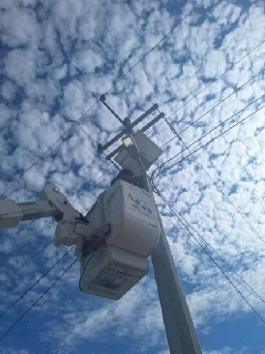
LA MATANZA | 23.638619, -110.276230 | 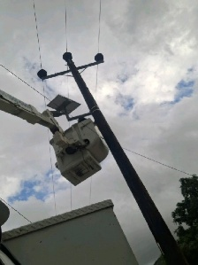
LA MATANZA | 23.638259, -110.272236 | 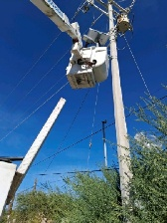
LA MATANZA | 23.638896, -110.275327 | 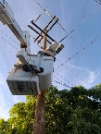
LA MATANZA | 23.646109, -110.262120 | 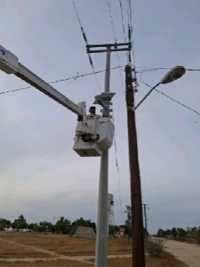
LA MATANZA | 23.645601, -110.261369 | 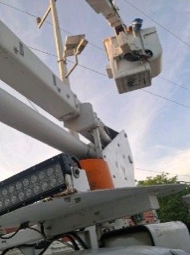
LA MATANZA | 23.646354, -110.261759 | 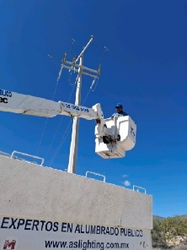
MELITON ALBAÑEZ | 23.661309, -110.420306 | 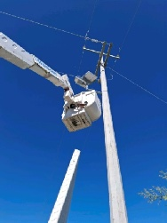
MELITON ALBAÑEZ | 23.661885, -110.421861 | 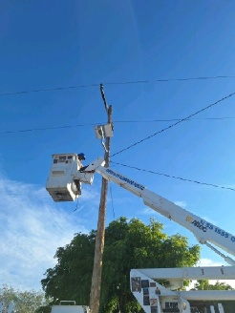
MELITON ALBAÑEZ | 23.660231, -110.422768 | 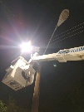
MELITON ALBAÑEZ | 23.659375, -110.421694 | 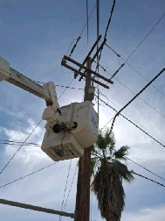
MELITON ALBAÑEZ | 23.657453, -110.420762 | 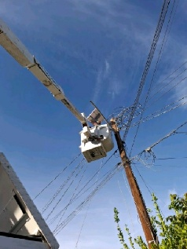
MELITON ALBAÑEZ | 23.657830, -110.419775 | 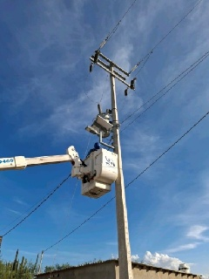
MELITON ALBAÑEZ | 23.658871, -110.420344 | 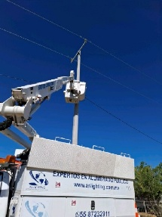
MELITON ALBAÑEZ | 23.660182, -110.420075 | 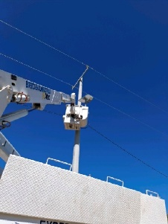
SANTA RITA | 24.593328, -111.465425 | 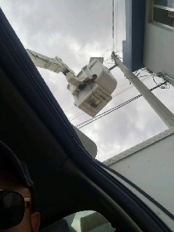
SANTA RITA | 24.594419, -111.466280 | 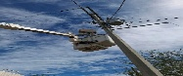
SANTA RITA | 24.589233, -111.465573 | 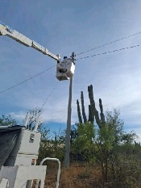
SANTA RITA | 24.589774, -111.465268 | 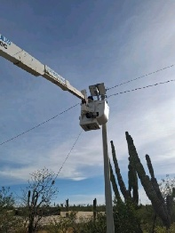
LAS POCITAS | 24.395384, -111.110363 | 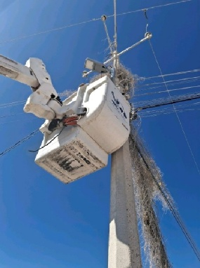
LAS POCITAS | 24.395482, -111.109848 | 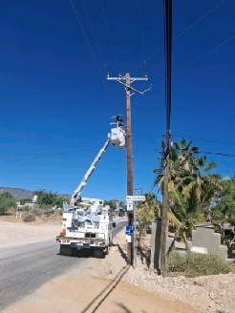
LAS POCITAS | 24.396401, -111.107812 | 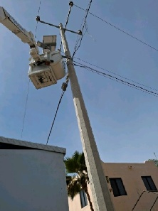
LAS POCITAS | 24.396066, -111.107413 | 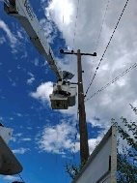
LAS POCITAS | 24.396278, -111.107060 | 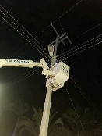
LAS POCITAS | 24.396419, -111.106893 | 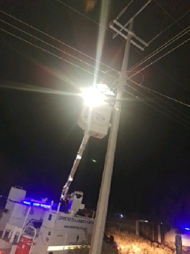
LAS POCITAS | 24.395827, -111.105429 | 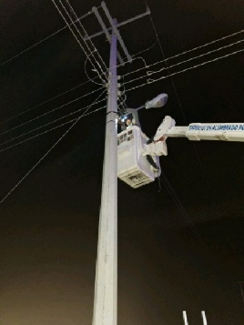
LAS POCITAS | 24.395290, -111.103746 | 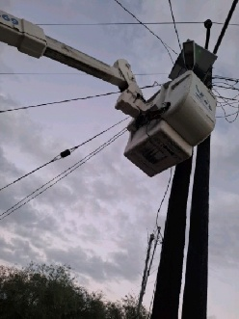
LAS POCITAS | 24.394804, -111.103753 | 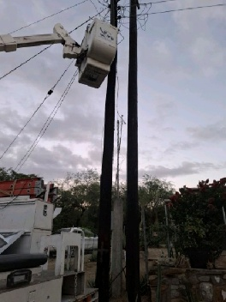
LAS POCITAS | 24.393057, -111.105217 | 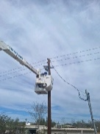
LAS POCITAS | 24.392263, -111.103809 | 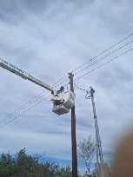
LAS POCITAS | 24.391179, -111.106117 | 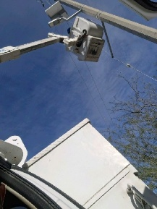
LAS POCITAS | 24.391497, -111.106483 | 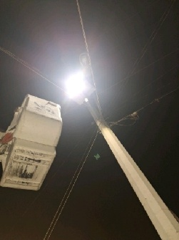
LAS POCITAS | 24.391509, -111.106975
LAS POCITAS | 24.392618, -111.108251
SAN HILARIO | 24.349128, -110.996329 | 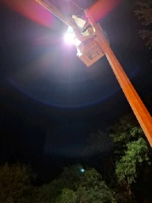
SAN HILARIO | 24.349069, -110.995211 | 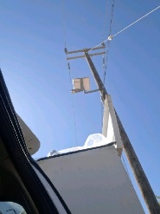
SAN HILARIO | 24.347838, -110.995275 | 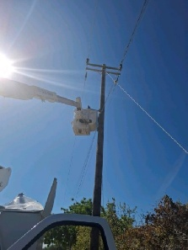
SAN HILARIO | 24.347903, -110.996452 | 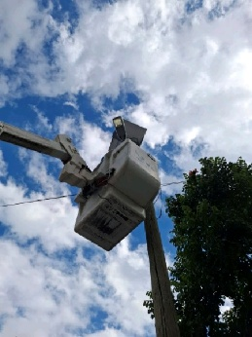
REFORMA AGRARIA 02 | 24.003464, -110.825995 | 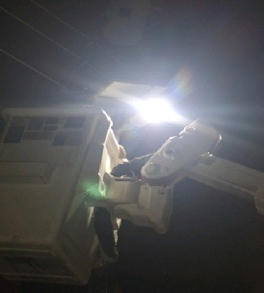
REFORMA AGRARIA 02 | 24.005652, -110.825645 | 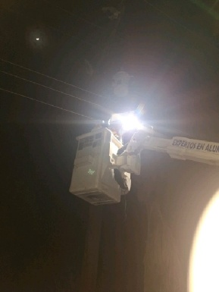
REFORMA AGRARIA 02 | 24.005058, -110.824901 | 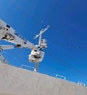
REFORMA AGRARIA 02 | 24.004853, -110.824613 | 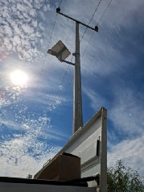
REFORMA AGRARIA 02 | 24.004479, -110.824208 | 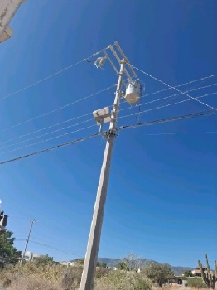
REFORMA AGRARIA 02 | 23.977172, -110.812637 | 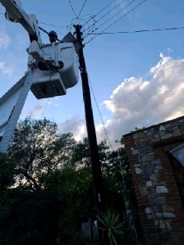
REFORMA AGRARIA 02 | 24.003175, -110.824745 | 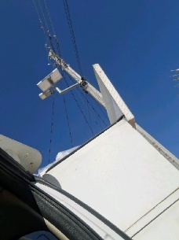
REFORMA AGRARIA 02 | 24.002850, -110.823580 | 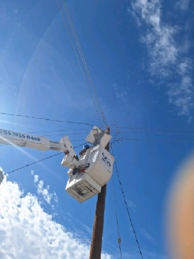
REFORMA AGRARIA 02 | 24.003956, -110.826599 | 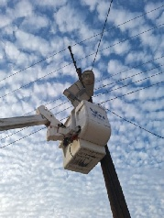
CONQUISTA AGRARIA | 23.984344, -110.813806 | 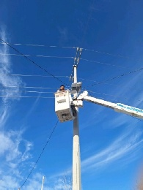
CONQUISTA AGRARIA | 23.983537, -110.812497 | 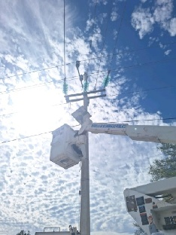
CONQUISTA AGRARIA | 23.983308, -110.811274 | 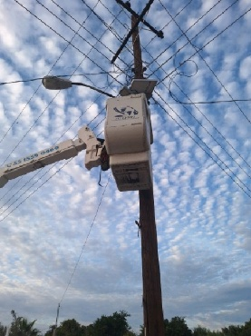
CONQUISTA AGRARIA | 23.983148, -110.810161 | 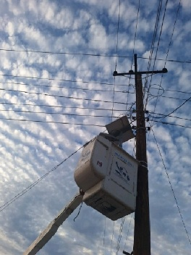
CONQUISTA AGRARIA | 23.981979, -110.815434 | 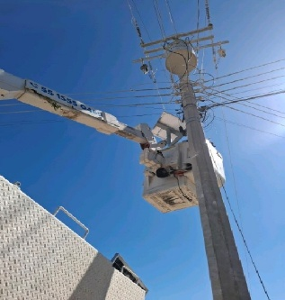
CONQUISTA AGRARIA | 23.980977, -110.810553 | 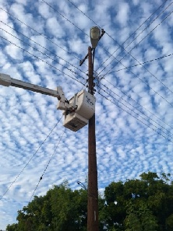
CONQUISTA AGRARIA | 23.982884, -110.809151 | 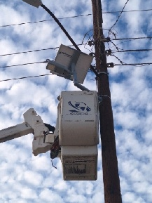
REFORMA AGRARIA UNO | 23.959277, -110.746076 | 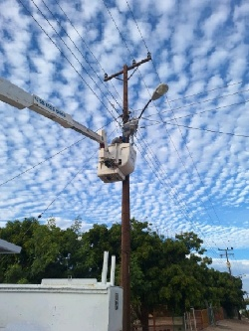
REFORMA AGRARIA UNO | 23.961054, -110.745509 | 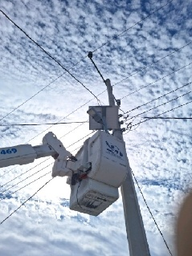
REFORMA AGRARIA UNO | 23.960620, -110.746448 | 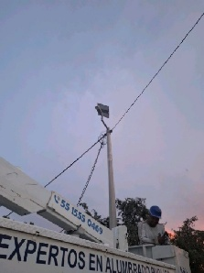
REFORMA AGRARIA UNO | 23.961326, -110.745899 | 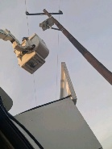
REFORMA AGRARIA UNO | 23.962301, -110.745066 | 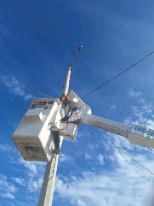
REFORMA AGRARIA UNO | 23.962567, -110.745962 | 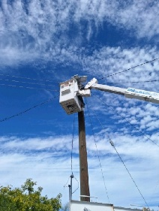
REFORMA AGRARIA UNO | 23.962180, -110.746296 | 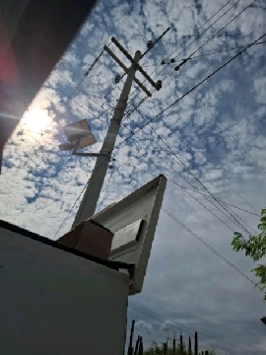
EL CARRIZAL | 23.784555, -110.311304 | 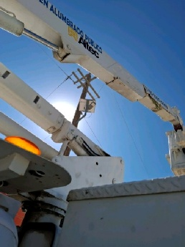
EL CARRIZAL | 23.775764, -110.312739 | 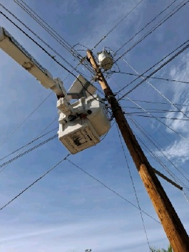
EL CARRIZAL | 23.786965, -110.309684 | 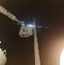  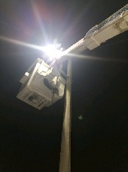
EL CARRIZAL | 23.786423, -110.313356
EL CARRIZAL | 23.785331, -110.313470 | 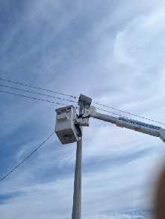
EL CARRIZAL | 23.783107, -110.313845 | 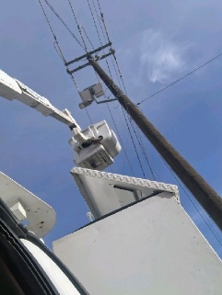
EL CARRIZAL | 23.787608, -110.315477 | 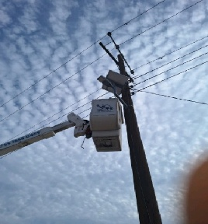
LA TRINIDAD | 23.805832, -110.316957 | 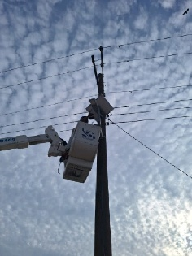
LA TRINIDAD | 23.806552, -110.316894 | 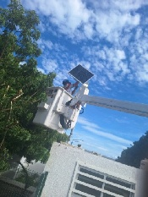
LA TRINIDAD | 23.808551, -110.317116 | 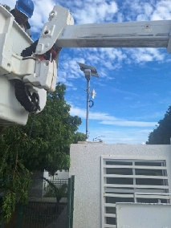
LA TRINIDAD | 23.808573, -110.317692 | 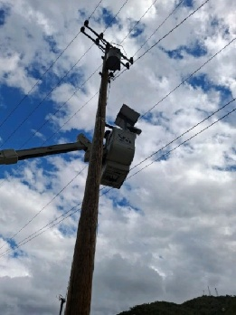
LA TRINIDAD | 23.810403, -110.317292 | 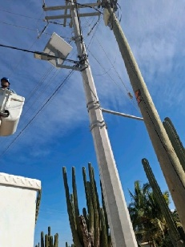
EL CARRIZAL | 23.797398, -110.308186 | 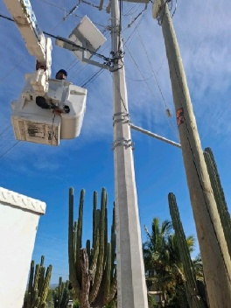
SAN PEDRO | 23.924289, -110.265201 | 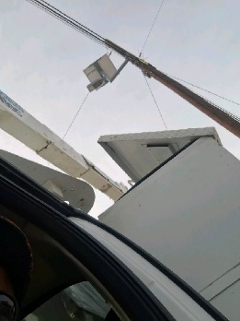
SAN PEDRO | 23.925723, -110.266689 | 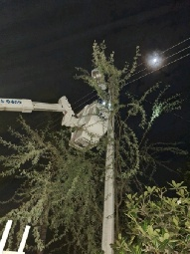
SAN PEDRO | 23.925547, -110.268000 | 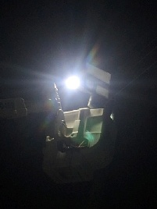
SAN PEDRO | 23.932571, -110.262212 | 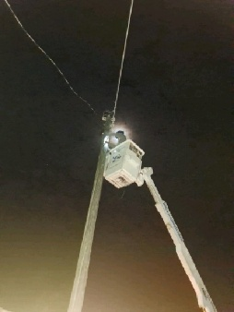
SANTA RITA | 24.59395, -111.46524 | 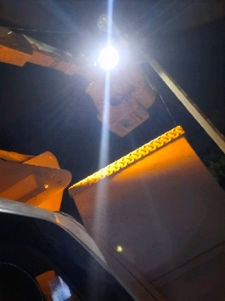
CONQUISTA AGRARIA | 23.97888, -110.8164 | 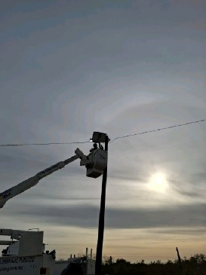
SAN HILARIO | 24.347834, -110.995276 | 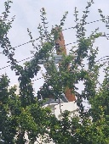
REFORMA AGRARIA UNO | 23.96214, -110.74645 | 