SJmp3 - Solo Java sound player description

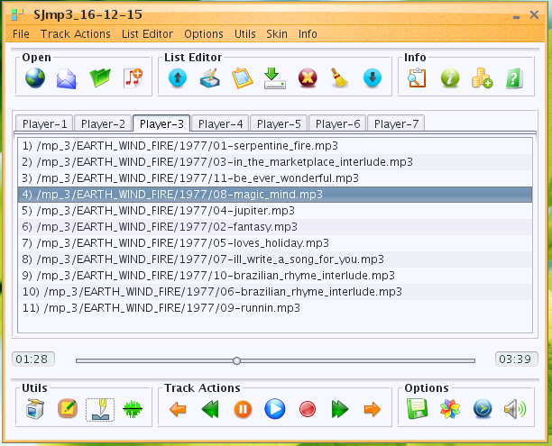
SJmp3 - stable 100%-pure java free cross-platform Solo Java sound player, including:
- network stream audio over HTTP/HTTPS/Anonymous FTP with/without Proxy-Server;
- up to 7 playlist at the same time
- tag editor
- Simple and intuitive graphical User Interface
- m3u playlist editor
- Different playing modes.
- Seek by slider using my native seeking algorithm.
- Fast Forward / Fast Backward, Next / Previous track, Play / Pause / Stop track actions.
- Support recursive search media-files in directories tree.
- File/Stream Information.
- Audio-mixer support.
- User settings save.
- wav to mp3 and mp3 to wav converter
- mp3 splitter by time/size
- over 35 skins (Look and Feels)
- NOT used JMF
- Supported Formats: mp1, mp2, mp3, mpga, wav.
- Internet Radio support
- Need JRE 1.8, Tested on WinXP,Win7,Linux CentOS.
Support mp1/2/3-files by jlayer library : http://www.javazoom.net/javalayer/javalayer.html
Successfully tested on Windows and Linux 32 and 64 bit operational systems.

1) Track Actions support:
- Fast Forward / Fast Backward ( step is a 5% of a track time );
- Next / Previous track;
- Play / Pause / Stop;

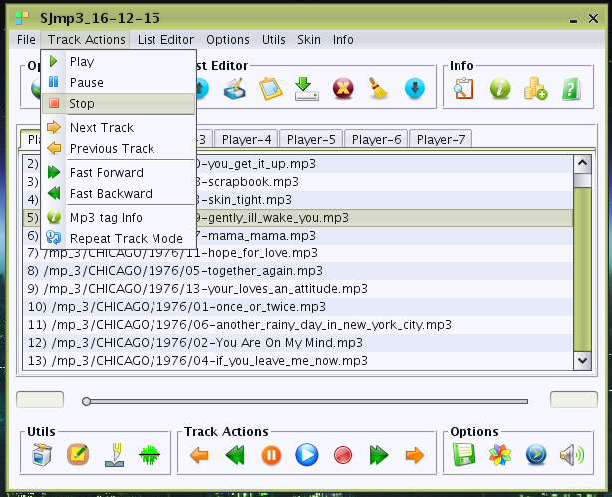
2) Track Seeking by Slider

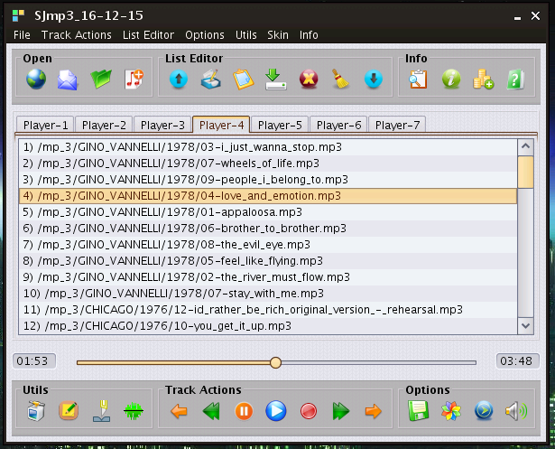
Seek not used javazoom BasicPlayer (http://www.javazoom.net/jlgui/developerguide.html), I'm using my native seeking algorithm.
3) You may be add to player File / Folder / URL / M3u-PlayList: In menu «File» or Tool Bar «Open». «Open Folder» support recursive search audio-files in directories tree.
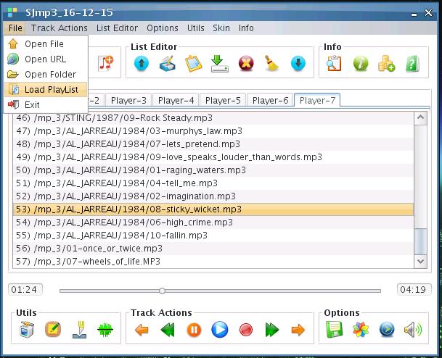
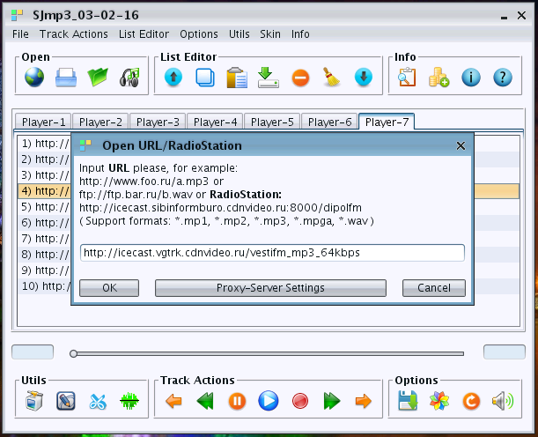
4) For Network Stream Audio over HTTP/HTTPS/Anonymous FTP is support Proxy:

- button «Proxy-Server Settings» in open URL dialog;
- menu «Options» -> Proxy-Server Settings;
- button in «Utils» Tool Bar;

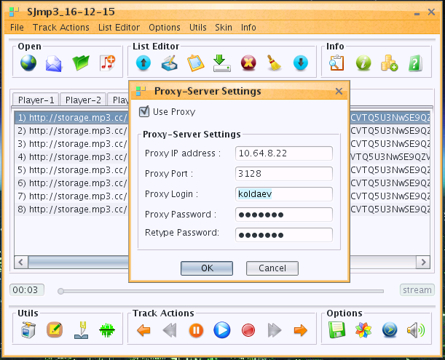
While Network Stream is playing, the Fast Forward / Fast Backword track actions is disabled because it is a strem, not a file, and the mp3-file-info is not show the size of file, duration and number of all frames. Network Stream Audio over HTTP and Anonymous FTP was successfully tested with- and without Proxy-Server.

5) M3u-PlayList Editor:

Menu «List Editor» or Tool Bar «List Editor».

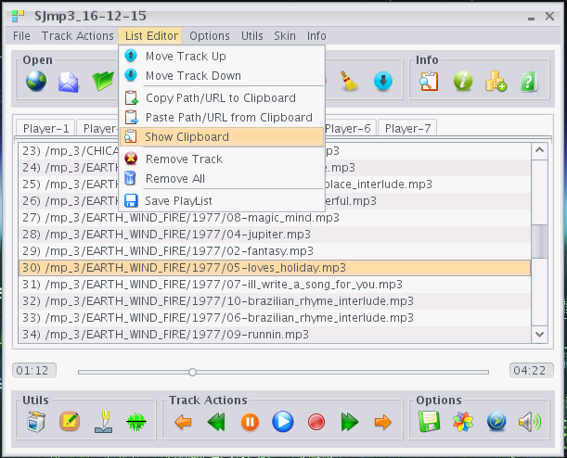
You can copy the liked URL from your browser into ClipBoard and then paste URL from Clipboard into current List (Player-1/2/3/4/5/6/7). Also you can copy Path/URL from one List to Clipboard and then paste it to another List.
Remove Track and Remove All actions deleted tracks only from current List — not from file system.

6) Support different playing modes:

Menu Options -> Mode Select or button in «Options» Tool Bar:
- No Repeat mode;
- Loop = Repeat PlayList mode;
- Shuffle = Random selection mode;
- Repeat Track mode;
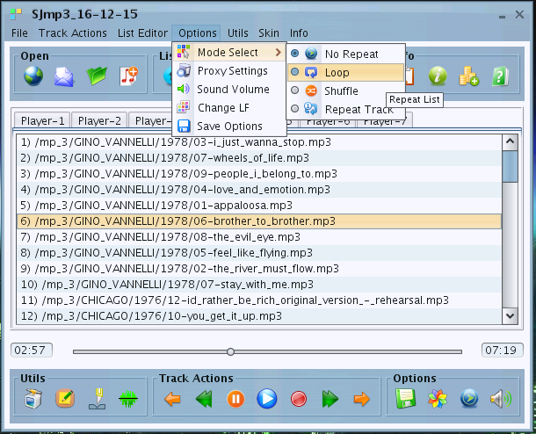
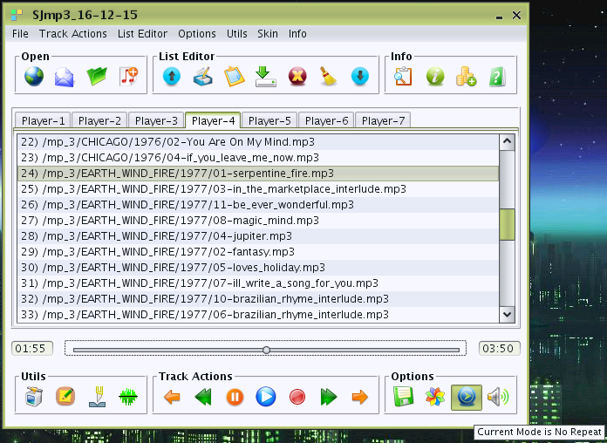

7) Over 35 skins support: From Substance and TinyLAF libraries. Menu Options -> Change LF, menu «Skin» or button on Options ToolBar.
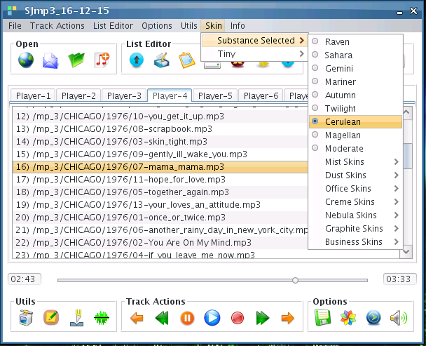
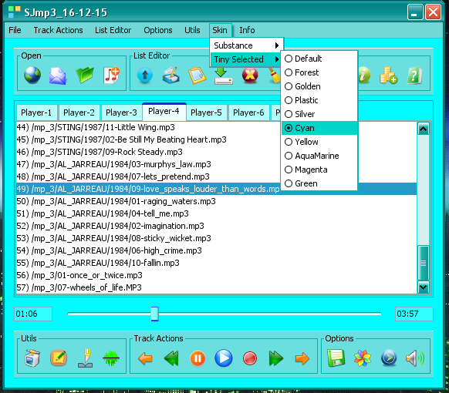

8) Integrated Mp3 id3tag Editor:

menu «Utils» or button in «Utils» ToolBar.

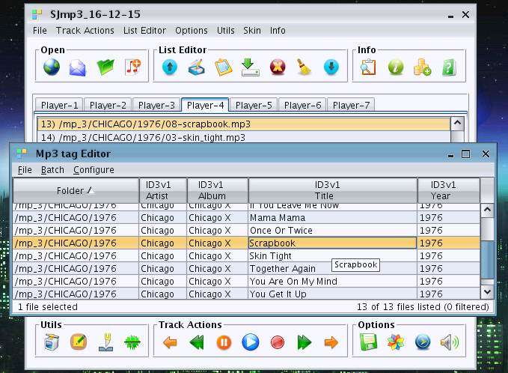

9) Integrated mp3-splitters by time and by size:

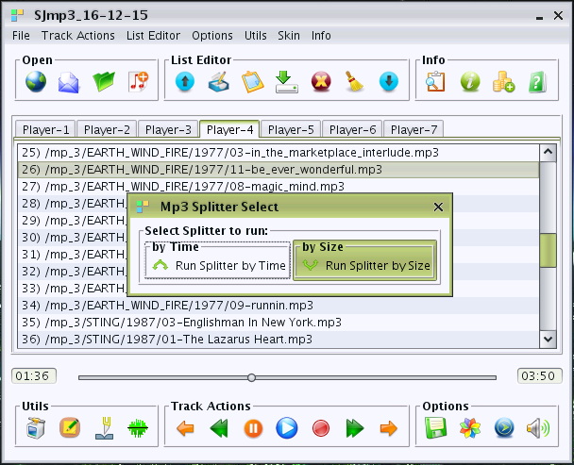
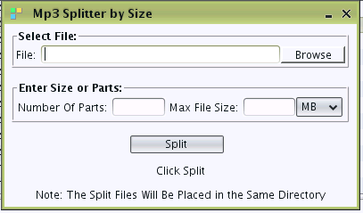
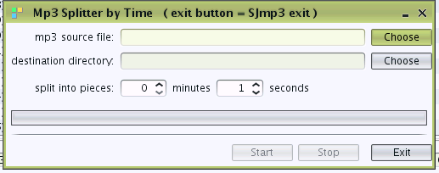
Successfully tested on Windows and Linux 32 and 64 bit operational systems.

10) Integrated wav-to-mp3 and mp3-to-wav converter:

Menu «Utils» or button in ToolBar «Utils».

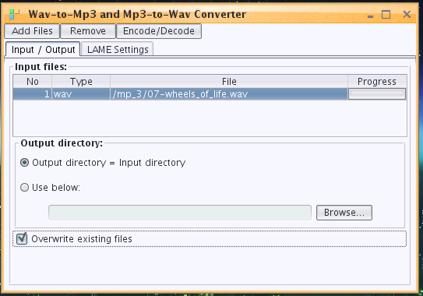
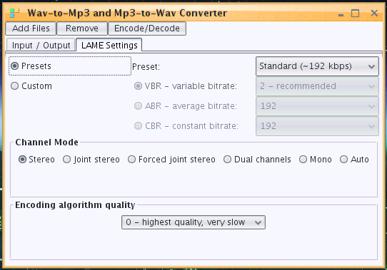
Successfully tested on Windows and Linux 32 and 64 bit operational systems.

11) Sound Volume Control:

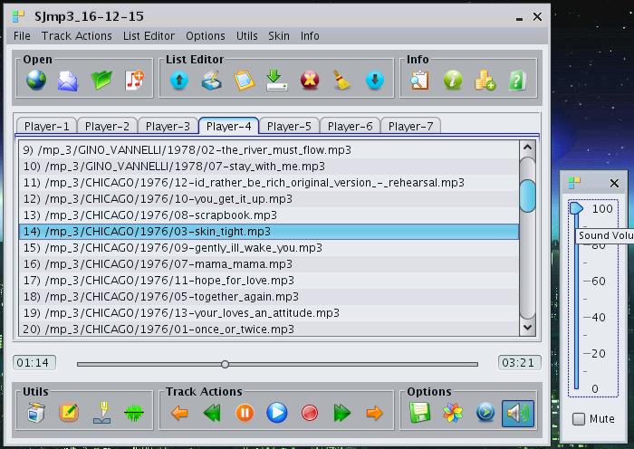
Successfully tested on Windows and Linux 32 and 64 bit operational systems.

12) File/Stream Information support:
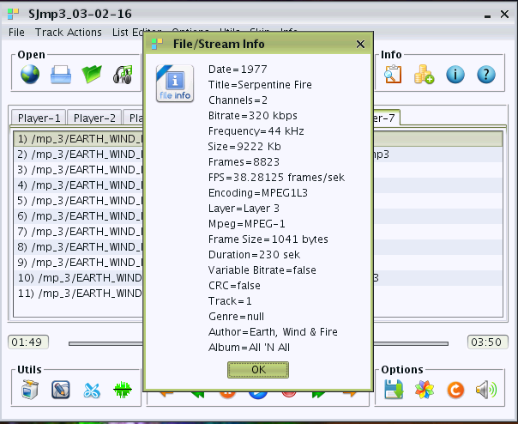
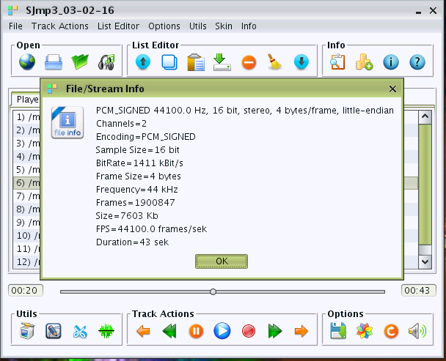
13) Popup menu support:

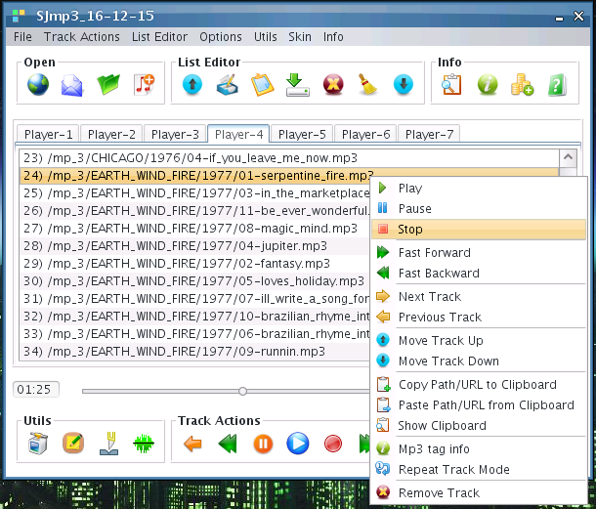

14) User setting save support:
menu «Options» -> Save Options or button in ToolBar «Options».

15) Up to 7 playlist at the same time support — Player-1 -> Player-7 on TabbedPane.

With best regards,
Roman Koldaev,
Saratov city,
Russia,
harp07@mail.ru

