1- I want, when sending a request for a client, to have the option to either fill his data automatically, or he can fill it by himself when accepting the invitation via WhatsApp or email, and if 1 info is filled, the 2nd party doesn’t need to refill it but can adjust it after by the coach if needed and not the client. Infos should contain number, email, name and surname, current bodyweight, when registering the 1st time, the date of creating this account, which is auto calculated, height and age, male or female. U can also upload a self photo of the client, if he have any allergies, taking medications, any prior injuries during the gym, type of work and how many average steps per day, and if they have any gym or other sport background, their favorite food, food what they hate and what they prefer to have, and make it the total calories expenditure can be calculated through specific formulas from internet that uses weight, height, age, sex and how much the training intensity is per week. Autofill these data from the client's data panel and be ready to be calculated once the coach decide the intensity + ur detailed goals.
notes:
2- For the second point, after the account are created and the invitation is accepted, the coach is going to assign a specific program for a specific time or weeks. Once it is created, it should show the date this program is created and started and until what day it ends, how many weeks and how much is paid for this program, make it that u can't assign during the same date of weeks a 2nd program, which is illogical. U either need to delete the previous one and create a new one or adjust directly the program, make it that the 1st ever the account is created the client will receive a notification to pay so their assigned diet and training programs and his account to be actually activated, so if the payment is not registered by the coach, that is paid manually, the account once opened will show only the data of this client and the whole other sections are blocked and they say pay so u have access, and before 3 days of ending their current mesocycle that it's about to end and they need to talk with the coach so they need to renew and pay for a whole new program that is set by the coach, make it also that the coach can whenever he want press a button of block to block the account of any clients.
note:
constraints, prohibition if blocked page.
3- For diet plan section I need ur help and for u to be creative, make it that I can add whatever recipe that I want and for sure I add each ingredient weighed and how it is, raw, cooked or else, and the total protein, carbs and fats, calories that within this meal, make it that it can auto detect from Google and certified web the macros and they can be manually adjusted by me.
So once I want to assign for a client his diet it will be assigned within the same section of assigning the training program if I choose to assign it, and when assigning the diet plan I can choose how many meals are there, and for each meal I can choose multiple meal recipes to be chosen of, and after that the total macros of the diet plan can be auto calculated by choosing a meal and an average macros per meal.
notes:
dataset recipes.
4- Make a section where the client can input his daily bodyweight and that is well organized, and it follows the date of the current active program, and that once the meso is done the data and the changes of the BW are calculated and showed, cooperated with the diet and training plan section and duration. Make them sync perfectly.
Like the program starts at 27/7/2026, for example, so it appears for her to note daily the bodyweight.
Week 1: Monday = ….
Tuesday ……

.

.

Sunday, then a mean number is calculated.
Week 2 etc….
Can u tell him to give me the capability to add dishes with their whole recipes from internet directly into my meal library without the need to manually input everything? And each meal contain exactly how to do it and the weight of each nutrient, raw or after cooking, and the expected macros and calories.
Notes:
Daily null by default
5-Make it that there is a section to control the theme of the whole web. U can upload, or u can tell the app or AI to choose random photos, background photos related to the topic or uploaded by the coach, by a standard one, and for me a specific set of Solo Leveling that also adapts and changes the name of each section depending on the Solo Leveling theme, and it shows rank and level up for the client each time he marks a workout as done and diet as accomplished, and after completing a total number of weeks, for example every 10 weeks, he ranks up. Use ur creativeness for these effects that should be added, and he loses EXP when he doesn’t or fails to workout.
notes: progress bar around profile.
6- I want to sell this app/web for coaches also, not only clients, so any suggestion or anything u would like to add or adjust, tell me about it, and any error or duplicate that is appearing should be adjusted by u or tell me before and how to adjust, and SYNC EVERYTHING and do not let it be possible to input contradictions.
notes base44 fucking crazy logic backend syncing malfunctions
7- I want to add a section where I can, with 1 click, import the chosen client data, weight, height, age, then I choose the intensity of his workout that is needed so it shows automatically his BMR. After that I choose the amount of protein that I want for this client, for example 150, so it automatically then calculates 150 × 4 = 600 cal from protein. Let's say the BMR was 2500, it leaves us with 1900. Now I can choose the % of fat that I want from the initial 2500, let's say 25% = 625, divided by 9 = 70g of needed fats, and the rest amount of calories 2500 - 625 - 600 = 1275, divided by 4 = the needed grams of carbs. So every detail will be shown for this client respectively to his data. So every time I add a new calculation for each client it creates its own sample for him. Plus if it was BMR = 2500, make that there is another section that all the numbers are based on. If I did not put 2000, it uses the auto BMR for all other calculations. For example, if I want to lose weight, the BMR shows 2500, I choose to put for him 2000 cal, so every other fats %, protein and carbs calculation uses the 2000.
notes: take 3, calculate 3rd
“””””””””””””””””””””””””””””””””””””””””””””””””””””””””””””””””””””””””””””””””””””””””
8.1- main lifts non modifiable, accessories exs client can modify
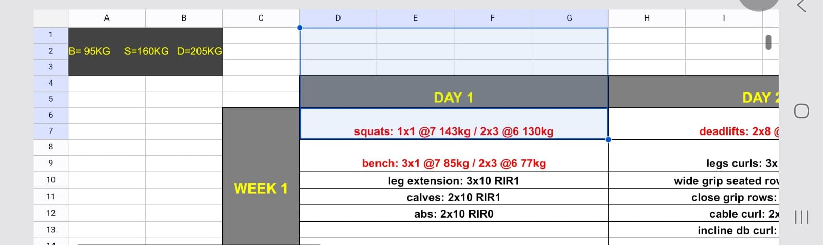
8- I want to add a button that locks the upcoming weeks that appear for the client so he cannot see the table. He can only see it week by week of the upcoming weeks because they think that it is a simple copy-paste, so each week opens automatically when the week progresses depending on the international calendar, and make it that there is an option for me to make them all appear if I want for some clients.
9- Make it that there is a section where the coach and client can chat directly in the app + make it that I can add notes in a specific area close to the diet plan of a specific meal and etc….
10- I want that when I add a 1RM stored data to be able to apply them to the specific program, so adjusted weights are for the program to whom I assign these specific sets of 1RM, and for each program I assign the wanted 1RM. The AI generating meals is not working, fix this bug. I press on it but nothing appears or changes nor does a notification appear. Plus look at his photo, how I can input 2 same subscription durations and it is applicable, and the money is overwritten by the new subscription. Fix this problem that I can't add another week and subscription duration or program duration that contradicts with old ones.
11- For the training program sections, so when I want to have a table shape and can only be seen day by day, have the button to tell that the workout is done for today and is completed by the client, to add or remove notes from clients and coach as well. The table should be like the number of days on the 1st line and in the 1st column the number of weeks, and within each week and day intersection I can put whatever I want from the exercises, and if there is an uploaded video for the exercise it can be shown by pressing a button. Also each exercise should contain the total number of sets, reps, weight, RIR and RPE, both of them ranging from 0 to 10, and that are synced. Make sure to understand what RIR and RPE are from internet. Plus for each exercise also sometimes I can assign for each set 1 specific weight etc…. for set 2 and 3 the same specific weight etc….
Plus make it that I am able to add or delete days or weeks for the program and it is always adjustable by the coach for the client + search about the RPE calculator that uses the most sophisticated formulas and % to be able to calculate the weight for the next workout on a different day so I can, with a single button, for a powerlifter for example, after setting the whole exercises with weight and etc…. for week 1, with a single click I can duplicate the same routine of these days for the next week or weeks, and just by choosing how much the RPE and reps are increased so the weights are auto calculated. So once it starts with week 1 at RPE 6, I choose to progress 0.5 RPE per week with the same reps, so week 2 RPE 6.5, week 3 RPE 7 etc…., and the weights are auto calculated based on the preset 1RM for the specific chosen lifter in the program on the top right corner of the table or from the weight of week 1.
12- For each program when assigned to the client, make it that it duplicates the standard one that is originally saved in the program section. Once copied, the program is named Meso 1 etc…. or can later be changed, and is saved under a specific section named by the name of the client, and that shows his whole subscriptions and assigned workout and plans, and make everything sync.
13- Make 2 different sections like libraries for meal recipes and choices that I can add, create, take from AI or internet, or manually add, and another one for training videos and exercises. These videos can be uploaded and can only be downloaded by the coach, and then assigned with each specific exercise that will be able to pop up when the specific button of watching in the training program is pressed. These 2 libraries are usually hidden from the clients except if the coach taps in the specific area of the specific client that he has extra access to these libraries, so he can see everything, not only what is assigned for his programs.

