The user interface has a menu :
  - File, Edit, View,Image,Filters,Tools,Window,information
  - 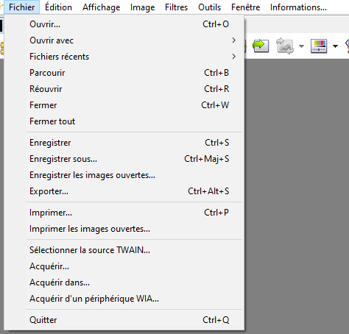
  - File:
    - Open
    - Recent files
    - Browse
    - Reopen
    - Close.
    - Close all.
    - Save
    - Save As
    - Print
    - Quit
  - Edit :
    - Cut,
    - Copy
    - Past
    - Delete
    - Rename
  - View :
    - Full screen.
    - Real size
    - Adjust :
      - No Adjustment
      - Adjust to the size of the window
      - Adjust to the width of the window
    - Zoom +
    - Zoom -
    - File
      - Next File
      - Previous File
      - Last One
      - First One.
    - Display Tabs
    - Display Tool bar
    - Display State bar
  - Image :
    - Number of used colors
    - Rotate
      - 90° clock wise
      - 90° reverse clock wise
      - 180°
    - Mirror :
      - Vertical
      - Horizontal
    - Resize
    - Correct red eyes
  - Tools:
    - Find a file
    - Hexadecimal display
    - Diaporama
    - Send by email
    - Parameters
    - Slide Show
    - Show pictures on all the screens : Place the selected pictures on the screen
  - Window :
    - Tile (en cascade)
    - Tile horizontally

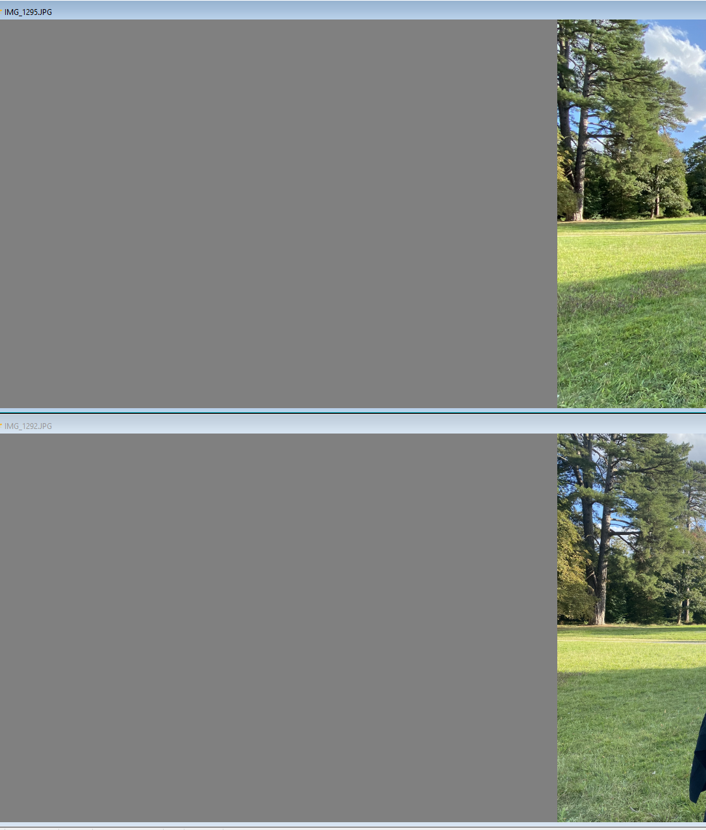
- Tile Vertically
- Minimize all
- Restore all
- Info :
Help

