**Hand-in due Oct 13, 2020 This hand-in assignment is a compulsory moment of the examination and should be solved individually. Submit it via your Canvas-account.**

**Problem 1: Kinematics**

A research group is enrolled in the implementation of a humanoid robot. The conceptual design appears below. It consists of 35 revolute joints but observe that 30 of them are organized in groups of three whose axes are intersecting in a single point to reproduce spherical motions (*in the way as for the three last revolute joints of a decoupled robot*), as shown below.

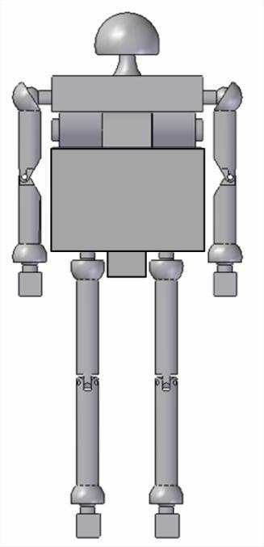 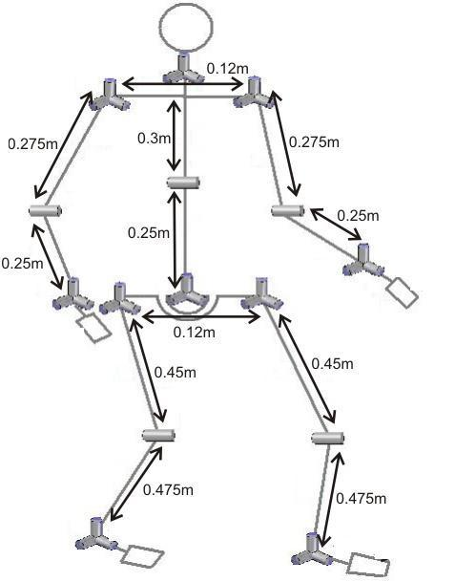

The four limbs of the robot have the same kinematic structure that can be schematically represented as follows:

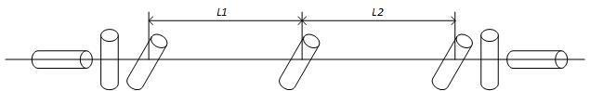

1) Find the DH parameters for the limbs (*i.e.,* the DH--‐parameters for the kinematic chain in the above scheme). **Hint**: It is important that the x-axis of a coordinate system is normal to the z-axis of the previous coordinate system!

2) Build the geometric model of one arm using the Robotics Toolbox and simulate an arbitrary joint-interpolated motion between two arbitrary configurations.

3) How many solutions to the inverse kinematics does the simulated kinematics chain have? Give a reasoned answer.

4) Assemble two legs and two arms so that the result corresponds to the designed robot in the case in which the robot’s trunk joints are blocked.

All 4 questions above must be answered correctly to ensure a pass for this kinematics part.

**Problem 2: Robotics Toolbox / dynamics**

(a) Use Peter Corke’s toolbox (recommended release 10.2) to set up a model of the 3 DOF robot which corresponds to the first three joints of IRB140, see Fig.3. You should in addition to the kinematic parameters also supply enough parameters (choose ’realistic masses’, total robot weight is about 100kg) to be able to get a dynamic model representation. (You don’t have to present an explicit model, but just define it to solve the subproblems below).

Make sure you choose your direction of the rotational axes (z-axes for DH-parameters) to get the same angle convention (direction and zero-position) as in RobotStudio (compare and verify).

(If you need to change the zero-position/offset for some link, you can use the Link-parameter offset, property of the Link-object in Peter Corke’s toolbox).

(b) Find out how much (stationary) torque is needed on the motor side to overcome the influence of gravity for the configuration (θ1 = 0 ◦ , θ2 = 10 ◦, θ3 = 40◦) . You can approximate the gear ratios to 1:100 for all three motors.

(c) Make a path-generation/simulation for jointwise or linear motion from   
( θ1 , θ2 , θ3 ) = (10◦ , 20 ◦ , 30 ◦ ) to (−10◦ , 40◦ , 10◦ ) .   
The robot is supposed to start and stop (i.e., zero velocity) at these points.

(d) Make a simulation of a “free-falling” robot from its home-position (joint torques =0). (No considerations need to be taken to joint limitations and colliding links.)

