

CSC1109 Data at Speed and Scale - Assignment 2

Name: | Lee Hickey
Student Number: | 21407166
Student Email | lee.hickey28@mail.dcu.ie

Name: | Brian Cafferty
Student Number: | 22432286
Student Email | brian.cafferty4@mail.dcu.ie

Name: | Alex Davis
Student Number: | 20449904
Student Email | alex.davies23@mail.dcu.ie

Introduction
Recommender systems are generally seen on retail or entertainment platforms to suggest products and media, however, they are equally valuable in sports analytics. Data can be used to analyse patterns in games and similarities between different teams and players in varieties of sports. Organisations use recommender systems to comprehend the large amounts of data they are collecting. In this project, we developed a hybrid recommender system using traditional NBA box score data from 1996 to 2025. This system identifies teams that are most similar to each other based on:
- Collaborative Filtering: similarity in team performance against the same opponents using a cosine similarity matrix between teams.
- Content Based Filtering: similarity in team statistics such as points, winning margins, rebounds, assists, etc. Completed using a cosine similarity matrix between the team's statistical profile.
- Hybrid Score: weighted average between both scores

We performed data cleaning using Apache Pig and large-scale data processing and querying using Apache Spark, SparkML and PySpark. Our motivation is to understand whether past NBA results and teams statistical data can be used to identify teams that are similar to each other. This identification will enable us to understand the expectation of teams across an NBA season against each particular opponent. This analysis will give coaches and fans a tool to understand “who plays like who”.

What Data
We used the team_traditional.csv from the NBA Team traditional Boxscore dataset located on Kaggle. It contains 70,850 team box scores spanning 30 seasons from the 1996/1997 season to the 2024/2025 season, which is around 35000 regular season and playoff games. The unique identifier is the ‘gameid’, but we will be focusing on the ‘teamid’ as our identifier, as we are focusing on teams performance. For the overall team performance, columns such as ‘home’, ‘away’, ‘+/-’, ‘PTS’ and ‘win’ will enable opponent-outcome modelling (CF). Statistical comparison can be derived from ‘FGA’ (Field Goal Attempts), ‘3PM’ (3 pointers made), ‘TOV’ (turnovers), ‘REB’ (rebounds), ‘AST’ (assists), ‘STL’ (steals) and ‘FTM’ (free throws made) (CB). This dataset is effective as it contains specific game totals and efficiency metrics such as ‘3P %’ (3 pointer percentage, ‘FG %’ (Field goal percentage) and ‘FT %’ (Free throw percentage).
Additionally, we incorporated the traditional.csv, which includes player traditional boxscores , which contains over 758,000 player game statistics. This dataset is significantly larger than the team dataset and provides deeper insight into how individual player performance contributes to team outcomes.
Both datasets include game identifiers, team identifiers, scoring statistics, efficiency percentages, rebounds, assists, steals, blocks, fouls, and season information.
To combine the two datasets we used the shared keys:
- ‘gameid’
- ‘teamid’
This allowed us to enhance our team comparison analysis by including player-level statistics, something not possible with only the original dataset.
The combined dataset enabled advanced visualisations such as:
- Michael Jordan scoring patterns across different opponents
- Team vs opponent performance heatmaps
- Point differential vs win rate
- Chicago Bulls opponent weakness profiles
This also strengthens both CF and CB components of our recommender system, because team similarity is influenced by players' individual contributions, not just team totals.
Initial issues we ran into that required cleaning were:
- Missing TeamIDs
- Missing PTS values
- Incorrect data types

From these issues, we agreed that Apache Pig was the most efficient option to process and clean the data inside HDFS.

What Analytics (Cleaning, Preparation, Processing)
In our cleaning Pig script:

- We loaded our raw CSV data using PigStorage(‘,’).
- We removed the header row, to prevent it from being processed as a game record.
- Filtered out rows where TeamID or PTS columns were NULL or empty, as they are required for analysis.
- Stored clean data to HDFS ‘outputs/clean’.
- In addition to our original columns, we added ‘AVG Points’, ‘AVG Rebounds’, ‘AVG Assists’, ‘AVG +/-’, and ‘Win Rate’ for further analysis. This also gave us a sanity check that the cleaned dataset behaved correctly as we intended it to.

Inside our PySpark notebook:

- Loaded Pig-Cleaned data from HDFS using ‘spark.read.csv’.
- We changed the data so that each row represented a game with two teams, instead of 2 separate rows per game, for each team.
- We then created the two matrices for our hybrid recommender system
- The first matrix represented “teams that beat similar opponents by similar margins are considered similar” (Collaborative Filtering)
- The second matrix represented “teams that acquire similar statistics, average statistics and efficiency metrics are considered similar” (Content-Based Filtering)

Features were vectorised using ‘VectorAssembler’.

We extended our Apache Pig workflow to clean both datasets and generate a joined team–player dataset, which allowed for richer analytics. We loaded and cleaned the massive player statistics file, removing the header row and invalid entries: We performed a JOIN on (gameid, team) to connect player performances with their corresponding team totals
This join enabled us to:
- Analyse which players influence win rate the most
- Examine team performance, by players
- Create heatmaps of teams vs opponents using individual statistics
- Produce player-specific performance plots (e.g. Michael Jordan’s scoring vs teams)
- Understand how individual player playstyles influence team similarity (CB model)
Including the player CSV dramatically improves the depth of the recommender system because team similarity is now influenced by both:
- how a team performs
- how the players within that team perform
This produces more realistic similarity scores.

Analytics Task & Results
Our aim in this project is to create a Collaborative Filtering recommendation system combined with a Content-Based recommendation system for NBA Data.

We used cosine similarity between the rows of the CF matrix. If two teams consistently perform similarly, they receive a higher score in the matrix. Metrics such as points scored, score difference, and home/away record are used to define performance. For example, if the ‘Orlando Magic’ and ‘LA Lakers’ are both low scoring defensive teams, they will have a high CF similarity. If ‘Toronto Raptors’ and ‘Detroit Pistons’ perform differently vs these defensive teams, they will have a lower similarity. Scores are dependent on seasonal consistency, ability to perform against specific teams and the difficulty of their schedule (NBA teams do not play each team an equal amount of times, fixtures are dependent on region).

Cosine similarity is also calculated for the rows of the CB matrix. We use variables such as average points per game, average rebounds and average turnovers to determine playing style. For example, if the ‘Boston Celtics’ and ‘Miami Heat’ both have high volumes for assists and points, they are clustered together, whereas, if ‘Milwaukee Bucks’ and ‘LA Clippers’ are slow-paced teams with small average-points per game and a bad three point percentage, they will both be clustered together as teams having similar playing style. Tactical identity is captured rather than the outcome of a game.

We take an average of the CB matrix score and CF matrix score to retrieve our Hybrid Recommender System score.

HYBRID = (0.4 * CB) + (0.6 * CF)
There is more weight on CF due to the focus on how similarly teams perform against other teams being the focus of the project.

In addition to the hybrid recommender system, we performed several analytical visualisations using the joined dataset. Examples include:
Michael Jordan Points vs Opponent
Shows which teams he dominated most. This demonstrates how player-level performance varies by opponent and helps explain why Chicago’s CF similarity fluctuates depending on their star’s matchup success.
+/- Distribution for Michael Jordan
High consistency in positive +/− suggests strong contribution to Chicago’s similarity and win models, as seen in Figure 1.
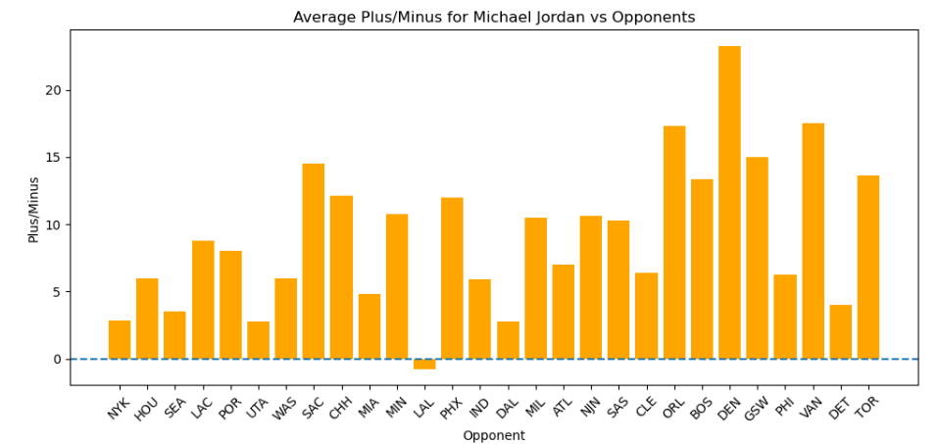
Fig. 1.

Team vs Opponent Heatmap
This heatmap highlights which teams perform well or poorly against specific opponents across seasons.This ties directly into Collaborative Filtering, since CF similarity measures "how similarly two teams perform against the same opponent".
Point Differential vs Win Rate Scatterplot
Shows a clear positive correlation — teams that win by larger margins have higher win percentages.
This reinforces why the point differential was weighted heavily in the CF matrix.
Chicago Bulls Weakest and Strongest Opponents Graph
Teams that regularly beat Chicago lower Chicago's CF similarity score against strong defensive teams.
This helps explain why some teams appear closer/further in the hybrid recommendations.
These analyses provide context for why certain teams rise to the top of the similarity rankings.

Top 10 teams with the highest average hybrid score
TeamID | Team Code | Average Hybrid Score
1610612759 | SAS | 0.86
1610612738 | BOS | 0.79
1610612762 | UTA | 0.78
1610612747 | LAL | 0.77
1610612760 | SEA | 0.77
1610612760 | OKC | 0.77
1610612742 | DAL | 0.76
1610612748 | MIA | 0.74
1610612745 | HOU | 0.74
1610612754 | IND | 0.73

As we can see from these results San Antonio Spurs were very consistent, balanced statistically and performed predictably across opponents, so the hybrid recommender system picked them as the “most similar team to others”, meaning their tactics and style align closely with many typical NBA teams/patterns.

Teams that follow San Antonio's high average hybrid score are Boston Celtics, Utah Jazz and Los Angeles Lakers. These 4 teams are amongst the 7 highest win rates of NBA teams in the last 30 years, correlating their similar playstyle to success.

By incorporating player-level statistics into the joined dataset, both collaborative filtering and content-based filtering scores became more indicative. Teams with deep squads, consistent rotations of players, and stable statistical profiles displayed naturally higher hybrid similarity scores. This highlights why our recommender system identifies them as the most comparable teams across multiple eras.

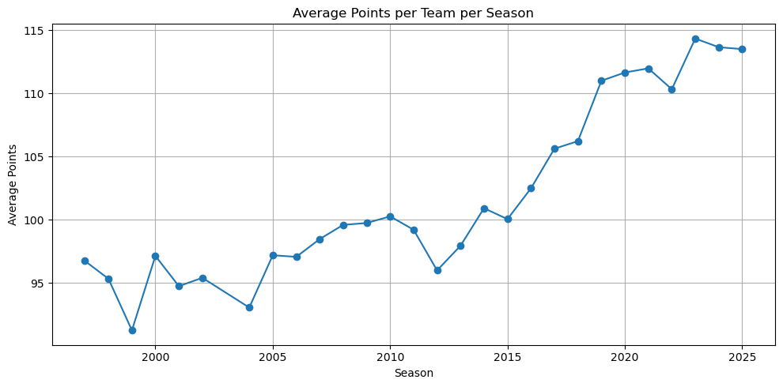
Fig. 2.
Figure 2 shows a consistent rise in average points per game from the late 1990s to 2025. Teams seem to have adapted to strategies resulting in higher average scores in 2014, when the relatively stable pattern of 92-100 points per game steadily increased every year since. This sharp upward trend reflects strategic changes such as faster pacing, reduced mid-range shooting, increased three-point shooting and offensive-driven systems. By 2019, teams were regularly scoring over 110 points.
This upward trend also reflects why certain teams appear highly similar in our hybrid recommender system. Teams that adapted early to these offensive strategy changes (Spurs, Celtics, Jazz) show statistical profiles that match league-wide patterns, resulting in them ranking highly in similarity. Their rising CB metrics make these teams more comparable.
Overall, this graph has highlighted the evolution in NBA offensive gameplay, enabling our recommender system to detect increasing similarity between teams.

Related Work
Several major organisations use similar hybrid recommender systems:
- Netflix: Combines similar user behaviour with viewing habits [1]
- Spotify: Merges intrinsic sonic features with the co-occurence of songs [2]
- Sports analytics literature: Many NBA analytics teams use video segments. A content-based recommender system can search for similar game situations with the same or other opponents. Combining this with teams statistics for these games [3]

Our hybrid approach is aligned well with these industries standard methods and reinforces the positive approach to using cosine similarity matrices.

Challenges & Lessons Learned
We encountered several issues throughout the duration of our project:
Original proposal: We struggled to develop an NBA recommender system idea, but after thorough research, landed on what we believe is a strong project idea.
Data cleaning: Missing rows, data type and data formatting issues required preprocessing.
Cosine similarity: We had to ensure there were no null values, as cosine similarity is highly sensitive to missing values.
Sandbox: The sandbox requires a lot of computational power, we found it difficult to always connect to the Graphical UI.
Spark complexity: Cosine similarity across many teams is computationally expensive but Spark handled it efficiently once vectors were assembled.
Hybrid weighting decisions: We tested a range of weights to ensure the most accurate representation of both models. A 0.6/0.4 split produced the most precise similarity relationships.
Overall, working with these complex distributed systems taught us real-world lessons about debugging, performance, and data modelling.

Responsibility Statement (“Who did what?”)

Belbin Team Roles
- Resource Investigator: AD
- Plant (Idea generation): BC
- Monitor Evaluator: LH
- Specialist (Technical detail): BC
- Shaper (Driving progress): AD
- Implementer (Coding, execution): LH
- Completer Finisher: BC
- Coordinator: LH
- Teamworker: AD

Specific Contributions

Lee Hickey: Pig cleaning script, Spark loading & transformations, Report Structure, Gitlab structure, Mid-way submission.
Brian Cafferty: Recommender system research and code (CF, CB, Hybrid), Report Writing, Mid-way submission.
Alex Davis: Visualisations, Report Writing, Mid-way submission, SparkML.

Distribution of marks: We agreed unanimously that all 3 members of the team, after contributing equally, be rewarded 33% of the available marks, i.e an even distribution.

Response to Peer Feedback

The peer feedback we received was extremely helpful with improving our processes and finalisation of our project.
One of the main suggestions was to consider using more advanced visualisation libraries, such as Seaborn or Plotly,
instead of relying just on Matplotlib. This feedback allowed us to think more critically about how to present our
results clearly and effectively. We improved the structure of our visualisations to ensure they were easy to interpret
without moving to a new library.

They identified a potential challenge in high correlation that we may have faced if we had done predictive
modelling, and while we eventually decided to go with a similarity based approach rather than predictive modelling.
This guided us to be selective with the features we used. They gave positive comments on both our dataset and the
technologies used, which gave us confidence in our datasets and overall project.

Overall, the feedback encouraged us to improve our visuals, think more carefully about our feature selections and
explore the technologies we picked.

Conclusion

In this project, we created a full analytical pipeline that allowed us to process, clean, and model NBA team data
across multiple seasons. Using Apache Pig, we produced a clean and reliable dataset suitable for large-scale
processing. We were then able to use Spark and PySpark to explore the data and build meaningful features from it.

We developed a Collaborative filtering model and a Content-Based model. We then created a Hybrid recommender
system by combining both model’s scores. Each model provided insights into the similarities between teams, based
on opponent-based matchup performance and their playstyles. The hybrid recommender in particular gave the most
balanced results, revealing relationships that neither CF or CB would capture individually.

Overall, this project gave us practical experience with distributed systems, feature engineering, recommender
system design, and large-scale analytical processing. It also showed us how techniques used in recommender
systems can be applied to sports analytics in a useful way, similar to how professional organisations analyse
matches and team profiles. The workflow we built represents a data-driven approach that modern sports
teams and analysts rely on today.

References

[1] Netflix Research. (n.d.).
https://research.netflix.com/research-area/recommendations

[2] Kitishian, D., & Kitishian, D. (2025, July 21). Spotify’s AI Strategy: Analysis of
Dominance in streaming Audio - Klover.ai. Klover.ai - Klover.ai.
https://www.klover.ai/spotify-ai-strategy-analysis-of-dominance-in-streaming-audio/

[3]Sports Recommender Systems: Overview and research issues. (n.d.).
https://arxiv.org/html/2312.03785v1

