QF600 HOMEWORK4 WANGHAOTONG
Q1.a.Estimate the expected deviation from market return, for the ten industry portfolios.
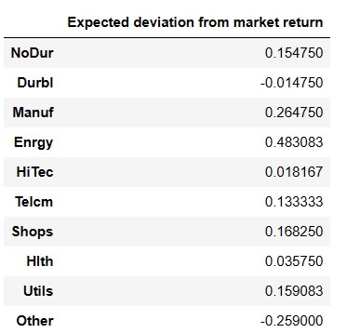
Q1.b Estimate the covariance matrix of return deviations.
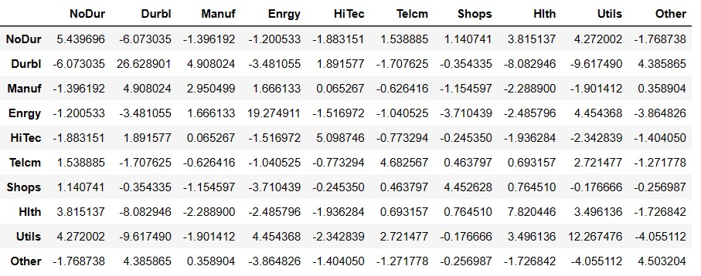
Q1.c Plot the minimum-tracking-error frontier generated by the ten industry portfolios.
First,I calculate the zeta,alpha,delta and Rmv follow the following code
And then I defined a function to generate the tracking error
And then plot the minimum-tracking-error frontier generated by the ten industry portfolios.
The graph has shown below.
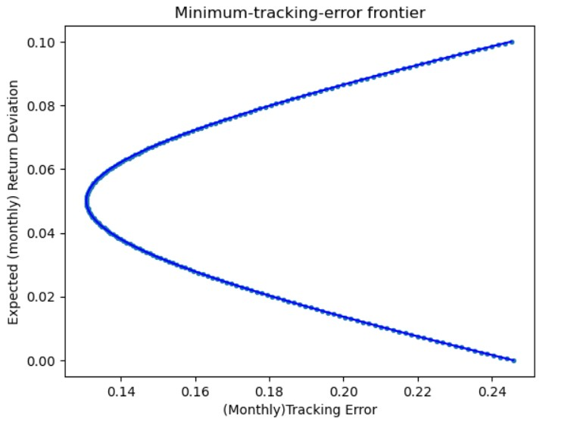
Q1.d Plot the line starting from the origin that is tangent to the upper half of the minimum-tracking-error frontier.
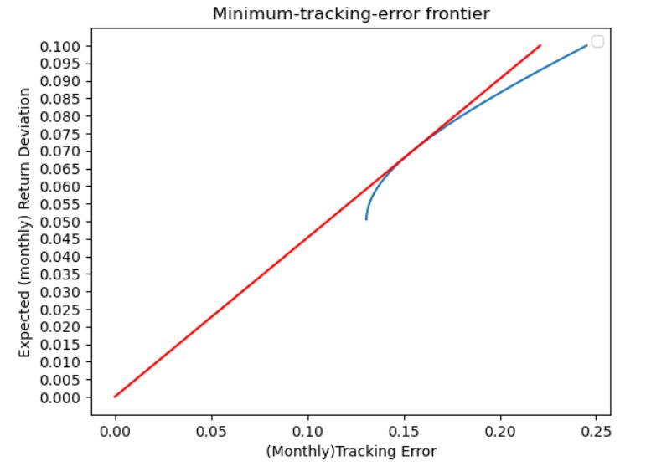
Q1.e Calculate the information ratio and portfolio weights for the "tangency" portfolio.
I calculate the information ratio follow the following code.
The information ratio = 0.4525
And the i calculate the weight follow the equation below
And finally the weight for the ten portfolios
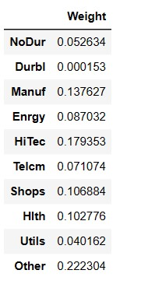
Q2.a Plot the data points with mean return on the vertical axis vs standard deviation of return on the horizontal axis.
First I write a for loop as follows
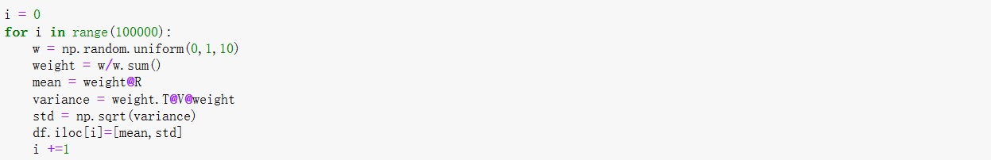
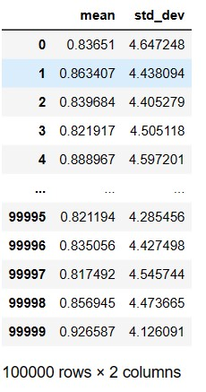
and I get a table which contains the mean and the standard deviation

And finally I plot the data points with mean return on the vertical axis vs standard deviation of return on the horizontal axis.
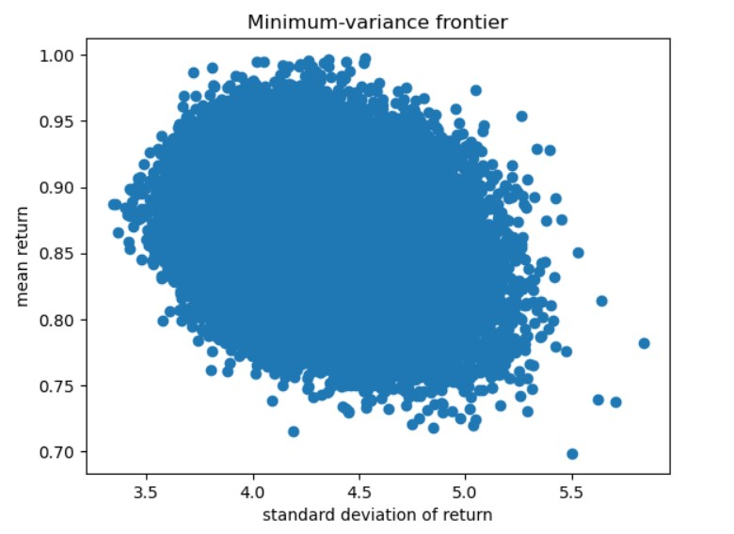
Q2.b Plot the new data points (on a separate graph) with mean return on the vertical axis vs standard deviation of return on the horizontal axis.
I rewrite the for loop as below
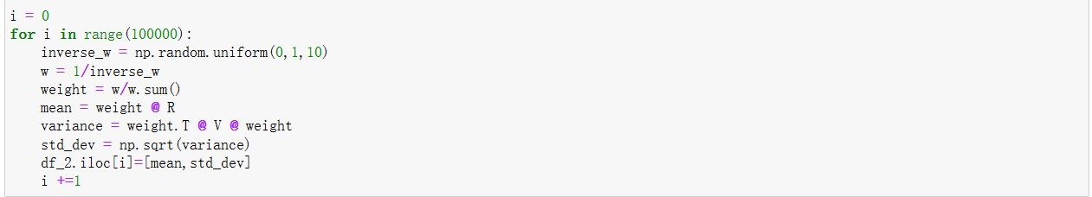
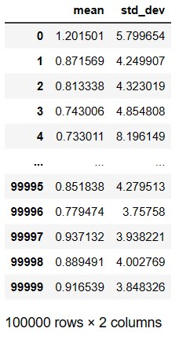
And then get the table contains mean and standard variation

And finally plot the new data points (on a separate graph) with mean return on the vertical axis vs standard deviation of return on the horizontal axis.
