Q1.Calculate μM and σM for each value of γ, and plot σM/μM (on the vertical axis) vs γ (on the horizontal axis).
First I generate the epsilion and disaster factor follows the coding as below.
and assign different value to v follow different probability like below
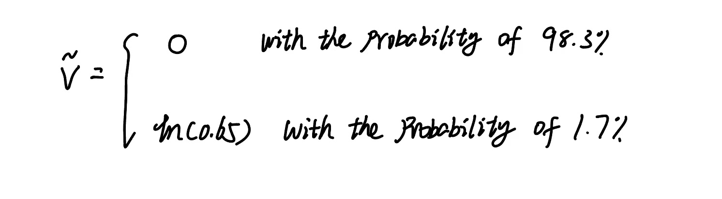
follow the code below
What’s more,I generate gamma and calculate mean and standard variation of m for each different gamma,finally i got the table as below
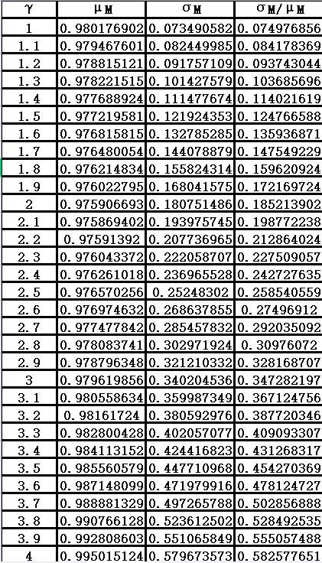

TheμM and σM for each value of γ are shown above and the plot of μM and σM for each value of γ is shown below.
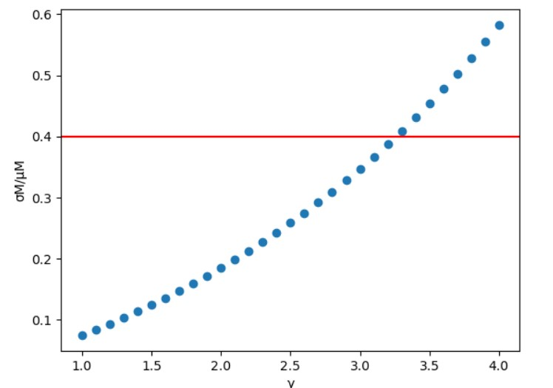
Q2.Find the smallest value of γ for which σM/μM > 0.4. Explain the economic significance of this result.

As we can see from the above table,the smallest γ for which σM/μM > 0.4 is 3.3.
γ means the constant of relative risk aversion of power utility, determining a person’s aversion to risk. A smaller γ indicates a lower degree of risk aversion and a higher γ indicates a higher degree of risk aversion.
σM/μM is the volitality ratio that measures the relative volitality of pricing kernel.The pricing kernel has lower limit of zero but no upper limit, making the probability distribution of pricing kernel skewed on right side.
γ = 3.3 represents reasonable degree of (relative) risk aversion,which means there is no equity premium puzzle.The volatility ratio can not be lower than the highest Sharpe ratio.If the volatility ratio is lower than the highest Sharpe ratio, investors may not be optimally diversifying their investments according to their risk preferences, potentially foregoing the possibility of higher returns.
The significance of finding the minimum gamma-adjusted volatility ratio is greater than Sharpe ratio lies in finding the minimum risk aversion coefficient of investors under the condition of adequate risk allocation. The smaller the gamma value, the lower the risk aversion degree of investors, that is, the more inclined to take risks. Finding this critical value is conducive to better asset allocation and risk management of investors.

