Q1.Calculate price-dividend ratio for market portfolio and plot price-dividend ratio (on vertical axis) vs b₀.
First I generate the random variable ε,follow the code as below.
and then calculate lng and generate b0,from here,all the preparation work are done.

What we want to do is to find the x for each b0,which make the absolute value of e(x) less than 10^-5.And calculate the price-dividend ratio and make the plot.
Below are the result of P/D ratio and the plot.
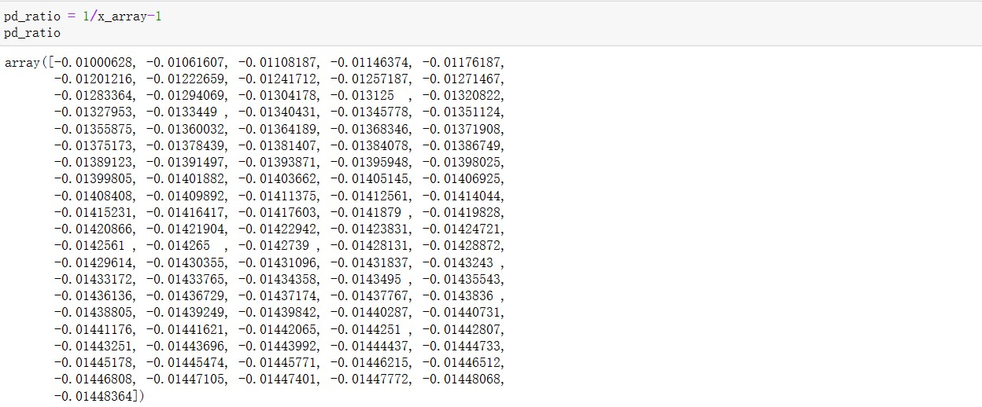
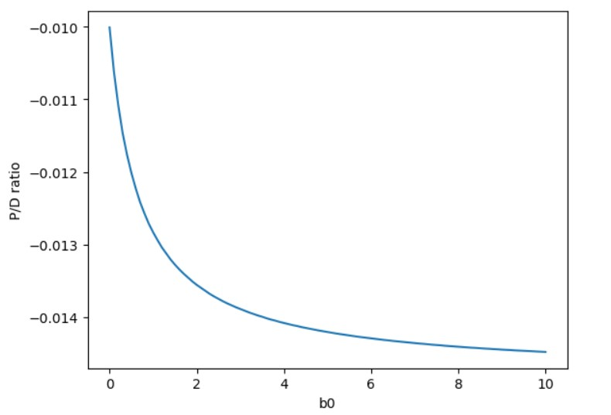

Q2.a Calculate expected market return and Plot equity premium (on vertical axis) vs b0.
Below are the result of equity premium and the plot
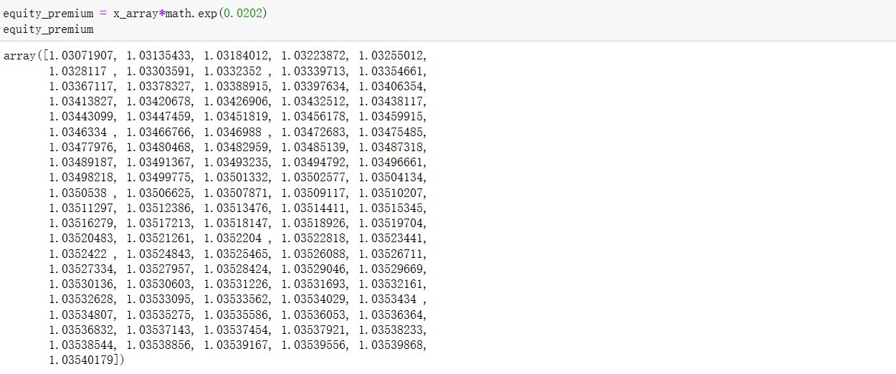

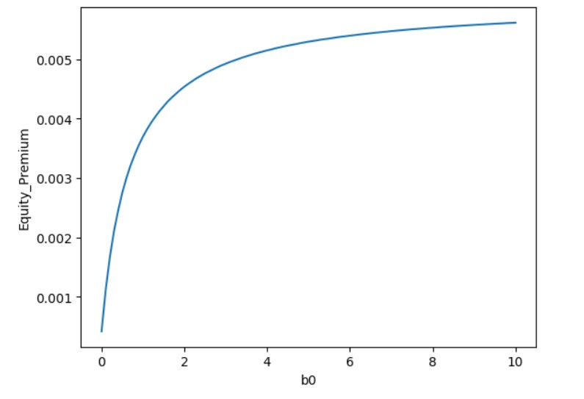
Q2.b Briefly explain main characteristics of v(∙) (which is utility function to measure utility from recent financial gain or loss), as well as economic significance of b0 and λ.
Xt represents recent financial gain or loss, and v(Xt) is a utility function used to measure the satisfaction or utility derived from these financial changes. In this case, it seems that the utility function incorporates both risk aversion and loss aversion.In this context, the utility function v(Xt) plotted against the Xt axis would exhibit a larger slope coefficient (greater sensitivity) for negative values of Xt, reflecting the greater aversion to losses. On the positive side of the Xt axis, the slope coefficient is 1, indicating that gains are treated as having a one-to-one relationship with utility, which means they have a linear utility increase.

λ (lambda) represents the degree of sensitivity of investors to experiencing financial losses.λ is used to model the behavior of investors who are more averse to losses than to risks.Typically, λ is set to a value greater than 1 to capture this heightened loss aversion.

b0 represents the scaling factor for the marginal utility of aggregate consumption. It is typically assumed that b0 > 0 because an investor's lifetime gains would increase their utility, and vice versa. b0 measures the extent to which recent financial gains or losses contribute to the investor's lifetime utility. With this scaling factor, recent losses or gains have a cumulative effect on the investor's lifetime utility.

