Calculate risk premium and standard deviation of (excess) return for the investor's optimal portfolio.
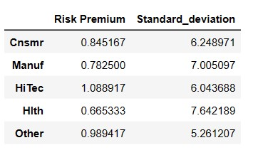
Calculate implied risk premiums for the five industry portfolios. You must show all relevant working.
