sharp ratio
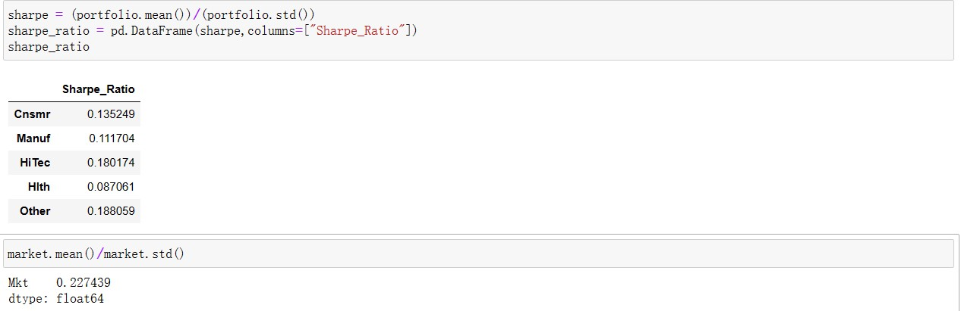

treynor ratio
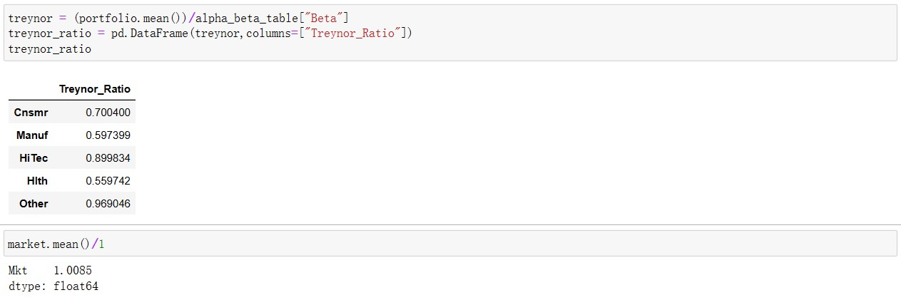
sortino ratio
