Q1.1 Table of the intercept and slope coefficients for the ten industry portfolios.

I calculate the slope and the intercept follow the code below,and just change the input of index to get the result.
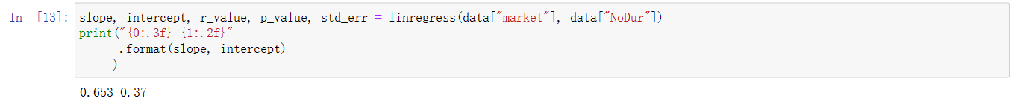
And i summary the data into the following table
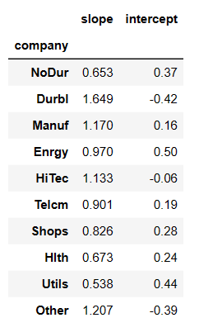
Q1.2 Briefly explain the economic significance of the intercept and slope coefficients.
The intercept coefficient represents “pricing error” (relative to CAPM) for individual assets or “passive” portfolios,which represent the excess return of portfolios relative to excess return of market portfolio,which means the additional return or loss beyond market expectations.
The slope coefficients represents the market risk coefficient,which is also known as systematic risk,indicating the systematic correlation or sensitivity of an portfolio to the market portfolio. A higher β value implies a higher sensitivity to market fluctuations.

Q2.1 show the SML line
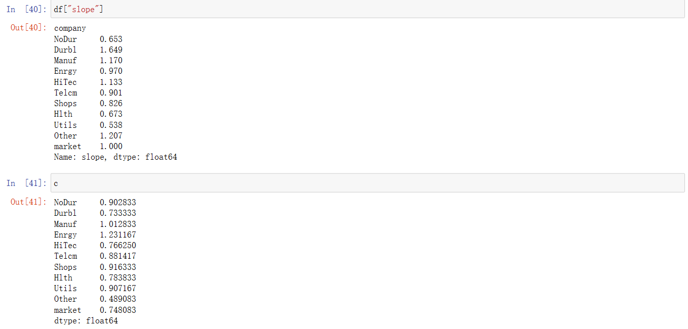
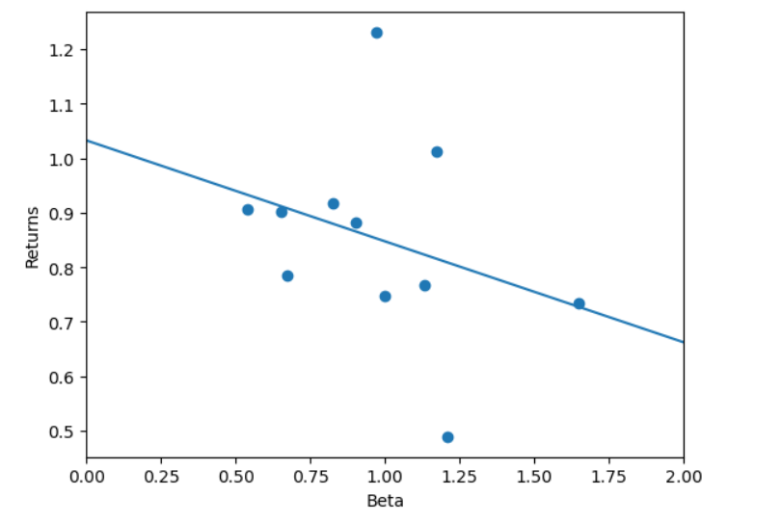
Q2.2 Briefly explain the economic significance of the SML.
The Security Market Line (SML) has significant economic importance in the field of finance and investment. SML is a graphical representation of the Capital Asset Pricing Model (CAPM), which helps measure the relationship between investment risk and expected returns.The economic significance of SML in finance and investment lies in helping investors understand and manage risk and make wiser choices regarding asset allocation and investment decisions. It provides a useful framework for assessing the risk-return relationship among different assets in the capital market.
In the graph above we can see that overall the lower the risk (beta), the higher the return, and on average these ten portfolios outperform a given market portfolio.The reason why the average performance of these ten portfolios will outperform the market portfolio is because the number of ten industries is too small and the different parameters of different industries are not taken into account.In other words, if more industry data were taken into account, non-systemic risks would be diversified.

