Q1.Create a table showing the performance metrics for the ten industry portfolios.
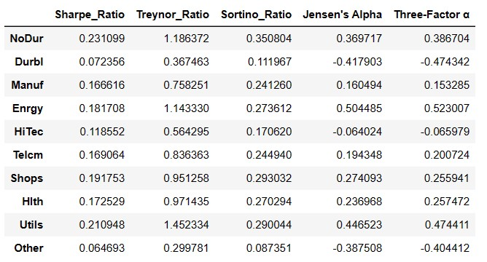

Q2.Plot your results as a bar chart for each performance metric.
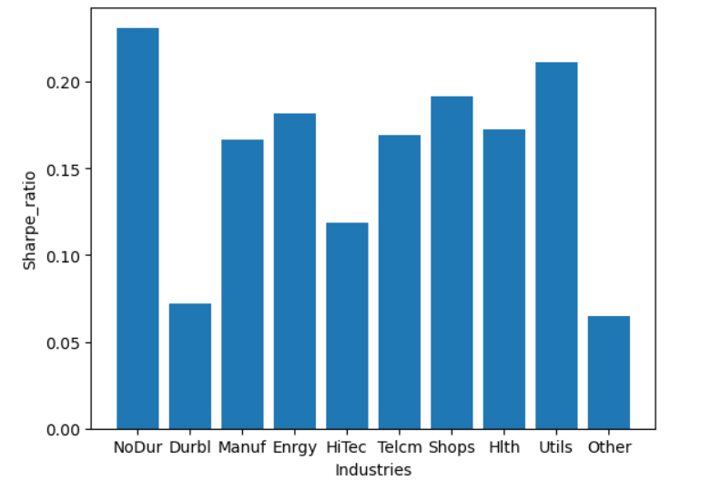
Sharpe Ratio:

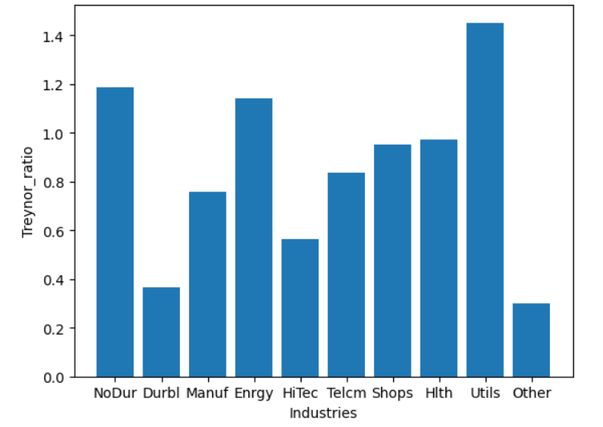
Treynor Ratio(based on CAPM β）：

Sortino ratio (using risk-free rate as target)：
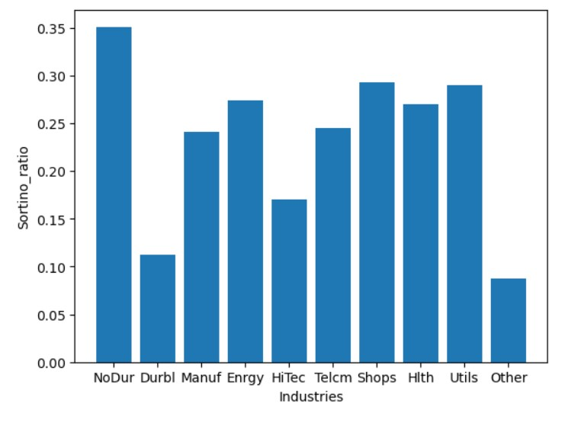

Jensen’s Alpha:
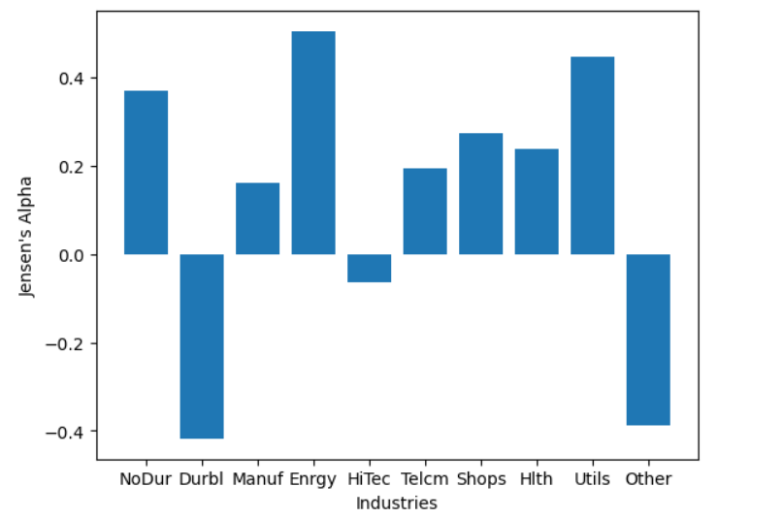

Three Factor alpha:
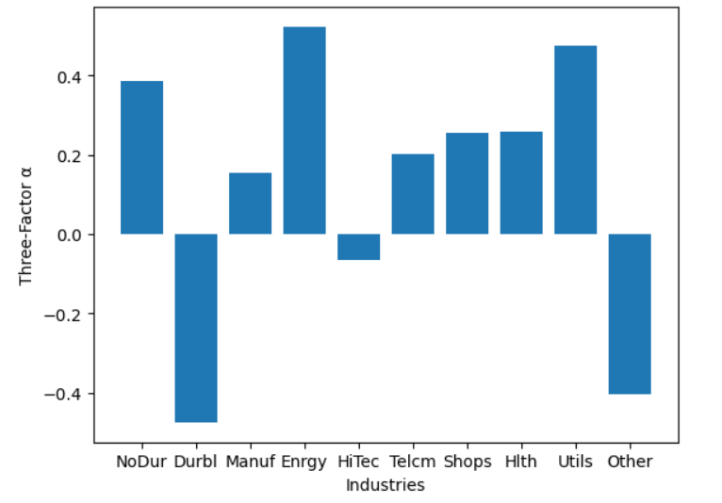

Q3.Briefly explain the economic significance of each of the three performance ratios (but not α's).
Sharpe Ratio: Sharpe ratio is risk premium per unit of standard deviation,its economic significance lies in helping investors evaluate the trade-off between risk and return, enabling them to make more informed investment decisions.A high Sharpe Ratio generally indicates that a portfolio or asset has earned a higher return per unit of risk. We can make reasonable investment decisions based on Sharpe ratio and investors' own risk preference.

Treynor Ratio:Treynor ratio is risk premium per unit of market risk.Investors can use it to evaluate the market risk exposure of their portfolios and determine whether adjustments are needed to achieve a more favorable risk-return trade-off.However,it will fail to account for other types of systematic risk besides market risk,so it should be used in conjunction with other performance metrics and analyses to make well-informed investment decisions.

Sortino Ratio:Sortino ratio is expected deviation from target (or benchmark) return, per unit of below-target semi-deviation.It is an improvement upon the Sharpe Ratio, as it focuses specifically on downside risk, which includes only the volatility or risk associated with negative returns.

