Q1.1 Show the mean and standard deviation of the ten industries
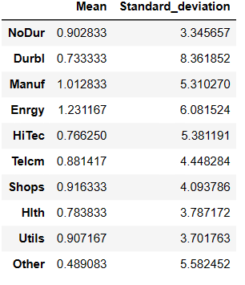
Q1.2 Show the minimum variance frontier
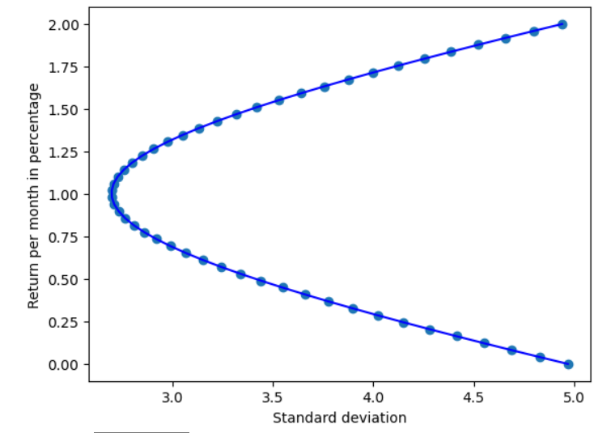

Q1.3 Briefly explain
First of all,the minimum-variance frontier help us to understand the relationship between risk and return,it help the investor to balance the return and risk
Second it help us to diverse our portfolio,by combining the risky asset and low risk asset,investor can create a portfolio that is more suitable for his or hers risk aversion

Q2.1 Plot the efficient frontier (with the riskless asset) on the same graph as the minimum-variance frontier generated by the ten industry portfolios.
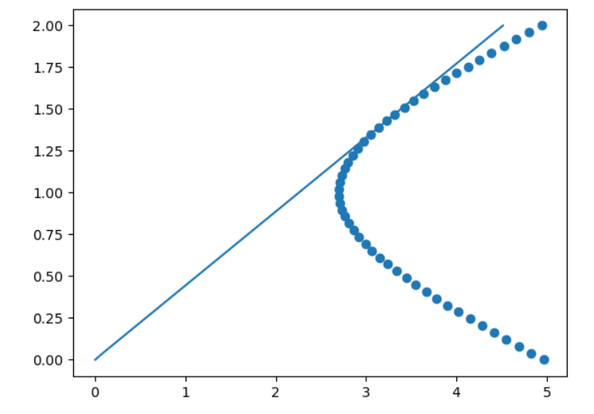
Q2.2 Briefly explain
The effective frontier provides a very good choice for investors to make portfolio investment. All points on the effective frontier curve are consistent with the given risk, and the return is higher. Or given the same return, the risk is lower.
Help us make better portfolio recommendations and determine the best asset allocation to meet their specific risk tolerance and investment goals. By choosing a portfolio point on the efficient frontier, investors can construct a risk-adjusted portfolio to achieve maximum return or minimum risk.

Q3.1 Sharp ratio

Q3.2 Weights

Q3.3 Briefly explain
The tangency portfolio is considered the optimal portfolio for an investor seeking to maximize their risk-adjusted returns. It provides a balance between risk and return, making it a desirable choice for investors who aim to optimize their investment allocations.
Investors can use the tangency portfolio as a benchmark for assessing their own portfolios. If their portfolio lies below the efficient frontier (line connecting the risk-free rate and the tangency portfolio), they may not be optimizing their risk-return trade-off.

