Mike Hickey

Professor Tom

Digital Signals Processing

May 16, 2018

Lab1

%Problem1

% d = 5

% x = 0:0.01:10

% graph = heaviside(x-d)

% plot(x, graph)

% xlabel("Time")

% ylabel("Amplitude")

% title("Unit Step Function")

% ylim([-2 2])

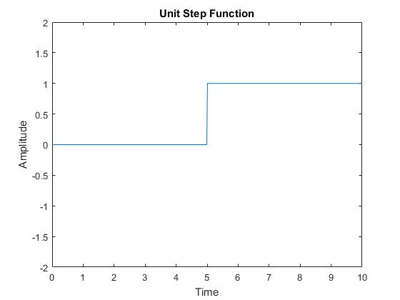

%Problem2, if the sampling rate of x is changed

%to a larger number, the function appears differently

%x = 0:1:10 will have a piece wise attribute with a slope of 1

%Problem3

% T = 0.1 %amount of time between each sample

% k = 0:99 %iterator, the k-th sample

% A = 1

% alpha = 0.8

% n = k\*T

% y = A\*alpha.^n

% x = n

%

% stem(x,y)

% xlabel("k\*T")

% ylabel("A\*alpha.^n")

% title("Problem3 alpha = 0.8")

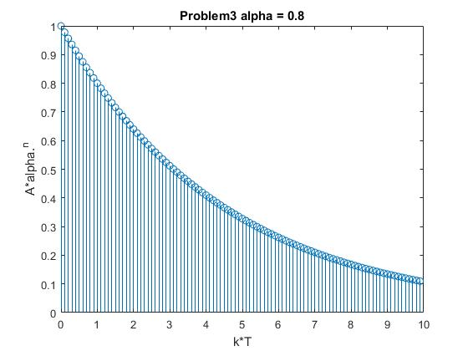

%Problem4

% T = 0.1 %amount of time between each sample

% k = 0:99 %iterator, the k-th sample

% A = 1

% alpha = 1.6

% n = k\*T

% y = A\*alpha.^n

% x = n

%

% stem(x,y)

% xlabel("k\*T")

% ylabel("A\*alpha.^n")

% title("Problem4 alpha = 1.6")

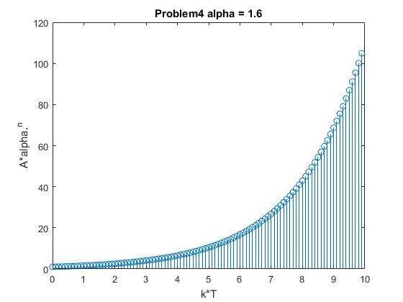

%Problem5

% T = 0.1 %amount of time between each sample

% k = 0:49 %iterator, the k-th sample

% A = 1

% alpha = 1

% n = k\*T

% y = A\*alpha.^n

% x = n

% ylim([-1 2])

% stem(x,y)

% xlabel("k\*T")

% ylabel("A\*alpha.^n")

% title("Problem5")

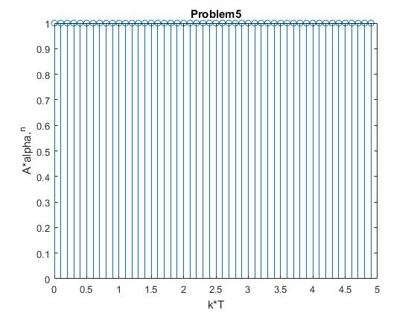

%Problem6

% k = 0:24

% T = 1

% n = k\*T

% XofN = cos((pi\*n)/4)

% subplot(2,1,1)

% plot(n, XofN)

% xlabel("k\*T")

% ylabel("XofN = cos((pi\*n)/4)")

% title("Problem6")

%Problem 7

% k = 0:24

% T = 1

% n = k\*T

% subplot(2,1,2)

% X1ofN = cos((pi\*(n+8))/4)

% plot(n, X1ofN)

% xlabel("k\*T")

% ylabel("cos((pi\*(n+8))/4)")

% title("Problem7")

% %Same thing.

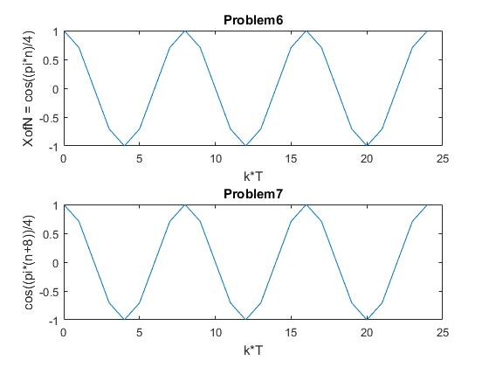

% %Problem8

% k = 0:24

% T = 1

% X2ofN = cos((3\*pi\*k\*T)/8)

% subplot(2,1,1)

% plot(k\*T, X2ofN)

% xlabel("k\*T")

% ylabel("cos((3\*pi\*k\*T)/8)")

% title("Problem8.1")

%

% X3ofN = cos((3\*pi\*(k\*T+16))/8)

% subplot(2,1,2)

% plot(k\*T, X3ofN)

% xlabel("k\*T")

% ylabel("cos((3\*pi\*(k\*T+16))/8)")

% title("Problem8.2")

% Same Thing

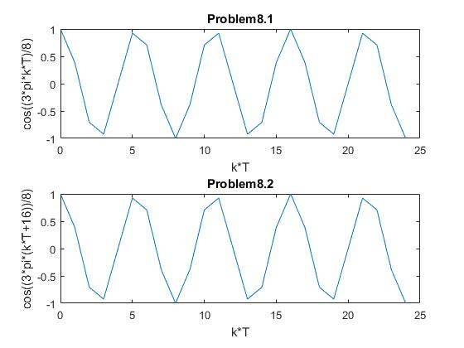

% Problem9

% The sinusoid from problem 7 has a higher frequency

% Than the sinusoid from problem 8 because the definition

% of wavelength is the distance between two corresponding points.

% Since problem7's sinusoid takes less time to complete one wavelength,

% this sinusoid has a higher frequency.

% Problem 10

% The sinusoid from problem8 takes more time to achieve periodic behavior.