Mike Hickey

Professor Tom

Digital Signals Processing

Lab3

Problem 1

[5 3 7] [1 1 1]

[7 6 10] * (1/9) * [1 1 1] = 47/9 = 5.222

[4 3 2] [1 1 1]

[1 5 3] [1 1 1]

[4 7 6] * (1/9) * [1 1 1] = 35/9 = 3.88

[2 4 3] [1 1 1]

[5 3 7] [1 1 1]

[7 6 10] * (1/9) * [1 1 1] = 47/9 = 5.222

[4 3 2] [1 1 1]

[4 7 6] [1 1 1]

[2 4 3] * (1/9) * [1 1 1] = 41/9 = 4.55

[5 2 8] [1 1 1]

[7 6 10] [1 1 1]

[4 3 2] * (1/9) * [1 1 1] = 45/9 = 5.0

[2 8 3] [1 1 1]

Output

|  |  |  |  |
| --- | --- | --- | --- |
| 0 | 0 | 0 | 0 |
| 0 | 3.88 | 5.22 | 0 |
| 0 | 4.55 | 5 | 0 |
| 0 | 0 | 0 | 0 |

Problem 2

The pixels will be all averaged together and scrunched down. Decreasing the quality of the photo. However, this averaging of the pixels will create a smoother photo, possibly resulting in higher “apparent” quality. Overall, with the filter applied, the image size will be reduced allowing for light transfer over the internet.

Problem 3

[5 4 4] [-1 -1 -1]

[1 2 1] * [-1 8 -1] = -19

[3 8 9] [-1 -1 -1]

[4 4 5] [-1 -1 -1]

[2 1 2] * [-1 8 -1] = -29

[8 9 3] [-1 -1 -1]

[1 2 1] [-1 -1 -1]

[3 8 9] * [-1 8 -1] = 41

[1 3 3] [-1 -1 -1]

[2 1 2] [-1 -1 -1]

[8 9 3] * [-1 8 -1] = 49

[3 3 1] [-1 -1 -1]

Output

|  |  |  |  |
| --- | --- | --- | --- |
| 0 | 0 | 0 | 0 |
| 0 | -19 | -29 | 0 |
| 0 | 41 | 49 | 0 |
| 0 | 0 | 0 | 0 |

Problem 4

It appears that some of the photo is getting quite dark and some is quite bright. I am assuming that the pixel values represent light levels, therefore this is a black and white image. I am assuming that the negative numbers are black pixels, or pixels turning off. And that the positive numbers are not quite white, however they are brighter than the negative numbers.

Problem 5

A picture containing photo, person, man, sitting

Description generated with high confidenceA person sitting in front of a computer

Description generated with high confidence

Problem 6

The following photo is a blurry image of the previous. Because of the filter applied.

A person sitting at a desk

Description generated with very high confidence

Problem 7

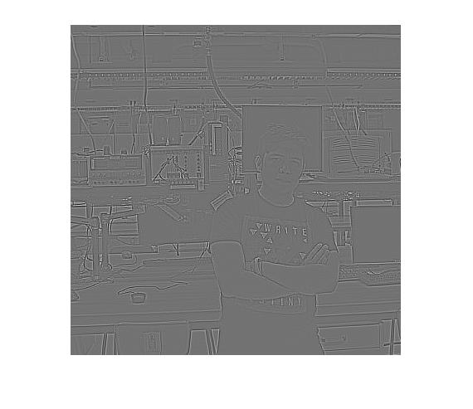

When the filter from problem 3 was applied to the image, much of the contours are shown. One can see a generic outline of shapes. This filter somewhat acts like an edge detector.

Problem 8

A person standing in front of a computer

Description generated with high confidence

This filter is very similar to the previous blurring filters.

Problem 9

A picture containing photo, person, man, sitting

Description generated with high confidence

The following photo is quite saturated. This is the “Insta Rich” filter. The process of filtering photos by the convolution operator is quite interesting,