Michael Hickey

Professor Tom

Digital Signals Processing

Lab 9 Homemade Discrete Fourier Transform

July 19th, 2018

Code:

import numpy as np

import matplotlib.pyplot as plt

import time

from scipy.io import wavfile

times = []

def myOwnDFT(data):

# Start a clock timer to track how long the function takes.

start = time.time()

# The number of elements in signal u

N = len(data)

# Set up the for loop bounds

n = np.arange(0, N)

k = np.arange(0, N)

sum = 0

# The empty list, which will store the Fourier series.

Un = []

# Nesting for loops

# This Outer forloop dictates what array index we are working on.

for g in n:

# Reset the sum before it is appended.

sum = 0

# This forloop dictates what sum we input into the array.

for i in k:

# Perform Summation for value of n.

sum = sum + data[i]*np.exp( (-2)*np.pi*1j*i*g/N )

# Append the result of the summation to the end of Un array.

Un = np.append(Un, sum)

Un = np.absolute(Un)

end = time.time()

print("Elapsed Time: " + str(end-start) )

# Store the elapsed time in an array.

times.append(end-start)

# Un is of the form np.array()

return Un

def makeSinWave(freq, freq_length):

# Creating a list of frequency from 0 to freq_length in increments of 1 Hz

t = np.linspace(0, 1, freq_length)

# Create sin waves.

return np.sin(2*np.pi*freq*t)

if __name__ == "__main__":

end_freq = 1200

if 1 :

for i in range(200, end_freq, 200):

# Make a sin wave

sin_wave_1 = makeSinWave(10, i)

# Get the length of the sin wave.

length_of_sin_myDFT = np.arange(len(sin_wave_1))

# Jam the sin wave into my DFT function.

sin_myDFT_1 = myOwnDFT(sin_wave_1)

# Start Plotting

fig = plt.figure()

fig.suptitle('myDFT of Sin Waves, size ' + str(i) , fontsize = 15)

ax = plt.subplot(5,1,1)

ax.set_title("Frequency 10")

# Plot the sin wave against a list of frequencies the length of the sin wave.

plt.plot(length_of_sin_myDFT, sin_myDFT_1)

ax = plt.subplot(5,1,3)

ax.set_title("Frequency 20")

sin_wave_2 = makeSinWave(20, i)

sin_myDFT_2 = myOwnDFT(sin_wave_2)

plt.plot(length_of_sin_myDFT, sin_myDFT_2)

ax = plt.subplot(5,1,5)

ax.set_title("Frequency 30")

sin_wave_3 = makeSinWave(30, i)

sin_myDFT_3 = myOwnDFT(sin_wave_3)

plt.plot(length_of_sin_myDFT, sin_myDFT_3)

# Plot the times it takes to calculate all the functions

print(times)

print(len(times))

fig6 = plt.figure()

length_of_time_list = np.linspace(0, 14, len(times))

plt.stem(length_of_time_list, times)

plt.ylabel("Time for Completion in Seconds")

plt.xlabel("Iteration")

print("Running...")

fig7 = plt.figure()

# Perform the myOwnDFT on the wave file

fs, wav_data = wavfile.read("kpt1note2k.wav")

length_of_data = len(wav_data)

wav_myOwnDFT = myOwnDFT(wav_data)

plt.plot(np.arange(length_of_data), wav_myOwnDFT)

plt.suptitle("kpt1note2k.wav through myOwnDFT")

plt.xlabel("Frequency in Hz")

plt.ylabel("Amplitude")

plt.show()

1. Plots against frequency for different frequencies and length of summation

A screenshot of a cell phone

Description generated with very high confidenceA screenshot of a cell phone

Description generated with very high confidenceA screenshot of a cell phone

Description generated with very high confidenceA screenshot of a cell phone

Description generated with very high confidenceA screenshot of a cell phone

Description generated with very high confidence

1. How long each plot took to calculate.

A screenshot of a cell phone

Description generated with very high confidence

1. Estimate how long it takes to perform our DFT on the lab 8 wav file.

I estimate a few months.

This is a graph of the lab 9 wav file after it has been passed through myOwnDFT

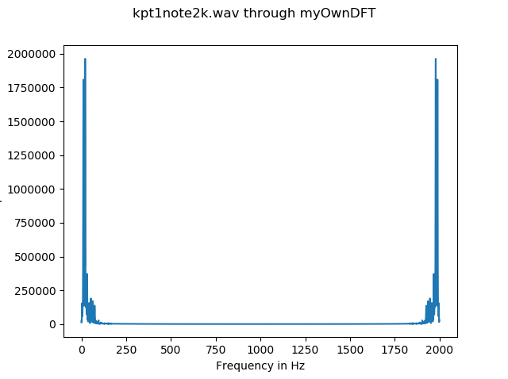

1. What was the note

I estimate B1