### Methodology for Developing a Heatwave warning systems Database

#### Heatwave warnings systems – Introduction

In 2022, heatwaves struck the world and broke many long-standing records. Heatwaves seriously affect human health and life on Earth. The Intergovernmental Panel on Climate Change (IPCC) identified Heat Health Warning Systems and corresponding policy actions as adaptation options to anticipate and manage the health risks of extreme heat.

Heat–health warnings have been shown to effectively reduce premature deaths caused by heatwaves and achieve health benefits. For example, in July 2006, during a severe heatwave in France, the Heat–Health Watch Warning System saved more than 4300 lives in 18 days. The Hot Weather–Health Watch/Warning System in Philadelphia, PA, USA had a massive benefits-to-costs ratio. Nevertheless, most low-income, and middle-income countries, especially those that are highly populated, are particularly vulnerable to longer, more frequent, and more intense heatwaves and still implement the traditional high temperature forecast warnings, which are insufficient to protect population health.

This project will use data mining and machine learning to complete an existing Heat Health Warning Systems Inventory through screening of peer-reviewed and internationally available literature (scientific, technical, and socio-economic literature in scientific journals and other publications) as well as supporting material (reports, conference proceedings, published reports and proceedings from Workshops and Expert Meetings, etc). The database will be completed through data mining and machine learning by screening the internet with key words to find which additional countries have a heatwave warning system or a heat health warning system. The result of the datathon will be a database (excel worksheet) that will be used to develop graphs such as a map and graphics, infographics to provide an overview of gaps and statistics by WMO region.

#### Definitions:

**Heat health warning system** according to the World Health Organization (WHO), is a coordinated set of actions and procedures designed to protect public health during periods of extreme heat. It is an early warning system that aims to prevent and mitigate the adverse health effects of high temperatures on vulnerable populations[1].

**Heat wave warning systems** is a systematic approach to monitor, predict, and communicate the occurrence of heat waves in order to reduce the adverse impacts on human health, infrastructure, and the environment. It involves the integration of meteorological data, climate forecasts, and relevant socio-economic factors to provide timely warnings and enable preparedness actions[2].

#### Use the following steps to carry out the project

* Use this link (<https://community.wmo.int/en/members/profiles> to extract data on heatwaves warning system/services, see example below, if heatwave is in the list of warnings provided, then indicate a yes in the provided excel sheet (for the corresponding country in **column B** in the excel sheet called “Heatwaves Warning Systems (WMO data)”).

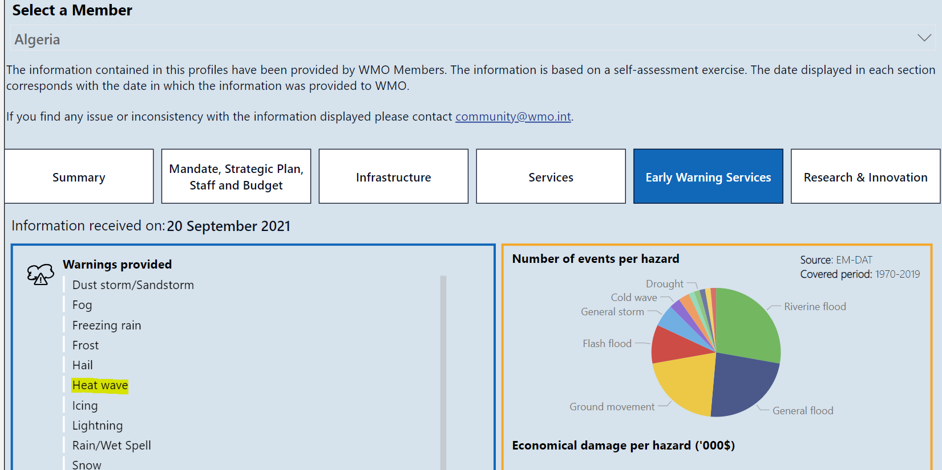

* Complement the country information on heatwave warning systems with scientific literature and research papers review: Explore academic databases, such as Google Scholar, ResearchGate, or the Intergovernmental Panel on Climate Change (IPCC) website, to access scientific publications and reports to find out if a country has a heatwave warning system or a heat health warning system (or confirm the WMO data).

See criteria here for screening of scientific articles:

[AR6_FS_assess_literature.pdf (ipcc.ch)](https://www.ipcc.ch/site/assets/uploads/2021/07/AR6_FS_assess_literature.pdf)

[ipcc-principles-appendix-a-final.pdf](https://www.ipcc.ch/site/assets/uploads/2018/09/ipcc-principles-appendix-a-final.pdf)

#### Data sources

1. [PubMed (nih.gov)](https://pubmed.ncbi.nlm.nih.gov/)
2. [ResearchGate | Find and share research](https://www.researchgate.net/)
3. [ScienceDirect.com | Science, health and medical journals, full text articles and books.](https://www.sciencedirect.com/)
4. [Google Scholar](https://scholar.google.com/)
5. [JSTOR Home](https://www.jstor.org/)
6. [ScienceOpen](https://www.scienceopen.com/)
7. <https://www.biomedcentral.com/journals>
8. <https://link.springer.com/>
9. <https://www.ncbi.nlm.nih.gov/>
10. <https://bmjopen.bmj.com/content/6/7/e012125>
11. <https://www.thelancet.com/journals/lancet/home>
12. <https://www.mdpi.com/>
13. <https://www.nature.com/npjclimatsci/>
14. <https://www.ssph-journal.org/journals/international-journal-of-public-health/about>
15. <https://www.jhsci.ba/ojs/index.php/jhsci>
16. <https://ajph.aphapublications.org/>
17. <https://onlinelibrary.wiley.com/journal/10991751>
18. <https://www.scimagojr.com/journalsearch.php?q=21100853497&tip=sid>

Example of articles:

1. Pascal M, Laaidi K, Wagner V, Ung AB, Smaili S, Fouillet A et al (2012) How to use near real-time health indicators to support decision-making during a heat wave: the example of the French heat wave warning system. PLoS Curr 4: e4f83ebf72317d
2. Pascal M, Wagner V, Le Tertre A, Laaidi K, Honore C, Benichou F et al (2013) Definition of temperature thresholds: the example of the French heat wave warning system. Int J Biometeorol 57(1):21–29
3. Lowe etal., ‘Heatwave early warning systems and adaptation advice to reduce human health consequences of heatwaves’, International Journal of Environmental Research and Public Health, (2011), 4623-48, 8(12)
4. Hajat et al., ‘Heat–Health Warning Systems: A Comparison of the Predictive Capacity of Different Approaches to Identifying Dangerously Hot Days’, *American Journal of Public Health* 100, no. 6 (June 1, 2010): pp. 1137-1144.

<https://doi.org/10.2105/AJPH.2009.169748>

1. Kotharka R and Ghosh A, “Progress in extreme heat management and warning systems: A systematic review of heat-health action plans (1995-2020)”, Sustainable Cities and Society, (2022), 103487, 76

1. <https://www.who.int/publications/i/item/9789289071918>
2. <https://public.wmo.int/en/media/news/wmo-who-issue-guidance-heat-health-warning-systems>