**NOISE SCORE – Extended ReadMe**

*Note: Root (‘./’) is set at the start of git Branch ‘Sid-dev’*

Anchor

**Part I: Adding a new collection**

* Manifest.js is located under *‘./server/manifest.js’*
* To add a new collection first add the api route as a plugin (below is the example for a new collection called measurements)
  + 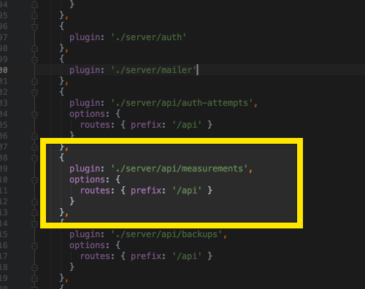
* Now we have to add the route for the model under *‘hicsail-hapi-mongo-models’*
  + 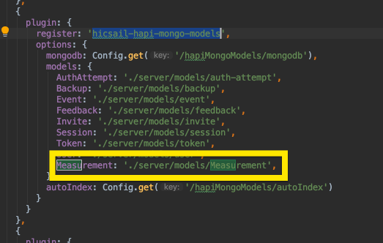

**Part II: Adding a Schema/Model**

* Models are stored under *‘./server/server/models/user.js’* (for the user model)
* Modify the *.schme* variable (see image)
  + 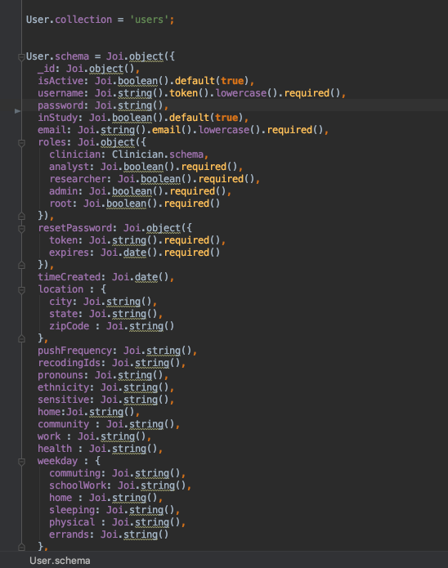
* Modify the ‘*create*’ function to take in parameters (you will call this function from another file, so you have control over the parameters) and insert a document
  + 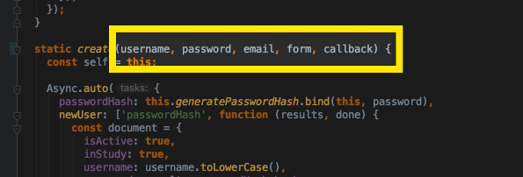

**Part III: Adding API Calls**

* (*NOTE:* I would recommend copying and modifying the *measurement.js* API file)
* API calls are stored under *‘./server/server/api/users.js’* (for the user model)
* You can add a server.route() method as needed
  + 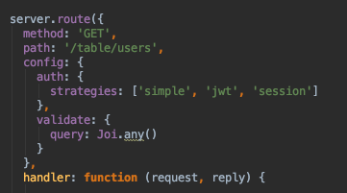
* The request variable will hold any data that you passed as a query, and the reply variable will be used to respond
* Note: The model is defined within the server.route function (see image). So you can use the model just like another monogoDB model (User.pageFind, User.findByID, etc)
  + 
  + 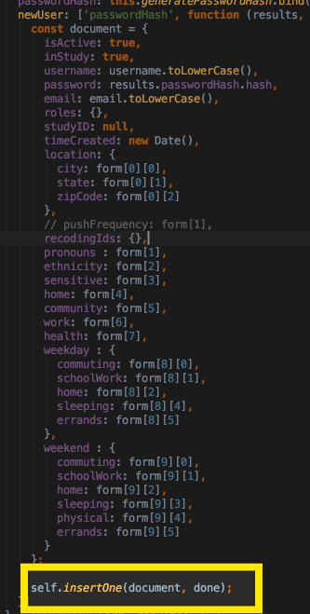
* Now to add API calls, functions are stored under *‘./server/server/api/*

React-Native

**Adding a Page**

**Part I: Modify the App.js**

* + The app.js file is located under ‘./App.js’
  + There are multiple navigators to choose from (how you get around the app)
    - StackNavigator – Login screens of the app
      * 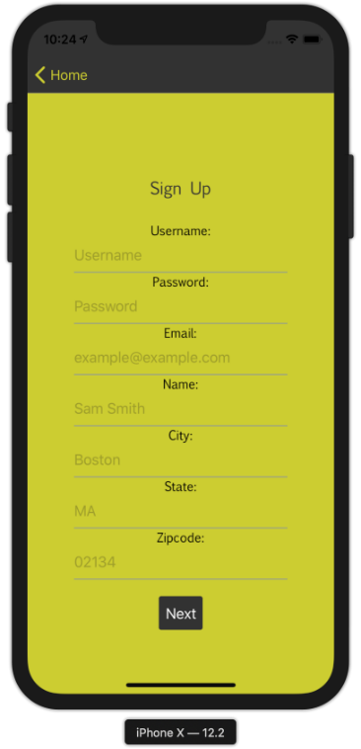
      * 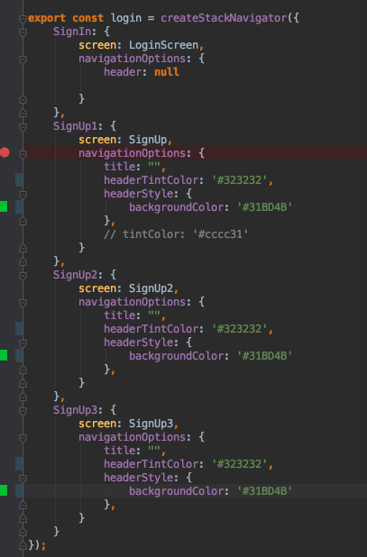
    - BottomTabNavigator – Main portion of the app
      * 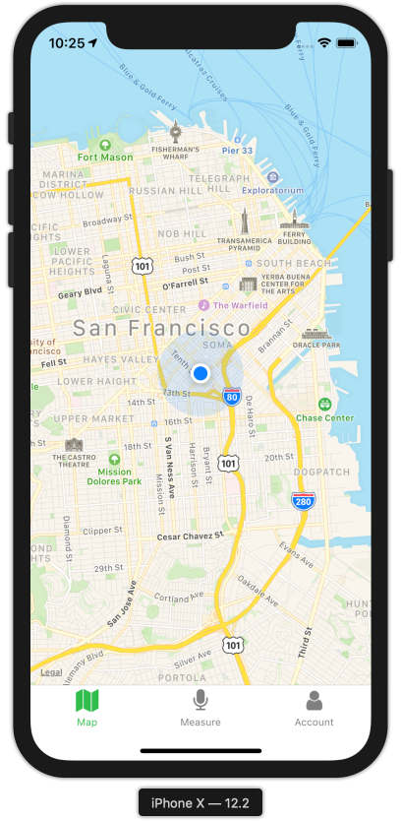
      * 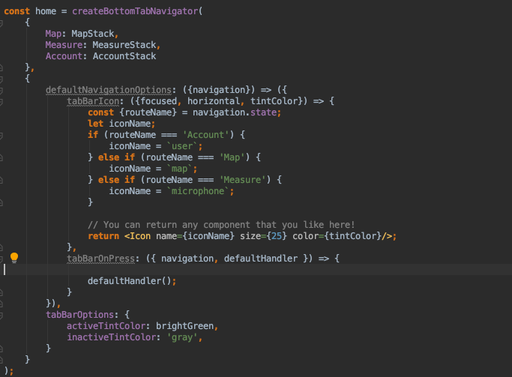
    - Remember you can put StackNavigators inside other Navigators (see Map, Measure, Account on BottomTabNavigator code)
  + To add a screen. First import the file at the top (we will create the file after)
    - 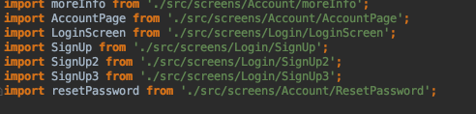
  + Next create a stack using the file you imported
    - 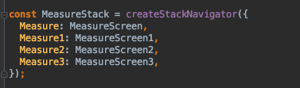
  + Now ensure that the Stack is linked somewhere inside the main home BottomTabNavigator
    - 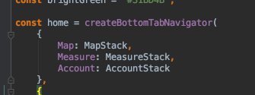
    - (See how home, links to our MeasureStack which links to the file we imported.

**Part II: Create the Code for the Page**

* Use the following code to get your page started:
* **import** React **from** 'react';  
  **import** {AsyncStorage, StyleSheet, View } **from** 'react-native';  
  **import** axios **from** "axios";  
    
  **export default class** AccountScreen **extends** React.Component {  
    
   constructor(props) {  
   **super**(props);  
   // You can set local variables for the page here  
   **this**.state = {  
   username: **null**,  
   };  
    
   }  
    
   componentDidMount() {  
   // Function when a page is initially loaded  
    
   // Add listener to notice when we need to reload data  
   **this**.subs = [  
   **this**.props.navigation.addListener('willFocus', () => **this**.updateData())  
   ];  
    
    
    
   }  
    
   updateData(){  
   // Function that is called whenever we focus on a page  
   }  
    
   **async** removeItemValue(key) {  
   // Function to remove a value from local storage (AsyncStorage)  
   **try** {  
   **await** AsyncStorage.removeItem(key);  
   **return true**;  
   } **catch** (exception) {  
   **return false**;  
   }  
   }  
    
   render() {  
    
   **return** (  
   <View style={styles.container}>  
   <Text>Hello World</Text>  
   </View>  
   )  
    
   }  
    
  }  
    
  // Used to keep all the style elements organized   
  **const** styles = StyleSheet.create({  
   container: {  
   flex: 1,   
   },  
  });
* Modify the code as needed but this will more or less work

React-Native Heatmap

**Solutions Explored:**

* [react-native-heatmap](https://github.com/pjamrozowicz/react-native-heatmaps)
  + Why it didn’t work?
    - Last commit 11 months ago
    - Need Google Maps
* [Heatmap.js](https://www.patrick-wied.at/static/heatmapjs/)
  + Why it didn’t work?
    - It needs an HTML Dom element to append too
    - Meant to be used for the web (HTML) not react-native
    - Might be able to be used (see proposed solution)
* [react-native-webview-leaflet](https://www.npmjs.com/package/react-native-webview-leaflet)
  + Why it didn’t work?
    - Got a host of errors when trying to implement it
    - *Could work* but did not give it enough time
* [react-native-maps](https://github.com/react-native-community/react-native-maps/blob/master/docs/circle.md) Circles
  + Why it didn’t work?
    - Looked very bad
    - 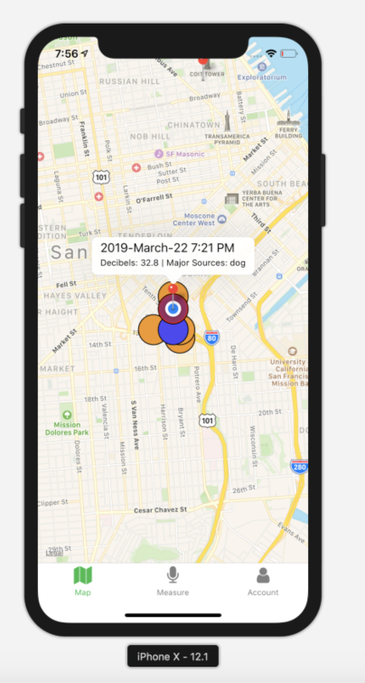

**Proposed Solution**

Unfortunately, I did not get enough time to finish the heat map, but if I did have more time this is what I would try next.

* react-native has a component called <WebView/>
* As there is no documentation for a react-native heatmap. I would have tried to create a heatmap that renders as an HTML file.
  + I would definitely use [heatmap.js](https://www.patrick-wied.at/static/heatmapjs/)
* I would then link this HTML file as a <WebView/> component to generate the heatmap