WEB ENVIROMENT

First of all, we had to design the webpage. To do so we created a quick prototype on paper, and then began formalizing it using "Lucidspark".



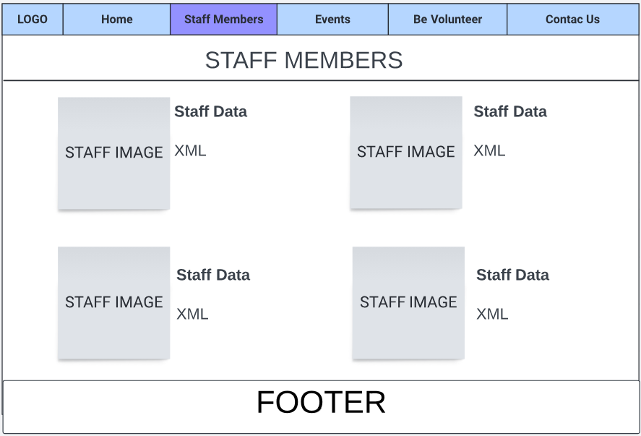

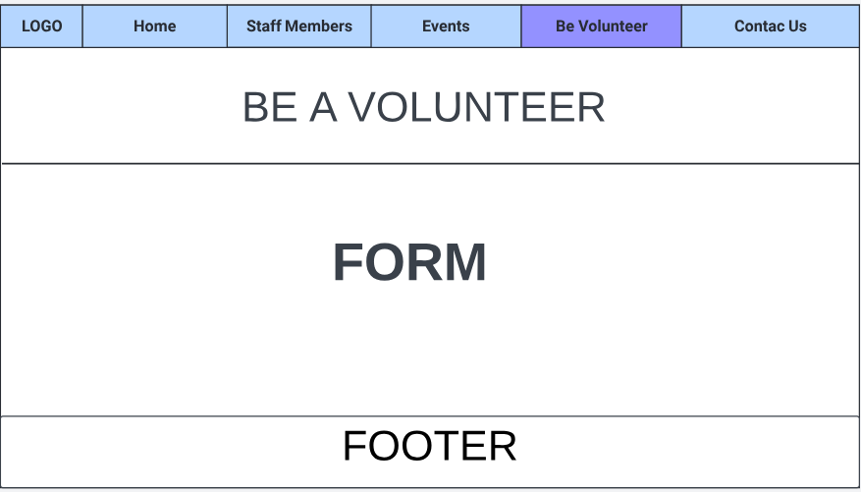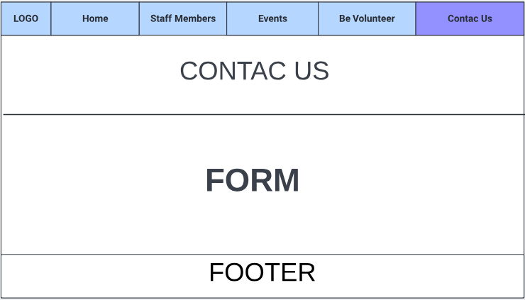

As seen in the images, the structure was simple and effective. With the approval of the design, we began creating the template (navbar and footer). After several attempts, we finally achieved something that was convincing.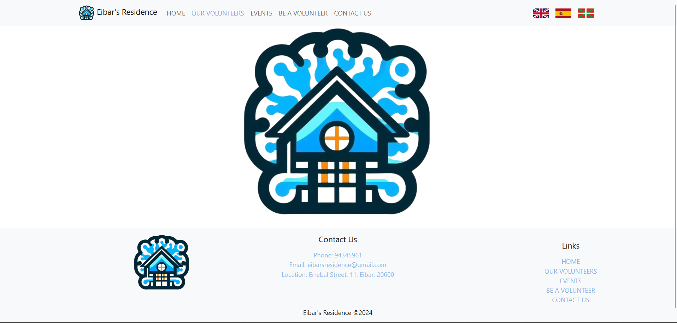

The navbar and footer are within a container, and both are responsive. In fact, here is an example on a smaller screen:

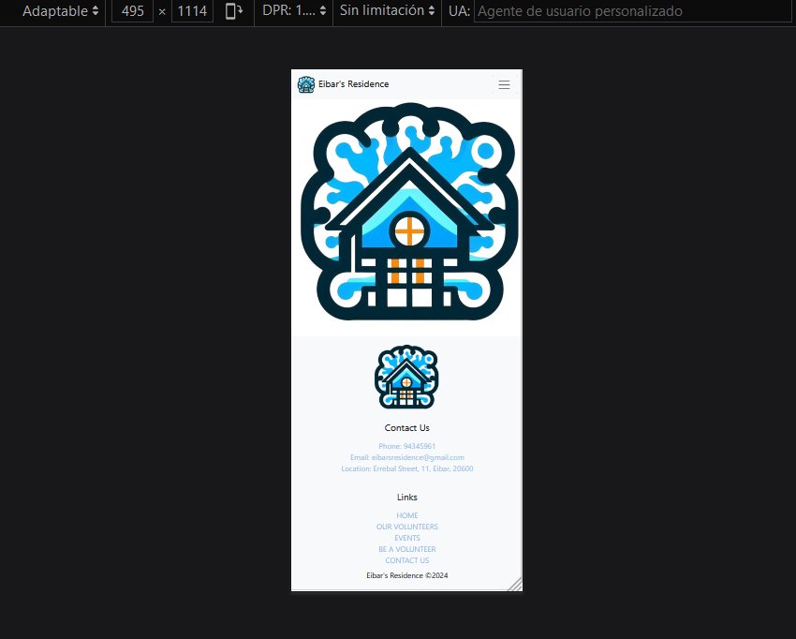

**INDEX**

The index is contained within a container. The first part consists of simple text with an image on the right, made responsive using Bootstrap: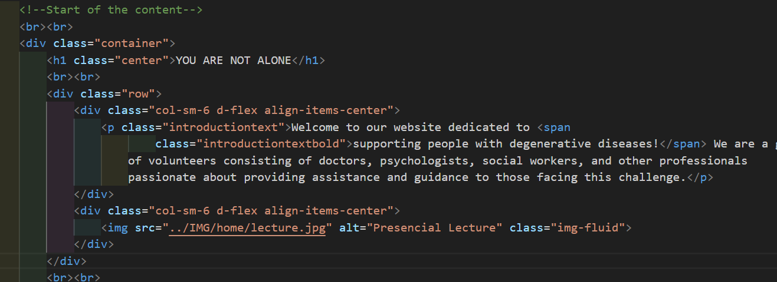

The second part is a bit more intricate. The intention is to create a star shape with an image inside. To achieve this, we used the following structure:

<div class="row mt-3">

<div class="col-sm-4"></div>

<div class="col-sm-4">CONTENT</div>

<div class="col-sm-4"></div>

<div class="row mt-4">

<div class="col-sm-4">CONTENT</div>

<div class="col-sm-4">IMG</div>

<div class="col-sm-4">CONTENT</div>

<div class="row mt-3">

<div class="col-sm-2"></div>

<div class="col-sm-4">CONTENT</div>

<div class="col-sm-4">CONTENT</div>

<div class="col-sm-2"></div>

To conclude, we added some opinions: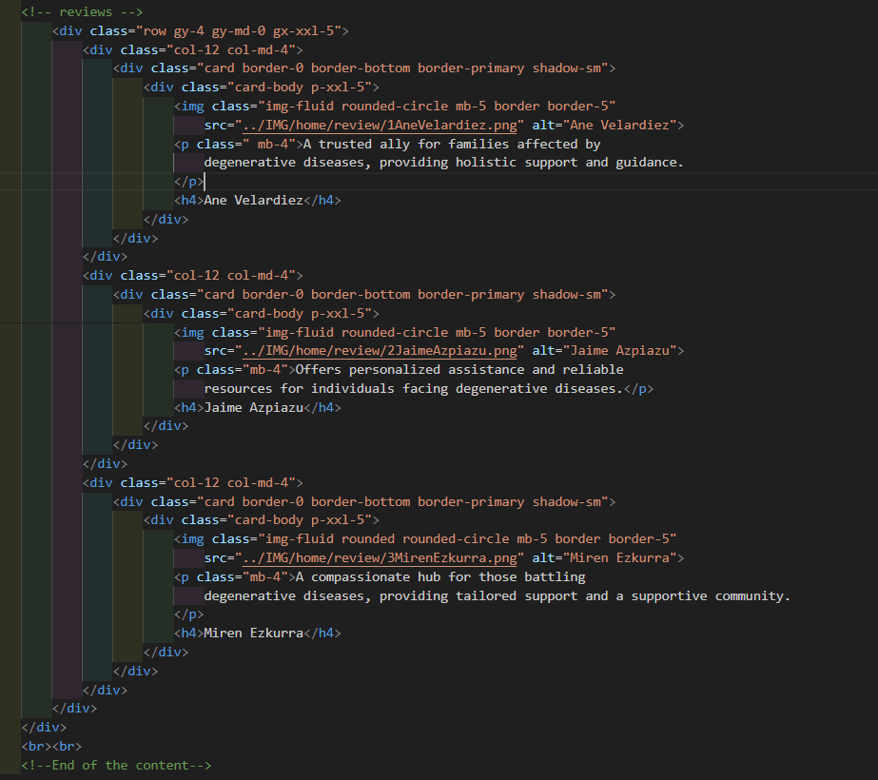

This is the complete code, and to briefly explain, each opinion is contained within a main **div** with a specific style.

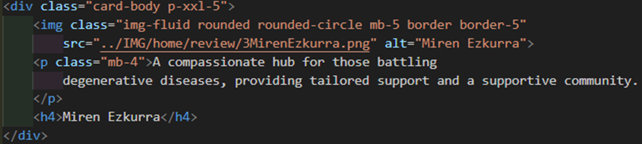Within each opinion, there's an image and text below it, which is adjusted using another **div**.

**OUR VOLUNTEERS**

The first part of the page features a straightforward responsive text with an image. Below that, we have two carousels, each containing six divs with an image and corresponding XML data.

We adapted the structure of the carousel from [W3](https://www.w3schools.com/bootstrap5/tryit.asp?filename=trybs_carousel), but we needed to modify it to include three divs inside each window. While this modification was relatively straightforward, the carousel was not responsive initially. We had to find a solution to make it responsive, and ultimately, this is the result:

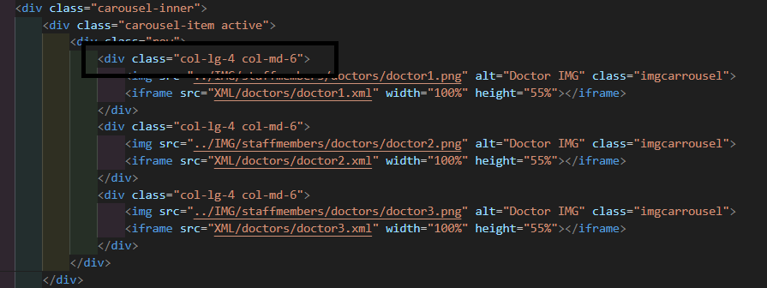

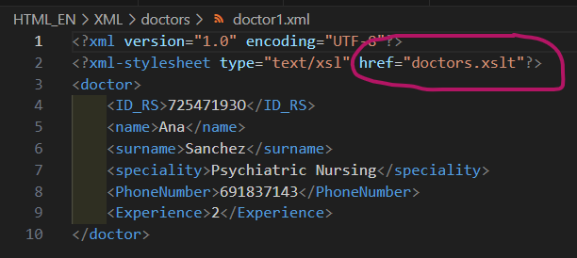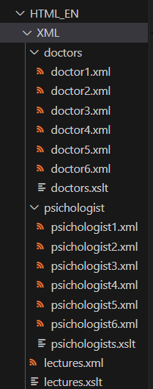Regarding the XML, we added it using an iframe within each div for each of the professionals. To achieve this, we had to create one XML document for each professional and then link all of these with an XML stylesheet to add design to it.: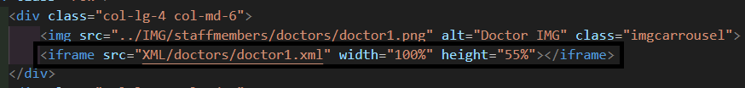

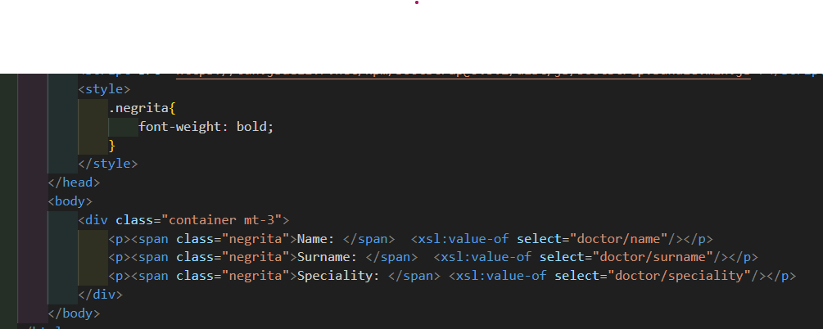

1Doctors.xslt

**EVENTS**

The Events page is structured with responsive text and image sections, separated by lines.



Regarding the lectures table, it's created using XML and represents a relationship between the tables "health_staff" and "lectures".

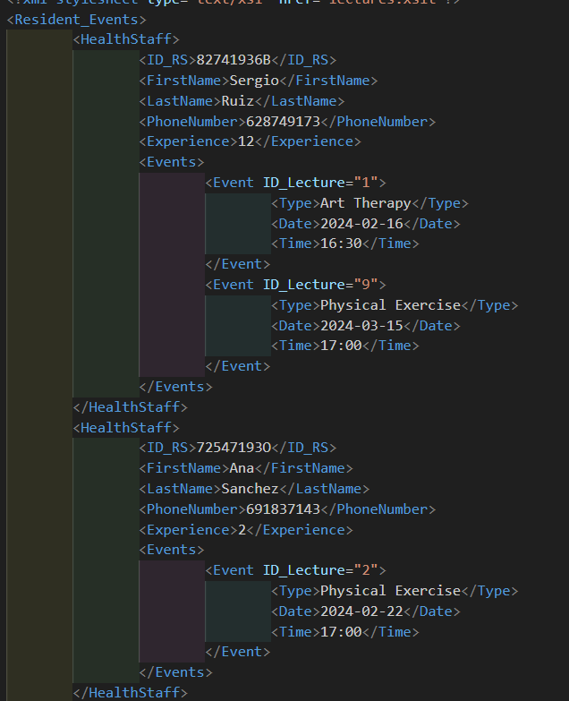  
As you can see, each lecture has an ID attribute. Initially, this was intended to facilitate sorting the lectures chronologically. However, as we encountered several issues with this approach, we decided to order them by date instead. However, having 10 records in XML was too much to display on the web, so we implemented a filter to show only the latest 5 (without following any specific order), and then sorted them by date.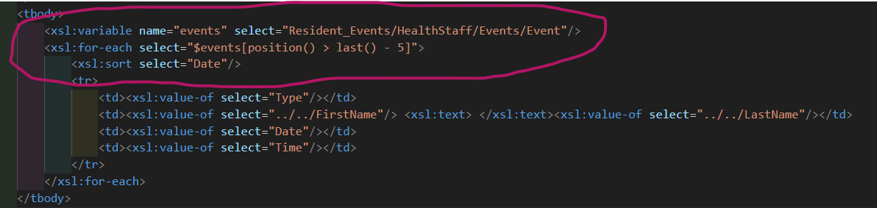

To conclude this section, we had to add <xsl:text> to include a space between the first name and the last name of the professional.

**FORMS**

To conclude, we have the forms: "BE A VOLUNTEER" and "CONTACT US".

Both forms use the same structure to ensure responsiveness.



Each question in both forms is required, and we have added a pattern to all the questions to ensure data consistency.

**BE A VOLUNTEER:**

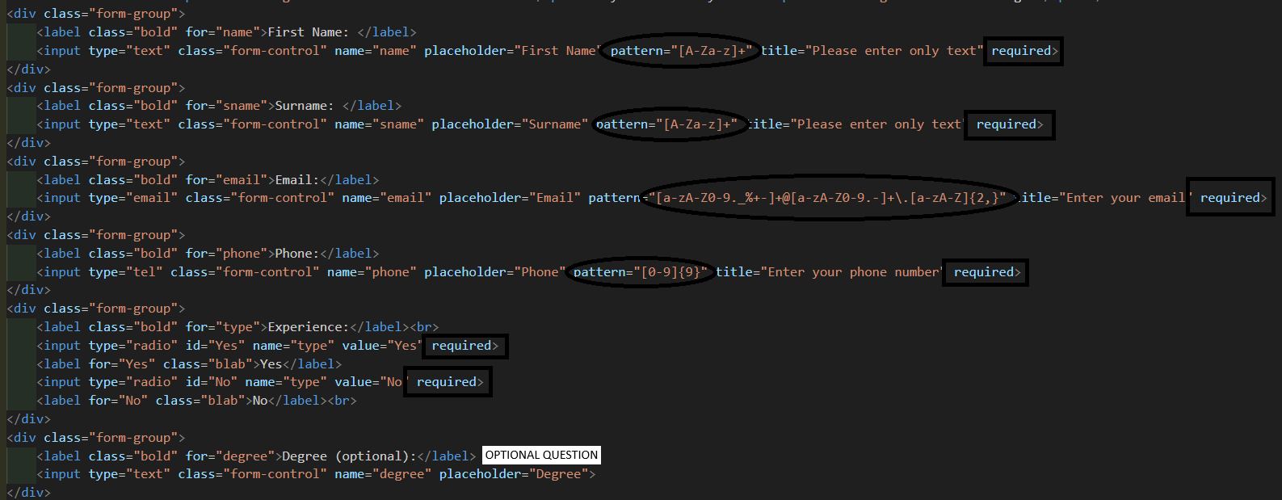

**CONTACT US:**

