.Net Standard Library

.NET Framework 4.6.2 MVC

.Net Core 2.0

.NET Framework 4.6.2 - Umbraco

# .NET Framework 4.6.2 MVC

How to do:

1. Make your packages.config into a PackageReference item group
2. Insert the PackageReference item group into the csproj file and set AutoGenerateBindingRedirects to true.
3. Delete your packages.config or make it unreadable.
4. Rebuild and add ASA.Apim.NetStdLib to your solution.
5. Now fix ‘Consider app.config remapping of assembly waring’
6. Then fix ‘Found conflicts between different versions of the same dependent assembly.’

Explanation:

1. Find your packages.config in your project. Open it and copy all content. Then go to <https://www.mking.net/tools/packagereference-converter> and paste it in and convert it.
2. Find your project.csproj file and open it. Locate the first <PropertyGroup></PropertyGroup> and set <AutoGenerateBindingRedirects>false</AutoGenerateBindingRedirects> to <AutoGenerateBindingRedirects>true</AutoGenerateBindingRedirects>. If it don’t exists, insert it. Then locate <ItemGroup> and insert the PackageReference item group as a new <ItemGroup>.
3. You can just rename it to packages.config_ and then delete it, when you are sure it all works.
4. ---
5. This warning can be fixed by either removing the <ItemGroup>’s with the old package references or download the files via nuget. Remember you can’t download System.Web and System.Web.Routing via nuget. These still have to be added manually. A good package to download is Microsoft.CSharp.
6. In Visual Studio, double-click this warning (or select it and press Enter) to fix the conflicts. Then it will add it to the web.config. Alternative, you have to add all the assemblyBindings yourself.

Packages.config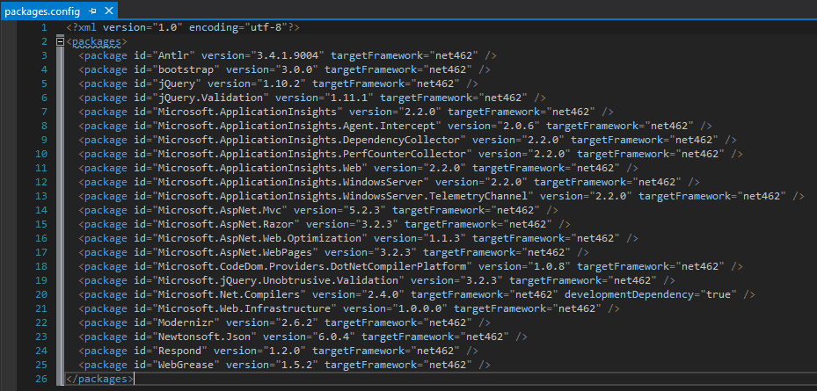

PackageReference item group (Should be inserted into .csproj file)  
