|  |  |  |  |  |
| --- | --- | --- | --- | --- |
| Adı | HIDAYATULLAH | Ders Adı | İLERİ ALGORİTMA ANALİZİ | IAU ile ilgili gÃ¶rsel sonucu |
| Soyadı | ARGHANDABI | Lect. | Dr. İLKNUR DÖNMEZ |
| Ders Kodu | BYL565 | Proje Deposu | <https://github.com/hidayatarg/Depth-First-Search-DFS> |

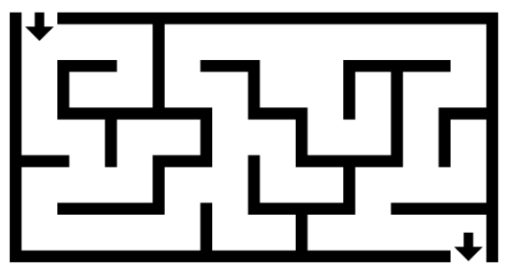Ödev

Şekildeki gibi bir labirenti dolaşan ve sonunda doğru yolu kendi kendine bulan LabirentCözen fonksiyonu yazınız.

1-Öncelikle labirentinizi graf olarak göstermeniz gerekmektedir.

2-Grafı ya komşuluk matrisi kullanarak yada link list kullanarak ifade edebilirsiniz. Yine bunu kendiniz oluşturup kod içinde tanımlamanız gerekmektedir.

3-İstenilen dil kullanılabilir: c, java, c++, python

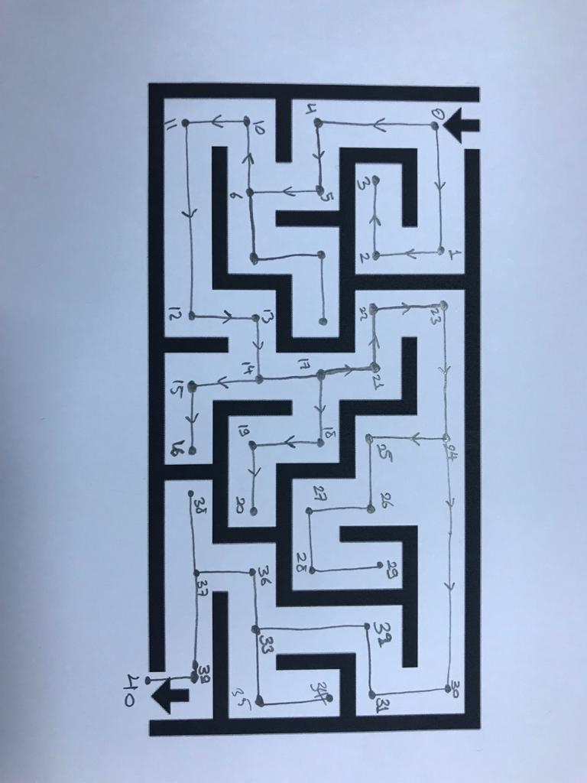4-Kod çalıştırılıp uğranılan düğümler gösterilecektir.

**Çözum**

Labirentinizi graf

9

8

7

AK = { 1, 4, 2, 3, 5, 6, 7, 10, 8, 9, 11, 12, 13, 14, 15, 17, 16, 18, 21, 19, 20, 22, 23, 24, 25, 30, 26, 27, 28, 29, 31, 32, 33, 34, 36, 35, 37, 38, 39, 40 };

AD = { 0, 2, 3, 4, 4, 5, 6, 8, 9, 10, 10, 11, 12, 13, 14, 16, 17, 17, 19, 20, 21, 21, 22, 23, 24, 26, 27, 28, 29, 30, 30, 31, 32, 33, 35, 36, 36, 37, 39, 39, 40, 40 };

Node Neighbors

0 1, 4

1 0, 2 (We only take the neighbors of forward direction of arrow exp: 2 enough)

2 1, 3 (We take 3)

3 2

4 0, 5 (we take 5)

5 4, 6 (we take 6)

6 7, 10 (we take)

… …

We complete this and place it AK with according to nodes in AD.

**OUTPUT:**

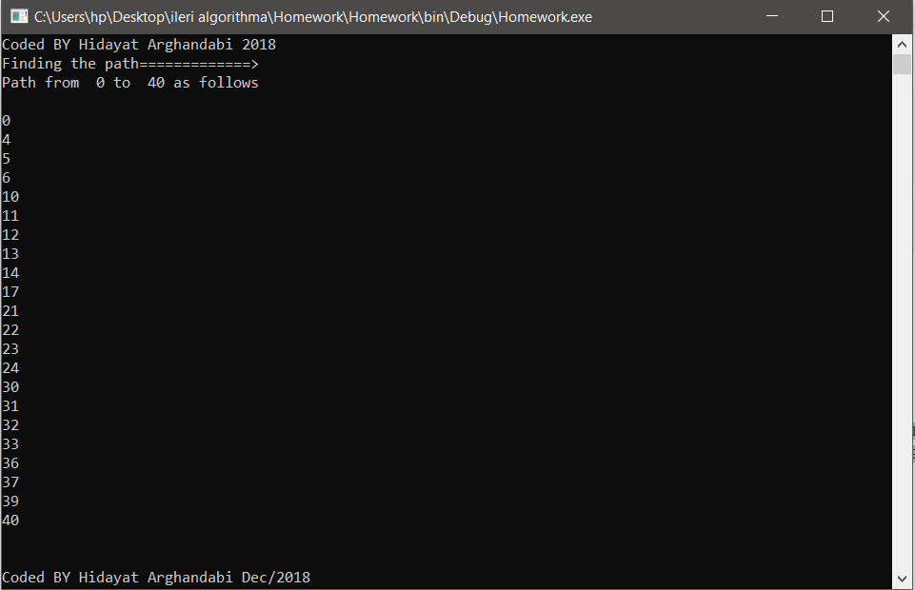

**Code in Csharp**

using System;

namespace Homework

{

class Program

{

// Static AK and AD arrays

static int[] AK = { 1, 4, 2, 3, 5, 6, 7, 10, 8, 9, 11, 12, 13, 14, 15, 17, 16, 18, 21, 19, 20, 22, 23, 24, 25, 30, 26, 27, 28, 29, 31, 32, 33, 34, 36, 35, 37, 38, 39, 40 };

static int[] AD = { 0, 2, 3, 4, 4, 5, 6, 8, 9, 10, 10, 11, 12, 13, 14, 16, 17, 17, 19, 20, 21, 21, 22, 23, 24, 26, 27, 28, 29, 30, 30, 31, 32, 33, 35, 36, 36, 37, 39, 39, 40, 40 };

// Starting Node

static int startNode = 0;

// Ending Node

static int endNode = 40;

static void Main(string[] args)

{

// Program start

Console.WriteLine("Finding the path=============>");

Console.WriteLine("Path from " + startNode + " to " + endNode + " as follows\n");

// Print Each node path

foreach (var y in FindPath(startNode, endNode, DepthFirstSearch(AK, AD)))

Console.WriteLine(y);

Console.WriteLine("\n\nCoded BY Hidayat Arghandabi Dec/2018 ");

// Pause the Program

Console.ReadLine();

}

// Finding the path

private static int[] FindPath(int startNode, int endNode, int[] parentList)

{

int[] path = new int[parentList.Length];

int currentNode = endNode;

for (int i = 0; i < parentList.Length; i++)

{

path[i] = currentNode;

if (currentNode == startNode)

return FlipArray(TrimArray(path, i + 1));

currentNode = parentList[currentNode];

}

// Flip the array => path

return FlipArray(path);

}

// Find the DFS

private static int[] DepthFirstSearch(int[] AK, int[] AD)

{

int nodeTotal = AD.Length - 1;

int[] parents = new int[nodeTotal];

for (int p = 0; p < nodeTotal; p++)

parents[p] = -1;

for (int s = 0; s < nodeTotal; s++)

{

if (CheckList(parents, s))

continue;

// Finding the Adjacent Node

if (FindAdjacentNode(AK, AD, s).Length > 0)

VisitedDfs(s, parents, FindAdjacentNode(AK, AD, s));

else

continue;

}

return parents;

}

private static void VisitedDfs(int s, int[] parents, int[] adjacentNode)

{

// Recursive

for (int v = 0; v < adjacentNode.Length; v++)

{

if (!CheckList(parents, adjacentNode[v]))

{

parents[adjacentNode[v]] = s;

VisitedDfs(adjacentNode[v], parents, FindAdjacentNode(AK, AD, adjacentNode[v]));

}

}

}

// Finding the Adjacent Node

private static int[] FindAdjacentNode(int[] AK, int[] AD, int node)

{

int[] adjacentNode = new int[AD[node + 1] - AD[node]];

for (int x = 0; x < adjacentNode.Length; x++)

{

adjacentNode[x] = AK[AD[node] + x];

}

return adjacentNode;

}

// Flipping the Array

private static int[] FlipArray(int[] array)

{

int[] flippedArr = new int[array.Length];

for (int i = 0; i < array.Length; i++)

{

flippedArr[array.Length - 1 - i] = array[i];

}

return flippedArr;

}

// The value with List

private static bool CheckList(int[] list, int value)

{

for (int x = 0; x < list.Length; x++)

{

if (value == list[x])

return true;

}

return false;

}

// Trimming

private static int[] TrimArray(int[] array, int length)

{

int[] trimmedArr = new int[length];

for (int i = 0; i < length; i++)

{

trimmedArr[i] = array[i];

}

return trimmedArr;

}

}

}