TITLE: PSET LAB 1

STIJ3074: WEB PROGAMMING

NAME: NURHIDAYATI BINTI ISHAK

MATRIX NO: 244775

1.Main Github page.

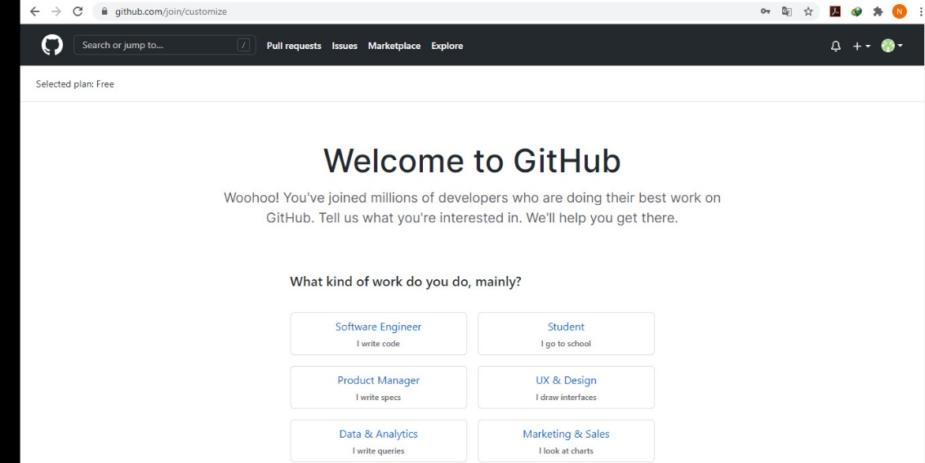

2. Git GUI

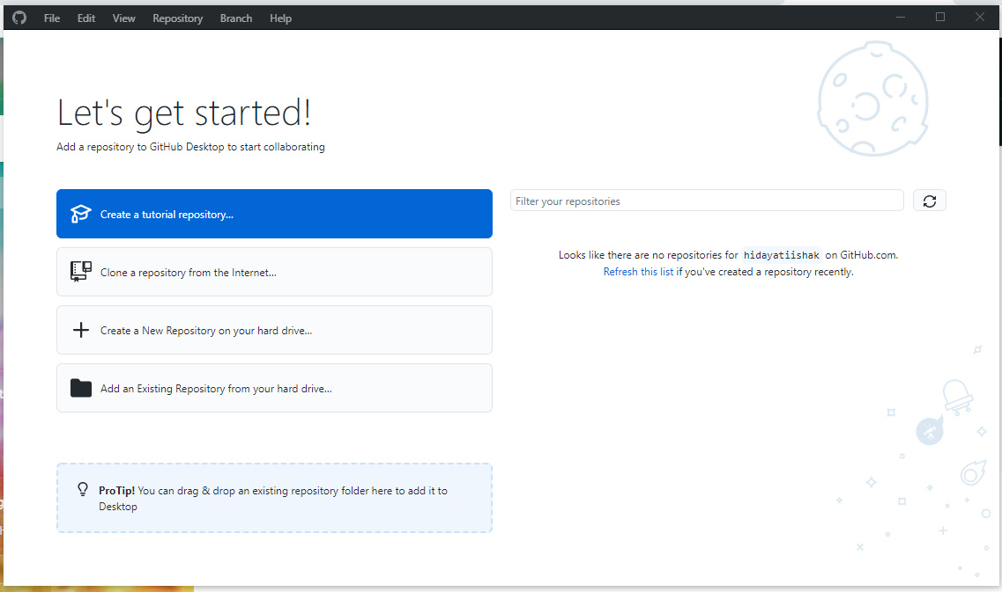

3.Stij3074 folder

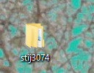

4.Git GUI Create Repository

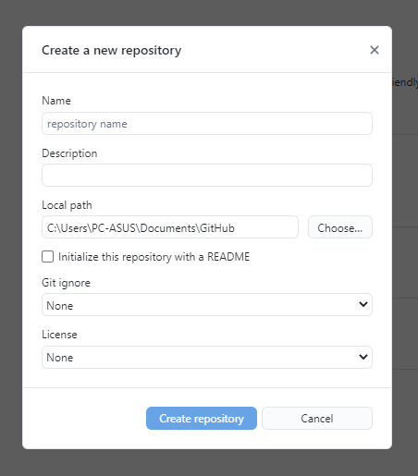

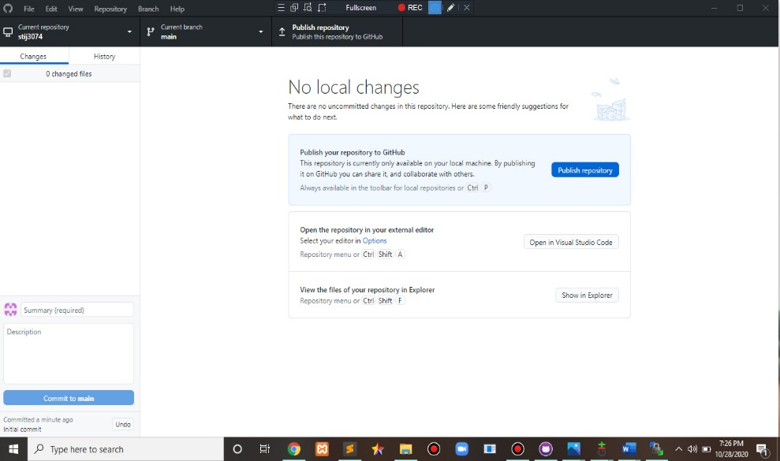

5. Main CPanel

6. Account

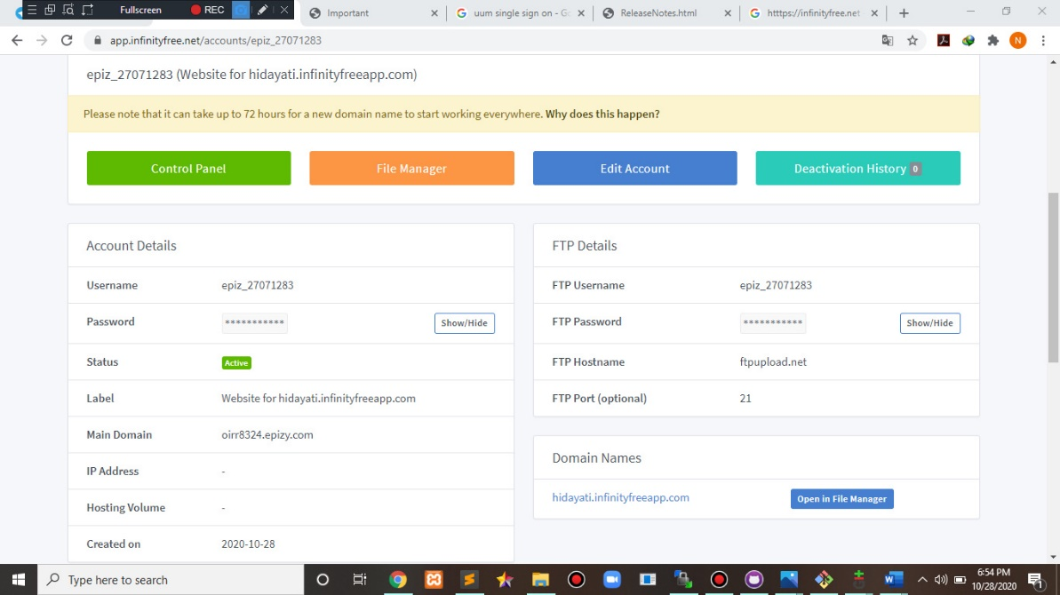

7. WinCSP interface

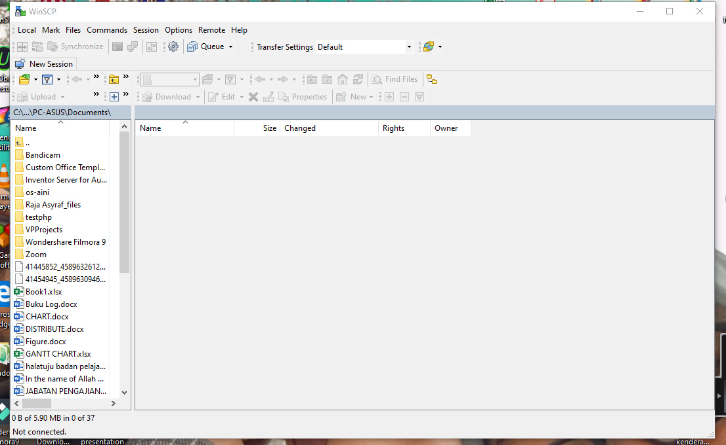

8. Successful WinSCP interface

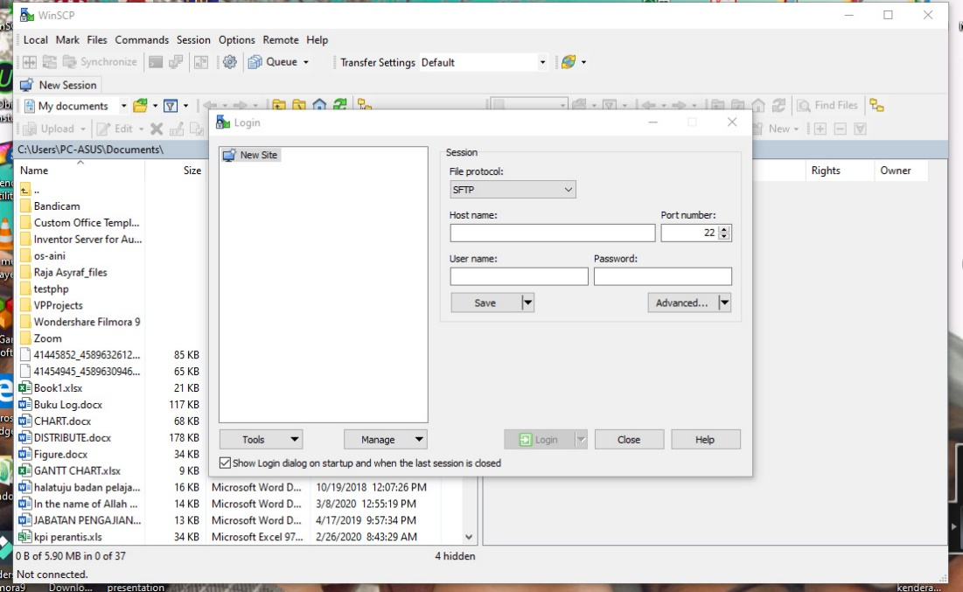

9. Registration folder

10. registration.html page

