* **Inner feedback loop** :controls current
* **Outer feedback loop** : controls current motor speed
* **Vref :** Speed demand set (V)
* **Vdir :** Motor direction
* **Brake :** If the voltage at the **Vbrk** pin goes high, then **Vref** is **overridden** and speed demand **set to zero to implement a braking action.**

Default speed demand 2V equals 40,000 rpm

Efficiency is calculated mechanical power out / electrical power in

**Datas:**

**Stall torque :** 0.44 mmNm

**Maximum permissible speed :** 100,000 rpm

**Mechanical time constant :** 5ms

**Rotor inertia :** 0.005 gcm^2

**Efficiency :** %41 at 0.23 mmNm and 40,000 rpm

**No-load current :** 22 mA

**Nominal voltage :** 12V

**Electrical Losses:**

1. fixed loss from Vcc*I0 **, Vcc :** nominal supply, **I0 :** no-load DC current drawn from power supply.

2. proportional to the square of instantaneous motor winding current. Approxximately square of the average torque.

**Controller :** PI controller used.Here, the datasheet gives the no-load time constant as 5ms. A typical rule of thumb is that an inner control loop should be at least ten times faster than the outer loop. This means a time constant of 0.5ms for the current controller.

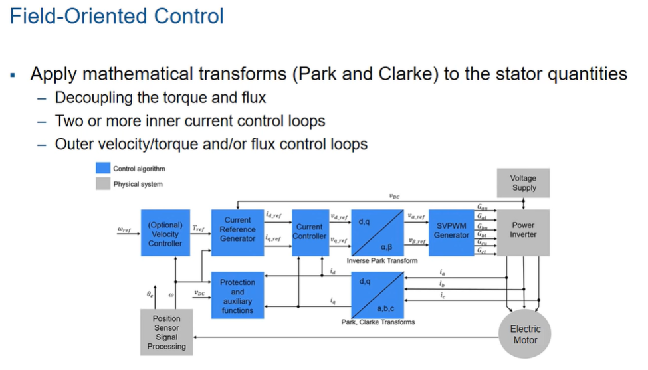

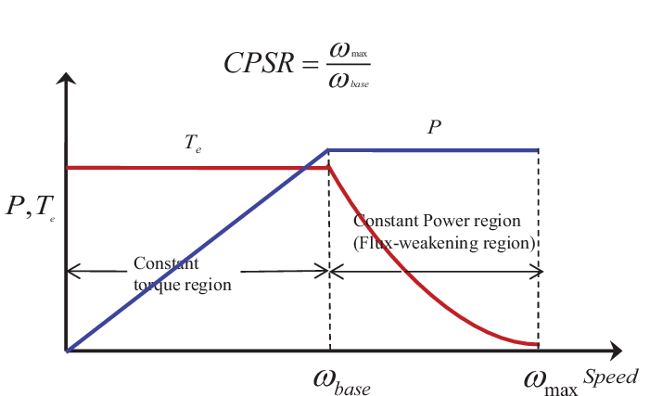

**TMSM motor torque vs speed map**

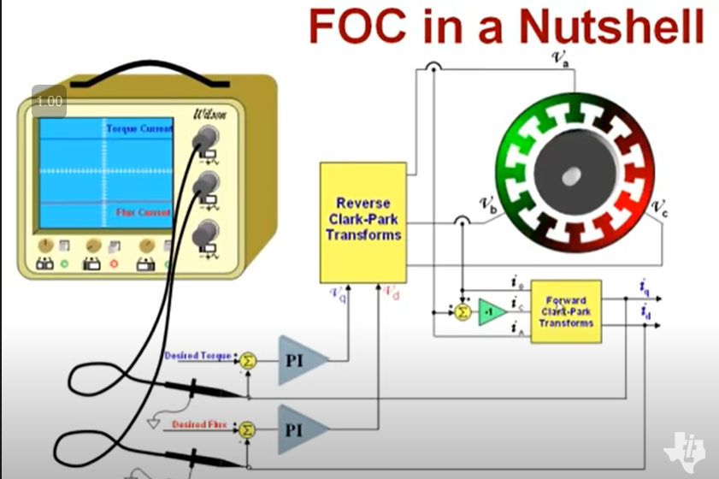

<https://www.mathworks.com/help/physmod/sps/ug/brushless-dc-motor.html>  
<https://www.youtube.com/watch?v=cdiZUszYLiA>

**Permanent Magnet Synchronous Machine Block**

<https://www.mathworks.com/help/physmod/sps/powersys/ref/permanentmagnetsynchronousmachine.html>

**Mechanical input section**

**Select Torque** Tm to specify a torque input in N.m and expose the Tm port. The machine speed is determined by the machine Inertia J and by the difference between the applied mechanical torque Tm and the internal electromagnetic torque Te.

The sign convention for the mechanical torque is when the speed is positive. A positive torque signal indicates motor mode and a negative signal indicates generator mode.

**Select Speed** w to specify a speed input in rad/s and expose the w port. The machine speed is imposed and the mechanical part of the model (Inertia J) is ignored.

Using the speed as the mechanical input allows modeling a mechanical coupling between two machines.