

**2022/2023 Fall**

**KON305E - CRN:12112**

Dr. Emre Dinçel

Hidayet Ersin DURSUN

040200502

Programming Techniq.in Control HW 2

**PART 1.1 :**

h = 0.1 ;

zeta = 0.01:h:1;

w = 0.01:h:15;

coeff = 1:h:10

** **

**h**, is the number of steps variable and 0.1 was chosen considering the computational capacity of the computer.

**Zeta** is between 0 and 1 as given in the question.

**W** (omega), was given as greater than zero in the question. Values ​​between 0.01 and 15 were selected.

Finally, the parameter requested in the question, namely the **coeff** variable, was chosen between 1 and 10, taking into account the computational capacity of the computer.

In the code part, w and zeta meshgrids were created. And the rise time (Tr) is calculated for all values ​​using for loops. The difference between the calculated values ​​and the value obtained from the MATLAB’s “stepinfo” function was chosen as the error and ISE (integral square error) was calculated. The coefficient corresponding to the smallest of the calculated errors for each coefficient is returned as the best coefficient.

**Result :**

best_coeff =

**3.900000000000000**

**PART 1.2:**

h = 0.1 ;

zeta = 0.01:h:1;

w = 0.01:h:15;

For the given intervals, the linear “fit” function is used for the selected limit values.

**Result :**

Coefficients (with 95% confidence bounds):

p1 **= 3.895** (3.894, 3.897)

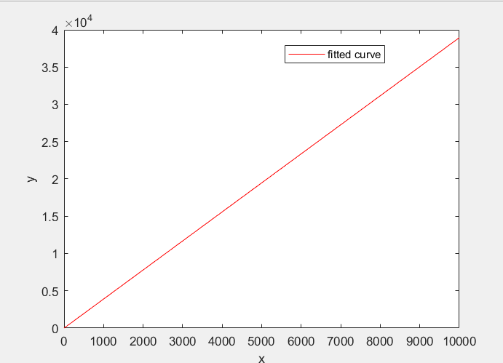

*The graph of fitted function for the rise time.*

**PART 1.3 :**

h = 0.1 ;

zeta = 0.01:h:1;

w = 0.01:h:15;

For the given intervals, the linear “fit” function is used for the selected limit values.

**Result :**

Coefficients (with 95% confidence bounds):

p1 = **1.999** (1.972, 2.027)

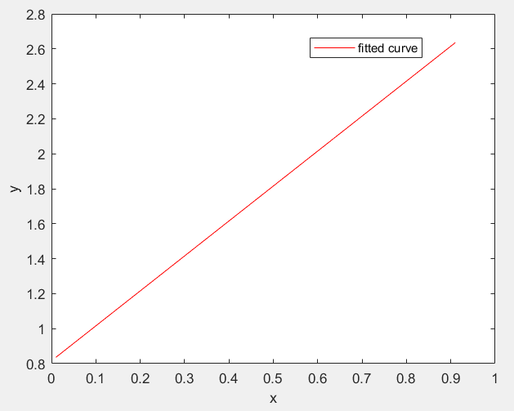

*The graph of fitted function for the rise time.*

**PART 1.4 :**

h = 0.1 ;

zeta = 0.01:h:1;

w = 0.01:h:15;

For the given intervals, the “fit” function is used for the selected limit values.

**Result :**

Coefficients (with 95% confidence bounds):

p1 = **2.107** (2.088, 2.126)

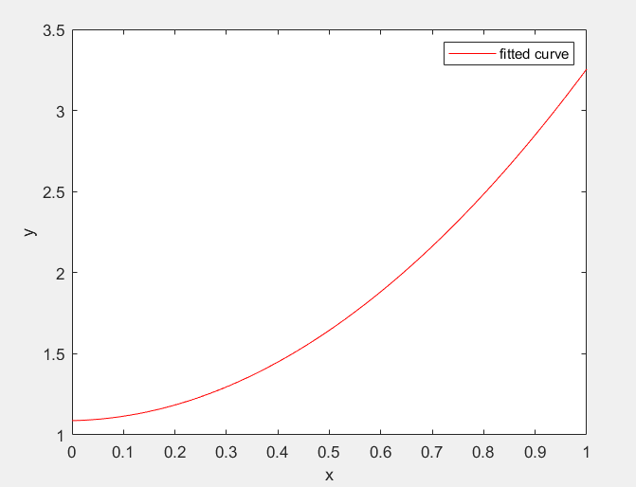

*The graph of fitted function for the rise time.*