10 Categories Example Output:

- AR
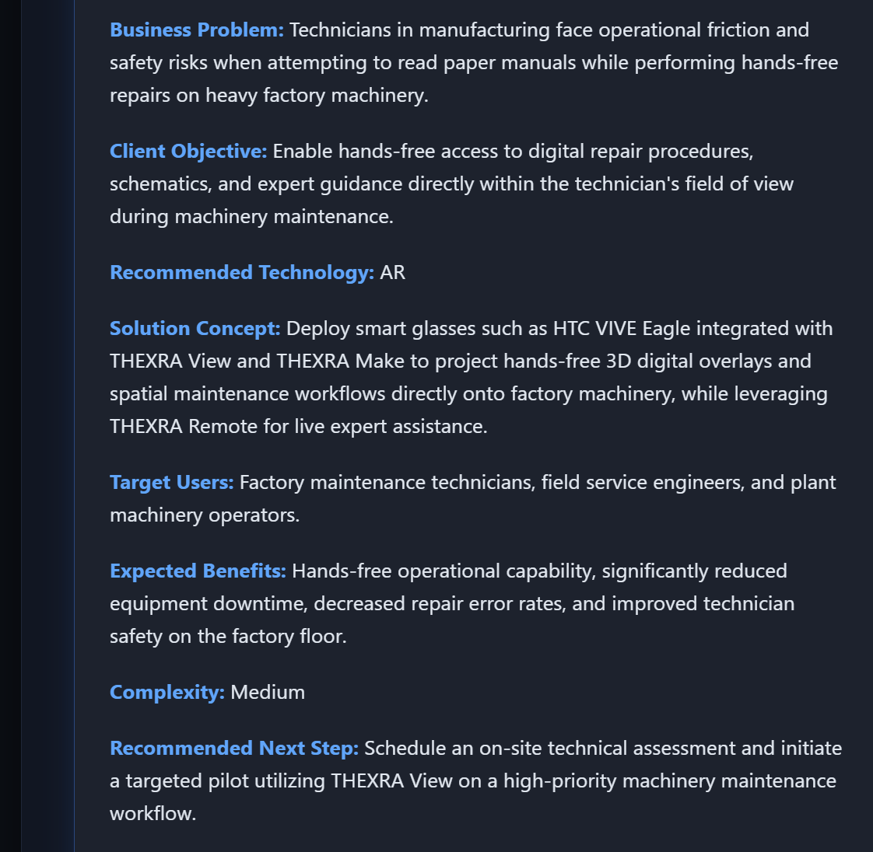

Company Name: FieldTech Solutions
Industry Vertical: Manufacturing
Primary Operating Location / HQ: Chicago, USA
Target User Count: 150
Core Problem: Technicians struggle to read paper manuals while doing hands-free repair on heavy factory machinery.
Target End User: Field service engineers
Current Operational Process: Paper manuals and physical reference guides
Desired Business Outcome / KPIs: Reduce mean time to repair by 35%
Estimated Budget Range: $50k – $100k
Delivery Timeline: 3 - 6months
Existing Systems: CAD/BIM Models Available
Special Technical Requirements: Smart glasses support, offline access

- VR
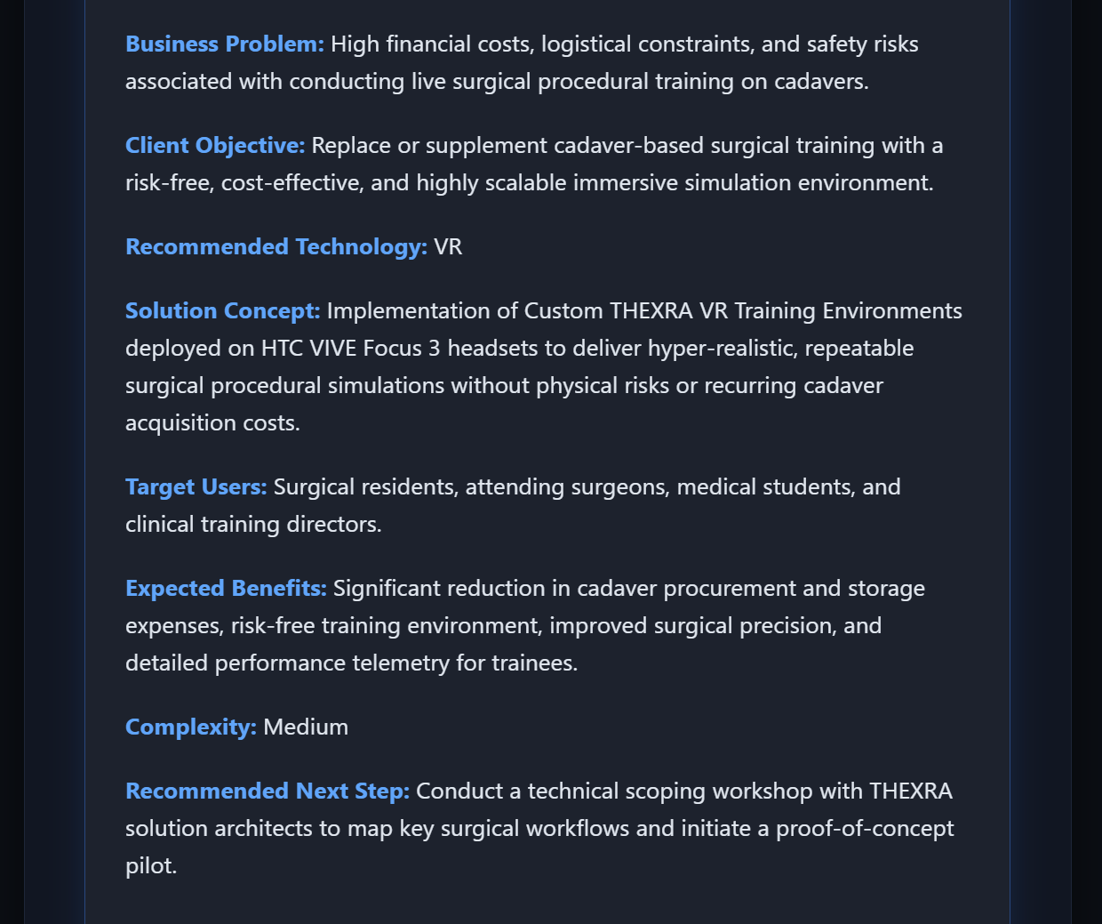

Company Name: MedTrain Global
Industry Vertical: Healthcare
Primary Operating Location / HQ: Houston, USA
Target User Count: 500
Core Problem: High risk and high costs associated with live surgical procedural training on cadavers.
Target End User: Surgical residents and nurses
Current Operational Process: On-site classroom slides and live observation
Desired Business Outcome / KPIs: Zero training risk, 50% faster surgical onboarding
Estimated Budget Range: $100k+
Delivery Timeline: 4 months
Existing Systems: LMS
Special Technical Requirements: Full immersive headset support, haptic simulation

- MR

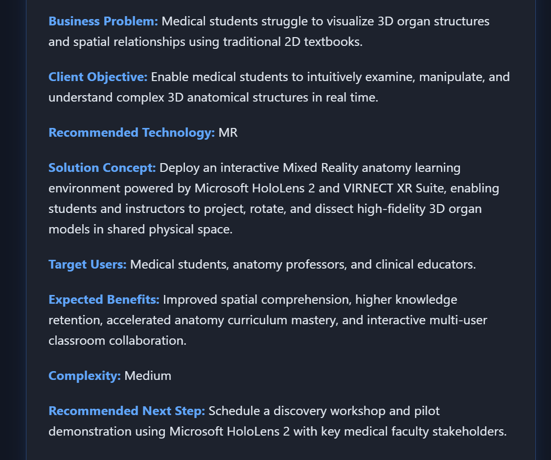

Company Name: BioAnatomy Academy
Industry Vertical: Education
Primary Operating Location / HQ: London, UK
Target User Count: 300
Core Problem: Medical students struggle to visualize 3D organ structures and spatial relationships on 2D textbooks.
Target End User: Medical students and instructors
Current Operational Process: 2D textbook diagrams and physical plastic models
Desired Business Outcome / KPIs: Boost student exam comprehension scores by 40%
Estimated Budget Range: $100k+
Delivery Timeline: 1 - 3 months
Existing Systems: LMS
Special Technical Requirements: Spatial anchors, interactive 3D holographic models

- AI
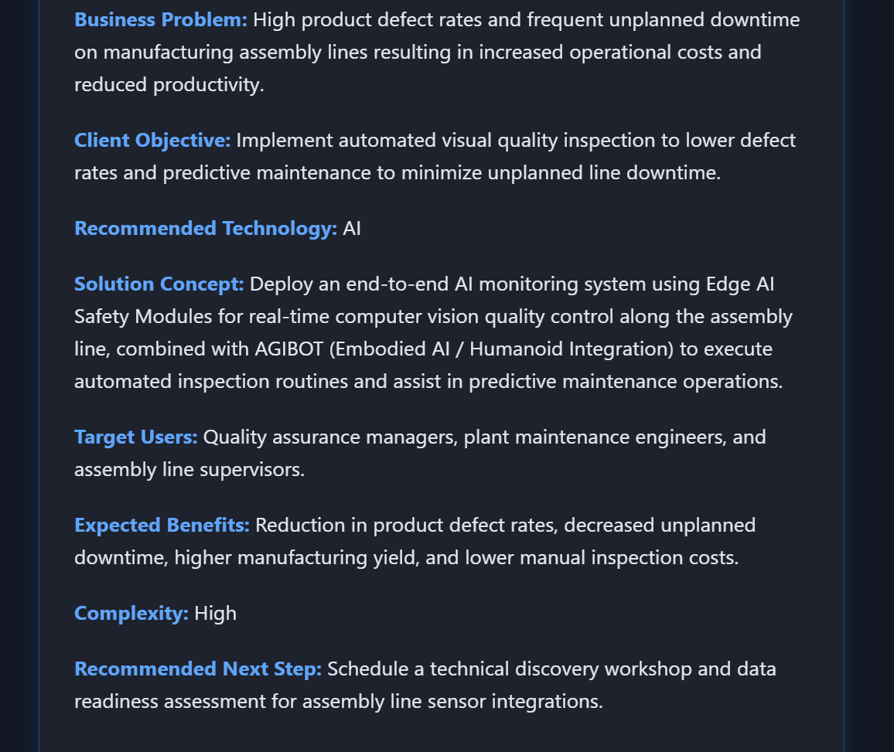

Company Name: Precision Forge
Industry Vertical: Manufacturing
Primary Operating Location / HQ: Detroit, USA
Target User Count: 200
Core Problem: High product defect rates and frequent unplanned downtime on assembly lines.
Target End User: Quality inspectors and maintenance team
Current Operational Process: Manual visual inspection and scheduled maintenance
Desired Business Outcome / KPIs: 90% automated defect detection, 25% lower downtime
Estimated Budget Range: $100k+
Delivery Timeline: 3 - 6 months
Existing Systems: IoT Sensors / Live Telemetry
Special Technical Requirements: Computer vision, real-time telemetry analytics

- Digital Twin

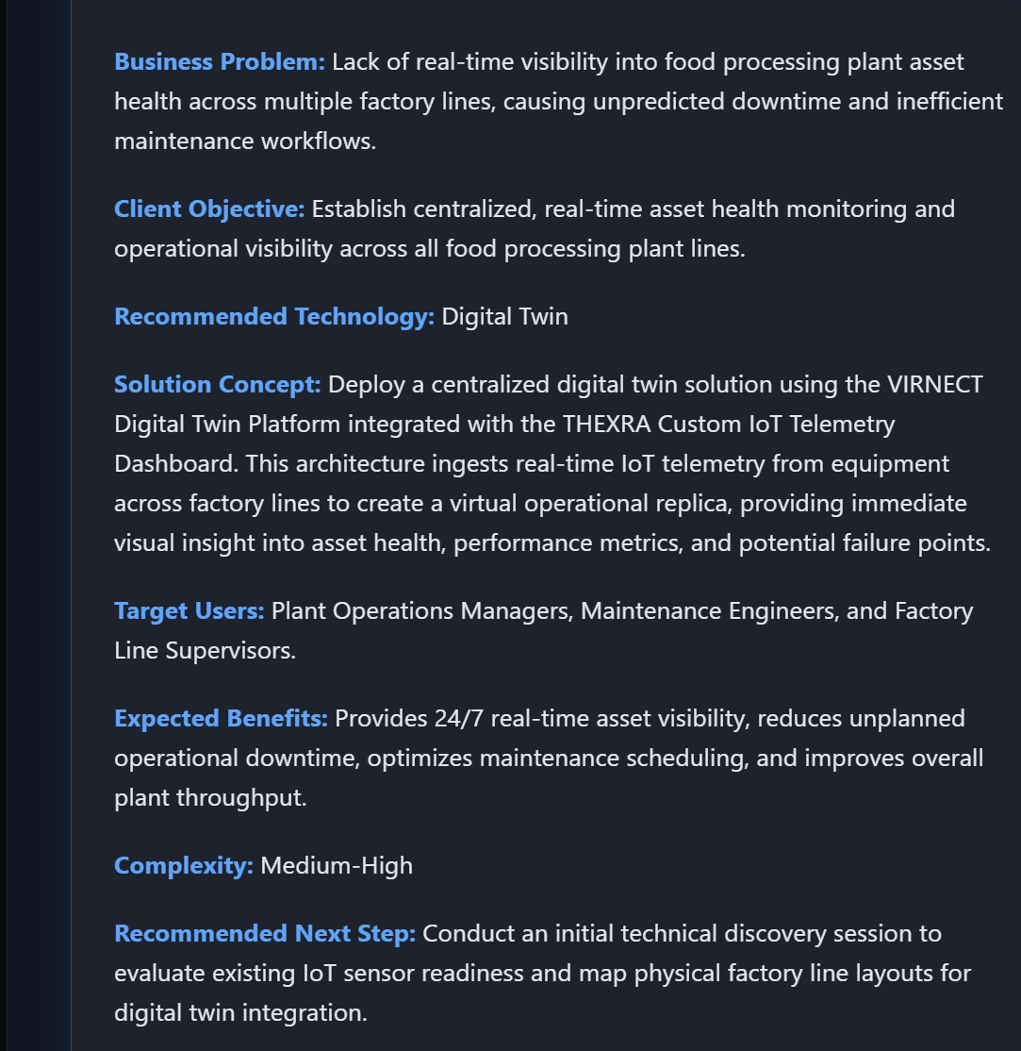

Company Name: SmartPlant Foods
Industry Vertical: Manufacturing
Primary Operating Location / HQ: Berlin, Germany
Target User Count: 80
Core Problem: Lack of real-time visibility into food processing plant asset health across multiple factory lines.
Target End User: Plant operators and system engineers
Current Operational Process: Manual hourly logs and static dashboards
Desired Business Outcome / KPIs: Predict asset failure 48 hours in advance
Estimated Budget Range: $100k+
Delivery Timeline: 6 - 12 months
Existing Systems: CAD/BIM Models Available , IoT sensors
Special Technical Requirements: Real-time IoT synchronization, 3D factory mapping

- Simulator

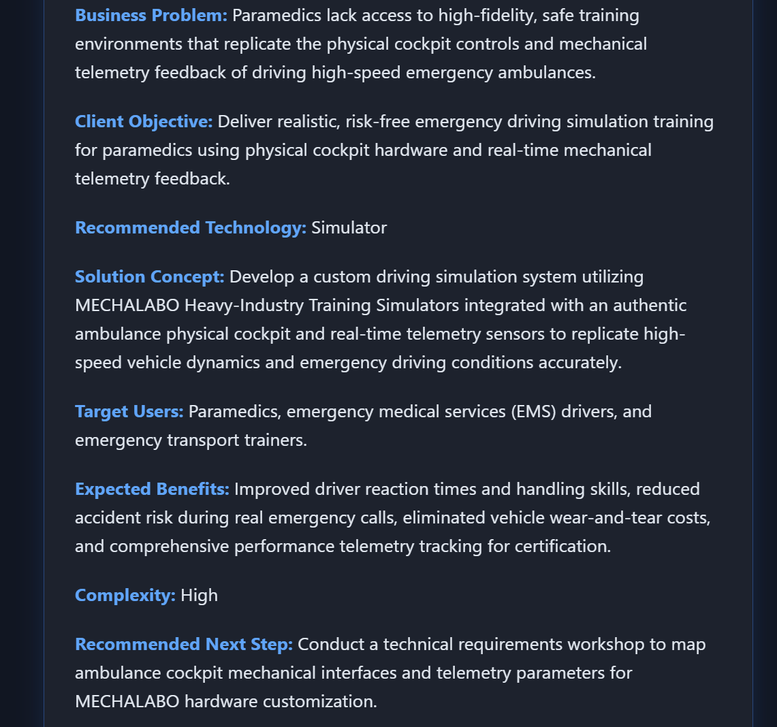

Company Name: HealthSim Tech
Industry Vertical: Healthcare
Primary Operating Location / HQ: Singapore
Target User Count: 120
Core Problem: Paramedics need realistic physical cockpit hardware and mechanical telemetry feedback to practice driving high speed emergency ambulances safely
Target End User: Emergency ambulance drivers
Current Operational Process: Supervised live equipment practice
Desired Business Outcome / KPIs: Cut equipment maintenance costs by 60%
Estimated Budget Range: $100k+
Delivery Timeline: 3 - 6 months
Existing Systems: LMS
Special Technical Requirements: Accurate physiological simulation, hardware telemetry output

- Interactive Display

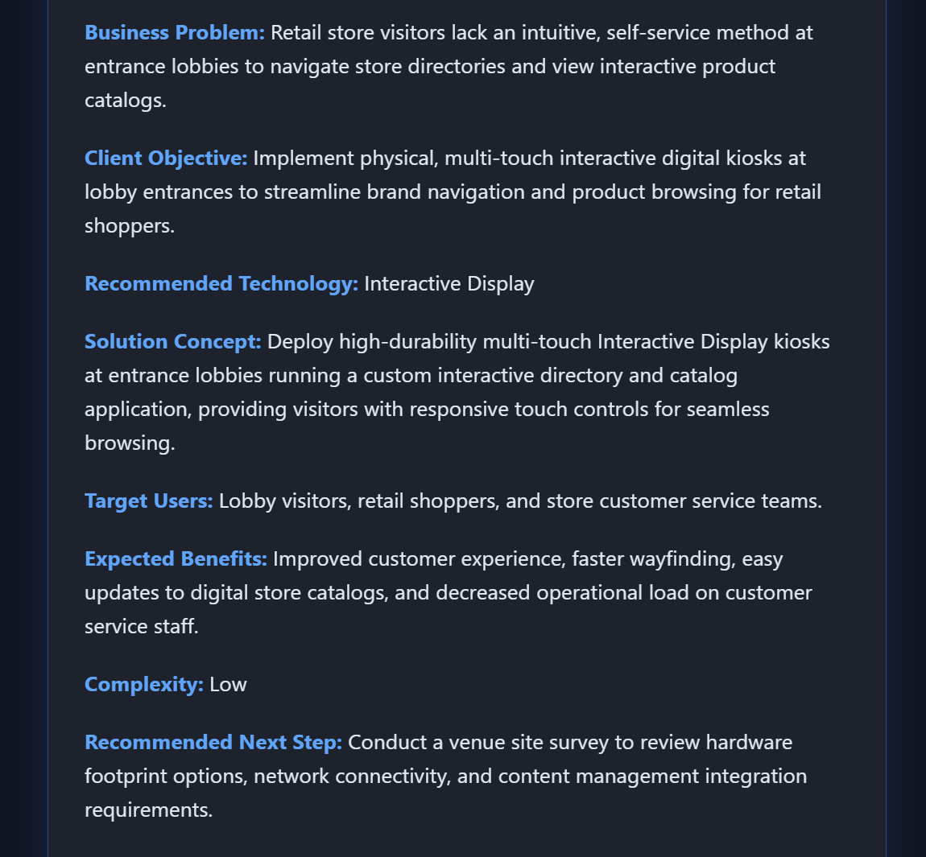

Company Name: Metro Malls
Industry Vertical: Retail
Primary Operating Location / HQ: Dubai, UAE
Target User Count: 1,000+
Core Problem: Visitors need physical, multi-touch interactive digital kiosks at entrance lobbies to browse brand directories and interactive store catalogs.
Target End User: In-store shoppers
Current Operational Process: Static printed directory boards
Desired Business Outcome / KPIs: Increase store directory engagement by 40%
Estimated Budget Range: $50k - $100k
Delivery Timeline: 1 - 3 months
Existing Systems: (None)
Special Technical Requirements: Multi-touch gesture control, heavy-duty kiosk enclosure

- Location-Based Experience

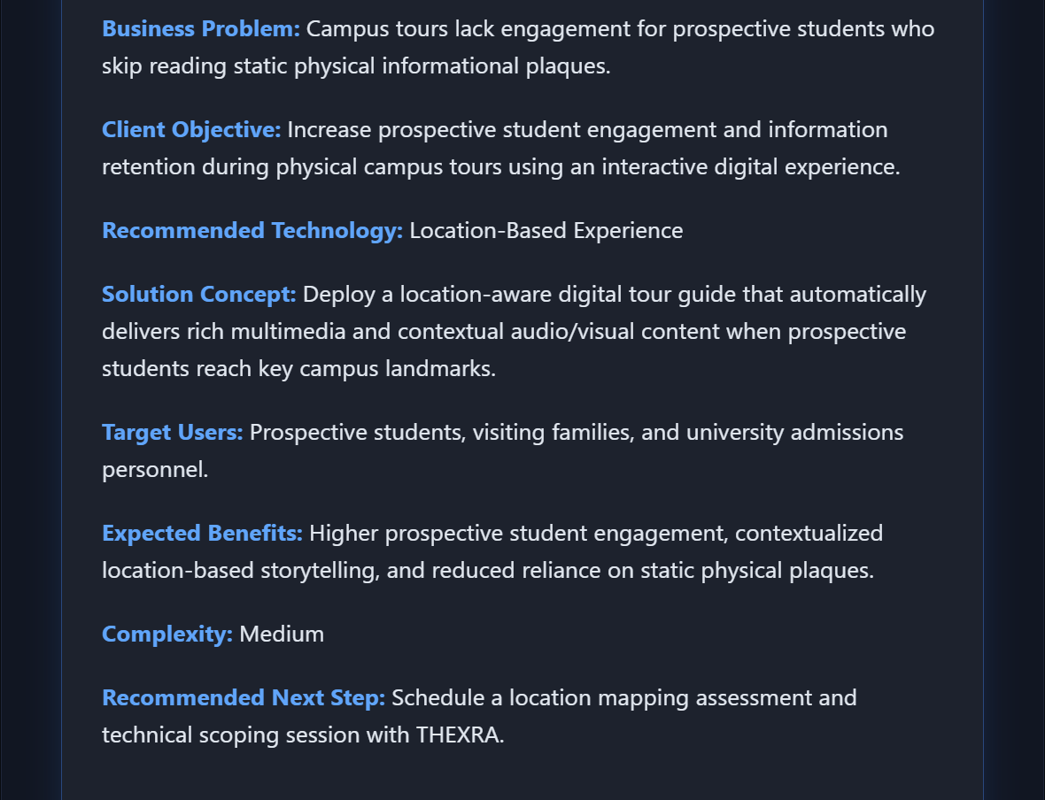

Company Name: EduCampus Interactive
Industry Vertical: Education
Primary Operating Location / HQ: Boston, USA
Target User Count: 1,000+
Core Problem: Campus tours lack engagement for prospective students who skip reading informational plaques.
Target End User: Prospective students and visitors
Current Operational Process: Paper campus maps and tour guides
Desired Business Outcome / KPIs: Increase prospective student engagement time by 30 minutes
Estimated Budget Range: $100k+
Delivery Timeline: 3 - 6 months
Existing Systems: IoT Sensors
Special Technical Requirements: Campus geofencing, room-scale audio triggers

- Mobile / Web

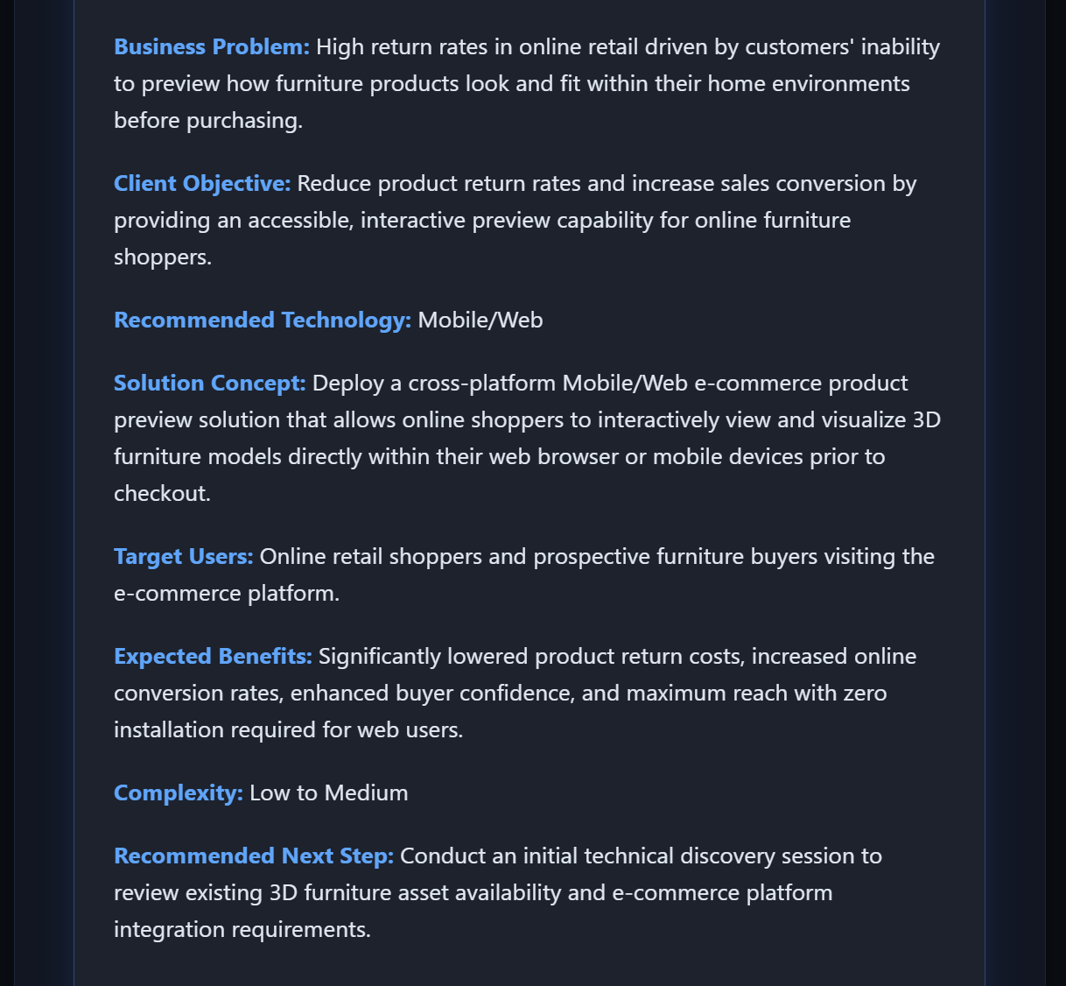

Company Name: SwiftCart E-Commerce
Industry Vertical: Retail
Primary Operating Location / HQ: Toronto, Canada
Target User Count: 1,000+
Core Problem: High return rates because online customers cannot preview how furniture looks at home.
Target End User: Online shoppers
Current Operational Process: Static 2D product photos
Desired Business Outcome / KPIs: Lower return rates by 20%, boost checkout conversion
Estimated Budget Range: $10k - $50k
Delivery Timeline: 1 - 3 months
Existing Systems: CAD / BIM Models Available
Special Technical Requirements: Zero-app install WebXR / WebGL browser compatibility

- Combination Solution

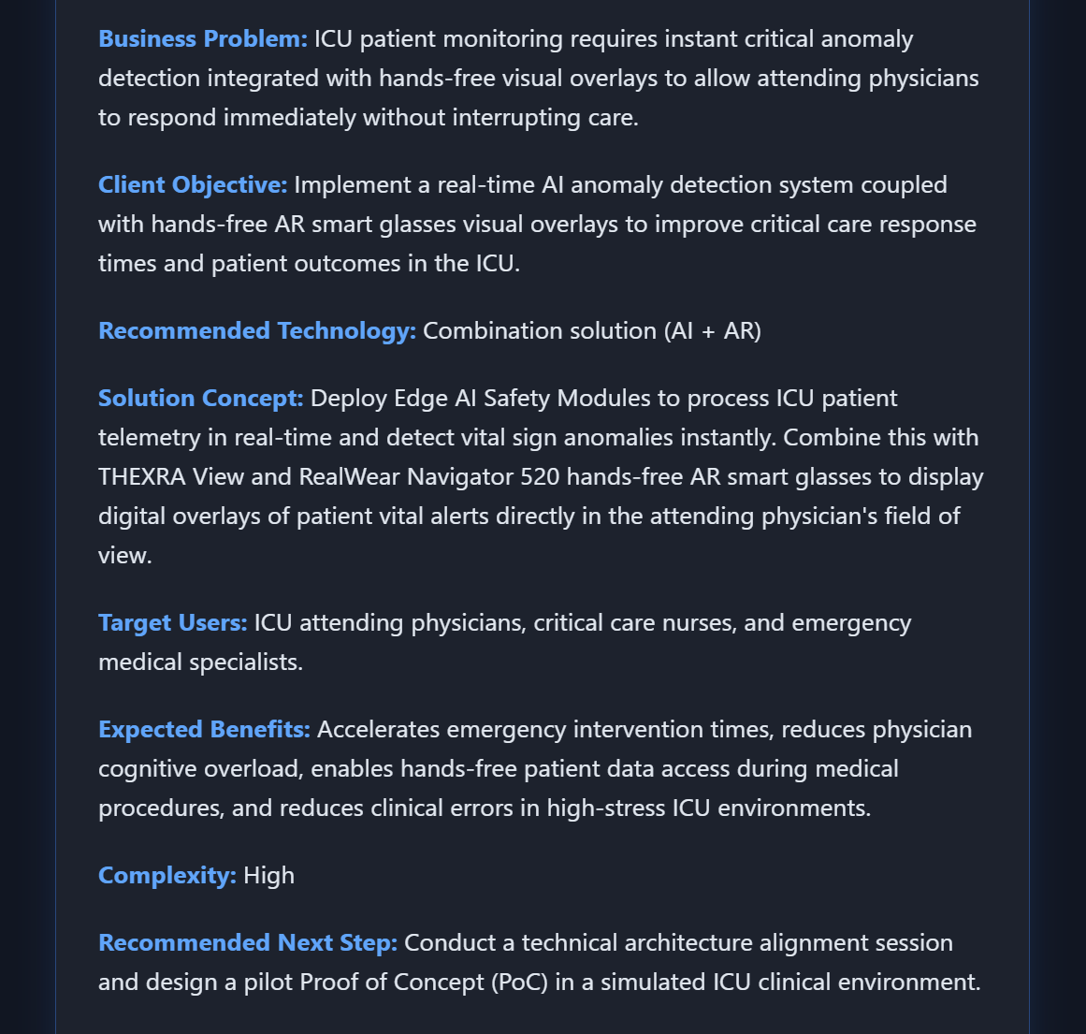

Company Name: Global Care Hospital
Industry Vertical: Healthcare
Primary Operating Location / HQ: Tokyo, Japan
Target User Count: 1,000+
Core Problem: ICU patient monitoring requires real-time AI anomaly alerts combined with hands-free AR visual overlays for attending physicians.
Target End User: ICU doctors and central monitoring team
Current Operational Process: Desktop monitors and phone calls
Desired Business Outcome / KPIs: 50% faster critical response time, automated risk alert triggers
Estimated Budget Range: $100k+
Delivery Timeline: 6 - 12 months
Existing Systems: Existing VR/AR Headsets , IoT Sensors
Special Technical Requirements: Multi-tech integration (AI risk alerts + AR hands-free doctor view)

