Test Scenario 1

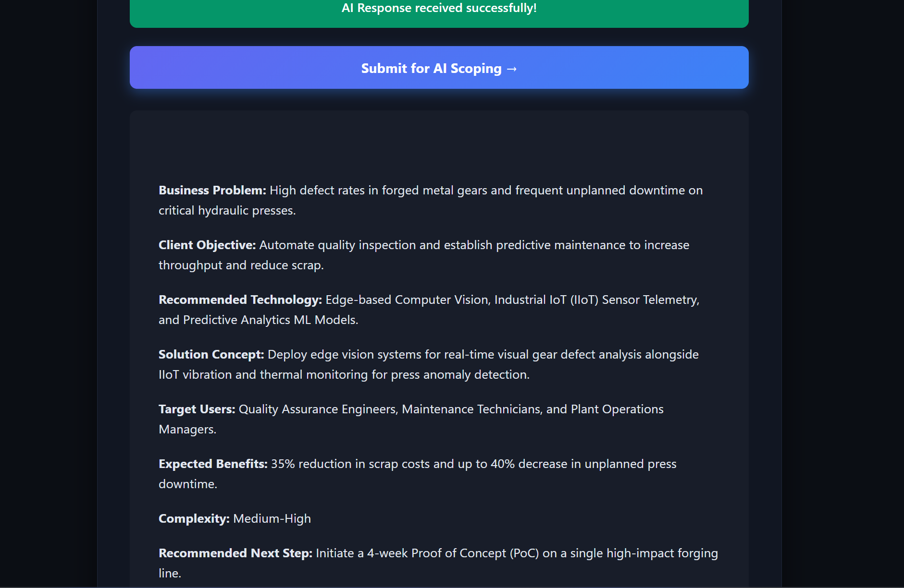

Company Name: Apex Auto Forging
Industry Vertical: Manufacturing
Primary Operating Location / HQ: Detroit, USA
Target User Count: 1-50
Core Problem: High defect rates in forged metal gears and frequent unplanned hydraulic press downtime.
Target End User: Plant Quality Engineers
Current Operational Process: Manual visual spot checks every 2 hours and post-production inspections.
Desired Business Outcome / KPIs: Reduce scrap rate by 35%.
Estimated Budget Range: $100,000+
Delivery Timeline: 6 - 12 Months
Existing Systems: CAD / BIM Models Available, IoT Sensors / Live Telemetry
Special Technical Requirements: Edge-AI computer vision, MQTT telemetry, air-gapped security.

Test Scenario 2

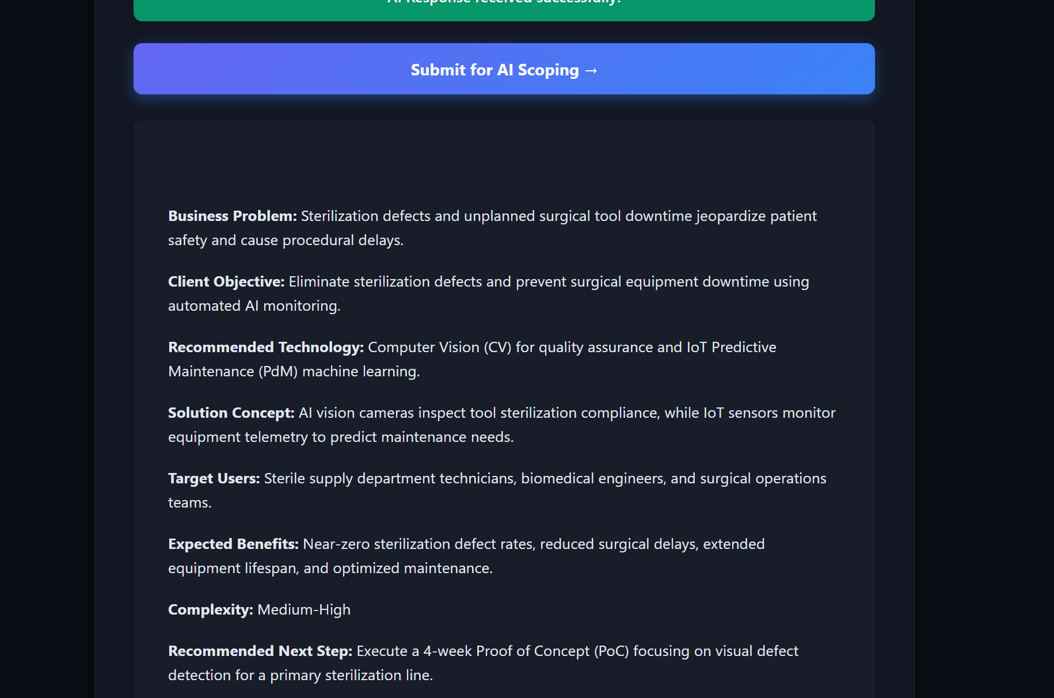

Company Name: Metro Health Systems
Industry Vertical: Healthcare
Primary Operating Location / HQ: Chicago, USA
Target User Count: 51 - 250
Core Problem: High defect rates in sterilizing medical tools and unplanned surgical equipment downtime.
Target End User: Biomedical Engineers
Current Operational Process: Manual post-sterilization audits and paper log tracking.
Desired Business Outcome / KPIs: Zero defect escapes to operating rooms; 20% downtime reduction.
Estimated Budget Range: $50,000 - $100,000
Delivery Timeline: 3 - 6 Months
Existing Systems: Enterprise LMS (Learning Mgmt), IoT Sensors / Live Telemetry
Special Technical Requirements: Edge-AI camera inspection, low-latency MQTT telemetry.

Test Scenario 3

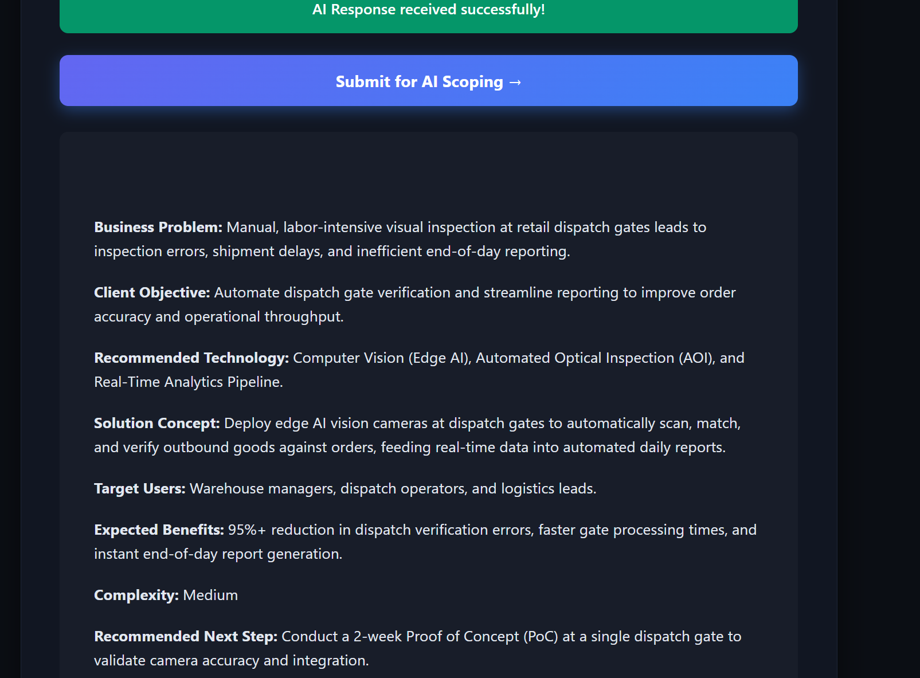

Company Name: OmniRetail Fulfillment
Industry Vertical: Retail
Primary Operating Location / HQ: Dallas, USA
Target User Count: 251 - 1000
Core Problem: Packaging defect rates on automated sorting belts and unexpected conveyor downtime.
Target End User: Warehouse Operations Leads
Current Operational Process: Manual visual checks at dispatch gates and end-of-day reports.
Desired Business Outcome / KPIs: Cut packaging scrap by 40%; keep conveyors running at 99% uptime.
Estimated Budget Range: $10,000 - $50,000
Delivery Timeline: 1 - 3 Months
Existing Systems: CAD / BIM Models Available, Existing VR/AR Headsets
Special Technical Requirements: High-speed Edge-AI vision, local MQTT pipeline, air-gapped network.

Test Scenario 4

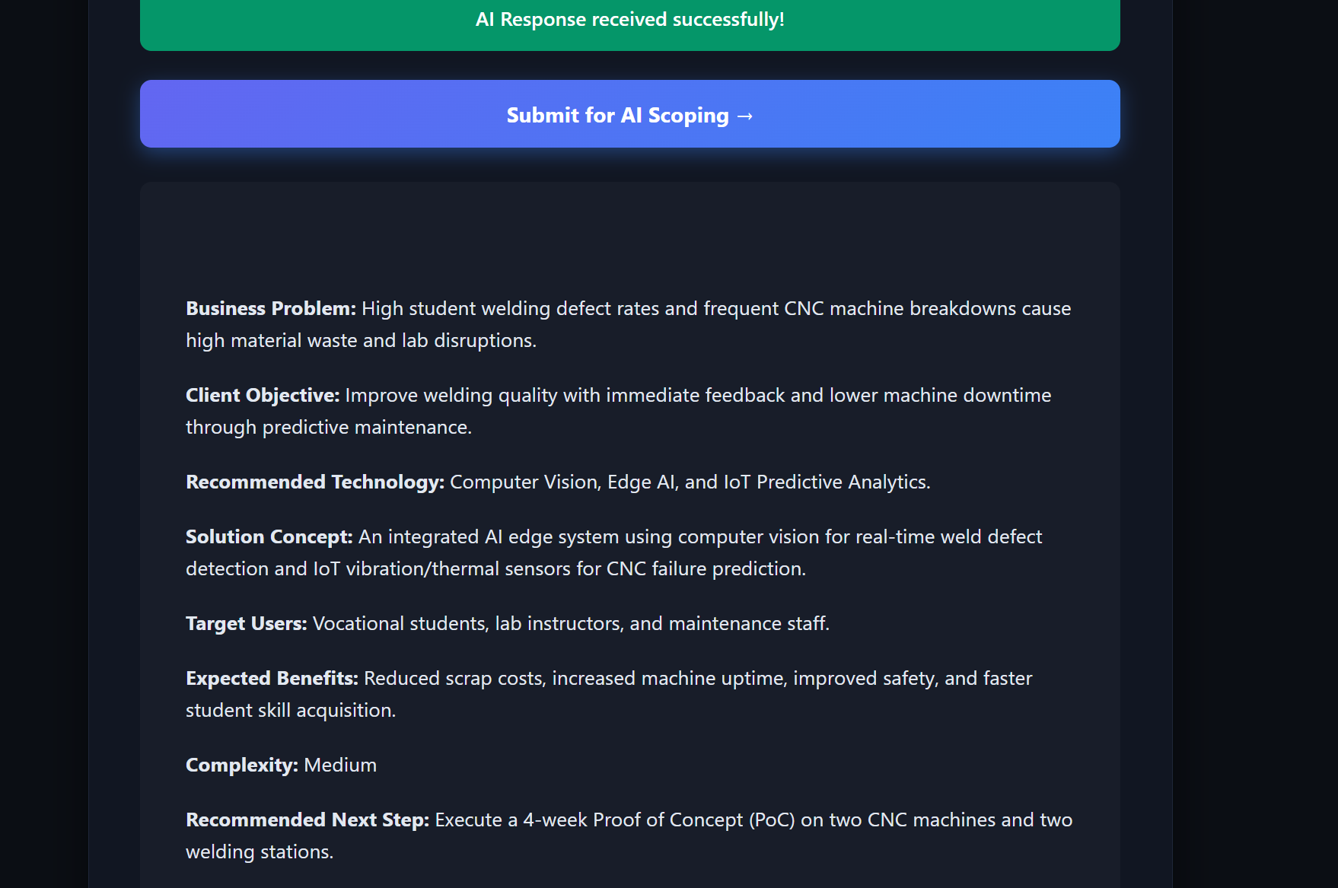

Company Name: CityTechnical Institute
Industry Vertical: Education
Primary Operating Location / HQ: Boston, USA
Target User Count: 51 - 250
Core Problem: High flaw rate in student welding lab parts and frequent CNC machine breakdowns.
Target End User: Vocational Lab Instructors & Students
Current Operational Process: Manual grading of finished lab samples after class.
Desired Business Outcome / KPIs: Provide real-time defect alerts to students; reduce machine repair costs by 30%.
Estimated Budget Range: $50,000 - $100,000
Delivery Timeline: 1 - 3 Months
Existing Systems: Enterprise LMS (Learning Mgmt), Existing VR/AR Headsets
Special Technical Requirements: None

Test Scenario 5

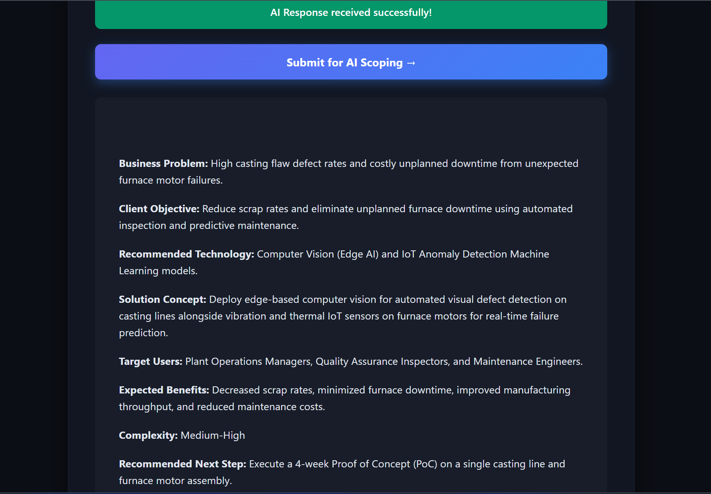

Company Name: Titan Steelworks
Industry Vertical: Manufacturing
Primary Operating Location / HQ: Milwaukee, USA
Target User Count: 1 - 50
Core Problem: High casting flaw defect rates and unexpected furnace motor failures.
Target End User: Maintenance Technicians
Current Operational Process: Weekly scheduled manual maintenance and spot checks.
Desired Business Outcome / KPIs: Cut rework time by 30%; eliminate unexpected motor breakdowns.
Estimated Budget Range: $100,000+
Delivery Timeline: 6 - 12 Months
Existing Systems: CAD / BIM Models Available, IoT Sensors / Live Telemetry
Special Technical Requirements: Ruggedized Edge-AI cameras, secure air-gapped server.

Test Scenario 6

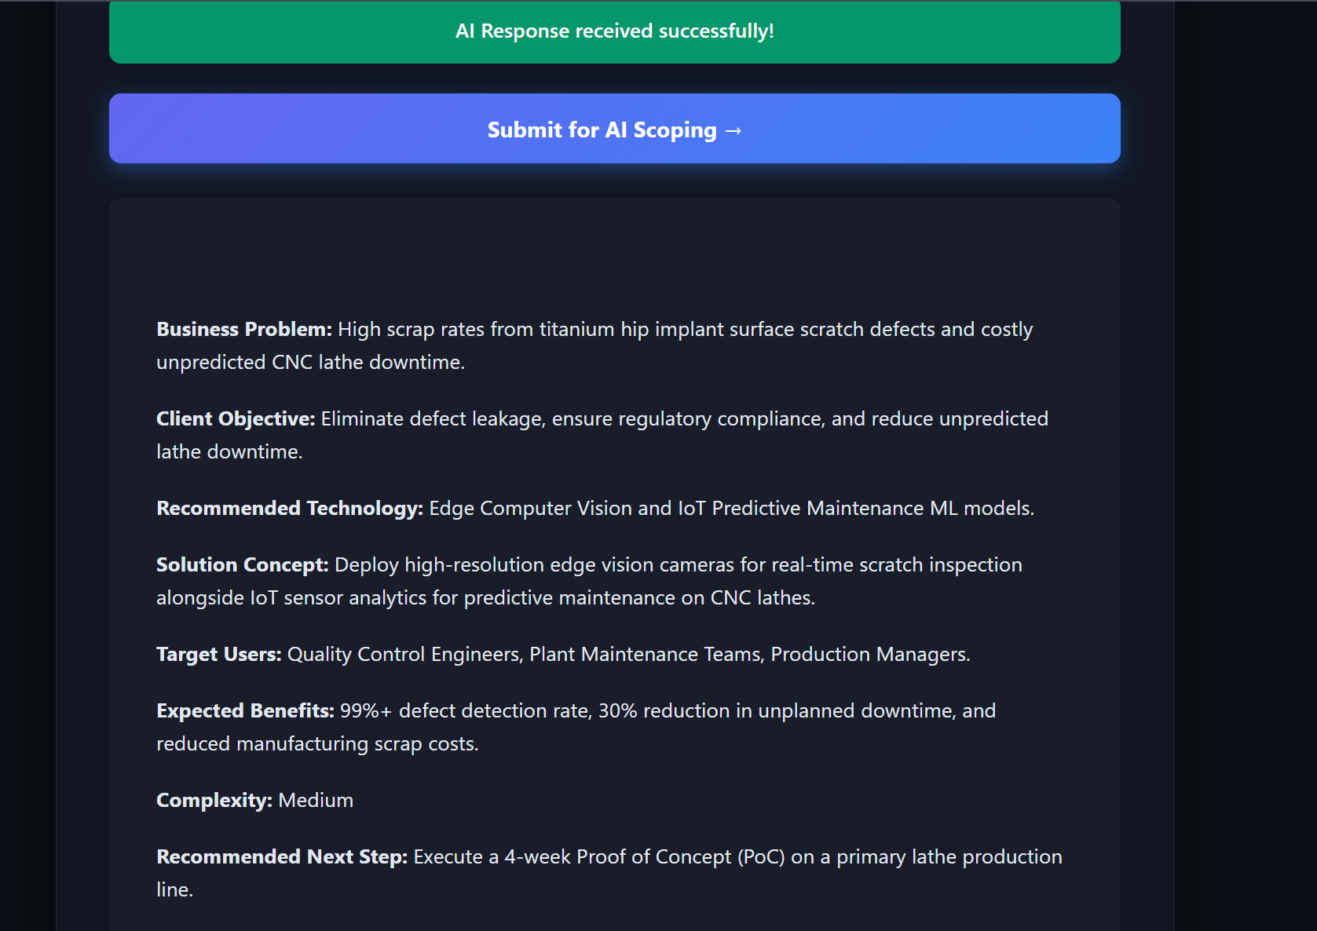

Company Name: BioMed Implant Corp
Industry Vertical: Healthcare
Primary Operating Location / HQ: Minneapolis, USA
Target User Count: 1 - 50
Core Problem: Surface scratch defects on titanium hip implants and unpredicted lathe downtime.
Target End User: Quality Assurance Specialists
Current Operational Process: Manual microscope spot inspections every 100 parts.
Desired Business Outcome / KPIs: 100% automated part inspection; predict tool failure 2 hours ahead.
Estimated Budget Range: $50,000 - $100,000
Delivery Timeline: 3 - 6 Months
Existing Systems: CAD / BIM Models Available, Enterprise LMS (Learning Mgmt)
Special Technical Requirements: Sub-millimeter Edge-AI vision, air-gapped security.

Test Scenario 7

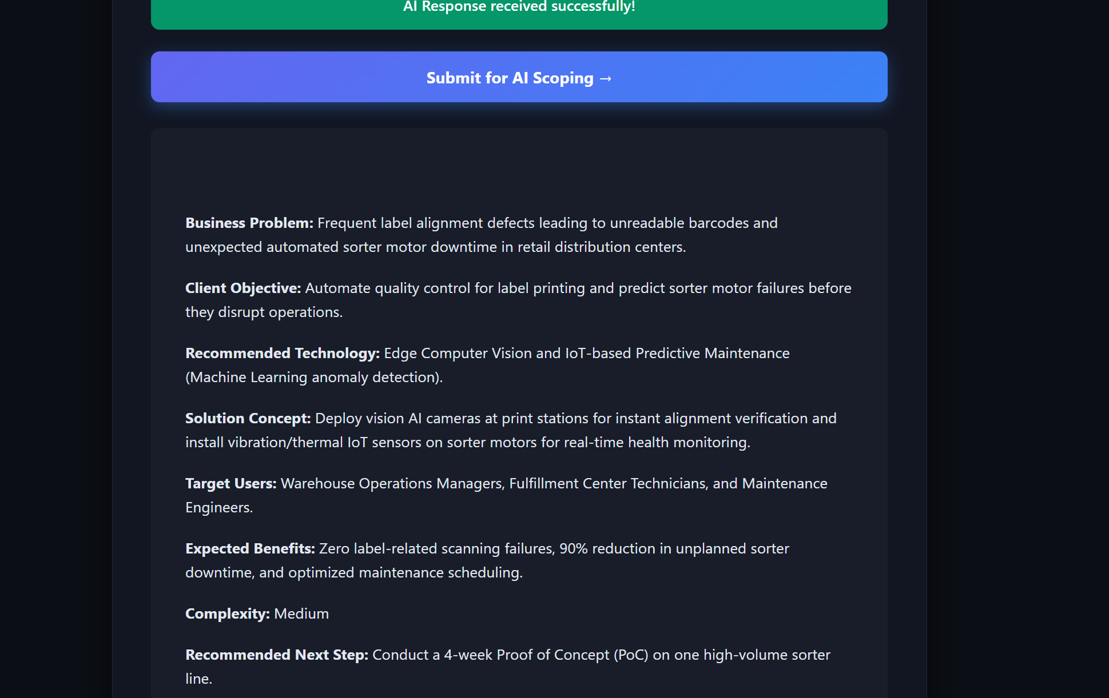

Company Name: Global Logistics Goods
Industry Vertical: Retail
Primary Operating Location / HQ: Seattle, USA
Target User Count: 1- 50
Core Problem: Label printing alignment defects and sudden automated sorter motor halts.
Target End User: Floor Shift Supervisors
Current Operational Process: Post-production batch sampling every 500 packages.
Desired Business Outcome / KPIs: Prevent unreadable barcode shipments; lower downtime by 25%.
Estimated Budget Range: $10,000 - $50,000
Delivery Timeline: 1 - 3 Months
Existing Systems: IoT Sensors / Live Telemetry
Special Technical Requirements: Edge-AI vision scanning.

Test Scenario 8

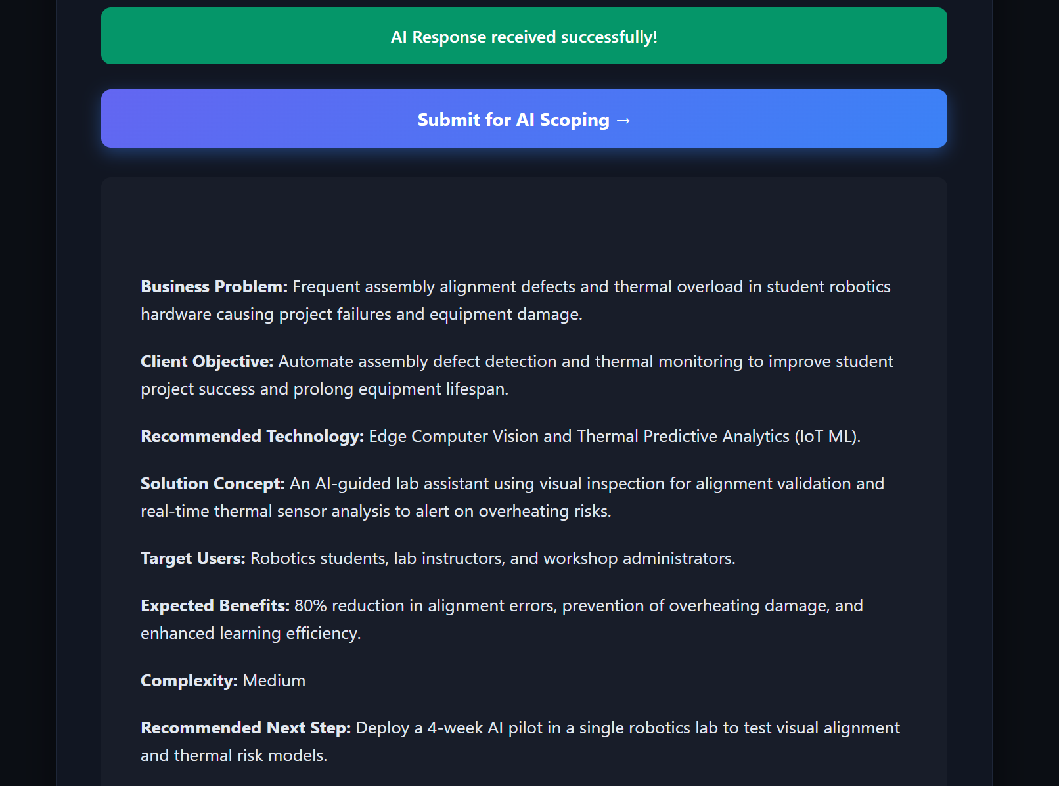

Company Name: Horizon University Labs
Industry Vertical: Education
Primary Operating Location / HQ: Austin, USA
Target User Count: 51 - 250
Core Problem: Assembly alignment defects in student robotics projects and equipment overheating.
Target End User: Engineering Faculty
Current Operational Process: Manual post-experiment review and physical inspections.
Desired Business Outcome / KPIs: Instant AI feedback on project builds; 98% lab equipment availability.
Estimated Budget Range: $50,000 - $100,000
Delivery Timeline: 3 - 6 Months
Existing Systems: Enterprise LMS (Learning Mgmt), Existing VR/AR Headsets
Special Technical Requirements: Edge-AI object identification, air-gapped internal network.

Test Scenario 9

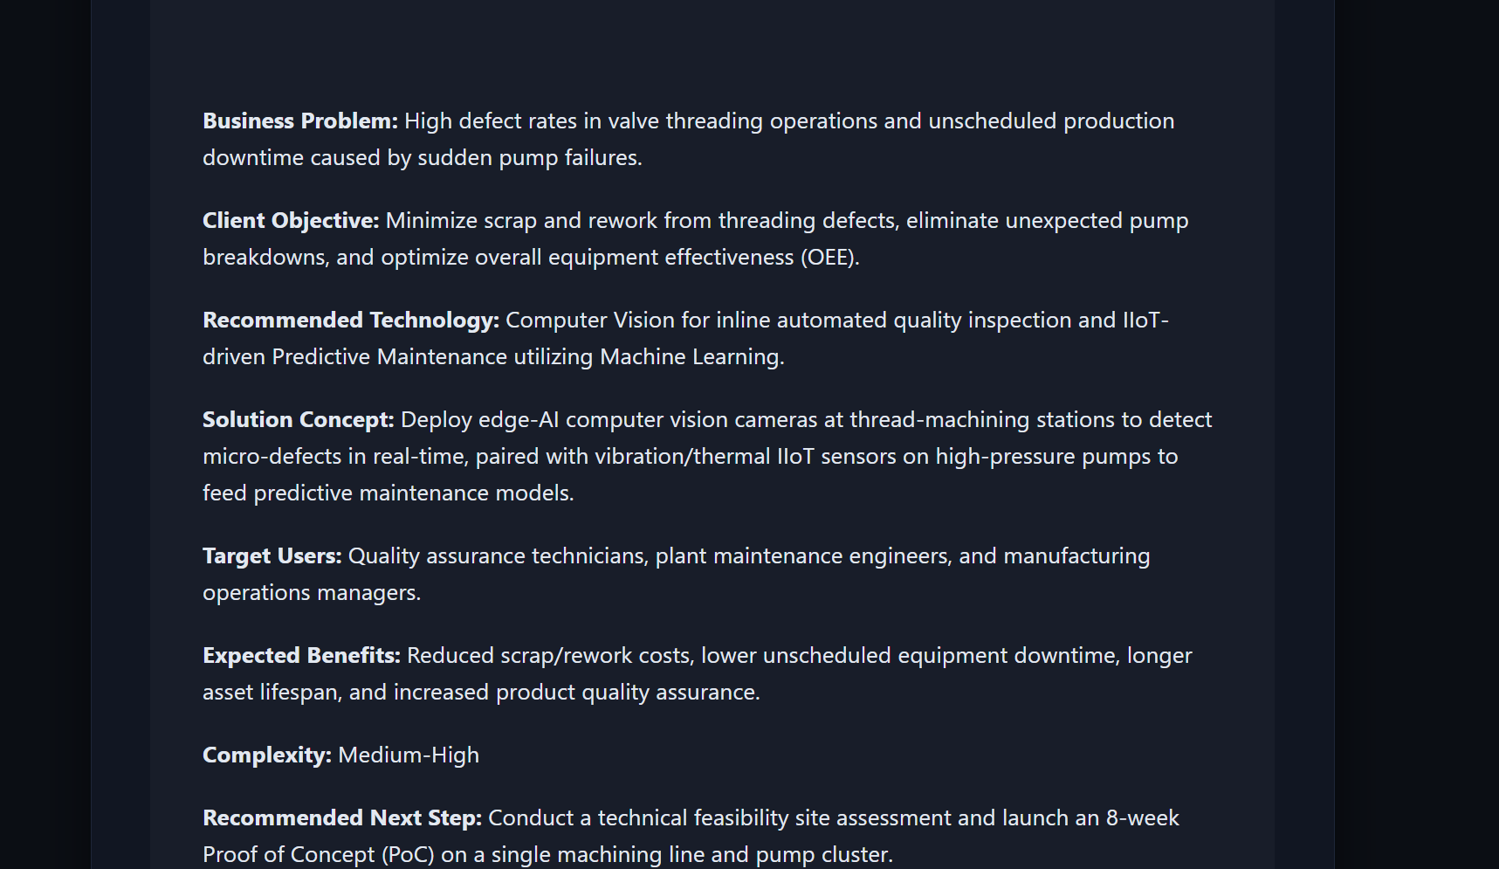

Company Name: Precision Valve Fab
Industry Vertical: Manufacturing
Primary Operating Location / HQ: Houston, USA
Target User Count: 1000+
Core Problem: Threading defect rates on high-pressure valves and sudden pump failures.
Target End User: Reliability Engineers
Current Operational Process: Manual thread calipers and hydrostatic testing.
Desired Business Outcome / KPIs: Reduce valve scrap cost by $150k/year; reach 99% uptime.
Estimated Budget Range: $100,000+
Delivery Timeline: 6 - 12 Months
Existing Systems: CAD / BIM Models Available, IoT Sensors / Live Telemetry
Special Technical Requirements: Industrial Edge-AI vision, encrypted MQTT over local broker.

Test Scenario 10

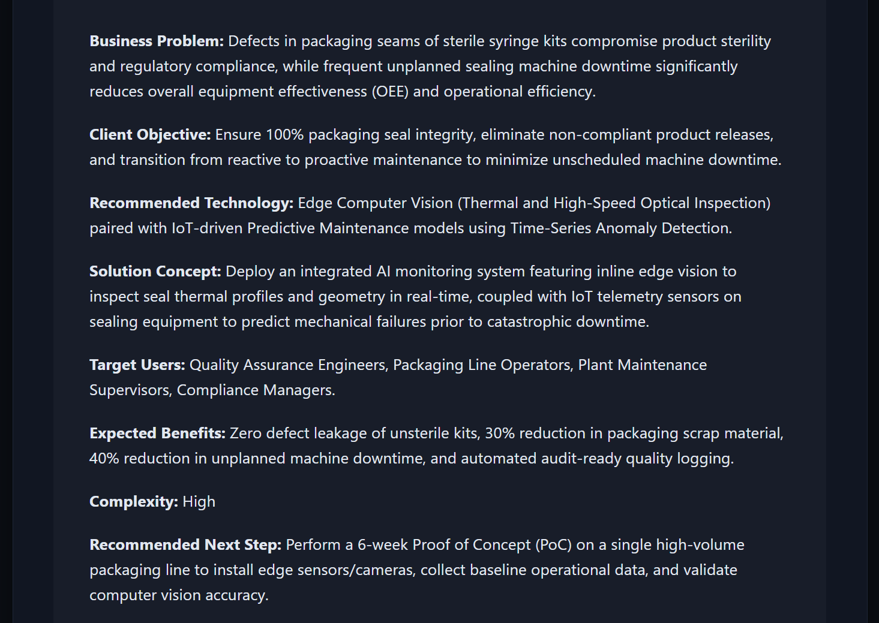

Company Name: CareTech Medical Devices
Industry Vertical: Healthcare
Primary Operating Location / HQ: San Diego, USA
Target User Count: 251 - 1000
Core Problem: Packaging seam defects in sterile syringe kits and unplanned sealing machine downtime.
Target End User: Cleanroom Production Leads
Current Operational Process: Manual visual inspection under UV light.
Desired Business Outcome / KPIs: Achieve 100% sterile seal verification; zero unplanned line halts.
Estimated Budget Range: $50,000 - $100,000
Delivery Timeline: 1- 3 Months
Existing Systems: Enterprise LMS (Learning Mgmt), IoT Sensors / Live Telemetry
Special Technical Requirements: High-speed Edge-AI vision, strict air-gapped deployment.

