Test Input Used

- Company Name: SurgicalHealth Innovations
- Industry Vertical: Healthcare
- Primary Operating Location / HQ: Boston, USA
- Target User Count: 51-250
- Core Problem: High cost and physical risk associated with training resident surgeons on complex spinal fusion procedures using cadavers.
- Target End User: Surgical Residents & Neurosurgeons
- Current Operational Process: Supervised physical observation in operating rooms and cadaver lab dissections.
- Desired Business Outcome / KPIs: Reduce training costs by 60% and improve surgical accuracy scores by 35% within 6 months.
- Estimated Budget Range: $100,000+
- Delivery Timeline: 3 - 6 Months
- Existing Systems: CAD / BIM Models Available, LMS enterprise
- Special Technical Requirements: Haptic feedback integration and multi-user surgical collaboration.

System Screenshots
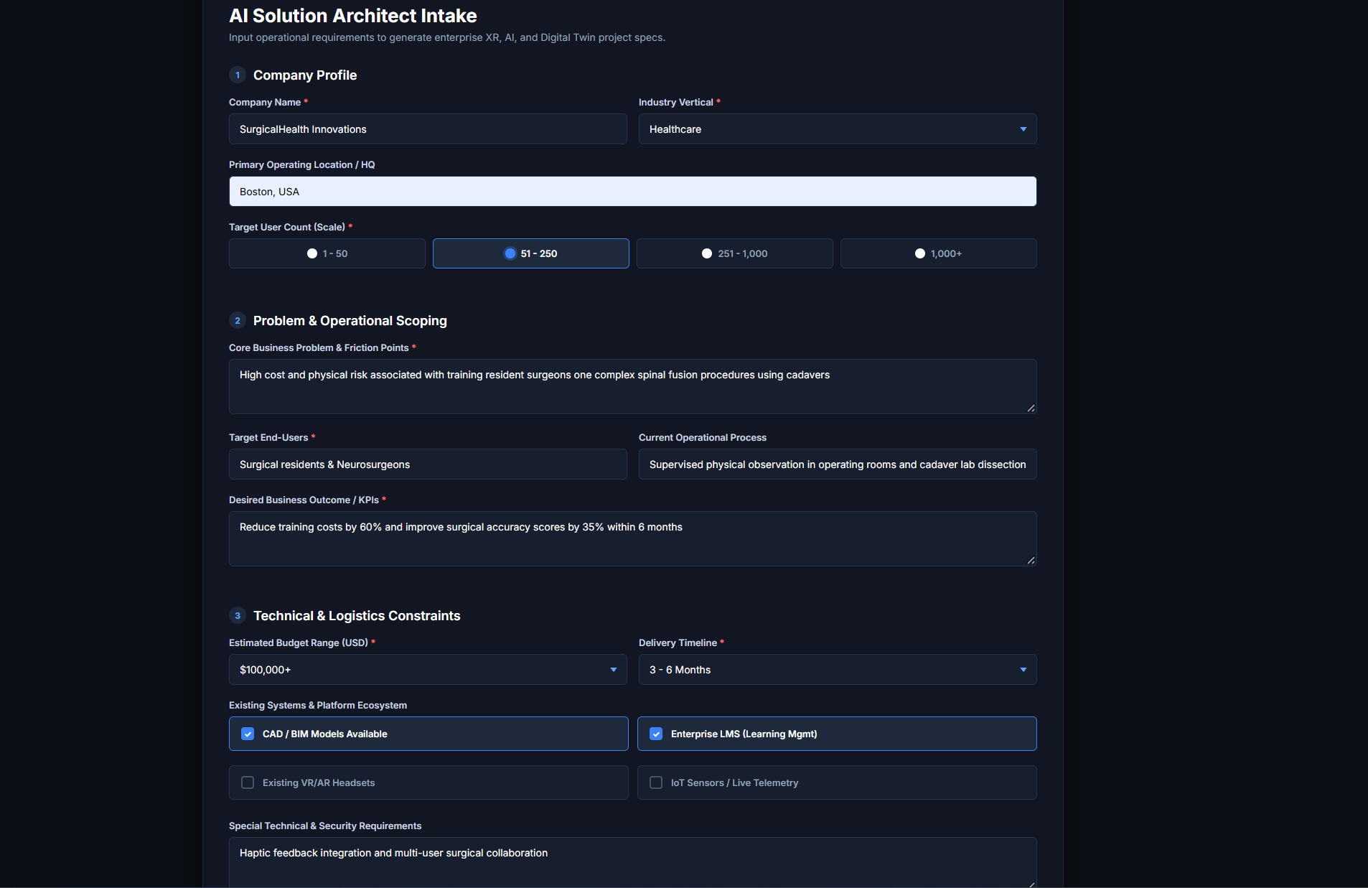
Image 1: Intake Form Requirements

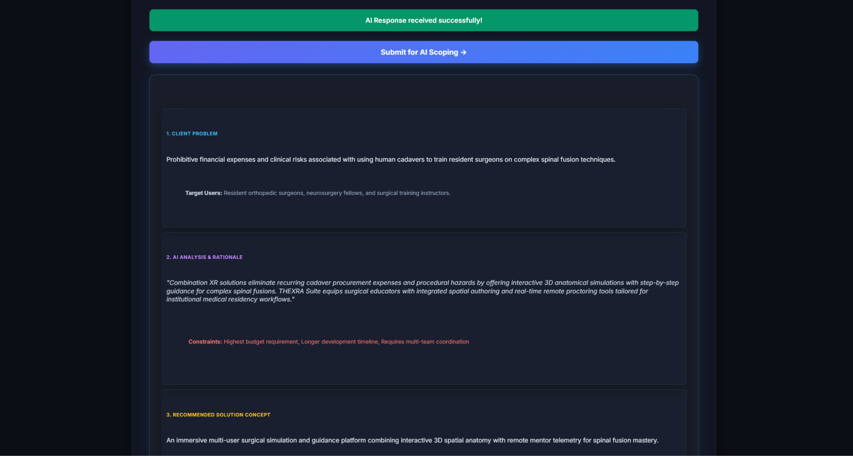
Image 2: Client Problem & AI Analysis
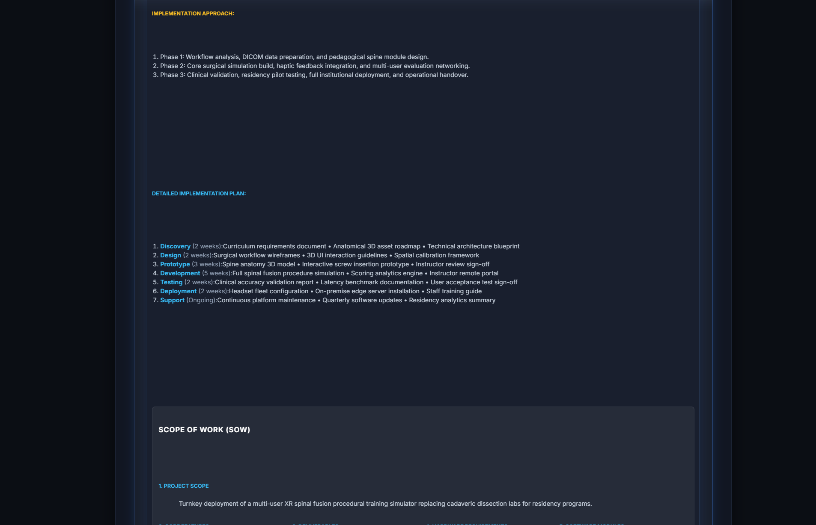
Image 3: Implementation Approach & SOW

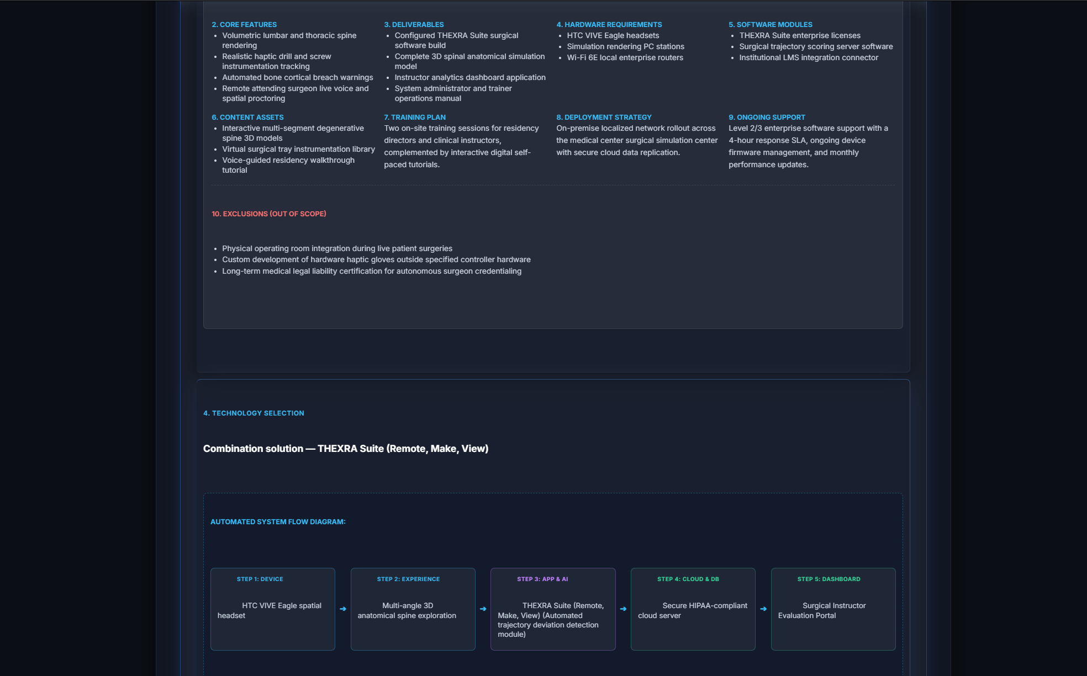
Image 4: Architecture Selection & System Flow Diagram
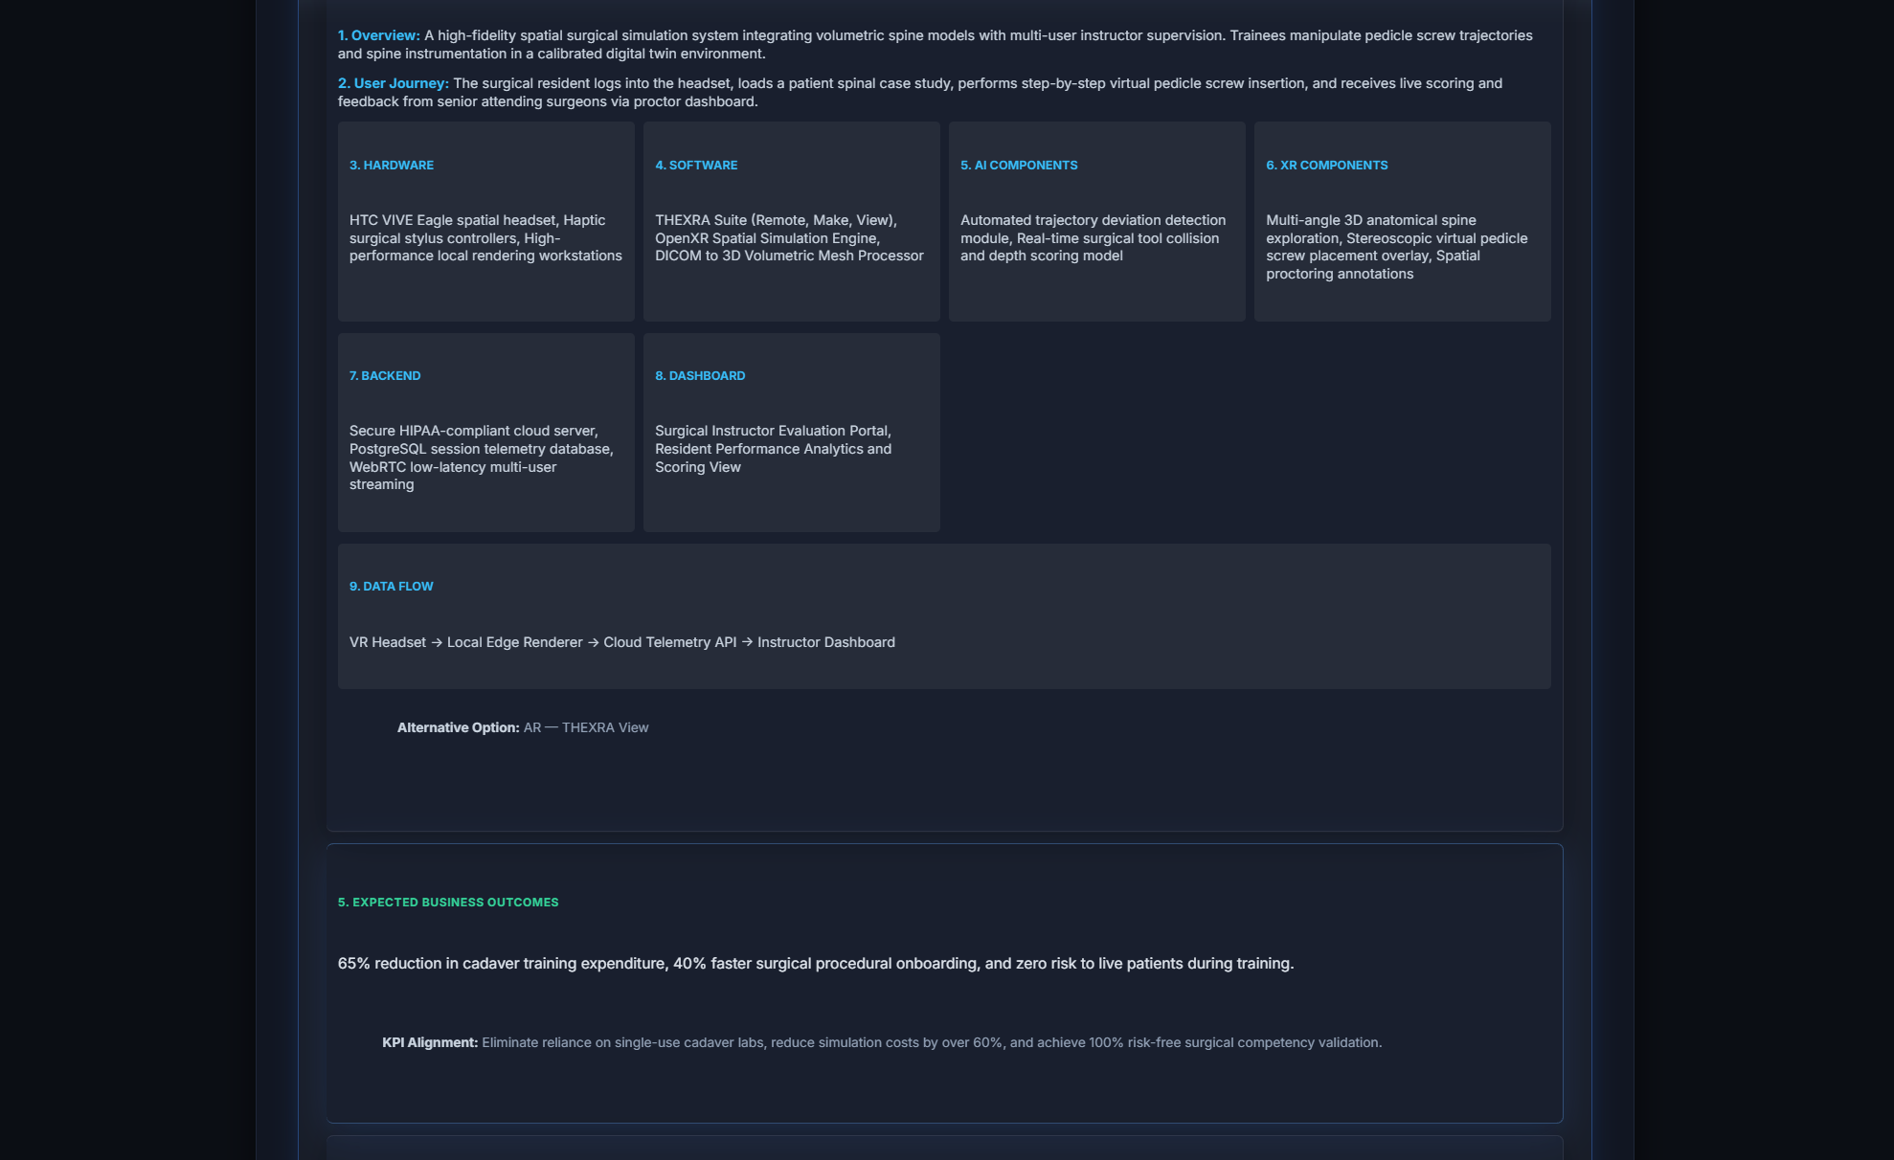
Image 5: Blueprint Details & Business Outcomes

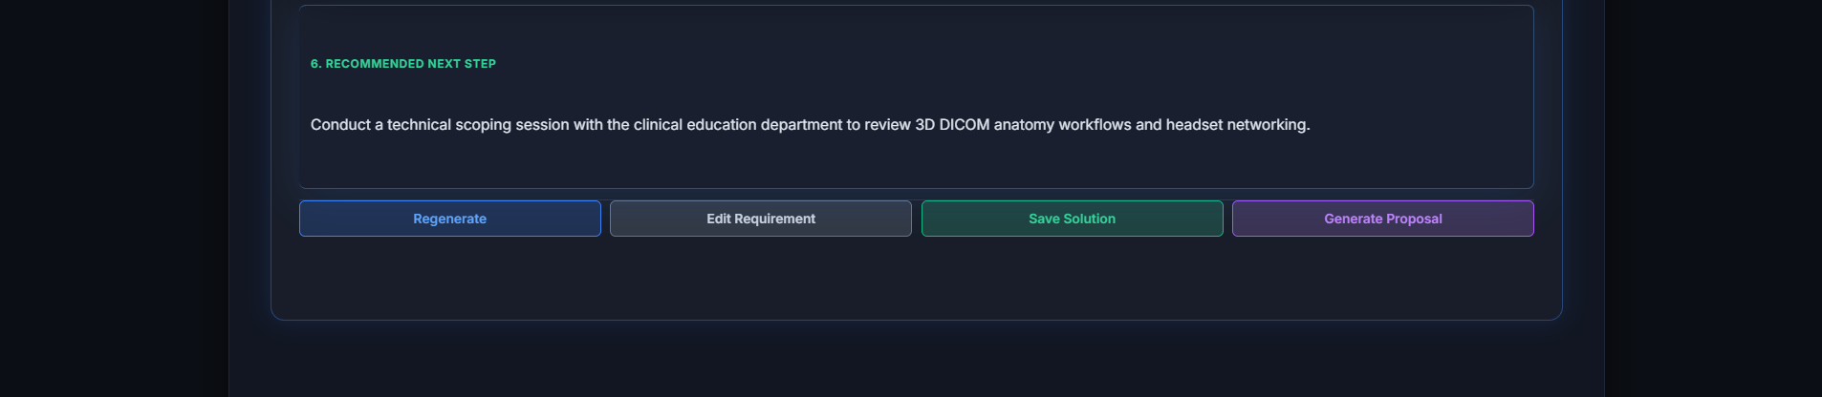
Image 6: Action Bar Controls & Footer

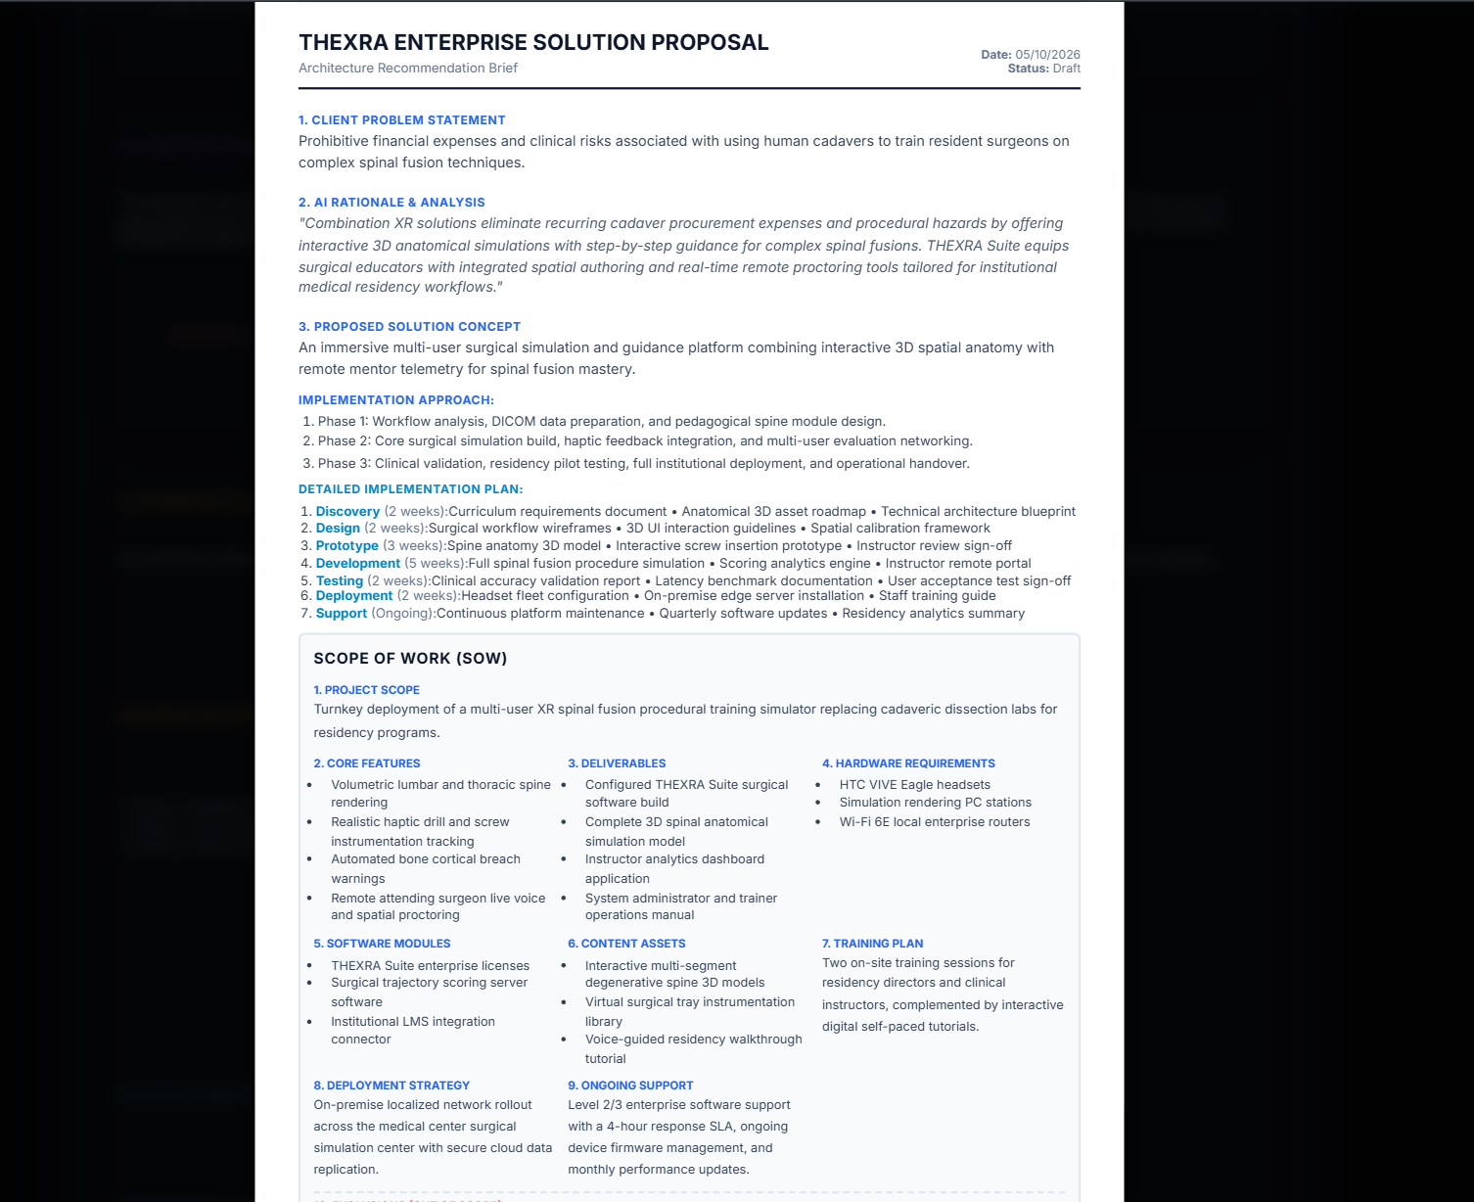
Image 7: Proposal Preview Modal

