Screenshots Day 19


Image 1: Header

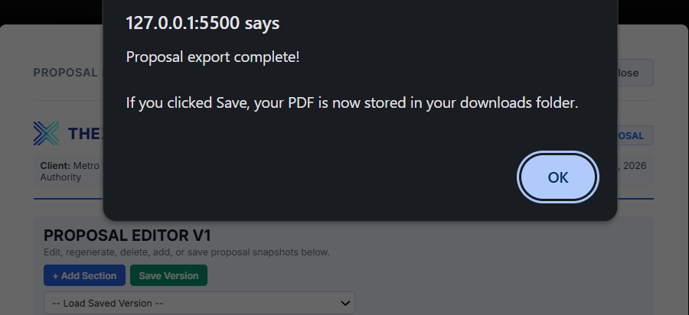
Image 2: Pop up after save PDF

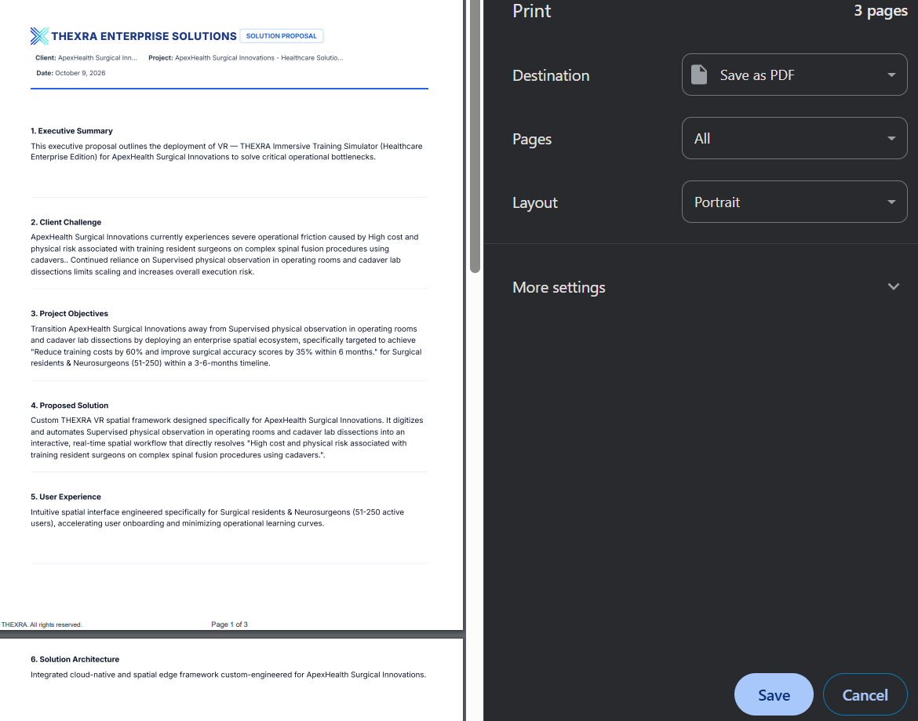
Image 3: Copyright and Page Counters Bottom-Page

