IP Addressing and CIDR

In the vast expanse of the internet, every device requires a unique identifier to communicate with others. This identifier is known as an IP address, and for many years, the prevalent version has been IPv4 (Internet Protocol version 4). IPv4 addresses are 32-bit numbers represented in a dotted-decimal format, such as 192.168.1.100. To effectively manage and distribute these addresses, a system called Classless Inter-Domain Routing (CIDR) was introduced.

**IPv4 Address Structure:-**

An IPv4 address is divided into four octets, each represented by a decimal number ranging from 0 to 255. These octets are separated by periods, creating a familiar dotted-decimal notation. The first three octets identify the network, while the fourth octet identifies the specific host device within that network.

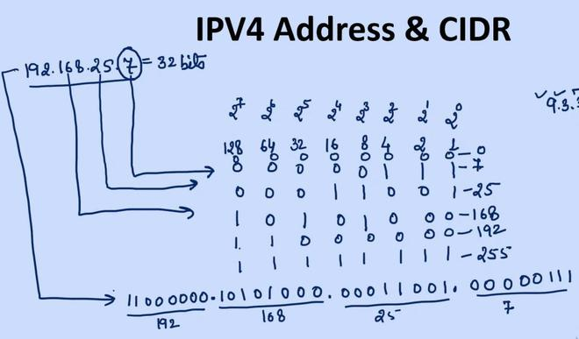

**Classless Inter-Domain Routing (CIDR):-**

Classless Inter-Domain Routing (CIDR) is an IP addressing scheme that improves the efficiency of address distribution and routing on the internet. It was introduced in 1993 to address the limitations of the previous classful addressing system, which was becoming increasingly inefficient as the internet grew.

**Key Features of CIDR**

Variable-Length Subnet Masking (VLSM): CIDR allows network administrators to create subnets of varying sizes, rather than being restricted to the rigid class-based addressing scheme. This enables more granular control over address allocation and reduces the waste of IP addresses.

* Supernetting: CIDR enables the aggregation of multiple subnets into larger blocks, resulting in more efficient routing and reduced routing table entries. This is particularly beneficial for large networks that have multiple smaller subnets.
* Route Summarization: CIDR facilitates the summarization of routing information, reducing the number of entries in routing tables and improving routing efficiency. This is particularly important for internet backbone routers, which handle a vast amount of traffic.

**Benefits of CIDR**

* Improved IP Address Efficiency: CIDR helps to optimize the allocation of IP addresses, reducing the waste of addresses and extending the lifespan of the IPv4 address space.
* Reduced Routing Table Size: CIDR-based routing tables are smaller and more manageable, simplifying routing operations and improving network performance.
* Seamless Network Scalability: CIDR-based networks can easily accommodate growth and changes in network topology, ensuring smooth scaling and adaptability.

**CIDR Notation:-**

CIDR emerged as a more flexible and efficient way to manage IP addresses compared to the older classful addressing scheme. Instead of assigning addresses based on rigid class boundaries, CIDR allows for the creation of subnets, which are smaller divisions within a network. Each subnet has its own unique prefix length, represented by a number following a slash in the CIDR notation. For instance, 192.168.1.0/24 indicates a subnet with a prefix length of 24, meaning that the first 24 bits are dedicated to the network address and the remaining 8 bits are for host addresses. CIDR notation simplifies the representation of subnets and makes it easier to manage and identify different network segments.

Example 1. What is the maximum number of usable host addresses in this subnet and how many network bits are there in this subnet?

**Subnet:**192.168.1.0/24

**Given:-**

IP address:192.168.1.0

Prefix length: 24

**Calculation:**

Convert the IP address to binary format:

192.168.1.0 = 11000000.10101000.00000001.00000000

Separate the network bits from the host bits based on the prefix length:

Network bits: 11000000.10101000.00000001

Host bits: 00000000

Determine the number of usable host addresses:

2^host bits - 2 = 2^8 - 2 = 254

**Result:**

The subnet 192.168.1.0/24 has a network address of 192.168.1.0 and a broadcast address of 192.168.1.255. There are 254 usable host addresses in this subnet.

**Example 2.** What is the maximum number of usable host addresses in this subnet?

**Subnet:** 192.168.0.0/16

**Given:-**

IP address: 192.168.1.0

Prefix length: 24

**Calculation:**

Convert the IP address to binary format:

192.168.0.0 = 11000000.10101000.00000000.00000000

Separate the network bits from the host bits based on the prefix length:

Network bits: 11000000.10101000

Host bits: 00000000.00000000

Determine the number of usable host addresses:

2^host bits - 2 = 2^16 - 2 = 65534

**Result:**

The subnet 192.168.0.0/16 has a network address of 192.168.0.0 and a broadcast address of 192.168.255.255. There are 65534 usable host addresses in this subnet.

Virtual Private Clouds in AWS

In the ever-evolving landscape of cloud computing, Virtual Private Clouds (VPCs) play a crucial role in providing a secure and isolated environment for organizations to deploy their applications and services. Amazon Web Services (AWS), one of the leading cloud service providers, offers a robust VPC service that allows users to create their own virtual network in the cloud. This article explores the concept of VPCs in AWS, their benefits, and the key features that make them an integral part of modern cloud architecture.

## Understanding Virtual Private Cloud (VPC)

A Virtual Private Cloud is a logically isolated section of the AWS Cloud where users can launch AWS resources in a virtual network that they define. This virtual network closely resembles a traditional network that you might operate in your own data center, with the benefits of using AWS's scalable infrastructure.

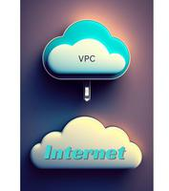Fig. 1

### Key components of AWS VPC include:

**Subnets:** VPCs are divided into subnets, each associated with an Availability Zone (AZ). Subnets provide a way to partition the network within the VPC. In the realm of computer networking, subnets play a pivotal role in organizing and managing IP addresses within a network. A subnet, short for sub-network, is a logical subdivision of an IP network.

In the context of Internet Protocol (IP) addressing, a subnet is a range of IP addresses within the larger address space of an organization's network. The primary purpose of dividing a network into subnets is to improve its efficiency and security. By organizing IP addresses into smaller, more manageable segments, network administrators can enhance performance, simplify management, and implement security measures more effectively.

**Let's consider a practical example to illustrate the concept of subnetting:**

Suppose an organization has the IP address range 192.168.1.0 with a subnet mask of 255.255.255.0. This organization might decide to create subnets with the following configurations:

* Subnet 1: 192.168.1.0 to 192.168.1.63
* Subnet 2: 192.168.1.64 to 192.168.1.127
* Subnet 3: 192.168.1.128 to 192.168.1.191
* Subnet 4: 192.168.1.192 to 192.168.1.255

Each subnet can then be assigned to a specific department, floor, or function within the organization. Devices within the same subnet share the same network address and can communicate directly with each other without the need for routing.

**Internet Gateway:**An Internet Gateway allows resources within a VPC to connect to the internet and vice versa or we can say an Internet Gateway serves as the entry and exit point for data traffic between a private network, such as a corporate intranet or a cloud-based Virtual Private Cloud (VPC), and the public Internet. Functioning as a bridge between the private and public realms, the Internet Gateway facilitates bidirectional communication, enabling users within the private network to access resources on the Internet and vice versa.

**The Journey of Data through an Internet Gateway**

Understanding the flow of data through an Internet Gateway provides insights into its crucial role in network communication:

Outbound Communication:-When a device within the private network initiates communication with an external server on the Internet, the data passes through the Internet Gateway. The Internet Gateway performs NAT, assigning the communication a public IP address and forwarding the data to the destination server on the Internet.

Inbound Communication:-External entities on the Internet seeking to communicate with devices within the private network send data to the public IP address associated with the Internet Gateway. The Internet Gateway, based on its routing and firewall rules, directs the incoming data to the appropriate device within the private network.

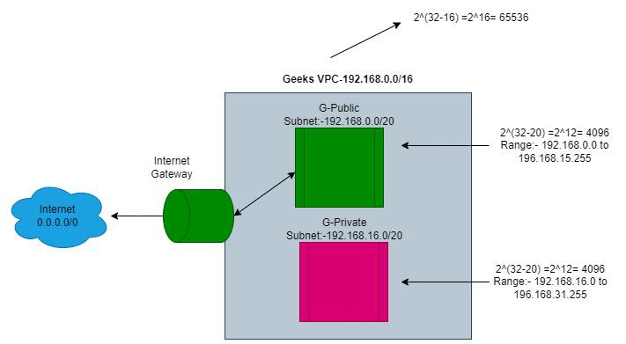Fig. 2 Internet Gateway

**Route Tables:** These define rules for routing network traffic between subnets. Each subnet in a VPC must be associated with a route table, which controls the traffic between subnets.

**The Essence of Route Tables in VPCs** :

At its core, a Route Table is a set of rules, known as routes, that are used to determine where network traffic is directed. In the context of VPCs, a Route Table is associated with a specific subnet and serves as a roadmap for data traveling within the virtual network.

**Key attributes and functionalities of Route Tables in VPCs include:**

* Subnet Association: Each subnet within a VPC is associated with a specific Route Table. This association defines the routing behavior for the traffic within that subnet.
* Default and Custom Route Tables: When a VPC is created, a default main Route Table is automatically associated with it. This main table applies to all subnets that are not explicitly associated with a custom Route Table. Organizations can create custom Route Tables to tailor routing configurations for specific subnets.
* Routing Entries: Route Tables consist of routing entries that define the destination of network traffic. Each entry specifies a destination (CIDR block) and the target (e.g., an Internet Gateway, a Virtual Private Gateway, or a specific instance).
* Local Route: A special local route is automatically included in every Route Table. This local route ensures that traffic destined for other instances within the same VPC is directed appropriately without leaving the VPC.
* Internet Gateway Routes: To enable communication between instances in a subnet and the Internet, a Route Table associated with a public subnet typically includes a route to an Internet Gateway. This allows instances to send and receive traffic from the public Internet.
* Route Propagation: Some AWS services, such as Virtual Private Gateways and VPN connections, support route propagation. When route propagation is enabled, the associated Route Table is updated automatically with routes learned from these services.

**Security Groups:** Security groups act as virtual firewalls for your instances to control inbound and outbound traffic. They are stateful, which means if you allow outbound traffic, the corresponding inbound traffic is automatically allowed.

**Network Access Control Lists (NACLs):** NACLs act as stateless network firewalls and operate at the subnet level. They allow or deny traffic based on rules defined for each subnet.

### Benefits of AWS VPC

1. **Isolation and Security:** VPCs provide a secure environment by allowing users to define their network topology and control traffic flow. With the use of security groups and NACLs, users have granular control over inbound and outbound traffic, enhancing the overall security posture.
2. **Scalability:** AWS VPCs are designed to scale horizontally, allowing organizations to expand their infrastructure seamlessly. Users can add or remove resources within the VPC based on their requirements, ensuring that the architecture grows with the business.
3. **Customization:** VPCs offer a high degree of customization, enabling users to define their IP address range, create subnets, and configure route tables. This flexibility allows organizations to tailor the VPC to meet specific application and business needs.
4. **Connectivity Options:** AWS VPCs provide multiple connectivity options, including Virtual Private Network (VPN) connections, AWS Direct Connect, and VPC Peering. These options allow users to establish secure connections between their on-premises data centers and AWS, creating a hybrid cloud architecture.
5. **Cost Management:** By using VPCs, organizations can optimize costs by paying only for the resources they consume. Additionally, the scalability of VPCs ensures that resources can be adjusted as needed, preventing over-provisioning.

### Key Features of AWS VPC

* VPC Peering: VPC peering allows users to connect one VPC with another, enabling the transfer of traffic between them using private IP addresses. This feature simplifies the network architecture and facilitates resource sharing between different VPCs.
* Transit Gateway: Transit Gateway is a highly scalable service that allows users to connect multiple VPCs and on-premises networks together. It simplifies network architecture and provides a centralized hub for connectivity.
* Elastic Load Balancing (ELB): ELB distributes incoming application traffic across multiple targets, such as Amazon EC2 instances, in multiple Availability Zones. This ensures high availability and fault tolerance for applications hosted within a VPC.
* AWS PrivateLink: AWS PrivateLink enables users to access services over a private connection, avoiding exposure to the public internet. This is particularly useful for accessing AWS services like Amazon S3 or Amazon DynamoDB securely.
* AWS VPN: AWS VPN provides a secure and scalable solution for connecting on-premises networks with AWS. It supports both site-to-site and client VPN connectivity, allowing organizations to extend their network seamlessly.

AWS Virtual Private Clouds serve as the backbone for building scalable, secure, and highly available cloud architectures. By leveraging the features and benefits of AWS VPCs, organizations can design and deploy applications with confidence, knowing that they have the tools and capabilities to meet their specific requirements. As cloud computing continues to evolve, VPCs remain a fundamental component for achieving a balance between flexibility, security, and scalability in the cloud.

VPC Security

In the rapidly evolving landscape of cloud computing, Virtual Private Clouds (VPCs) have become indispensable for organizations seeking scalable and flexible infrastructure solutions. VPCs offer a secure and isolated environment within the cloud, allowing businesses to build and deploy applications with confidence. However, the security of a VPC is paramount to safeguarding sensitive data and ensuring the smooth operation of critical systems. In this article, we'll delve into the key aspects of VPC security.

## Understanding Virtual Private Clouds (VPCs):

A VPC is a logically isolated section of the cloud where you can launch resources in a virtual network. It allows you to define your network architecture, control your IP address range, and configure route tables and gateways. While cloud service providers like AWS, Azure, and Google Cloud provide the infrastructure, it's the responsibility of the user to implement robust security measures within their VPC.

### Key Components of VPC Security:

1. Network Access Control Lists (NACLs): NACLs act as a firewall for controlling traffic in and out of subnets. They operate at the subnet level and are stateless, meaning that you must define rules for both inbound and outbound traffic. Regularly review and audit NACL rules to ensure they align with your security policies.
2. Security Groups: Security Groups are stateful firewalls that control inbound and outbound traffic at the instance level. Unlike NACLs, Security Groups automatically allow return traffic, simplifying rule configuration. Apply the principle of least privilege when configuring Security Groups to minimize the attack surface.
3. Subnet Isolation: Divide your VPC into subnets to segment workloads based on their function and security requirements. Critical components, such as databases and application servers, should reside in separate subnets. Use route tables to control traffic flow between subnets and enforce access policies.

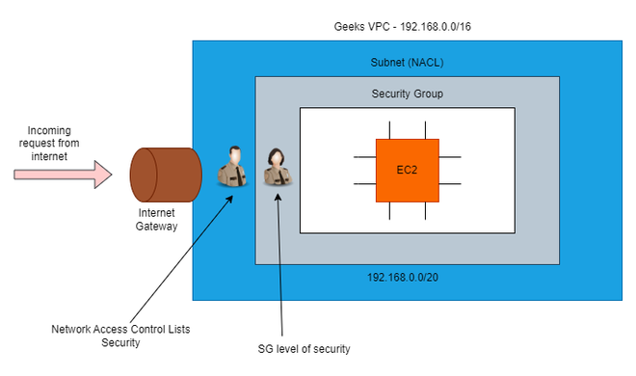Fig. 1

### Data Encryption:

* In-Transit Encryption: Encrypt data transmitted between resources using protocols like SSL/TLS. Enable encryption for data in transit by implementing Virtual Private Network (VPN) connections or Direct Connect.
* At-Rest Encryption: Implement encryption for data at rest using services like AWS Key Management Service (KMS) or Azure Key Vault. Encrypting data at rest provides an additional layer of protection, especially for sensitive information stored in databases or on disk.

### Identity and Access Management (IAM):

* Role-Based Access Control (RBAC): Leverage IAM services to manage user access to resources within the VPC. Implement RBAC to assign permissions based on job roles, ensuring that users have the necessary privileges without unnecessary access.
* Multi-Factor Authentication (MFA): Enable MFA for user accounts to add an extra layer of security. This helps mitigate the risk of unauthorized access, even if login credentials are compromised.

### Logging and Monitoring:

* CloudWatch Logs: Enable logging for VPC components and regularly review logs for suspicious activities. Set up alerts to notify administrators of potential security incidents.
* VPC Flow Logs: Activate VPC Flow Logs to capture information about IP traffic flowing into and out of network interfaces. Analyze these logs to identify and respond to potential security threats.

### Regular Audits and Reviews:

Conduct periodic security audits to assess the effectiveness of your VPC security measures. Stay informed about the latest security best practices and update your configurations accordingly.

## Network Access Control Lists (NACLs):

Network Access Control Lists (NACLs) play a crucial role in securing your Amazon Web Services (AWS) infrastructure by controlling inbound and outbound traffic to and from your virtual private cloud (VPC). NACLs act as a barrier between your VPC and the internet, allowing you to define rules that permit or deny traffic based on source and destination IP addresses and ports. It operate as stateless firewalls at the subnet level within a VPC. Stateless means that the rules for inbound and outbound traffic must be explicitly defined, and each rule applies to traffic in one direction. NACLs control traffic by evaluating rules based on source and destination IP addresses, ports, and protocols. Rules are processed in order, with the first rule that matches the traffic being applied. This makes it crucial to structure rules carefully to avoid unintended consequences.

### Key Features of NACLs:

* **Rule Structure:**NACLs consist of rules defined by a rule number, allowing for easy management and priority assignment. Each rule specifies a range of IP addresses, a protocol (TCP, UDP, or ICMP), and a rule action (allow or deny).
* **Stateless Nature:** NACLs are stateless, meaning that responses to allowed inbound traffic are not automatically allowed for outbound traffic. For example, if you allow inbound traffic on port 80, you must also explicitly allow outbound traffic on port 80 for responses to be permitted.
* **Rule Evaluation Order:** Rule evaluation is sequential and follows the rule number order. AWS evaluates rules in the NACL from the lowest rule number to the highest until it finds a rule that matches the traffic.
* **Numbering System:**NACLs use rule numbers to prioritize rules. It's essential to understand that rule numbers must be unique within a NACL, and there can be gaps in the numbering. When a rule is deleted, AWS does not automatically renumber the remaining rules.
* **Controlling Inbound and Outbound Traffic:** By defining rules for both inbound and outbound traffic, AWS NACLs allow organizations to implement specific access controls, limiting exposure to potential security threats.
* **Protecting Sensitive Resources:**NACLs play a crucial role in protecting sensitive resources by restricting access to authorized IP addresses and preventing unauthorized communication.

Network Access Control Lists are a vital component of AWS VPC security, providing granular control over inbound and outbound traffic. By following best practices and understanding the nuances of NACLs, you can create a robust security posture for your AWS infrastructure. Regular monitoring, auditing, and updates will help you adapt to changing requirements and ensure the continued effectiveness of your security policies.

## AWS Security Groups:-

In the AWS ecosystem, a Security Group acts as a virtual firewall for your instances to control inbound and outbound traffic. Essentially, it's a set of rules that define the allowed communication between instances within the same Security Group and those from external sources. Each rule specifies the traffic type (protocol and port range) and the source or destination of the traffic.

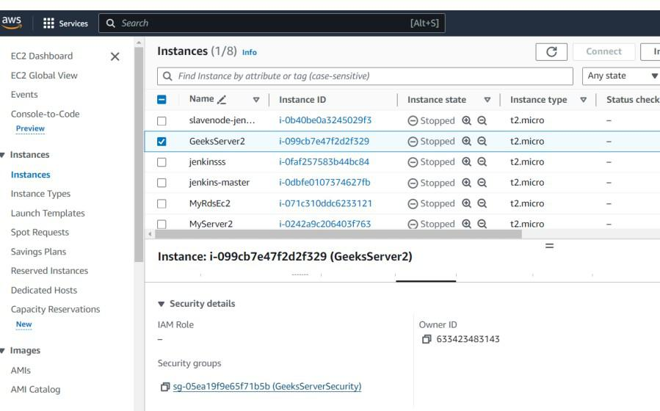Fig. 1

### Key Features of Security Groups:

* **Instance Level Protection:**Unlike Network Access Control Lists (NACLs), which operate at the subnet level, Security Groups operate at the instance level. Each instance in your Virtual Private Cloud (VPC) must be associated with one or more Security Groups, and the rules apply to traffic for that specific instance.
* **Stateful Nature:**Security Groups are stateful, meaning that if you allow inbound traffic from a specific IP address, the corresponding outbound traffic is automatically allowed. This simplifies the rule configuration process and reduces the risk of misconfigurations.
* **Default Deny Principle:** Security Groups follow the default deny principle. All inbound and outbound traffic is denied by default, and you must explicitly define rules to allow communication. This provides a strong security baseline for your instances.
* **Dynamic Rule Updates:** Security Group rules can be updated dynamically, allowing you to adapt to changing requirements without interrupting your instances. Changes to Security Group rules take effect immediately, providing flexibility and agility in managing your security policies.  
    
  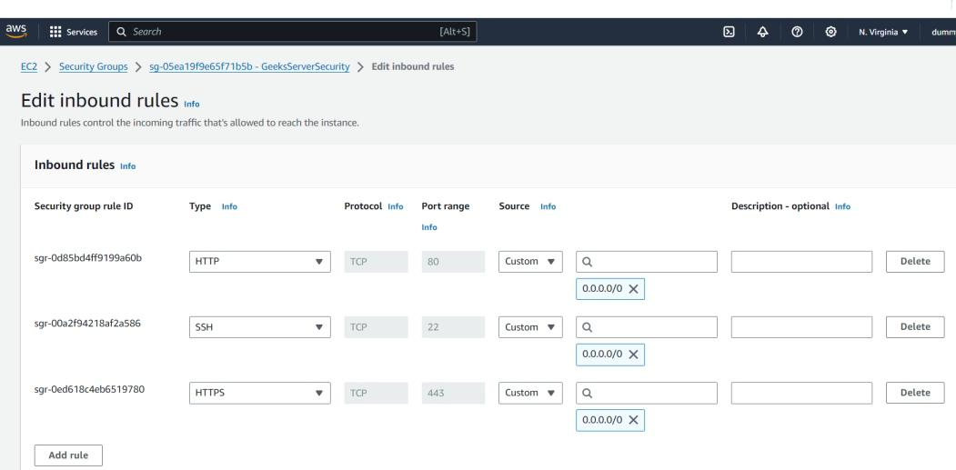Fig. 2

Security Groups are a fundamental building block for securing your AWS infrastructure. By adhering to best practices and understanding the core features, you can establish a robust security posture for your instances. Regular audits, thoughtful rule configurations, and a proactive approach to security will contribute to the resilience of your cloud environment. Embracing the power of Security Groups is an essential step towards creating a secure and compliant AWS architecture.