Group Project Documentation   
Basic Cross-Platform Application Programming with .NET

Dentist Booking System

**Prepared by Group 3**

Phạm Xuân Kiên – SE151212

Nguyễn Quốc Bảo – SE151333

Nguyễn Trung Hiếu – SE151323

Ho Chi Minh City, 2022

Table of Contents ii

1. Project Introduction 1

1.1 Product Perspective 1

1.2 User Classes and Characteristics 1

2. Database Design 1

3. System Architecture 1

4. Implementation 2

4.1. Deployment Considerations 2

4.2. Screenshots and explanations 2

# Project Introduction

## Product Perspective

Dentist booking system is a system for managing the appointment schedule of the dental center. The system includes a number of main functions such as viewing, adding, canceling, and editing, and writing notes for customer’s appointments. In addition, the system also manages some information about services, staff’s and dentist’s accounts such as viewing, adding, deleting, and editing their information. The system is used internally by dentistry with 3 main roles: admin, staff and dentist.

## User Classes and Characteristics

1. **Admin**
2. Create, Read, Update, Delete service

* Create a new service: admins can create a new service, all information must be filled in.
* View service list: admin can filter services through service search bar
* Update service information: admin selects a service in the service list to update its information.
* Remove service: admin can remove service by updating its status

1. Create, Read, Update, Delete account

* Create a new account: admin can create a new account for staff, dentist. All information must be filled in.
* View account list: admin can filter and view its details.
* Update account: admin can update staff’s and dentist’s information, except id and role.
* Delete account: admin can delete staff or dentist account through updating it’s status

1. Read appointment:

* View appointment list: admin can view list of appointments and filter by phone, date, dentist and status.

1. Read customer:

* View customer list: admin can view list of customers and can filter by name and phone.

1. Read, Update their account’s information

* Viewing profile: dentist can only view their own profile information
* For updating, the dentist can update all their account’s information except their account’s role and status

1. **Dentist**
2. Read, Update appointment

* View appointment list: dentists can view all appointments they have on that day. They can filter appointments by phone.
* View list of history appointments of customers: dentists can view 10 history appointments nearest to the customer.
* Update appointment: Add note and update status 2 (done) for appointment. If a client arrives more than 15 minutes late, the dentist can check this customer is absent (status = 3).

1. Read, Update their account’s information

* Viewing profile: dentist can only view their own profile information
* For updating, the dentist can update all their account’s information except their account’s role and status

1. **Staff**
2. Create, Read, Update, Delete appointment

* Create appointments: when receiving a call from a customer, staff will proceed to create an appointment if that customer wants.
* Update appointments: when receiving a call from a customer who demands an update appointment, staff will update the appointment for that customer.
* Cancel appointments: staff can cancel an appointment in the Appointment Detail form of that appointment.
* View list of appointments: staff can view list of appointments and filter by phone, date, dentist and status.

1. Create, Read, Update customer:

* Create customers: staff can add customers at any time or when the customer calls to book an appointment, the admin will ask if the customer has information in the system. If not, the admin will ask for the customer's information and put it in the system for tracking.
* Update customers: staff can update customer’s information if there are any changes when staff ask to confirm customer’s information.
* View customer list: staff can filter customers and view their profile information

1. Read, Update their account’s information

* Viewing profile: staff can only view their own profile information
* For updating, staff can update all their account’s information except their account’s role and status

## Business rules

| **No** | **Rule Definition** |
| --- | --- |
| 1 | Maximum 3 services for 1 appointment |
| 2 | Doctors can only mark absence for an appointment when that appointment late 15 minutes |
| 3 | An appointment can be only updated or canceled before its date 1 day |
| 4 | Each customer can only have a waiting appointment |
| 5 | A canceled appointment can’t be updated |

# Database Design

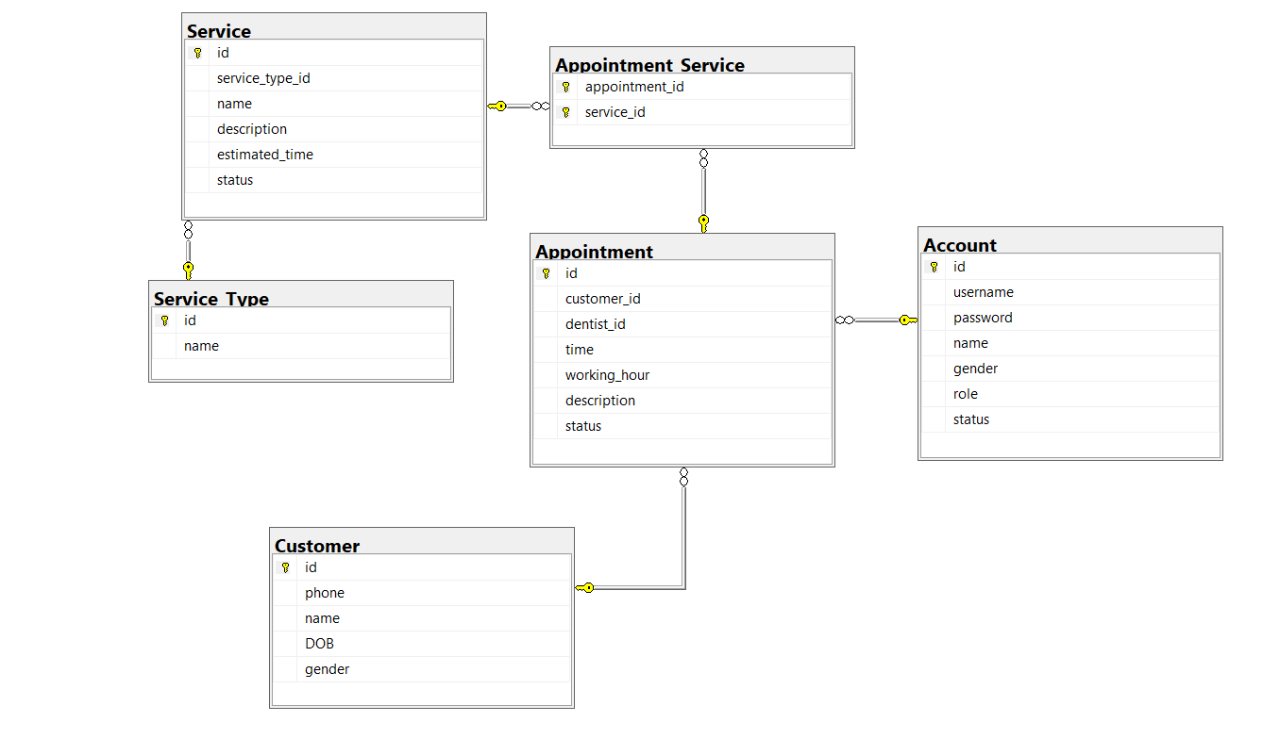

## Service Type

| Field Name | Type | Description | Unique | Not null | PK/F |
| --- | --- | --- | --- | --- | --- |
| Id | int | Unique define of service type | Yes | Yes | PK |
| Name | nvarchar(30) | Define name of service type | No | Yes | No |

## 

## Service

| Field Name | Type | Description | Unique | Not null | PK/FF |
| --- | --- | --- | --- | --- | --- |
| Id | int | Define unique service | Yes | Yes | PK |
| service_type_id | int | Define the id of service type | Yes | Yes | FK |
| name | nvarchar(30) | Define name of service | Yes | Yes | No |
| description | nvarchar(MAX) | Show information of service | No | No | No |
| estimated_time | float | Estimate time of service | No | Yes | No |
| status | decimal(1,0) | Status of service (active or Inactive) | No | Yes | No |

## Appointment

| Field Name | Type | Description | Unique | Not null | PK/FK |
| --- | --- | --- | --- | --- | --- |
| id | int | Define the uniqueness of the appointment | Yes | Yes | PK |
| customer_id | int | Define id of customer booking this appointment | No | Yes | FK |
| dentist_id | int | Define the id of the dentist who will perform this appointment | No | Yes | FK |
| time | date | The date the customer will come | No | Yes | No |
| working_hour | nvarchar(15) | Predict the start and end time of the appointment | No | Yes | No |
| description | nvarchar(MAX) | Describe the medical condition after being examined by a dentist | No | No | No |
| status | decimal(0,1) | Status of appointment | No | Yes | No |

## Appointment Service

| Field Name | Type | Description | Unique | Not null | PK/FK |
| --- | --- | --- | --- | --- | --- |
| appointment_id | int | Describe the id of appointment | No | Yes | PK and FK |
| service_id | int | Describe the id of service in appointment | No | Yes | PK and FK |

## Customer

| Field Name | Type | Description | Unique | Not null | PK/FK |
| --- | --- | --- | --- | --- | --- |
| id | int | Define the uniqueness of customer | Yes | Yes | PK |
| phone | nvarchar(10) | Phone number of customer | Yes | Yes | No |
| name | nvarchar(30) | Name of customer | No | Yes | No |
| DOB | date | Customer's date of birth | No | Yes | No |
| gender | bit | Gender of customer | No | Yes | No |

## Account

| Field Name | Type | Description | Unique | Not null | PK/FK |
| --- | --- | --- | --- | --- | --- |
| id | int | Define unique account | Yes | Yes | PK |
| username | nvarchar(30) | username is used to login | Yes | Yes | No |
| password | nvarchar(30) | Password of account | No | Yes | No |
| name | nvarchar(30) | Name of user of account | No | Yes | No |
| gender | bit | Gender of user | No | Yes | No |
| role | decimal(1,0) | Role of user | No | Yes | No |
| status | decimal(1,0) | Status of account | No | Yes | No |

# System Architecture

Hardware platform: Desktop

Operating System: Windows

Geographical location of:

* User: For internal dental center only
* Server and database: Hosted and stored data right in the dental center

Programming language: C#

Database: Microsoft SQL 2019

Framework: .NET 5.0, Entity Framework Core 5.0.12

Design pattern: 3-layer architecture, singleton

Application: Window Form Application

Class diagram:

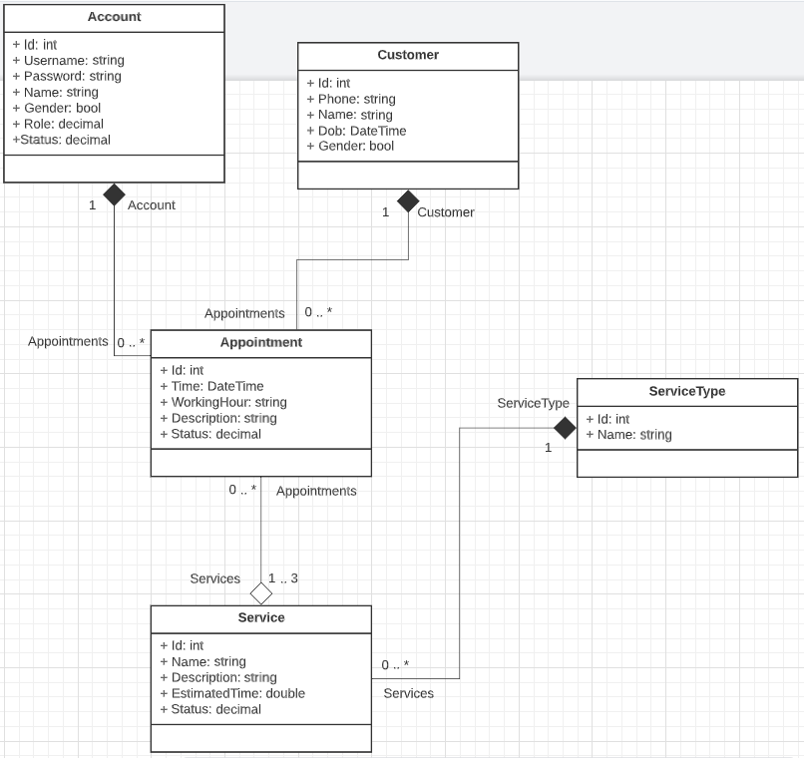

# Implementation

## Deployment Considerations

Users need to log in with the account provided by the center to use this system. For Admin users, the account will be provisioned first or imported from the database. Staff and Dentist users are created new accounts by Admin users. Then the personal information will be self-managed.

Because this system is hosted and stored data right in the dental center, it can only be used internally within the dental center.

Some data that is changed will have to initiate the change at the beginning or end of work time of the day to avoid arising data conflicts in the database (Ex: status of dentists, services, …)

The users in the system will need time to train to use this system, and need to be trained in CRUD on the allowed pieces of information.

The Staff will need to be trained in receiving calls from customers and checking their information as well as advising on services, hours, and working hours for customers to choose and use.

Dentists need training in managing their assigned appointments for the day, knowing when to miss appointments and taking care of unscheduled clients, taking notes. how in the description, know how to see the history of the customer's previous appointments, if any, to be able to treat more effectively

## Screenshots and explanations

1. **Login page**

Users who had an account on Database can login with three different role

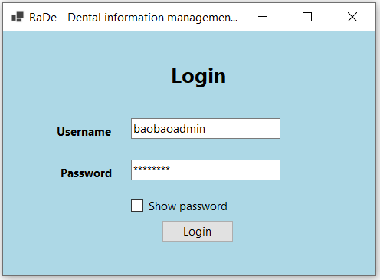

1. **Home page for admin**

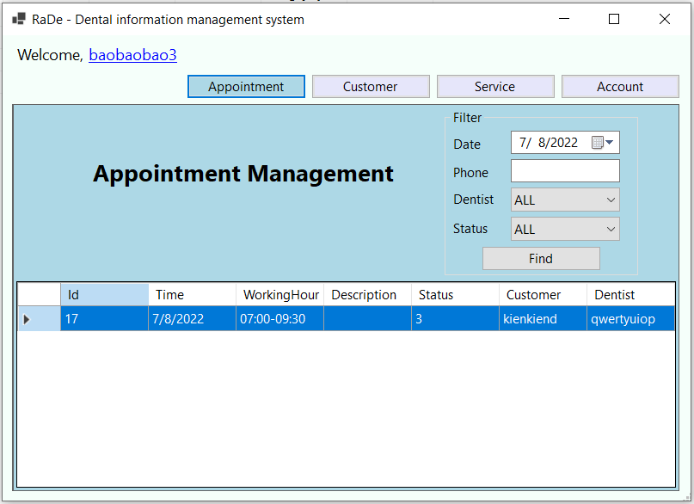

* Button appointment: Click to go to appointment panel.
* Button customer: Click to go to customer panel.
* Button service: Click to go to service panel.
* Button account: Click to go to account panel.
* Appointment panel for admin:

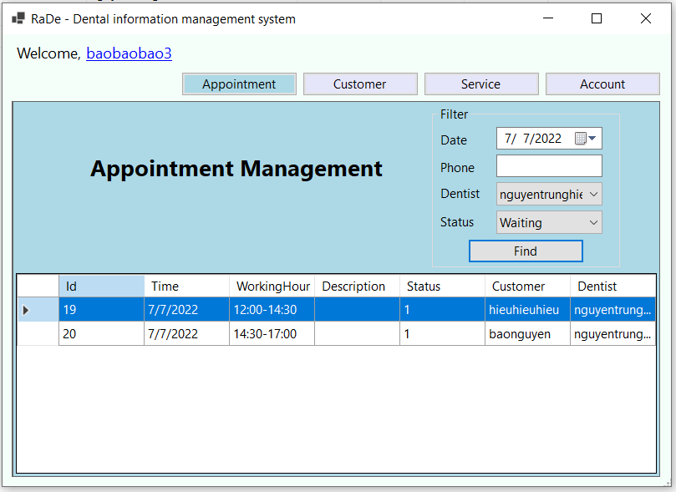

* + View appointment : Load all appointments into datagridview
  + Button “find”: filter appointment by phone, date, status.
* Service panel for admin

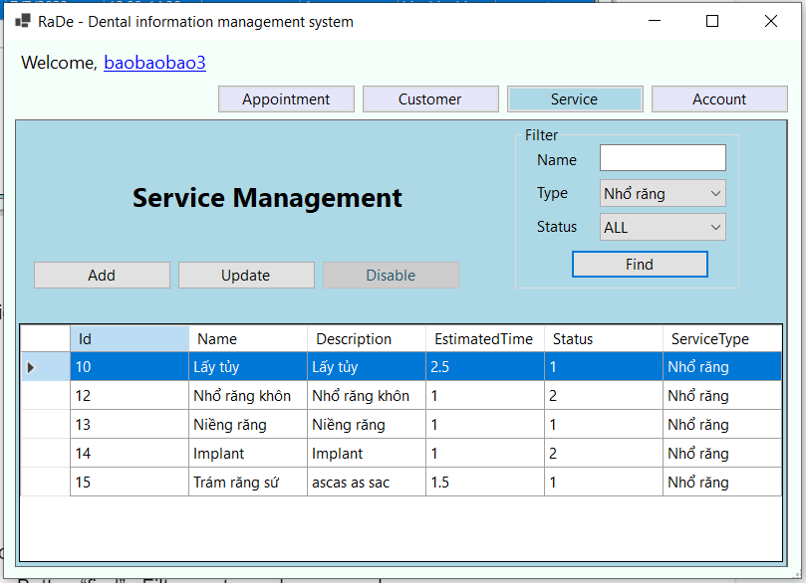

* Button “Add”: add new service
* Button “Update”: Update Service information
* Button “Disable” : Update service(Update status = 2)
* Button “Find” : Filter service by name, status, service type and load into datagridview
* Customer panel for admin

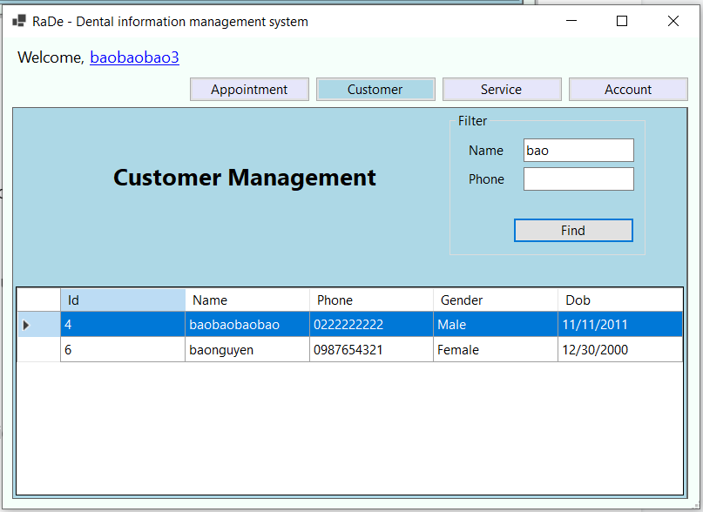

* Button “find” : Filter customer by name, phone
* Account panel for admin

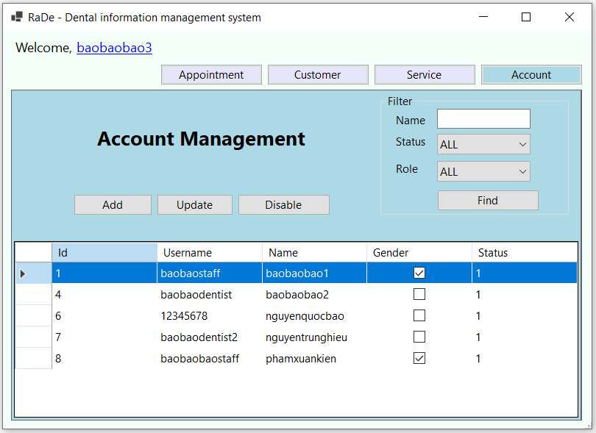

* Button “Add” : Add staff or dentist account
* Button “Update” : Update staff account and dentist account
* Button “disable” : Disable (Update status = 2 ) staff account, dentist account

1. **Account detail page**

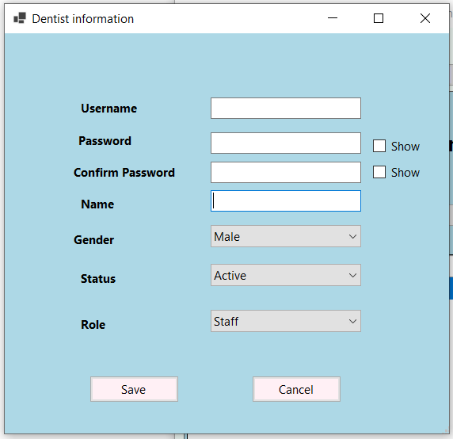

Use for adding, updating or viewing details of staff or dentist

1. **Service detail page**

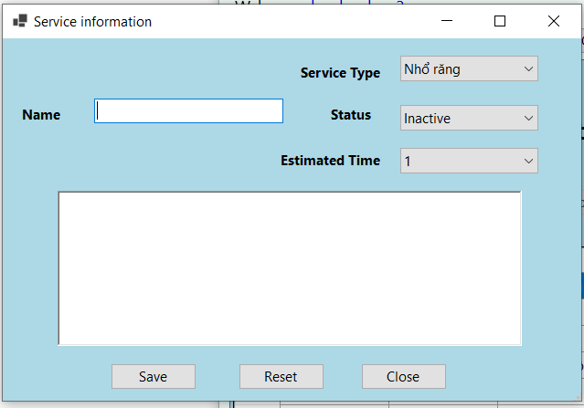

Use for adding, updating or viewing details of service

1. **Home page for dentist**

* Appointment panel for dentist:

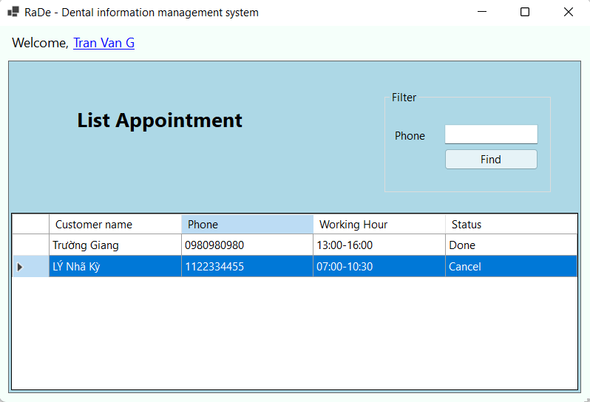

* Button find: dentist fills the phone number of the customer to find the appointment.
* List appointment: the book list contains the appointments available for the current day. The dentist can double click to select the appointment to view detailed information and proceed with the work.
* Update appointment panel:

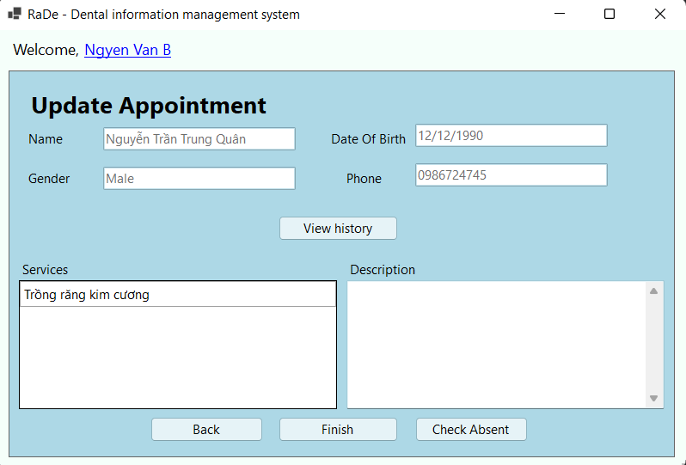

* Button view history: Click to show the last 10 appointments of this customer in **Customer’s history page for dentist**
* Button back: Click to come back from list appointment.
* Button finish: Click to finish the appointment when all service is done.
* Button Check Absent: Button dentist will click when customers are late for more than 15 minutes.
* Form customer history: this page will show 10 appointments nearest to this customer.
* List appointment: dentist click each element to see all service in this appointment and description about this appointment

1. **Appointment detail page for dentist**

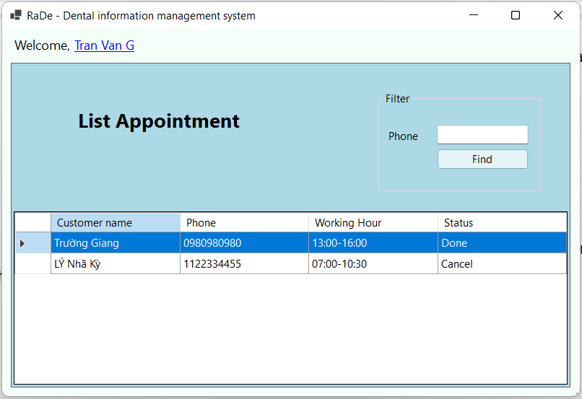

Button Check: dentist can choose this appointment to perform if it is waiting and show “OK” if it is done or canceled

1. **Customer’s history page for dentist**

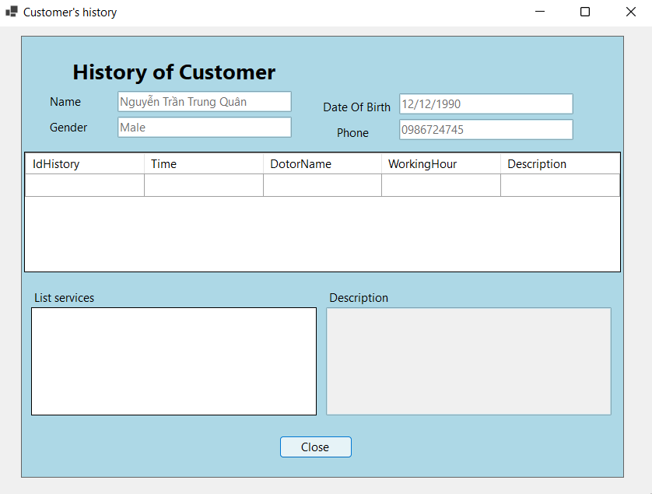

Show history appointment of a customer that dentist click on

1. **Home page for staff**

* Form home for staff :
* 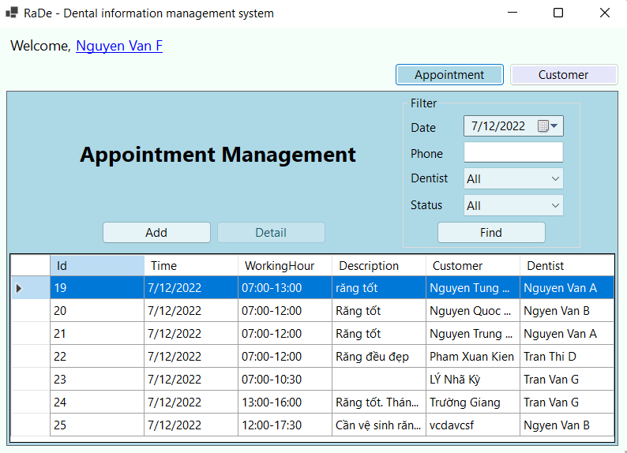
* Button appointment: Click to go to the appointment panel.
* Button customer: Click to go to customer panel.
* Link name: click to see the profile of account login.
* Customer panel for staff:

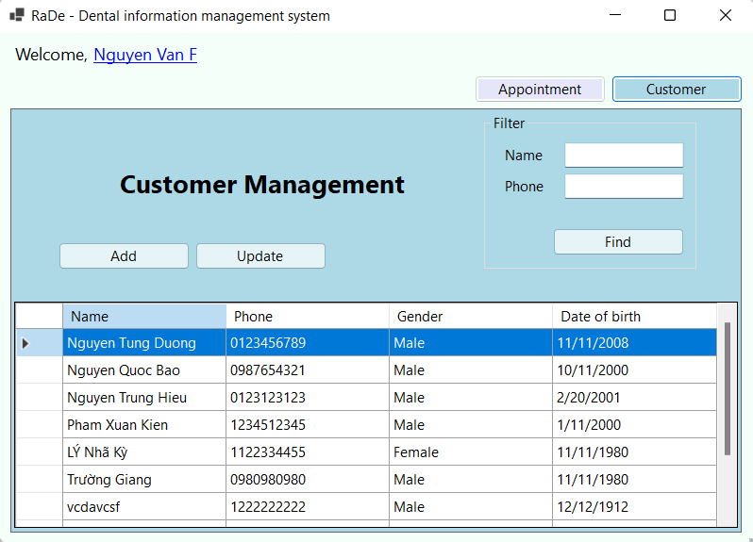

* Button add: Click to add new customer.
* Button update: Click to update the information of the customer.
* Button find: Click to filter customers by phone and name.
* View customer list: Double click to update this customer.
* Appointment panel for staff:
* 
* Button add: click to add a new appointment.
* Button detail: click to show appointment detail.
* Button find: click to filter appointments by date, phone, dentist and status.
* View appointment list: double click to update this appointment.

1. **Appointment detail page for staff**

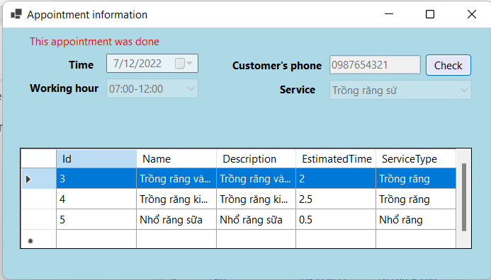

Show detail of appointment

* Button Delete service: click to delete the service you choose.
* Button cancel appointment: click to cancel appointment if the customer asks.
* Button Save: click to save this appointment.
* Button check: click to check the phone of a customer. If there is no result, it will change to add new customers.

1. **Customer detail page**

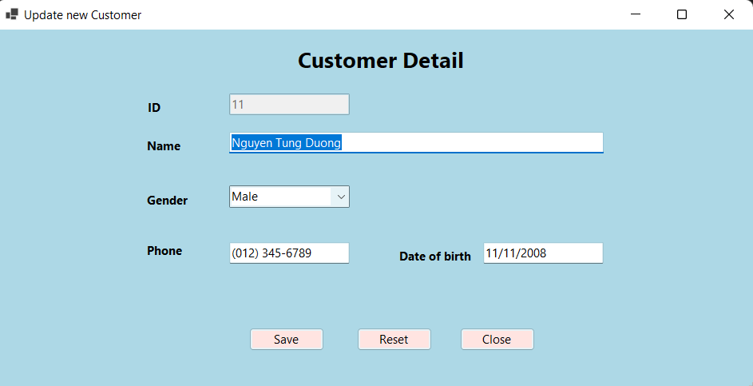

* Button Save: click to save, update or add new customers.
* Button Reset: if updating, reset all information and return the original state.
* Button Close: click to close form and cancel adding or updating customer.

1. **Profile page**

* Profile page:

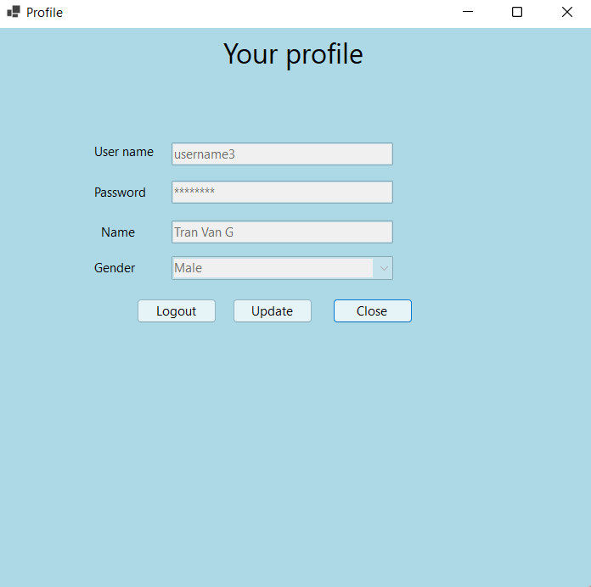

* Button update: Click to update account is logging.
* Button close: click to close form.
* Button logout: click to log out and comeback login page.
* Update profile page:

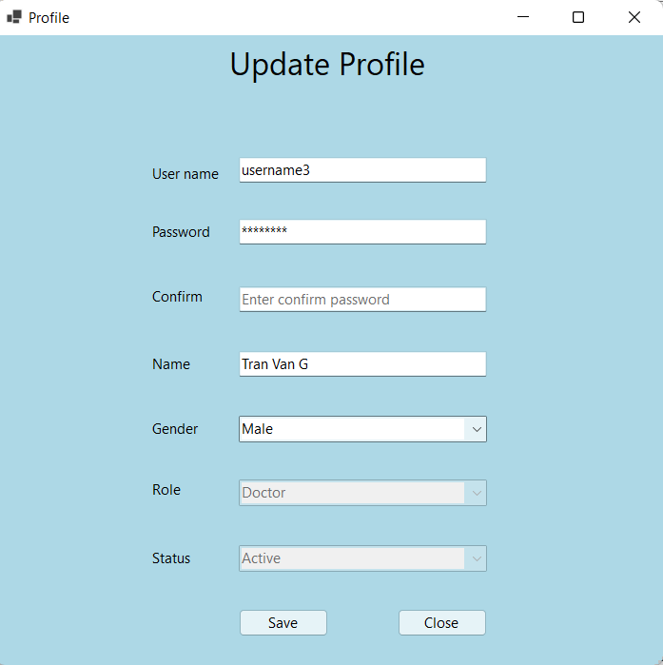

* Button Save: Click to save change information of account.
* Button cancel: click to close form and cancel change information of account.