Feature prioritization

**We will use the analytic hierarchy process (AHP) approach[1] in order to identify the best order in which to implement the U-Sem features. As stakeholders, I would like to ask you to fill the gray cells of the table bellow comparing the VALUE(importance) of the features. You can find the table describing the comparison scale bellow.**

Example: If you think that the "Plug-in environment" feature will add slightly more value to the product compared to the "Scheduling" than put "3" in the respective cell. If the opposite is the case then put "1/3".

|  |  |  |  |  |
| --- | --- | --- | --- | --- |
|  | **Plug-in environment** | **Scheduling** | **Universal data storage** | **Integration with Hadoop** |
| **Simplified access to social media** |  |  |  |  |
| **Plug-in environment** |  |  |  |  |
| **Scheduling** |  |  |  |  |
| **Universal data storage** |  |  |  |  |

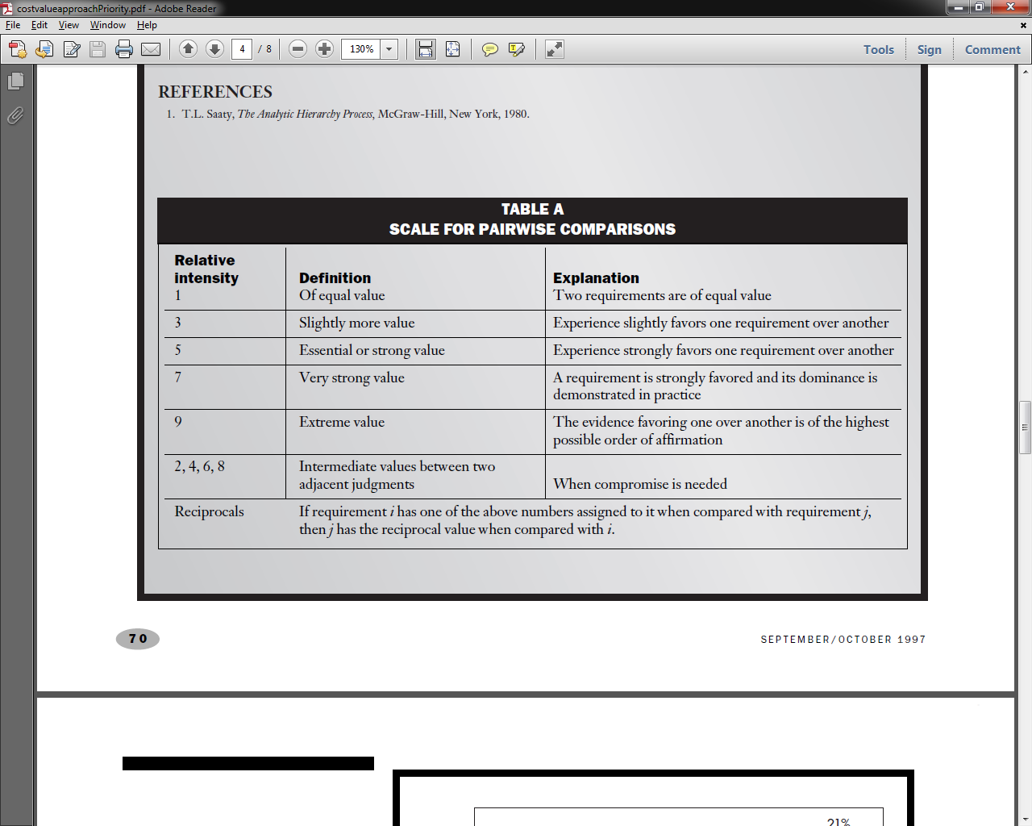

1. Karlsson, J. \& Ryan, K. (1997). A Cost-Value Approach for Prioritizing Requirements, IEEE Software September/October 1997, 67-74