

Republic of the Philippines

**Department of Education**

**Region V – Bicol**

**SCHOOLS DIVISION OFFICE OF CAMARINES NORTE**

Certificate of Appearance

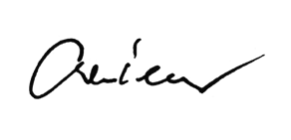

This is to certify that Mr./Ms. {{name}} of {{officeschool}} ({{division}}) attended the **Division Management Committee Meeting (MANCOM)** held at Wiltan Hotel, Daet, Camarines Norte on July 1, 2025.

**CRESTITO M. MORCILLA, CESO V**

Schools Division Superintendent

