JiraWLUploader

users guide

The application uses personal JIRA accounts to write work-logs from EXCEL to JIRA.

# Setting up JIRA account

The way of authentication has changed. Authorization headers are used, where the **UserEmail** and the **ApiToken** is used in a Basic authentication. The old User / Password authentication is not supported anymore.

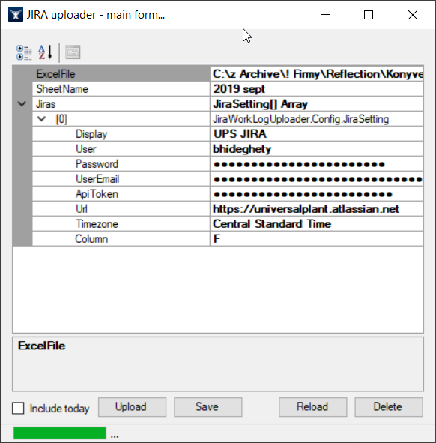

## Generate ApiToken

1. Log in to JIRA.
2. Visit <https://id.atlassian.com/manage/api-tokens>.
3. Press **Create API token** and on the pop-up **enter a name** for the token – see picture below.
4. When the token is created, a dialog will open. **Make sure you copy over the token from the dialog, as it will not be shown any more.** Use this token in the application settings. Make sure you save the settings (credentials will be encoded via a machine key, so the config is not usable when copied over to a different computer or when windows is reinstalled).

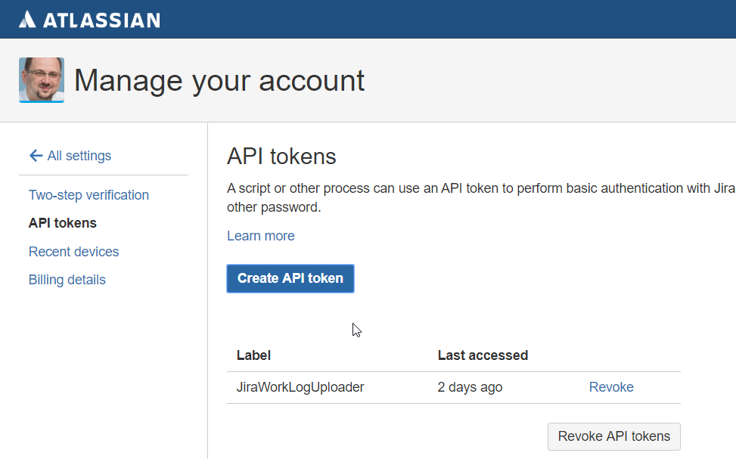

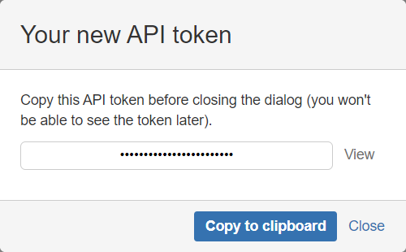

# The excel file

We can use any sheet for log, sheet is selectable from the app.

## Excel structure

* The excel is parsed from the 5th row downwards
* 1st column – date (if no date is written, the 1st date above that row is used)
* 2nd column – hours (numeric value)
* 3rd column – the JIRA task ID
* 5th column – the text for the work log
* Special columns for each JIRA server (contains HTTP status codes or -1 if no upload is wanted)

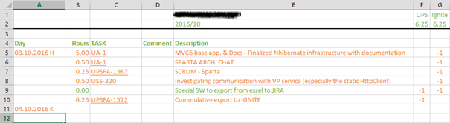

## Rules

Row is ignored if:

* No hours are filled
* No task ID is present
* No description is filled
* The corresponding JIRA column has other than 0 or empty value

## Codes inside special JIRA columns

* -1 = do not write log to the corresponding server
* 0 or empty = write log
* Greater than 0 = HTTP result code – whereas (200 to 300 = OK) = 201 is actually the “work log added” result

# The application

**Minimal configuration:**

* **ExcelFile** – File must not be locked (opened elsewhere) while working with this app – also note: the app will create a copy of the sheets before writing upload results, so best to keep XLSX in a specific folder (also that folder should be accessible by the account running this application).
* **SheetName** – Once the file is selected and not blocked, the app will fetch sheet names. We can split logs on a monthly basis, each month – separate sheet.
* **UserEmail**
* **ApiToken**
* **Url** – which is the URL to the JIRA
* **TimeZone** – this is the JIRA’s time-zone, must be set as we must consider time-shift when upload to get the entries with the desired date/time.
* **Column** – is the column’s name in excel where the upload status is stored (-1, 0, 404, 201)

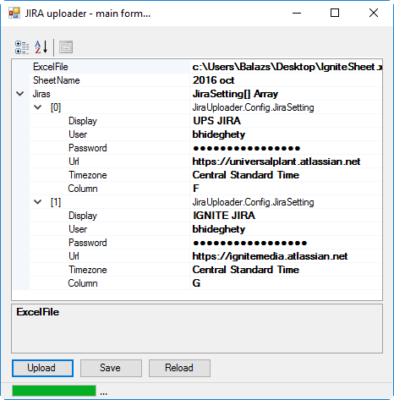

The application uses a slightly customized **PropertyGrid** to display settings. Settings are stored in **App.json**

**It’s important to have JIRA server time-zone set correctly – otherwise the logged time will be shifted!**

Save = save JSON

Reload = reload JSON

The COLUMN is an excel column name, and it should point to the column where the status codes for the given JIRA server will be stored. In most cases user does not need to log work to multiple JIRA’s so there will be only 1 JIRA setting and 1 status-code column – so when using the sample EXCEL as a template, it’ll be the column: F

## The upload

The application will do a backup of excel first (into the same directory) – the backup will be created with a timestamp in the name.

The upload process first will parse the selected sheet, then display the result.  
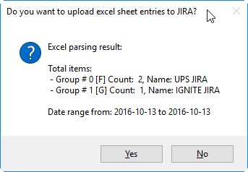

After confirming the result, upload will start. It’s not super-fast, it just works…

### Failsafe

The in-memory excel is modified while uploading (result codes are written)…

Before writing out modified excel (only when change is present) a backup file will be created… Backup is done with failsafe, so unlimited retries are possible on error.

The same failsafe is applied for the new excel file. This was needed for the case that if someone accidentally re-opened the original excel while upload was in progress…so he now has the possibility to close it and allow the application to write the results into it (anyhow changes done by the user will be replaced)…