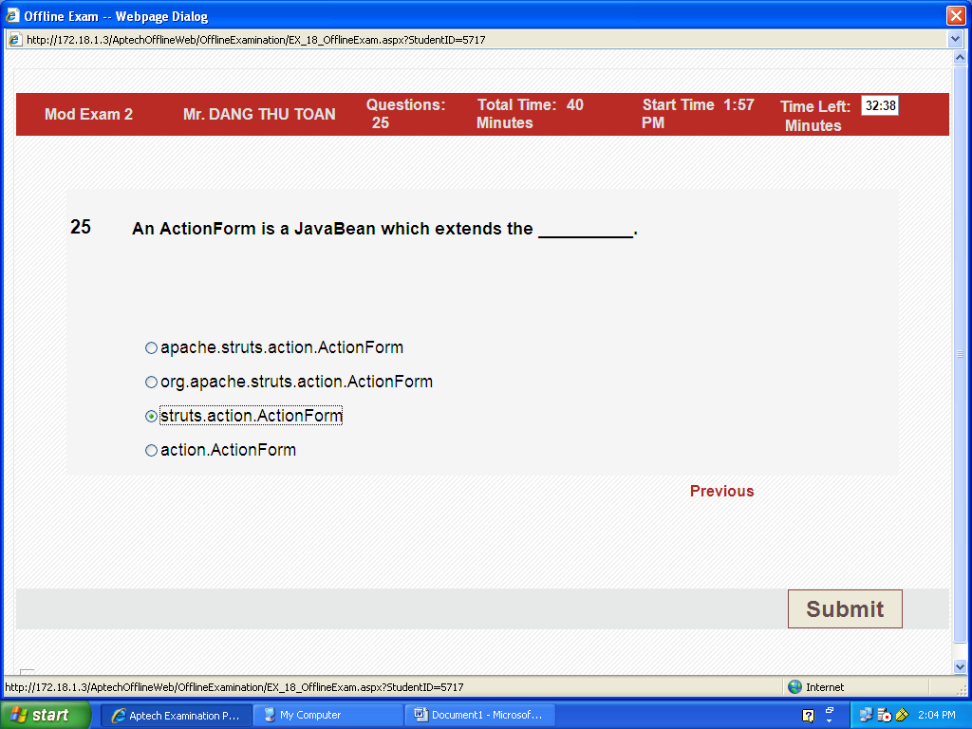
25b
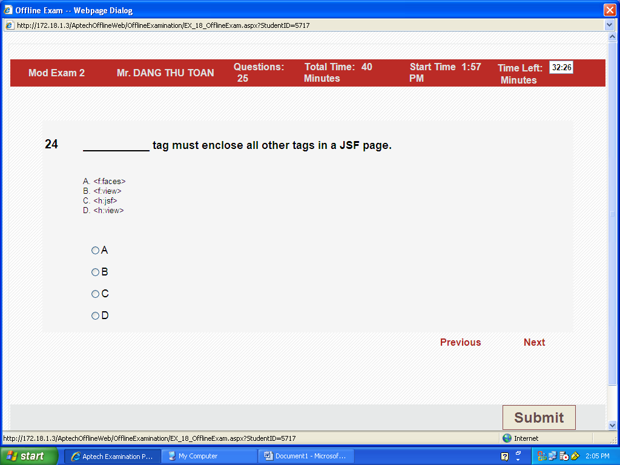
24b <f:view>, Thus, all component tags on the page must be enclosed in the view tag, which is defined in the jsf_core TLD:
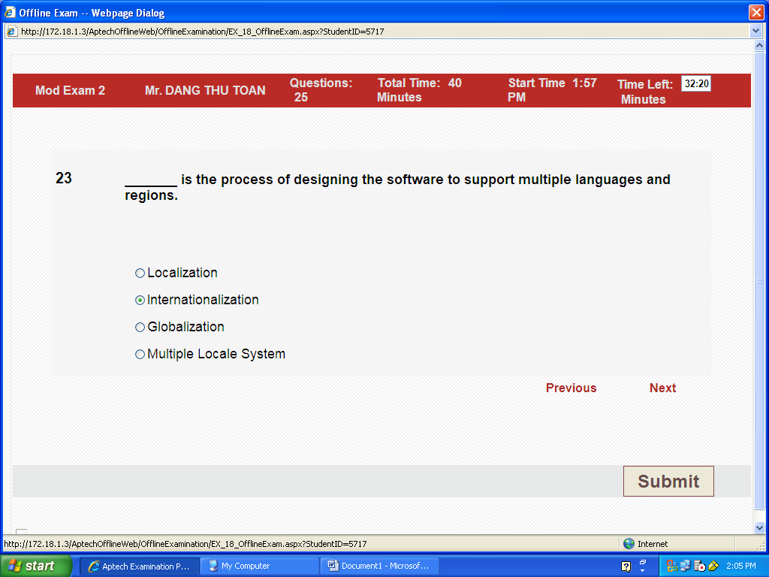
23 b International
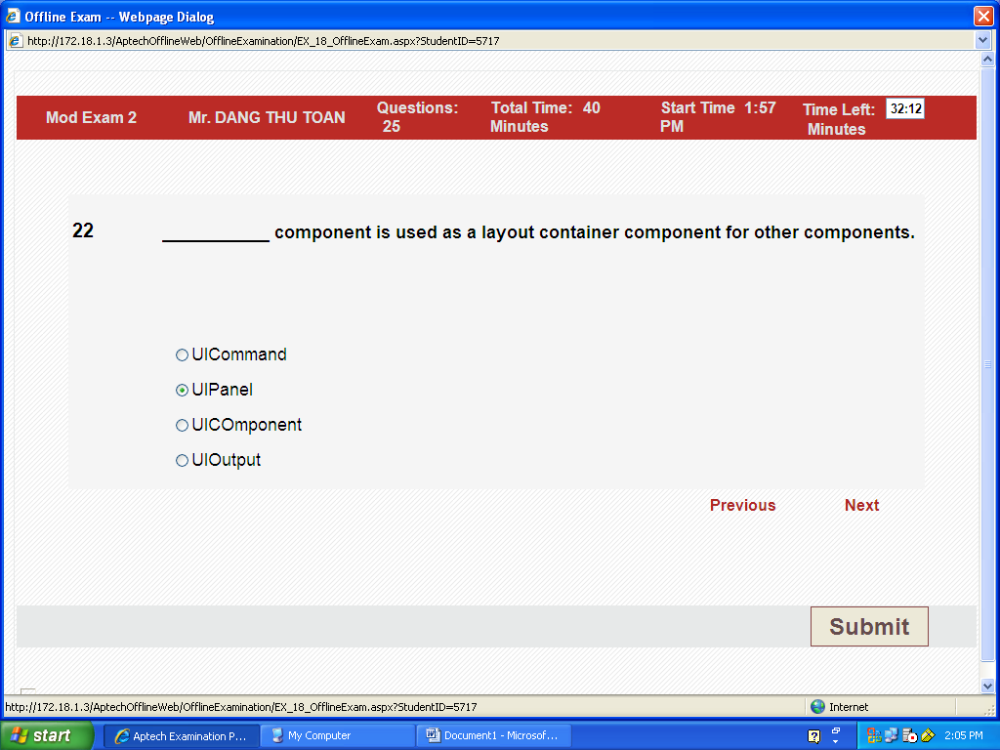
22 b, UIPanel (In sach) session 5 ,page 55/76
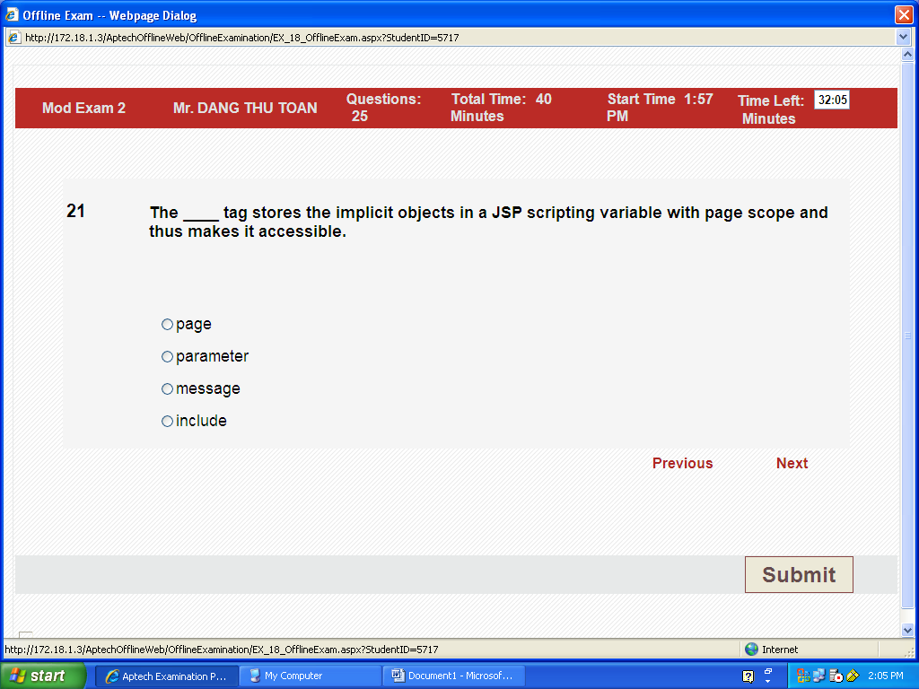
21a .page ( in cd session 4 slide 25)
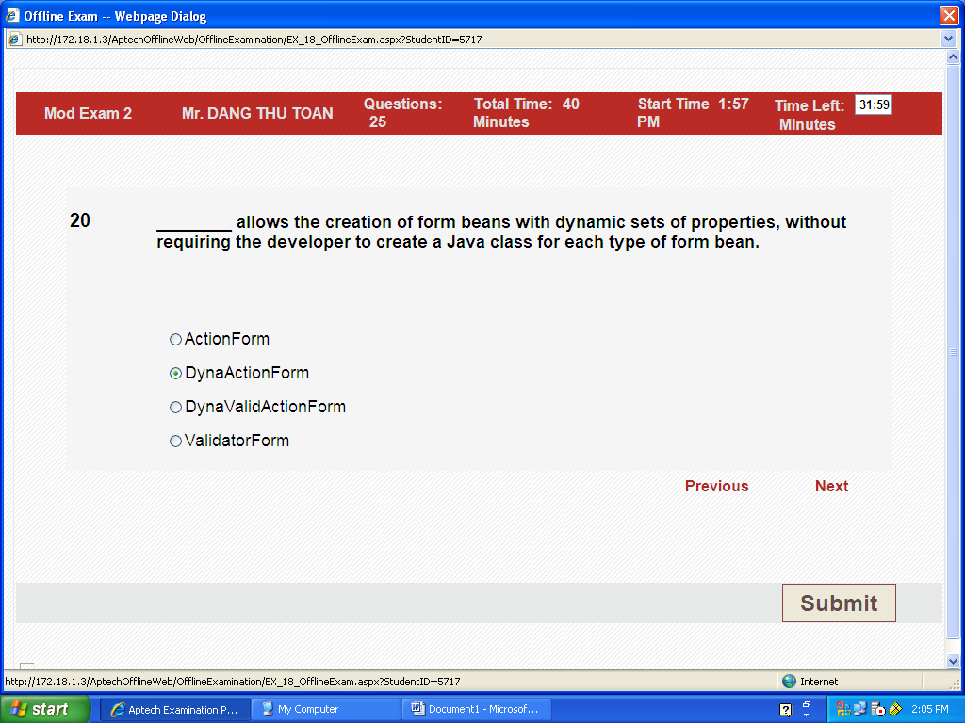
20b DynaActionForm
1.What is DynaActionForm?
A specialized subclass of ActionForm that allows the creation of form beans with dynamic sets of properties (configured in configuration file), without requiring the developer to create a Java class for each type of form bean.

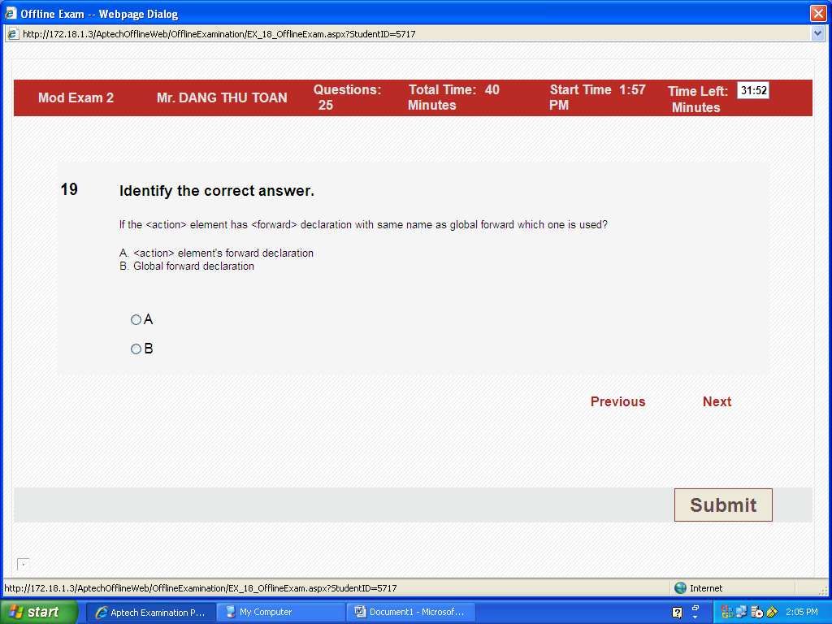 19a
.What if <action> element has <forward> declaration with same name as global forward?
In this case the global forward is not used. Instead the <action> element's <forward> takes precendence.
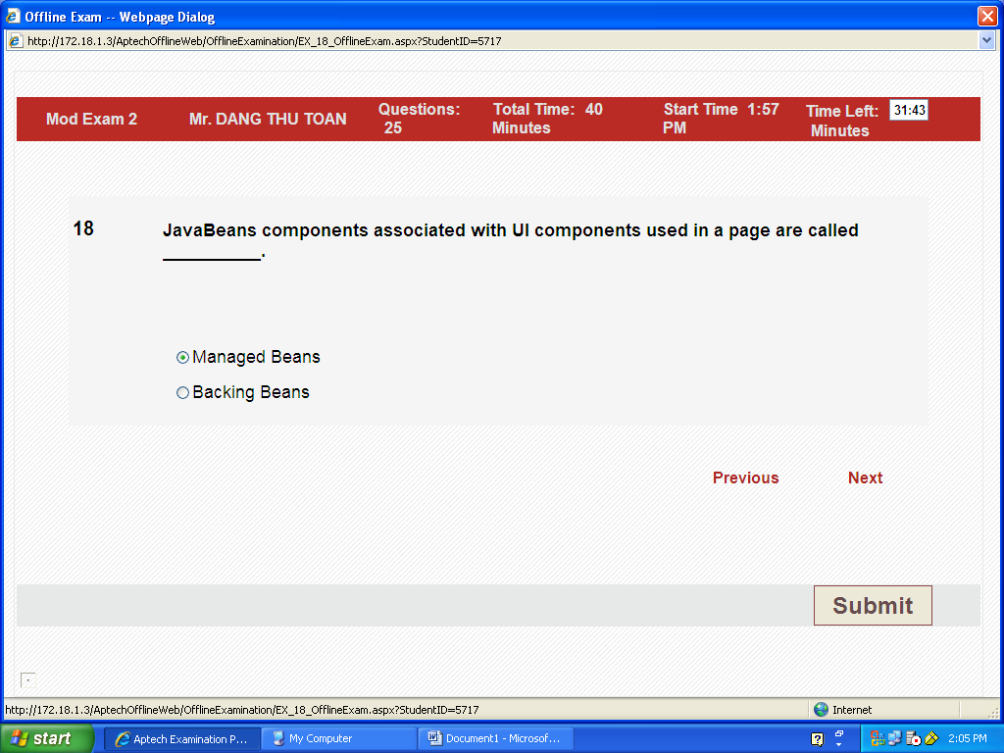18b.Backing Beans
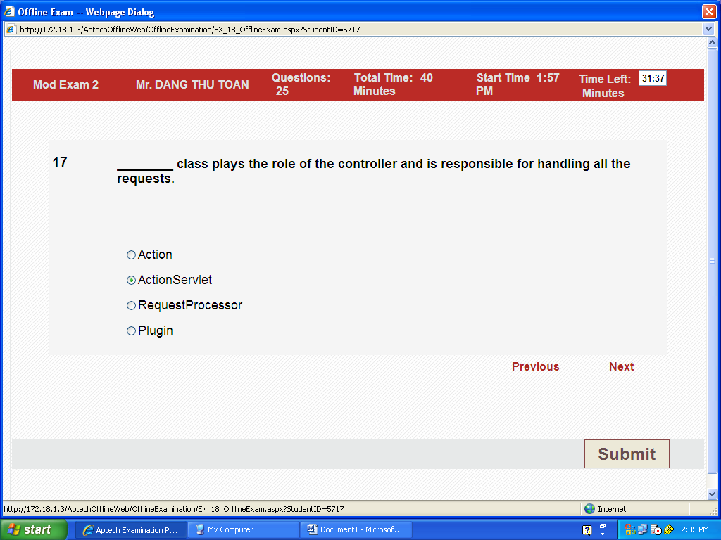
17b ActionServlet ( bai 3 sile 4 of 47)
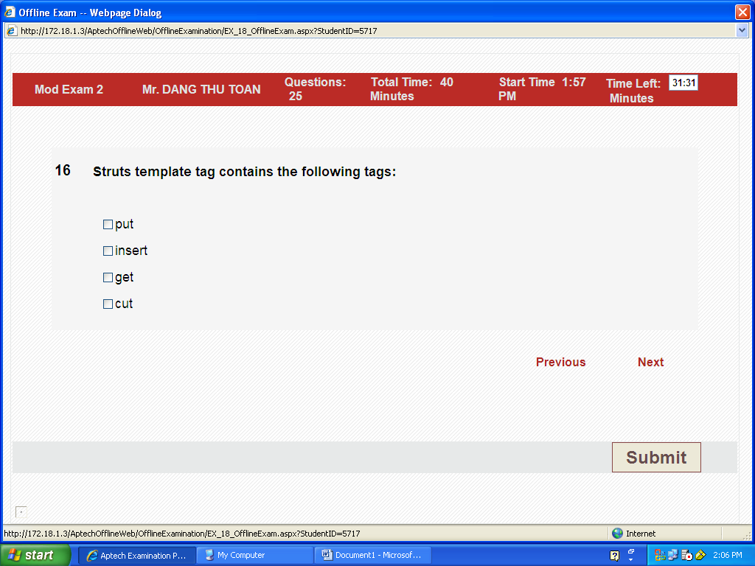
16 put, get ,insert
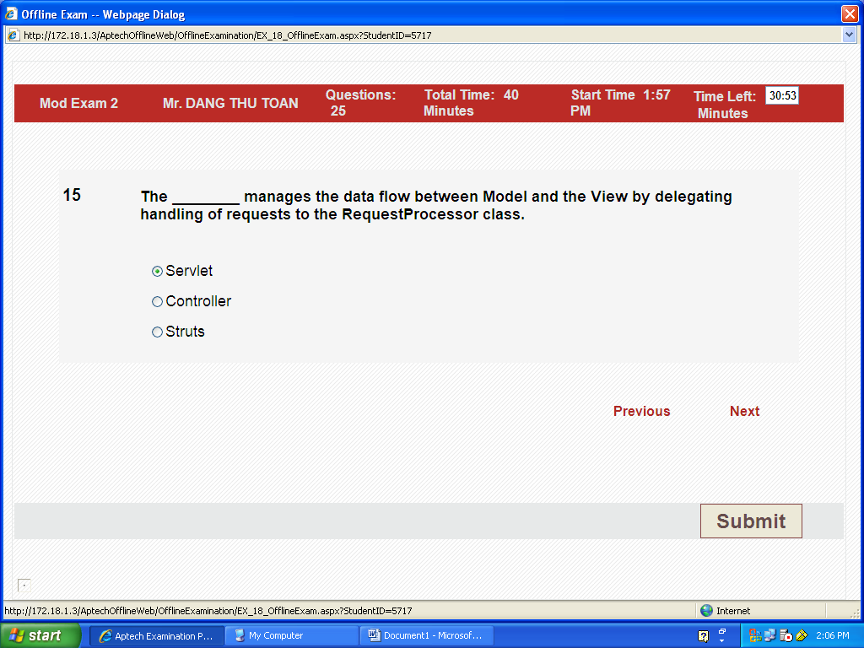
15 b Controller, (trong session 2 slide 14-35)
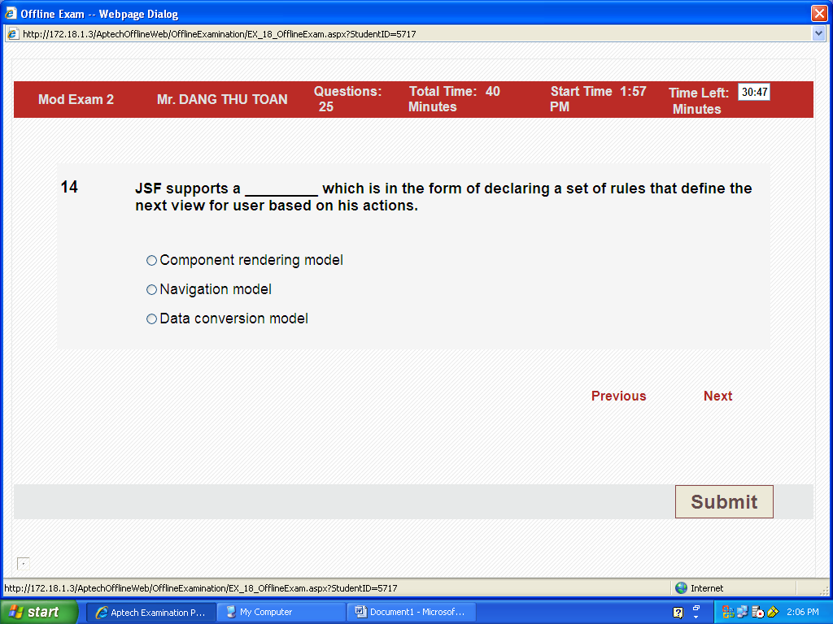
14 c, Navigation Model (in sach page 61/76)
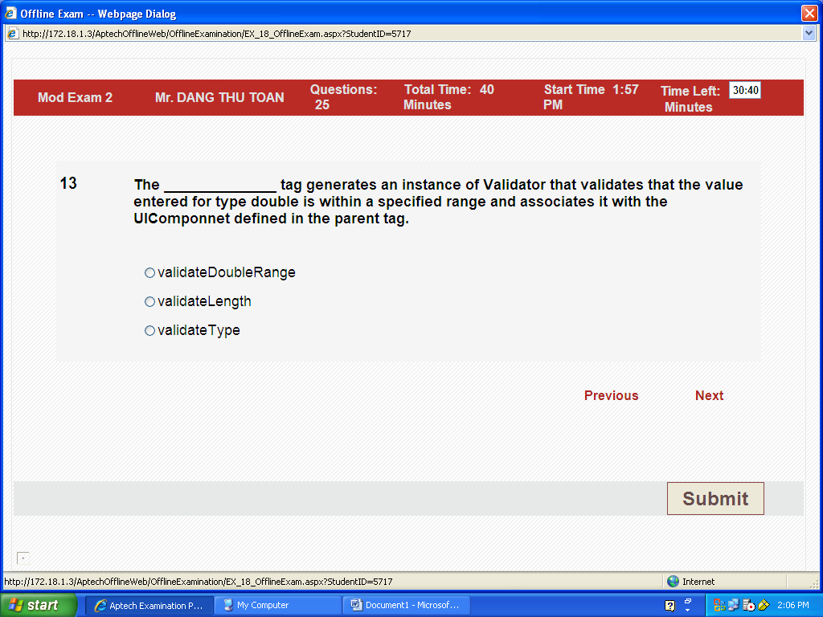
13a validateDoubleRange, (in sach page 71/76)
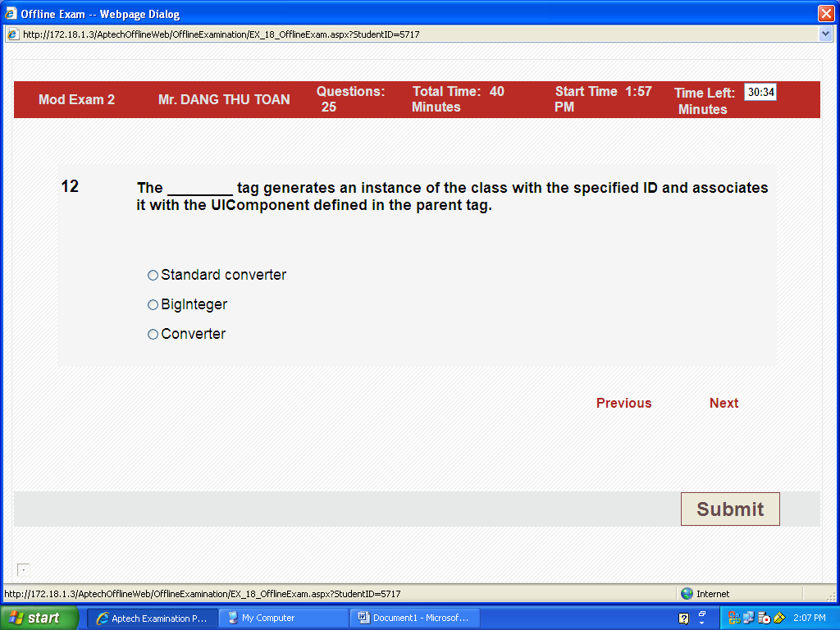
12 c Convertter ( page 69/76 in sach)
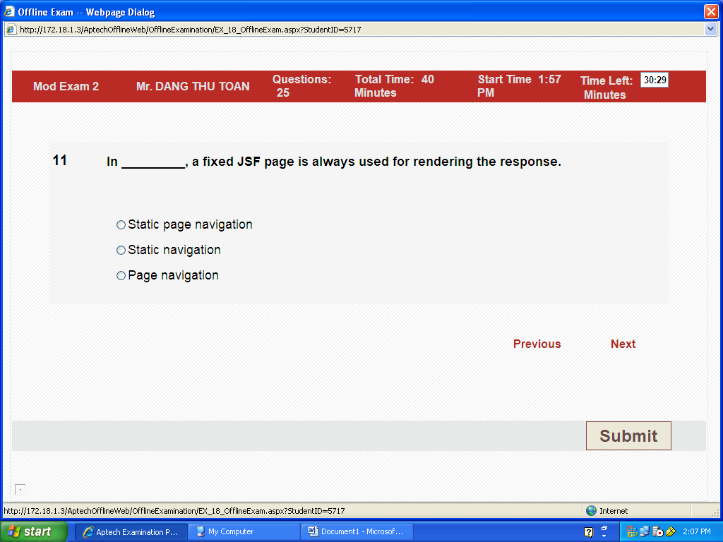
11a . Static page navigation
In a simple web application, page navigation is static. That is, clicking a particular button always selects a fixed JSF page for rendering the response.
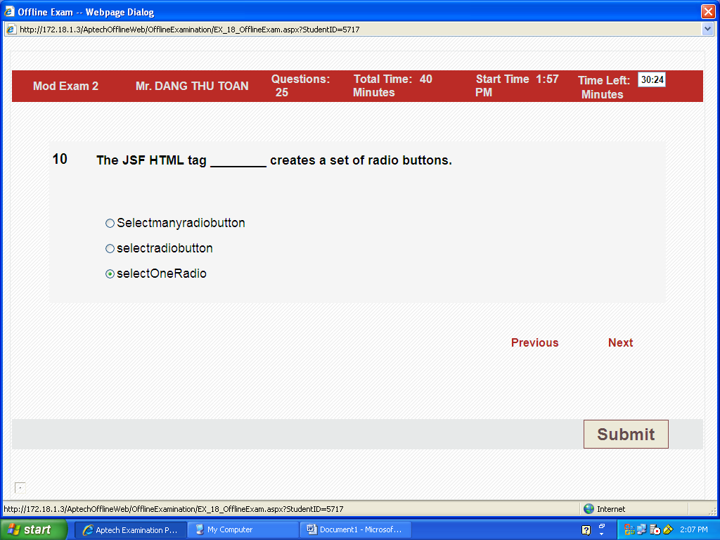
10c selectOneRadio

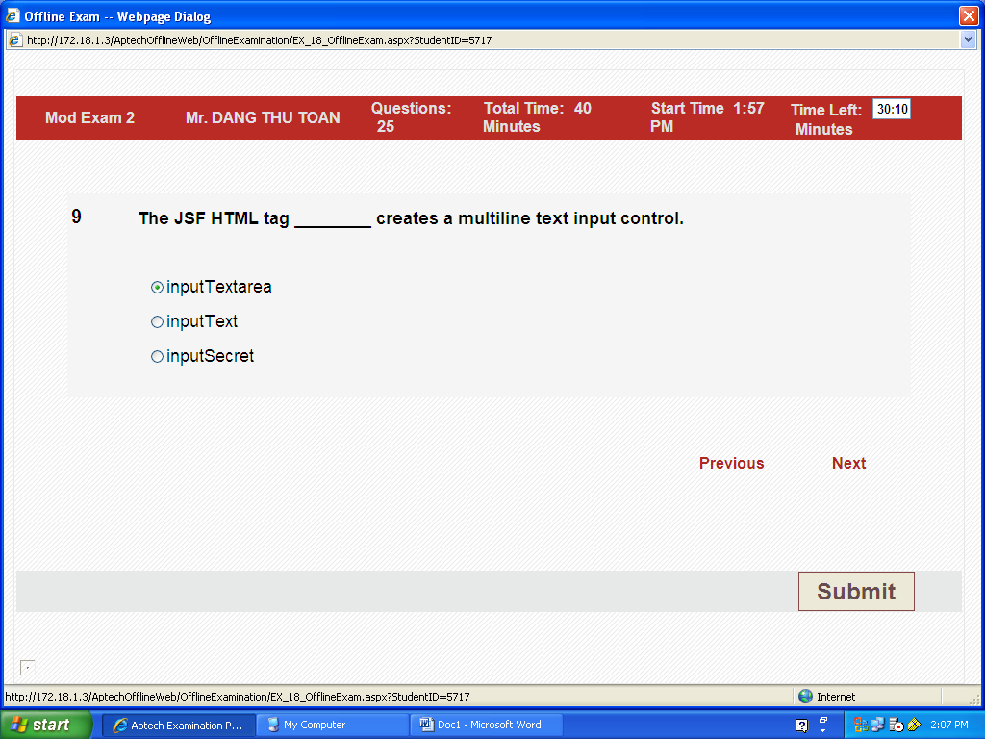
9a inputTextarea
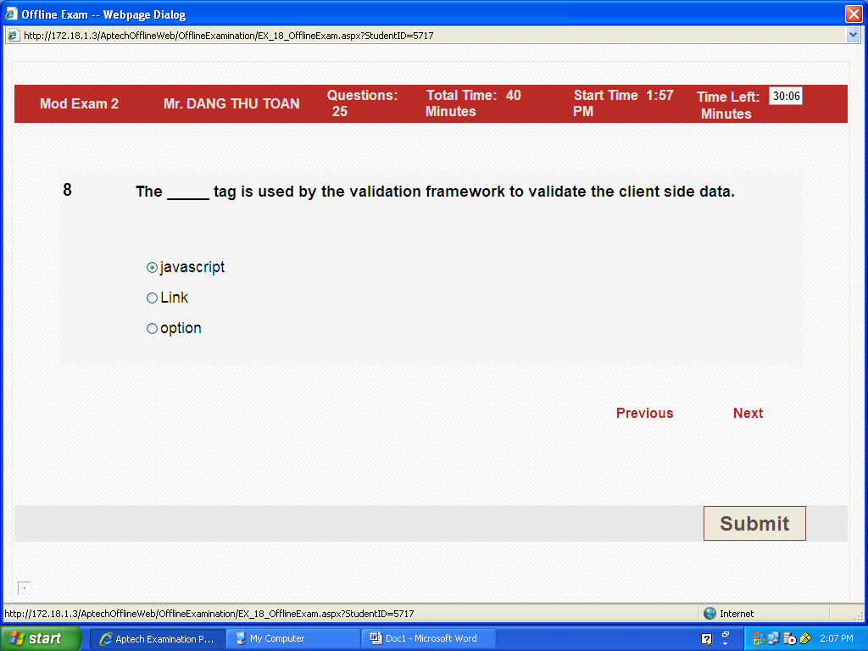
8a javascript
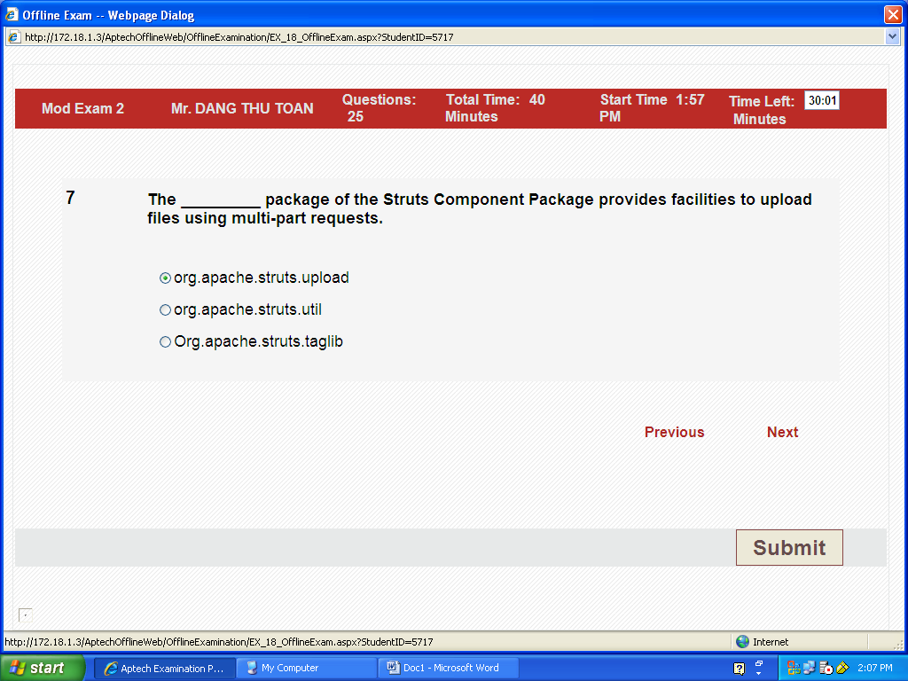

7 a org.apache.struts.upload

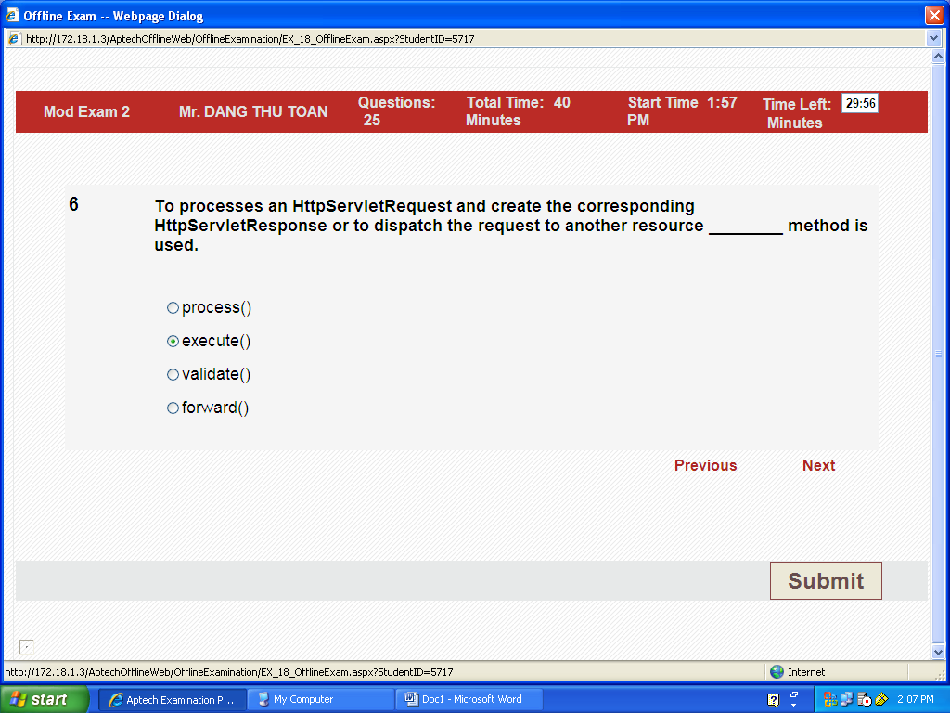
6b execute()

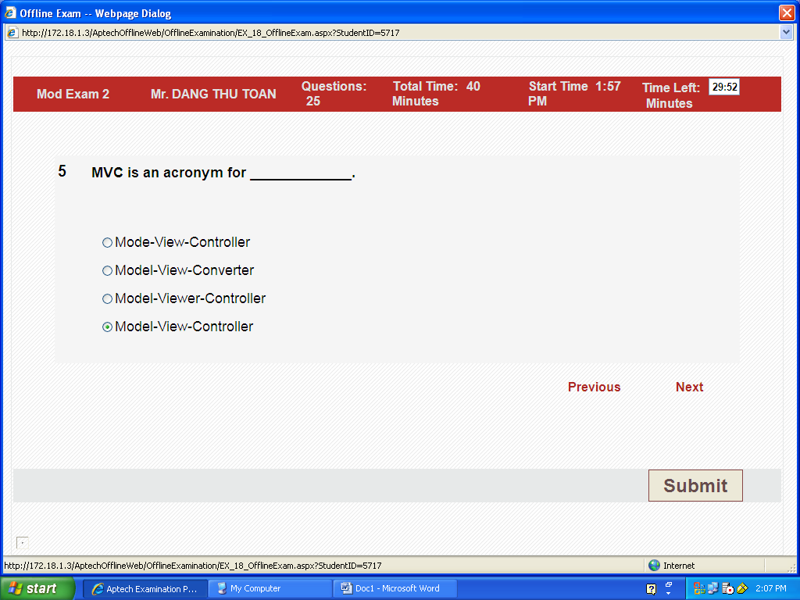
5d

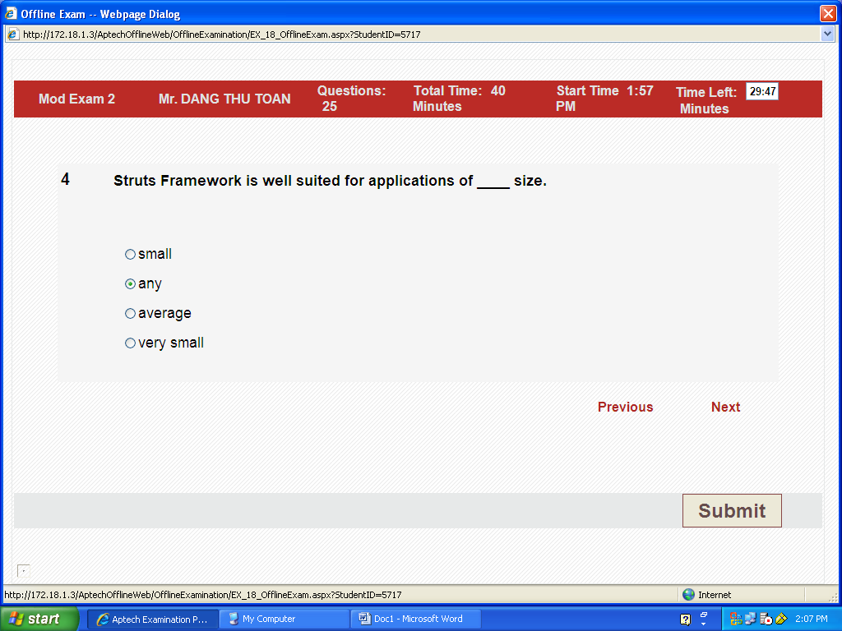
4b . any

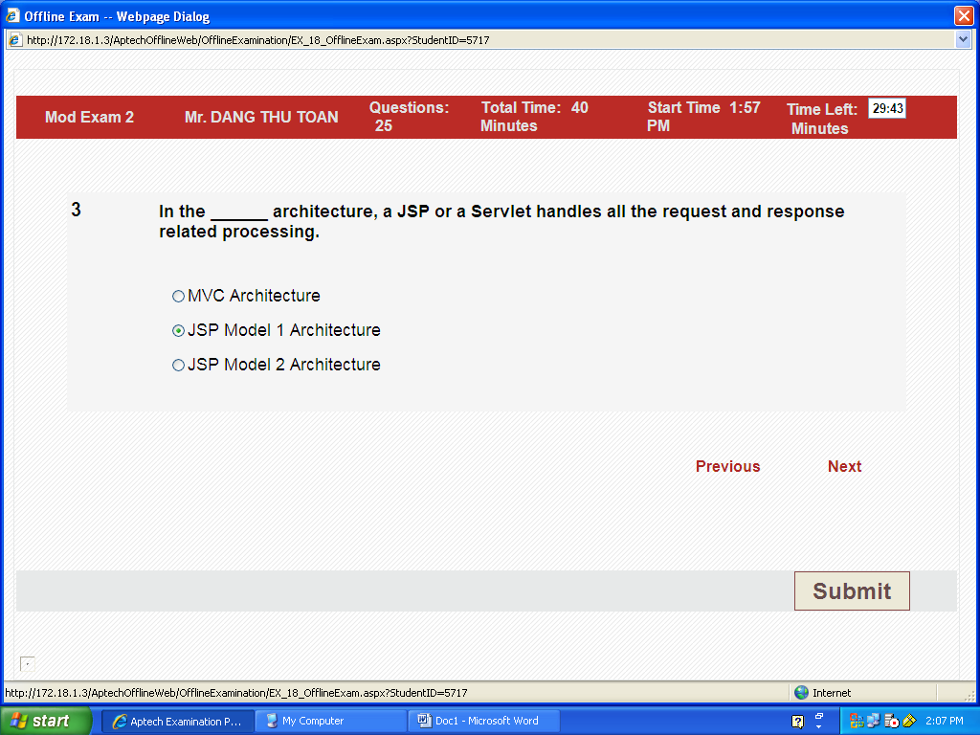
3c JSP Model 2 (in sach page 3of 76) (so sanh giua 1 and 2)ma JSP Model 1 cung dc

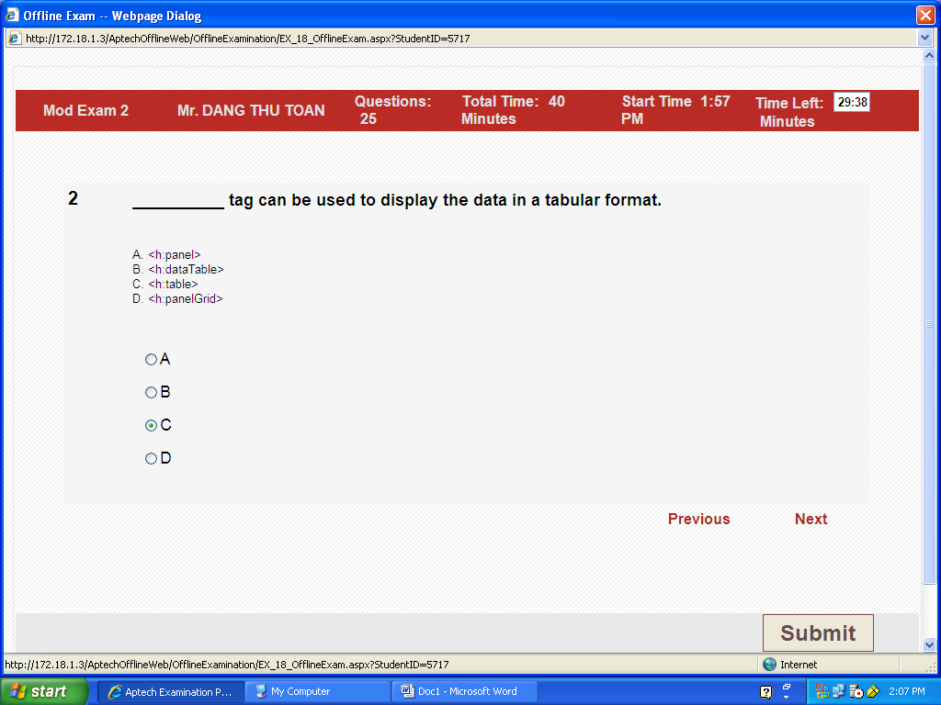
2b <h:dataTable>
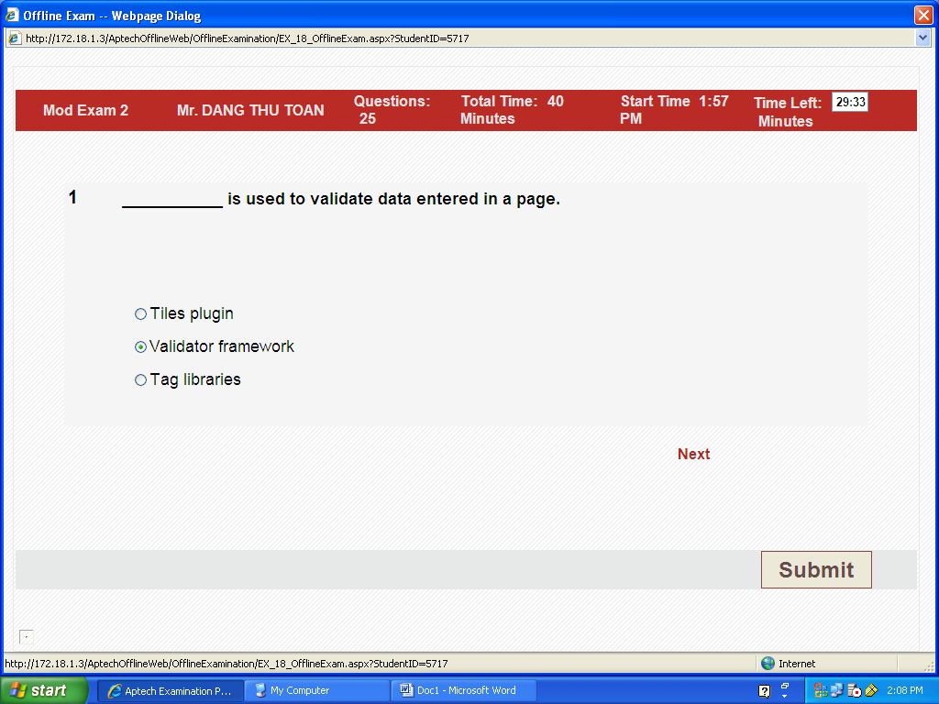
1b Validator framwork
------------------------------------------------------------------------------------
1 What is Managed Bean?
JavaBean objects managed by a JSF implementation are called managed beans. A managed bean describes how a bean is created and managed. It has nothing to do with the bean's functionalities.

9. What is Backing Bean?
Backing beans are JavaBeans components associated with UI components used in a page. Backing-bean management separates the definition of UI component objects from objects that perform application-specific processing and hold data.
The backing bean defines properties and handling-logics associated with the UI components used on the page. Each backing-bean property is bound to either a component instance or its value. A backing bean also defines a set of methods that perform functions for the component, such as validating the component's data, handling events that the component fires and performing processing associated with navigation when the component activates.

