Supplementary Information for: Occurrence records follow described species, not individuals, and cannot detect declines in most small animals
Hideyuki Doi

Supplementary Methods

1. Census data
Global abundance (N) and biomass (B) estimates were compiled with their sources, uncertainties and estimation methods; the provenance of every value, with verbatim quotations from the sources, is recorded in the repository (docs/data_provenance.md). Each estimate was classified as independent when it was extrapolated from field samples or from survey- or catch-based population models, as occurrence-derived when it used citizen-science or other occurrence data, as allometry-derived when density was predicted from body mass or other traits, or as mixed. Birds (1) were classed as occurrence-derived because eBird data inform the density of every species, and for 92% of land mammal species the abundances of ref. (2) come from a model with body mass among its predictors and were therefore classed as allometry-derived.
Ten groups had independent estimates (Table S1): soil nematodes (3); springtails (4); soil mites, obtained by rerunning the code of ref. (5) with a fixed random seed; non-arboreal ants (5); Antarctic krill (6); and enchytraeids, copepods, pteropods, planktonic cnidarians and mesopelagic fishes (7). For the last five groups, abundance is biomass divided by an assumed individual mass, so biomass was realigned to the same subgroup and the assumed mass entered the model as an observation. Biomass was converted to wet mass with each source’s own factors (the dry-to-wet ratios of ref. (5) and the carbon-to-fresh-mass equivalence of ref. (4)) or otherwise with a carbon-to-wet-mass ratio of 0.15 (7). Census uncertainties were converted to log-normal standard deviations, as (ln hi − ln lo)/3.92 for 95% intervals and reported ranges and as ln f/1.96 for a fold uncertainty f; where no uncertainty was reported, a fold of 10 was assumed, and a fold of 3 for assumed individual masses.

2. Occurrence records
All records in the GBIF snapshot of 1 November 2026 (GBIF.org, https://doi.org/10.15468/dl.jeesns; 3,887,364,403 records) were read from the Amazon Web Services open-data bucket with the R package arrow. Excluding absences left 3.75 × 10⁹ records, and excluding fossil specimens as well left 3.74 × 10⁹. The records were aggregated by taxon, year, basis of record and dataset class; for the analysed groups and mammals also by species, year, dataset and basis of record; by species, year and 1° grid cell; and as unique sampling events, defined as unique combinations of species, dataset, 0.1° grid cell and date. The event count was used as an alternative response because some datasets publish one record per individual or per sequence variant, as KRILLBASE does for krill.
Dataset classes (eBird, iNaturalist research-grade observations, and datasets with the DNA-derived data extension) were obtained from the GBIF application programming interface. From their titles and descriptions, datasets with the DNA-derived data extension were further classified as specimen barcodes (the International Barcode of Life dataset), reference sequence databases (EUKARYOME, excluded from DNA comparisons) or metabarcoding and environmental DNA (147 datasets) (data/derived/dna_dataset_types.csv).
Census groups were matched to GBIF taxa, which follow the Catalogue of Life eXtended Release, by explicit rules (Table S1). In sensitivity analyses, scope-corrected variants excluded water-mite, plant-associated, animal-associated and stored-product families from mites, excluded marine-dominated orders and animal-parasitic families and orders from nematodes, and extended mesopelagic fishes from Myctophidae to 15 families (docs/taxon_scope_variants.csv). Numbers of described species came from the Catalogue of Life (ChecklistBank dataset 316595), with Scyphozoa and Cubozoa combined (297 species) for jellyfish; alternative counts for mites (55,000) and nematodes (29,000) were taken from ref. (8) (Table S20). For birds, GBIF recognises more species than the Catalogue of Life count of described species used here, so the share of birds without records is truncated at zero (Table S13). Names of species with census estimates were resolved to accepted names with the GBIF species-matching service.

3. Initial models
In the initial model of records per individual, ln R_gk ~ Normal(ln N_g + a_k + b_k(ln M_g − c), √(τ_k² + 1/R_gk)) for group g and record type k, with latent ln N_g and ln M_g informed by the census observations. The four record types were fitted jointly, with priors b ~ N(0, 2), a ~ N(−25, 10) and τ ~ Half-Normal(0, 2). The 1/R term approximates Poisson variance; a Poisson likelihood mixed poorly in parameter-recovery tests at these large counts. Records of 388 mammal species with reported population sizes were analysed with a Poisson–log-normal model with order effects, in which the measurement error on ln N and the residual were combined into one term with a centred parameterisation because a brms implementation with a measurement-error term failed to converge; the two formulations are equivalent under a flat prior on latent abundance. In the initial detection simulations, annual counts were simulated as NegBin(λ₀E_te^(−dt), φ), with φ estimated from report-based mammals using species and year fixed effects, E_t the observed record trajectory of each group and d corresponding to a 30% decline per decade. Three analysis methods were compared (negative binomial regression with an effort offset, a binomial model of the relative reporting rate, and negative binomial regression of raw counts), and the time to detection was found by bisection over monitoring periods of 3 to 100 years. The denominator of the relative reporting rate was the group’s other records, and fits that failed, almost all of series without any records, were counted as non-detections.

4. Models of record allocation
Records were modelled directly with a Bayesian errors-in-variables regression, ln R_g ~ Normal(a + γ(ln N_g − c_N) + δ(ln M_g − c_M) + Xη, √(τ² + 1/R_g)), with latent N and M as above, fitted to all records only so that overlapping record types were not fitted jointly. The covariates X were the log number of described species and, in sensitivity analyses, an indicator of soil versus marine habitat. Priors were N(0, 2) for γ, δ and η, and N(0, 5) in a sensitivity analysis. Further variants replaced the response by scope-corrected records, by sampling events or by records without the three largest datasets of each group, and changed census inputs (jellyfish mass multiplied by 50 to reflect the low carbon content of gelatinous animals, a carbon-to-fresh-mass ratio of 0.105 for nematodes, krill abundance from unadjusted net samples, and springtail abundance and biomass from a rerun of the code of ref. (5)). Posterior predictive checks compared observed ln R with 95% prediction intervals. All fits had R̂ ≤ 1.01; the models with described species had 2 (log number of species only) and 9 (with habitat) divergent transitions out of 8,000, which were not removed by setting adapt_delta to 0.99.
For the ratio null model, records were permuted among groups 5,000 times and slopes of records per individual on body mass were computed by ordinary least squares on point estimates. For the DNA comparison, log(R_DNA/R_human) was regressed on log M, so that abundance cancels; census uncertainty was propagated by Monte Carlo simulation (4,000 draws) and the residual sampling uncertainty of the slope by draws from the t distribution.

5. Detection: analytical results, overdispersion and simulations
For a log-linear decline at rate d observed for T years with residual variance σ² on the log scale, the standard error of the slope is σ/√(T(T² − 1)/12). For a negative binomial count with mean λ and shape φ, σ² ≈ 1/λ + 1/φ. Power 1 − β at one-sided level α therefore requires T(T² − 1)/12 = (1/λ + 1/φ)(z_α + z_β)²/d², which gives the lower limit T ≈ [12(z_α + z_β)²/(φd²)]^(1/3) as λ → ∞. From the same expression I also derived the minimum decline per decade detectable within 10 years and the share of the population lost by the time of detection (Table S15).
To estimate overdispersion net of population trends, I fitted three negative binomial regressions to the annual records (2000–2024) of each species recorded at least once per year on average, all with an offset for the total records of the species’ group: an intercept-only model, a model with a linear trend and a model with a quadratic trend. The shape φ and the lag-1 autocorrelation of Pearson residuals were summarised by group, data source and record-rate stratum, with up to 200 species per stratum; bird records were split into eBird and non-eBird records, and mammal records were analysed with and without machine observations. The time to detection of a 30% decline per decade under constant effort was then recomputed for each group, using the trend-removed φ of the record-rate stratum corresponding to λ₀ (31 values from 10⁻² to 10⁴, 500 replicates). To assess the effect of temporal autocorrelation, latent log-normal year effects followed a first-order autoregressive process with ρ = 0.44, with variance chosen so that the marginal overdispersion equalled φ = 0.69, and stable and declining series were analysed with the effort-offset method.

6. Validation against structured monitoring
For 48 British butterfly species, I compared trends from 2000 to 2019 estimated in two ways. Trends from records used unstructured GBIF records, after removing the UK Butterfly Monitoring Scheme and the Wider Countryside Butterfly Survey (GBIF download https://doi.org/10.15468/dl.u8s7s5), and were analysed with the three methods described above. Trends from monitoring used UK Butterfly Monitoring Scheme site indices (2024 release; values of −2, which denote insufficient monitoring, were treated as missing), fitted with a quasi-Poisson generalised linear model with site fixed effects and a linear year term. The comparison ends in 2019, the last year before the largest unstructured dataset ends, and trends were classed as significant at two-sided α = 0.05.

7. Detectability of described species
For every described species in each group, λ was the mean number of records per year from 2015 to 2024, with λ = 0 for species without records. The time to detect a 30% decline per decade was read from the group’s curve in Section 5, taking the lower adjacent grid point, which is conservative. Mammal and bird species with body masses from COMBINE (9) and AVONET (10) were binned by order of magnitude of body mass, and bird species used the curve estimated from eBird records.

8. Other sensitivity and preliminary analyses
Fifty mammal species with survey-based censuses, after removing a duplicated elephant entry and an unverified polar bear value, were compared with the extrapolated relationship of the initial analysis (Table S7). The number of occupied 1° grid cells per species and year was compared with record counts as a coarse occupancy index (Table S6, Fig. S3). Multi-species indicators were simulated as pooled negative binomial regressions of K species with independent noise. The share of species never recorded was predicted from the observation model with literature totals of species richness; because this prediction shares those totals with the benchmark and over-predicts the number of recorded species by 4–11 times in four groups (Table S8), it is reported as unsupported.

9. Software, reproducibility and AI assistance
Analyses used R 4.6.1 with renv, targets, cmdstanr (CmdStan 2.40), brms, arrow and tidyverse, with random seed 20261103. All figures and tables are generated by code in the public repository (https://github.com/hideyuki-doi/observation-inequality). The work was carried out with Claude (Anthropic), an AI system, under the author’s direction. The system wrote and ran code, retrieved and summarised literature and data documentation, and drafted text, and the author approved each stage of analysis at predefined points and checked the results. Bibliographic entries were verified against Crossref or the original documents, and census values were checked against the source files, with verbatim quotations recorded.

Supplementary tables

Table S1. Census estimates and GBIF matching for the ten groups with independent censuses
Group | N (individuals) | B (g wet) | M (g wet) | Census source | GBIF rule | Records 2000–2024
soil_nematodes | 4.40e+20 | 2.10e+14 | 4.76e-07 | van den Hoogen J, Geisen S, Routh D, et al. (2019) Soil nematode abundance and functional group composition at a global scale. Nature 572:194-198 | phylum: Nematoda | 416,187
springtails | 2.00e+18 | 1.90e+14 | 9.50e-05 | Potapov AM, Guerra CA, van den Hoogen J, et al. (2023) Globally invariant metabolism but density-diversity mismatch in springtails. Nat Commun 14:674 | class: Collembola | 1,241,382
mites | 6.54e+18 | 6.53e+13 | 9.97e-06 | Rosenberg Y, Bar-On YM, Fromm A, Ostikar M, Shoshany A, Giz O, Milo R (2023) The global biomass and number of terrestrial arthropods. Sci Adv 9:eabq4049 | order: Sarcoptiformes, Mesostigmata, Trombidiformes | 1,315,602
ants | 5.00e+16 | 1.10e+14 | 2.19e-03 | Rosenberg Y, Bar-On YM, Fromm A, Ostikar M, Shoshany A, Giz O, Milo R (2023) The global biomass and number of terrestrial arthropods. Sci Adv 9:eabq4049 | family: Formicidae | 2,509,986
enchytraeids | 7.71e+17 | 1.29e+14 | 1.67e-04 | Bar-On YM, Phillips R, Milo R (2018) The biomass distribution on Earth. PNAS 115:6506-6511 | family: Enchytraeidae | 87,719
copepods | 1.41e+20 | 3.76e+15 | 2.67e-05 | Bar-On YM, Phillips R, Milo R (2018) The biomass distribution on Earth. PNAS 115:6506-6511 | class: Copepoda | 2,421,706
pteropods | 4.97e+17 | 8.80e+14 | 1.77e-03 | Bar-On YM, Phillips R, Milo R (2018) The biomass distribution on Earth. PNAS 115:6506-6511 | order: Pteropoda | 63,888
jellyfish | 1.97e+16 | 2.67e+14 | 1.36e-02 | Bar-On YM, Phillips R, Milo R (2018) The biomass distribution on Earth. PNAS 115:6506-6511 | class: Scyphozoa, Cubozoa | 173,734
mesopelagic_fish | 1.12e+15 | 3.45e+15 | 3.09e+00 | Bar-On YM, Phillips R, Milo R (2018) The biomass distribution on Earth. PNAS 115:6506-6511 | family: Myctophidae | 127,567
krill | 7.80e+14 | 3.79e+14 | 4.86e-01 | Atkinson A, Siegel V, Pakhomov EA, Jessopp MJ, Loeb V (2009) A re-appraisal of the total biomass and annual production of Antarctic krill. Deep-Sea Res I 56:727-740 | species: Euphausia superba | 95,798
All ten abundances classified independent. Provenance, verbatim quotations and uncertainty conversions: docs/data_provenance.md.

Table S2. Initial analysis: exponents of records per individual on body mass (main and sensitivity analyses)
Analysis | β all | β human obs. | β specimen | β DNA | R² (all) | P(β_DNA<β_human)
main | 0.72 [0.49, 0.94] | 0.75 [0.48, 1.01] | 0.66 [0.38, 0.95] | 0.51 [0.24, 0.79] | 0.90 | 0.935
S1_cumulative | 0.78 [0.57, 1.00] | 0.80 [0.58, 1.02] | 0.66 [0.37, 0.93] | 0.53 [0.27, 0.79] | 0.93 | 0.972
S2_S9_no_ebird | 1.22 [1.04, 1.43] | 1.29 [1.10, 1.53] | 1.06 [0.90, 1.24] | 0.89 [0.73, 1.06] | 0.96 | 0.999
S3_individualcount | 0.83 [0.41, 1.24] | 0.89 [0.43, 1.36] | 0.59 [0.27, 0.90] | 0.51 [0.18, 0.87] | 0.70 | 0.917
S4_species_level | 0.80 [0.56, 1.02] | 0.82 [0.53, 1.11] | 0.71 [0.44, 0.99] | 0.63 [0.36, 0.88] | 0.90 | 0.872
S5a_nematodes_baron | 0.63 [0.42, 0.84] | 0.66 [0.42, 0.91] | 0.57 [0.32, 0.84] | 0.42 [0.17, 0.67] | 0.91 | 0.962
S5c_ants_schultheiss | 0.76 [0.50, 1.01] | 0.79 [0.49, 1.07] | 0.70 [0.38, 1.01] | 0.55 [0.23, 0.85] | 0.86 | 0.905
S6a_acari_all | 0.72 [0.48, 0.95] | 0.74 [0.48, 1.02] | 0.66 [0.38, 0.93] | 0.50 [0.22, 0.78] | 0.90 | 0.932
S6b_plus_hydrozoa | 0.75 [0.54, 0.95] | 0.77 [0.52, 1.01] | 0.71 [0.46, 0.96] | 0.56 [0.28, 0.82] | 0.93 | 0.931
S7a_fold5 | 0.73 [0.48, 0.97] | 0.76 [0.48, 1.05] | 0.66 [0.37, 0.96] | 0.51 [0.22, 0.81] | 0.85 | 0.905
S7b_fold20 | 0.73 [0.50, 0.92] | 0.76 [0.50, 0.99] | 0.67 [0.39, 0.93] | 0.51 [0.25, 0.77] | 0.94 | 0.957
S7c_mfold10 | 0.71 [0.48, 0.93] | 0.74 [0.49, 1.00] | 0.66 [0.38, 0.93] | 0.51 [0.23, 0.77] | 0.90 | 0.946
S8a_plankton_Cx10 | 0.71 [0.47, 0.93] | 0.74 [0.48, 0.99] | 0.65 [0.36, 0.93] | 0.49 [0.22, 0.77] | 0.89 | 0.935
S9_add_birds_mammals | 1.27 [1.07, 1.48] | 1.33 [1.12, 1.58] | 1.07 [0.89, 1.24] | 0.89 [0.73, 1.07] | 0.96 | 0.998
S10_drop_soil_nematodes | 0.59 [0.34, 0.84] | 0.61 [0.32, 0.91] | 0.50 [0.18, 0.83] | 0.35 [0.04, 0.66] | 0.84 | 0.925
S10_drop_springtails | 0.73 [0.48, 0.99] | 0.75 [0.45, 1.05] | 0.67 [0.36, 0.97] | 0.53 [0.24, 0.81] | 0.88 | 0.904
S10_drop_mites | 0.79 [0.53, 1.06] | 0.84 [0.55, 1.14] | 0.75 [0.42, 1.07] | 0.57 [0.24, 0.89] | 0.90 | 0.926
S10_drop_ants | 0.62 [0.46, 0.79] | 0.64 [0.44, 0.85] | 0.54 [0.32, 0.77] | 0.39 [0.18, 0.60] | 0.95 | 0.980
S10_drop_enchytraeids | 0.72 [0.49, 0.95] | 0.75 [0.47, 1.02] | 0.66 [0.37, 0.97] | 0.51 [0.22, 0.80] | 0.90 | 0.921
S10_drop_copepods | 0.70 [0.44, 0.94] | 0.72 [0.45, 0.99] | 0.65 [0.34, 0.95] | 0.47 [0.17, 0.76] | 0.89 | 0.935
S10_drop_pteropods | 0.75 [0.52, 0.96] | 0.78 [0.52, 1.02] | 0.68 [0.38, 0.97] | 0.53 [0.26, 0.80] | 0.93 | 0.947
S10_drop_jellyfish | 0.73 [0.48, 0.96] | 0.74 [0.47, 0.99] | 0.71 [0.43, 0.97] | 0.53 [0.23, 0.82] | 0.90 | 0.893
S10_drop_mesopelagic_fish | 0.84 [0.55, 1.11] | 0.86 [0.51, 1.20] | 0.67 [0.31, 1.05] | 0.55 [0.20, 0.92] | 0.90 | 0.928
S10_drop_krill | 0.77 [0.51, 0.99] | 0.82 [0.52, 1.09] | 0.76 [0.44, 1.04] | 0.62 [0.33, 0.88] | 0.92 | 0.898
S11a_no_inat | 0.72 [0.51, 0.92] | 0.75 [0.52, 0.98] | 0.67 [0.39, 0.94] | 0.51 [0.24, 0.78] | 0.92 | 0.947
S11b_inat_only | 0.66 [0.17, 1.18] | 0.66 [0.16, 1.18] | NA | NA | 0.49 | NA
S12_add_prokaryotes | 1.01 [0.90, 1.12] | 1.22 [1.07, 1.37] | 1.26 [1.09, 1.43] | 0.91 [0.77, 1.04] | 0.98 | 1.000
S14_dna_strict | 0.73 [0.51, 0.95] | 0.75 [0.50, 1.01] | 0.66 [0.38, 0.95] | 0.50 [0.24, 0.76] | 0.90 | 0.949
S13_mc_ols | 0.73 [0.61, 0.88] | 0.75 [0.62, 0.90] | 0.67 [0.53, 0.79] | 0.51 [0.38, 0.64] | NA | NA
The exponent is not interpretable as evidence about detection because it is not identifiable from the records (Tables S11–S12). The S13 interval propagates census uncertainty only (not the regression sampling uncertainty) and is therefore narrower than the credible intervals. Sensitivity results are a robustness range, not independent replications.

Table S3. Species-level models within mammals and birds
Model | Species | Exponent [95% CI] | Note
Poisson–log-normal, mammals_report (main) | 388 | 0.32 [0.18, 0.47] | exponent of records per individual on body mass
Poisson–log-normal, mammals_all (sens; SVR allometry-derived) | 4726 | 0.48 [0.41, 0.55] | exponent of records per individual on body mass
Poisson–log-normal, birds_callaghan (sens; occurrence-derived) | 9263 | 0.11 [0.06, 0.16] | exponent of records per individual on body mass
OLS log10(R+0.5) ~ log10 N + log10 M, mammals with reported populations | 388 | N: 0.64 (SE 0.05); M: 0.20 (SE 0.04) | least squares

Table S4. Overdispersion of annual record counts in mammals, overall and by recording intensity (species and year effects)
Set | φ
All species (382) | 0.69 [0.66, 0.71]
Mean records/yr <1 (85 spp.) | 0.46 (SE 0.054)
Mean records/yr 1-10 (96 spp.) | 0.56 (SE 0.023)
Mean records/yr 10-100 (102 spp.) | 0.73 (SE 0.020)
Mean records/yr 100-1000 (67 spp.) | 0.93 (SE 0.030)
Mean records/yr >1000 (32 spp.) | 0.87 (SE 0.039)

Table S5. Spurious significant trends in simulations without decline, by record rate
Years | Records/species-yr | (a) false decline | (b) false decline | (c) false decline | (c) false increase
10 | <1 | 1.8% | 2.4% | 1.4% | 2.5%
10 | 1–10 | 10.0% | 22.3% | 9.7% | 14.8%
10 | ≥10 | 11.8% | 47.1% | 13.0% | 16.5%
25 | <1 | 3.7% | 6.6% | 1.6% | 15.3%
25 | 1–10 | 6.7% | 27.3% | 11.6% | 37.5%
25 | ≥10 | 7.1% | 47.5% | 13.9% | 40.8%
50 | <1 | 3.2% | 6.1% | 8.7% | 12.2%
50 | 1–10 | 5.6% | 24.9% | 36.9% | 20.9%
50 | ≥10 | 6.1% | 45.3% | 37.9% | 21.6%
Ten groups, 1,000 replicates each; independent years. (a) NB regression with effort offset; (b) binomial relative reporting rate; (c) NB regression on raw counts.

Table S6. Record counts versus occupied 1° cells: overdispersion and years to detect a 30% decline per decade
Group | Stratum | Species | φ records | φ cells | Years, records | Years, cells
ants | <1 | 300 | 0.09 | 1.11 | >100 | >100
ants | 1-10 | 300 | 0.21 | 1.40 | 72 | 64
ants | >=10 | 300 | 0.43 | 2.29 | 51 | 35
copepods | <1 | 300 | 0.08 | 0.44 | >100 | >100
copepods | 1-10 | 300 | 0.14 | 0.59 | 82 | 70
copepods | >=10 | 300 | 0.55 | 1.45 | 49 | 36
enchytraeids | <1 | 166 | 0.08 | 0.62 | >100 | >100
enchytraeids | 1-10 | 91 | 0.25 | 1.21 | 67 | 62
enchytraeids | >=10 | 31 | 0.63 | 2.63 | 47 | 37
jellyfish | <1 | 106 | 0.23 | 1.55 | >100 | >100
jellyfish | 1-10 | 49 | 0.62 | 3.45 | 51 | 46
jellyfish | >=10 | 35 | 1.25 | 7.23 | 37 | 23
mammals | <1 | 300 | 0.24 | 9.95 | >100 | >100
mammals | 1-10 | 300 | 0.33 | 3.72 | 62 | 52
mammals | >=10 | 300 | 0.68 | 4.51 | 44 | 26
mesopelagic_fish | <1 | 51 | 0.18 | 0.49 | >100 | >100
mesopelagic_fish | 1-10 | 98 | 0.37 | 0.97 | 59 | 52
mesopelagic_fish | >=10 | 58 | 0.54 | 1.36 | 49 | 37
mites | <1 | 300 | 0.12 | 0.61 | >100 | >100
mites | 1-10 | 300 | 0.20 | 0.87 | 72 | 63
mites | >=10 | 300 | 0.34 | 1.17 | 57 | 41
pteropods | <1 | 38 | 0.20 | 0.51 | >100 | >100
pteropods | 1-10 | 26 | 0.33 | 0.88 | 63 | 60
pteropods | >=10 | 19 | 0.72 | 1.77 | 44 | 35
soil_nematodes | <1 | 300 | 0.06 | 0.30 | >100 | >100
soil_nematodes | 1-10 | 300 | 0.10 | 0.42 | 90 | 91
soil_nematodes | >=10 | 27 | 0.21 | 0.67 | 67 | 53
springtails | <1 | 300 | 0.09 | 0.95 | >100 | >100
springtails | 1-10 | 300 | 0.16 | 0.91 | 77 | 68
springtails | >=10 | 206 | 0.40 | 1.84 | 53 | 36

Table S7. Mammal species with census abundances relative to the extrapolated relationship of the initial analysis
Set | Species | log10 M range | Median residual (log10) | 95% interval over line uncertainty | Within-set slope
census_independent | 50 | 4.7–8.2 | 3.82 | 1.73 to 5.93 | 0.63
census_mixed | 9 | 5–6.1 | 4.50 | 2.51 to 6.51 | 0.08
census_unclear | 72 | 4.5–6.8 | 4.41 | 2.46 to 6.38 | -0.05
report_land | 389 | 0.5–6.7 | 4.87 | 3.20 to 6.67 | 0.11
census_independent: survey- or survey/catch-model-based abundances (duplicated elephant entry and unverified polar bear removed).

Table S8. Never-recorded species predicted by the observation model (preliminary analysis, not supported)
Group | Estimated total species | Literature undescribed share | Predicted never recorded (25 yr) | Predicted recorded species | Observed recorded 2000–2024 | Ratio predicted/observed
ants | 34,293 | 0.58 | 0.79 [0.68, 0.89] | 7,136 | 9,503 | 0.8
copepods | 50,125 | 0.69 | 0.62 [0.43, 0.74] | 18,929 | 3,435 | 5.5
jellyfish | 360 | 0.32 | 0.43 [0.28, 0.59] | 207 | 194 | 1.1
mites | 223,607 | 0.87 | 0.88 [0.81, 0.94] | 26,207 | 6,767 | 3.9
soil_nematodes | 500,000 | 0.96 | 0.91 [0.77, 0.96] | 46,468 | 4,203 | 11.1
springtails | 50,000 | 0.82 | 0.75 [0.64, 0.85] | 12,657 | 2,530 | 5.0
The prediction and the benchmark share the literature richness totals; predicted recorded species exceed observed by 4–11 times in four groups.

Table S9. Records, sampling events and dataset concentration, 2000–2024
Group | Records | Sampling events | Datasets | Top-1 share | Top-3 share | Human obs. | Specimens | DNA barcodes (iBOL) | DNA metabarcoding/eDNA
ants | 2,509,986 | 916,499 | 2150 | 0.23 | 0.54 | 956,418 | 1,138,904 | 351,240 | 28,059
copepods | 2,421,706 | 681,129 | 1281 | 0.22 | 0.46 | 370,836 | 996,952 | 23,075 | 229,643
enchytraeids | 87,719 | 11,739 | 308 | 0.36 | 0.51 | 22,532 | 17,253 | 3,061 | 35,373
jellyfish | 173,734 | 105,392 | 646 | 0.24 | 0.46 | 142,976 | 4,148 | 2,060 | 4,062
krill | 95,798 | 8,447 | 47 | 0.85 | 0.91 | 10,599 | 2,807 | 552 | 1
mesopelagic_fish | 127,567 | 46,525 | 270 | 0.21 | 0.42 | 44,674 | 62,948 | 4,095 | 2,493
mites | 1,315,602 | 256,657 | 1527 | 0.27 | 0.51 | 469,382 | 504,560 | 193,093 | 104,065
pteropods | 63,888 | 16,098 | 317 | 0.25 | 0.33 | 12,265 | 30,507 | 2,548 | 2,667
soil_nematodes | 416,187 | 34,621 | 1110 | 0.17 | 0.29 | 79,717 | 80,978 | 13,505 | 145,054
springtails | 1,241,382 | 134,716 | 962 | 0.24 | 0.58 | 146,621 | 233,306 | 299,298 | 497,056
Sampling event = unique species × dataset × 0.1° cell × date.

Table S10. DNA-derived records by dataset type (all analysed groups and mammals, 2000–2024)
Type | Datasets | Records | Largest dataset
barcode_specimen | 1 | 931,748 | International Barcode of Life project (iBOL)
metabarcoding_other | 147 | 1,130,734 | CO1 Amplicon Sequence Variants of bulk arthropod samples (mild lysis) collected with Malaise traps from the Insect Biome Atlas project in Sweden
reference_db | 1 | 20,701 | EUKARYOME: the rRNA gene reference database for identification of eukaryotes

Table S11. Ratio artefact: exponent of records per individual on body mass under null record allocations
Allocation | Exponent
Observed records (OLS on point estimates) | 0.73
Identical records in every group | 0.89
Records permuted among groups (5,000) | 0.88 [0.69, 1.08]
Initial errors-in-variables estimate | 0.72 [0.49, 0.94]

Table S12. Errors-in-variables models of log records with free coefficients
Analysis | Parameter | Estimate [95% CI] | P(>0)
free: N + M | gamma (lnN) | -0.01 [-1.03, 0.80] | 0.49
free: N + M | delta (lnM) | -0.17 [-1.09, 0.59] | 0.32
free: N + M + log S | gamma (lnN) | -0.07 [-0.87, 0.66] | 0.42
free: N + M + log S | delta (lnM) | 0.00 [-0.74, 0.72] | 0.50
free: N + M + log S | lnS | 0.43 [-0.01, 0.86] | 0.97
free: N + M + soil | gamma (lnN) | 0.18 [-1.10, 1.18] | 0.65
free: N + M + soil | delta (lnM) | 0.06 [-1.20, 1.08] | 0.55
free: N + M + soil | soil | 0.75 [-2.00, 3.59] | 0.70
free: N + M + log S + soil | gamma (lnN) | -0.18 [-1.14, 0.92] | 0.37
free: N + M + log S + soil | delta (lnM) | -0.12 [-1.02, 1.02] | 0.41
free: N + M + log S + soil | lnS | 0.47 [-0.03, 0.94] | 0.97
free: N + M + log S + soil | soil | -0.41 [-2.97, 2.64] | 0.39
scope-corrected records, N + M + log S | gamma (lnN) | 0.06 [-0.74, 0.76] | 0.57
scope-corrected records, N + M + log S | delta (lnM) | 0.20 [-0.56, 0.88] | 0.74
scope-corrected records, N + M + log S | lnS | 0.48 [0.05, 0.89] | 0.98
species-events, N + M + log S | gamma (lnN) | -0.00 [-0.93, 0.79] | 0.50
species-events, N + M + log S | delta (lnM) | 0.20 [-0.64, 0.96] | 0.71
species-events, N + M + log S | lnS | 0.62 [0.15, 1.08] | 0.99
records without top-3 datasets, N + M + log S | gamma (lnN) | 0.10 [-0.46, 0.57] | 0.67
records without top-3 datasets, N + M + log S | delta (lnM) | 0.18 [-0.35, 0.65] | 0.78
records without top-3 datasets, N + M + log S | lnS | 0.58 [0.29, 0.89] | 1.00
main (priors N(0,2)), N + M + log S | gamma (lnN) | -0.06 [-0.85, 0.71] | 0.43
main (priors N(0,2)), N + M + log S | delta (lnM) | 0.01 [-0.72, 0.77] | 0.51
main (priors N(0,2)), N + M + log S | lnS | 0.43 [-0.00, 0.87] | 0.97
wider priors N(0,5), N + M + log S | gamma (lnN) | -0.07 [-0.97, 0.71] | 0.42
wider priors N(0,5), N + M + log S | delta (lnM) | 0.00 [-0.82, 0.77] | 0.51
wider priors N(0,5), N + M + log S | lnS | 0.44 [-0.01, 0.91] | 0.97
jellyfish mass ×50 (gelatinous C/wet), N + M + log S | gamma (lnN) | -0.14 [-0.86, 0.49] | 0.32
jellyfish mass ×50 (gelatinous C/wet), N + M + log S | delta (lnM) | -0.06 [-0.65, 0.48] | 0.39
jellyfish mass ×50 (gelatinous C/wet), N + M + log S | lnS | 0.42 [-0.00, 0.83] | 0.97
nematode C/fresh 0.105, N + M + log S | gamma (lnN) | -0.08 [-0.86, 0.66] | 0.41
nematode C/fresh 0.105, N + M + log S | delta (lnM) | -0.01 [-0.73, 0.74] | 0.49
nematode C/fresh 0.105, N + M + log S | lnS | 0.43 [0.01, 0.89] | 0.98
krill N, unadjusted nets, N + M + log S | gamma (lnN) | -0.07 [-0.90, 0.66] | 0.41
krill N, unadjusted nets, N + M + log S | delta (lnM) | 0.02 [-0.77, 0.78] | 0.53
krill N, unadjusted nets, N + M + log S | lnS | 0.46 [0.02, 0.92] | 0.98
S5b springtails from Rosenberg re-run, N + M + log S | gamma (lnN) | -0.11 [-0.93, 0.58] | 0.37
S5b springtails from Rosenberg re-run, N + M + log S | delta (lnM) | -0.04 [-0.75, 0.60] | 0.44
S5b springtails from Rosenberg re-run, N + M + log S | lnS | 0.42 [-0.02, 0.86] | 0.97
γ = 1 would mean records proportional to individuals. Posterior predictive coverage of observed records by 95% intervals was 10/10 in all variants (sim/rev_free_sensitivity.csv). R̂ ≤ 1.01 throughout; 2–9 divergent transitions of 8,000 in models with described species.

Table S13. Records per described species and share of species without records
Group | log10 M | Described species | Recorded 2015–2024 | No records 2015–2024 | Records/species/yr (2000–2024) | Median λ, recorded species
soil_nematodes | -6.32 | 19,667 | 2,196 | 88.8% | 0.8 | 0.40
mites | -5.00 | 29,017 | 3,758 | 87.0% | 1.8 | 0.30
copepods | -4.57 | 15,297 | 1,910 | 87.5% | 6.3 | 0.50
springtails | -4.02 | 8,926 | 1,586 | 82.2% | 5.6 | 0.50
enchytraeids | -3.78 | 840 | 217 | 74.2% | 4.2 | 0.90
pteropods | -2.75 | 141 | 70 | 50.4% | 18.1 | 1.45
ants | -2.66 | 14,438 | 6,683 | 53.7% | 7.0 | 0.80
jellyfish | -1.87 | 297 | 171 | 42.4% | 23.4 | 2.00
krill | -0.31 | 1 | 1 | 0.0% | 3831.9 | 357.60
mesopelagic_fish | 0.49 | 252 | 180 | 28.6% | 20.2 | 2.65
birds | 1.56 | 10,868 | 11,244 | 0.0% | 6813.4 | 289.90
mammals | 1.81 | 6,368 | 4,844 | 23.9% | 240.8 | 3.40
For birds, GBIF (COL eXtended Release) recognises more species than the Catalogue of Life count of described species used here, so the share without records is truncated at zero.

Table S14. DNA-derived relative to human-observation records against body mass (abundance cancels)
Contrast | Slope per log10 g [95%] | P(<0)
dna_all / human_obs | -0.24 [-0.42, -0.06] | 0.993
dna_barcode / human_obs | -0.11 [-0.32, 0.09] | 0.879
dna_metabarcoding / human_obs | -0.44 [-0.80, -0.08] | 0.989
specimen / human_obs | -0.09 [-0.29, 0.13] | 0.810

Table S15. Analytic detection metrics (power 0.8, one-sided α = 0.05)
φ | Records/species-yr | Years, 30%/decade | Years, 50%/decade | Min. decline detectable in 10 yr | Lost at detection (30%/decade)
0.06 | 10 | 99.3 | 63.7 | 100% | 97%
0.06 | ∞ | 99.1 | 63.6 | 100% | 97%
0.12 | 10 | 78.9 | 50.7 | 100% | 94%
0.12 | ∞ | 78.6 | 50.5 | 100% | 94%
0.25 | 10 | 62.1 | 39.9 | 100% | 89%
0.25 | ∞ | 61.6 | 39.5 | 100% | 89%
0.50 | 10 | 49.7 | 31.9 | 98% | 83%
0.50 | ∞ | 48.9 | 31.4 | 98% | 82%
0.69 | 10 | 44.9 | 28.8 | 97% | 80%
0.69 | ∞ | 43.9 | 28.2 | 96% | 79%
1.00 | 10 | 40.0 | 25.7 | 94% | 76%
1.00 | ∞ | 38.8 | 24.9 | 94% | 75%
1.33 | 10 | 36.8 | 23.6 | 92% | 73%
1.33 | ∞ | 35.3 | 22.7 | 91% | 72%
2.00 | 10 | 32.7 | 21.0 | 88% | 69%
2.00 | ∞ | 30.8 | 19.8 | 86% | 67%
4.00 | 10 | 27.3 | 17.6 | 80% | 62%
4.00 | ∞ | 24.4 | 15.7 | 75% | 58%
6.00 | 10 | 25.0 | 16.0 | 76% | 59%
6.00 | ∞ | 21.4 | 13.7 | 67% | 53%

Table S16. Overdispersion and residual autocorrelation estimated per species with an effort offset
Set | Records/yr | Species | φ, no trend | φ, linear trend | φ, quadratic trend | Lag-1 autocorrelation
ants | 1-10 | 200 | 0.27 | 0.40 | 0.55 | -0.02
ants | 10-100 | 200 | 0.65 | 0.83 | 0.96 | 0.12
ants | >=100 | 124 | 1.29 | 2.01 | 2.55 | 0.22
birds (eBird) | 1-10 | 200 | 1.03 | 1.49 | 1.69 | 0.02
birds (eBird) | 10-100 | 200 | 3.05 | 4.67 | 5.79 | 0.16
birds (eBird) | >=100 | 200 | 8.10 | 13.79 | 20.09 | 0.50
birds (excluding eBird) | 1-10 | 200 | 0.83 | 1.10 | 1.40 | 0.03
birds (excluding eBird) | 10-100 | 200 | 1.37 | 2.76 | 3.40 | 0.20
birds (excluding eBird) | >=100 | 200 | 1.81 | 4.27 | 6.11 | 0.50
copepods | 1-10 | 200 | 0.20 | 0.37 | 0.48 | 0.03
copepods | 10-100 | 200 | 0.69 | 1.09 | 1.31 | 0.19
copepods | >=100 | 83 | 1.62 | 3.08 | 3.20 | 0.39
enchytraeids | 1-10 | 91 | 0.28 | 0.40 | 0.48 | 0.01
enchytraeids | 10-100 | 30 | 0.76 | 1.01 | 1.01 | 0.13
jellyfish | 1-10 | 49 | 0.83 | 1.14 | 1.40 | -0.02
jellyfish | 10-100 | 23 | 1.14 | 2.40 | 2.49 | 0.03
jellyfish | >=100 | 12 | 3.94 | 5.63 | 5.84 | 0.37
mammals | 1-10 | 200 | 0.41 | 0.66 | 0.88 | 0.03
mammals | 10-100 | 200 | 0.76 | 1.25 | 1.48 | 0.19
mammals | >=100 | 200 | 1.54 | 3.00 | 4.26 | 0.38
mammals (no machine obs.) | 1-10 | 200 | 0.39 | 0.62 | 0.76 | 0.04
mammals (no machine obs.) | 10-100 | 200 | 0.83 | 1.30 | 1.90 | 0.18
mammals (no machine obs.) | >=100 | 200 | 1.69 | 3.79 | 5.66 | 0.43
mesopelagic_fish | 1-10 | 98 | 0.40 | 0.44 | 0.52 | -0.08
mesopelagic_fish | 10-100 | 51 | 0.77 | 0.81 | 0.81 | -0.07
mesopelagic_fish | >=100 | 7 | 1.65 | 1.90 | 1.07 | 0.02
mites | 1-10 | 200 | 0.29 | 0.56 | 0.69 | 0.01
mites | 10-100 | 200 | 0.43 | 0.80 | 0.89 | 0.17
mites | >=100 | 37 | 0.43 | 0.78 | 1.59 | 0.32
pteropods | 1-10 | 26 | 0.25 | 0.46 | 0.61 | -0.06
pteropods | 10-100 | 17 | 0.77 | 0.93 | 1.08 | 0.05
soil_nematodes | 1-10 | 200 | 0.14 | 0.25 | 0.49 | -0.05
soil_nematodes | 10-100 | 24 | 0.30 | 0.44 | 0.50 | 0.16
springtails | 1-10 | 200 | 0.17 | 0.34 | 0.48 | 0.01
springtails | 10-100 | 175 | 0.45 | 0.64 | 0.76 | 0.07
springtails | >=100 | 31 | 0.83 | 1.64 | 2.04 | 0.07

Table S17. Effect of year-to-year autocorrelation on the effort-offset method (φ = 0.69)
Scenario | Records/species-yr | Years | ρ = 0 | ρ = 0.44
no decline: false declines | 1 | 10 | 7.5% | 9.2%
30%/10yr: power | 1 | 10 | 8.9% | 11.5%
no decline: false declines | 1 | 25 | 7.7% | 11.6%
30%/10yr: power | 1 | 25 | 22.2% | 25.4%
no decline: false declines | 1 | 50 | 5.3% | 11.7%
30%/10yr: power | 1 | 50 | 59.2% | 58.9%
no decline: false declines | 10 | 10 | 11.7% | 18.0%
30%/10yr: power | 10 | 10 | 17.1% | 25.5%
no decline: false declines | 10 | 25 | 8.7% | 17.4%
30%/10yr: power | 10 | 25 | 38.9% | 44.0%
no decline: false declines | 10 | 50 | 9.3% | 16.9%
30%/10yr: power | 10 | 50 | 92.0% | 87.1%
no decline: false declines | 100 | 10 | 11.4% | 21.1%
30%/10yr: power | 100 | 10 | 22.1% | 29.1%
no decline: false declines | 100 | 25 | 11.7% | 18.1%
30%/10yr: power | 100 | 25 | 46.1% | 50.1%
no decline: false declines | 100 | 50 | 9.4% | 17.5%
30%/10yr: power | 100 | 50 | 97.0% | 91.1%
Share of 1,000 series flagged as significantly declining (one-sided α = 0.05).

Table S18. British butterflies 2000–2019: GBIF record-based trends versus UK Butterfly Monitoring Scheme trends (48 species)
Method | Pearson r | Spearman ρ | UKBMS declines detected | False declines | Opposite significant sign
(a) effort offset | 0.42 | 0.45 | 8/14 | 9/34 | 2
(b) relative reporting rate | 0.40 | 0.38 | 11/14 | 20/34 | 11
(c) raw counts | 0.42 | 0.43 | 0/14 | 1/34 | 12

Table S19. Share of described species by time to detect a 30% decline per decade
Group | Species | Never recorded 2015–2024 | Undetectable within 100 yr | Among recorded species | Detectable within 50 yr | Detectable within 25 yr
ants | 14438 | 53.7% | 74.6% | 45.2% | 6.3% | 0.0%
birds | 9269 | 0.2% | 0.4% | 0.3% | 98.8% | 89.2%
copepods | 15297 | 87.5% | 92.9% | 43.1% | 1.9% | 0.0%
enchytraeids | 840 | 74.2% | 85.5% | 43.8% | 3.9% | 0.0%
jellyfish | 297 | 42.4% | 55.9% | 23.4% | 26.3% | 5.7%
mammals | 4727 | 24.3% | 36.4% | 16.0% | 33.7% | 0.0%
mesopelagic_fish | 252 | 28.6% | 39.3% | 15.0% | 17.5% | 0.0%
mites | 29017 | 87.0% | 93.8% | 52.0% | 1.0% | 0.0%
pteropods | 141 | 50.4% | 64.5% | 28.6% | 11.3% | 0.0%
soil_nematodes | 19667 | 88.8% | 96.1% | 65.3% | 0.0% | 0.0%
springtails | 8926 | 82.2% | 89.6% | 41.3% | 2.7% | 0.0%

Table S20. Taxonomic scope corrections
Group | Records, main rule | Records, corrected | Described species used | Below 0.32 records/yr | Same, alternative species count
mesopelagic_fish | 127,567 | 246,448 | 968 | 62.1%
mites | 1,315,602 | 670,906 | 29,017 | 97.3% | 98.6% (55,000)
soil_nematodes | 416,187 | 207,898 | 19,667 | 96.6% | 97.7% (29,000)
Mites: water-mite, plant-, animal-associated and stored-product families excluded; nematodes: marine-dominated orders and animal-parasitic taxa excluded; mesopelagic fishes: 15 families (species count = species ever recorded). Alternative counts from literature compilations.

SI References
1. C. T. Callaghan, S. Nakagawa, W. K. Cornwell, Global abundance estimates for 9,700 bird species. Proceedings of the National Academy of Sciences 118, e2023170118 (2021).
2. L. Greenspoon, et al., The global biomass of wild mammals. Proceedings of the National Academy of Sciences 120, e2204892120 (2023).
3. J. van den Hoogen, et al., Soil nematode abundance and functional group composition at a global scale. Nature 572, 194–198 (2019).
4. A. M. Potapov, et al., Globally invariant metabolism but density-diversity mismatch in springtails. Nature Communications 14, 674 (2023).
5. Y. Rosenberg, et al., The global biomass and number of terrestrial arthropods. Science Advances 9, eabq4049 (2023).
6. A. Atkinson, V. Siegel, E. A. Pakhomov, M. J. Jessopp, V. Loeb, A re-appraisal of the total biomass and annual production of Antarctic krill. Deep Sea Research Part I: Oceanographic Research Papers 56, 727–740 (2009).
7. Y. M. Bar-On, R. Phillips, R. Milo, The biomass distribution on Earth. Proceedings of the National Academy of Sciences 115, 6506–6511 (2018).
8. M. HODDA, Phylum nematoda: Trends in species descriptions, the documentation of diversity, systematics, and the species concept. Zootaxa 5114, 290–317 (2022).
9. C. D. Soria, M. Pacifici, M. Di Marco, S. M. Stephen, C. Rondinini, COMBINE: A coalesced mammal database of intrinsic and extrinsic traits. Ecology 102, e03344 (2021).
10. J. A. Tobias, et al., AVONET: Morphological, ecological and geographical data for all birds. Ecology Letters 25, 581–597 (2022).

Supplementary Figures
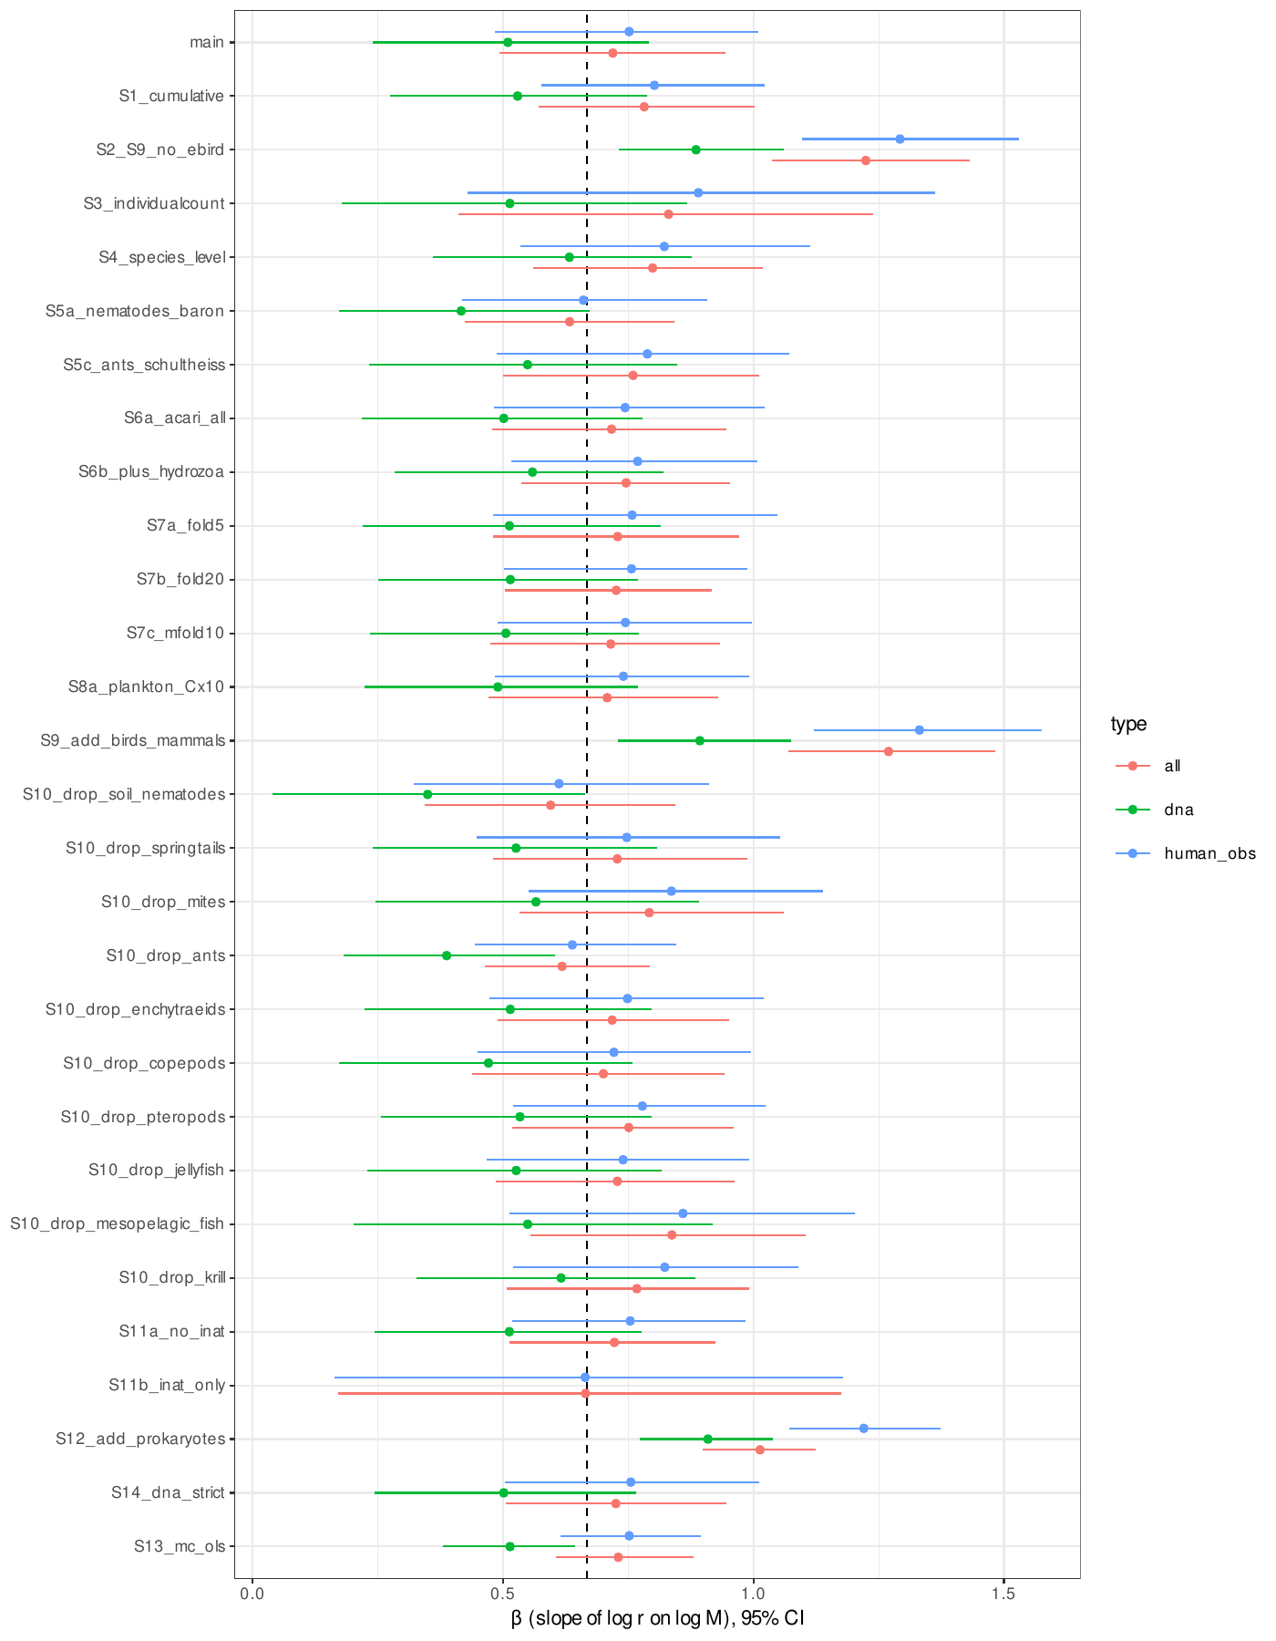
Fig. S1. Exponents of records per individual on body mass in the initial analysis. Posterior medians and 95% credible intervals of the exponent β in the main analysis and in all sensitivity analyses, for all records, human observations and DNA-derived records; the S13 analysis uses Monte Carlo propagation with ordinary least squares. The dashed line marks 2/3. Because abundance and body mass are collinear across groups, the exponent is not identifiable from the records (Table S11).
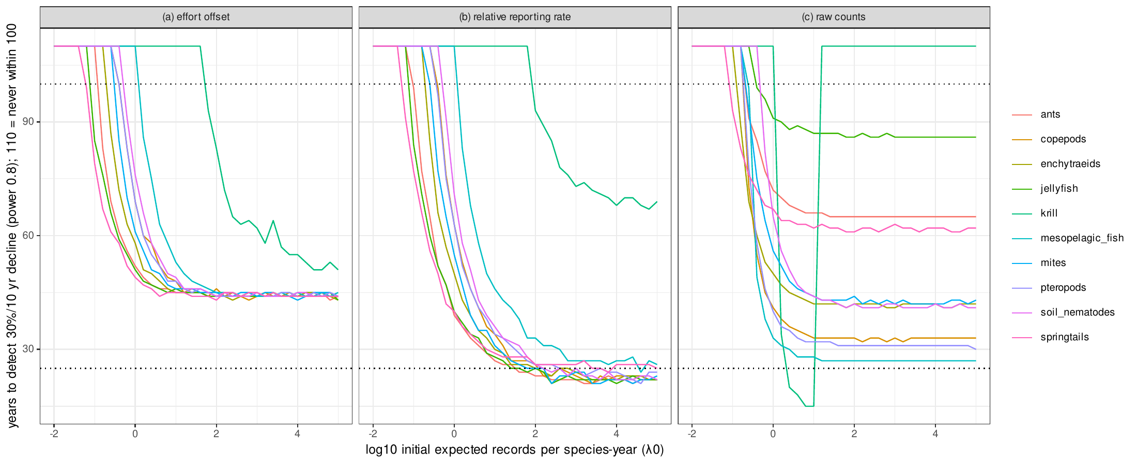
Fig. S2. Initial detection simulations. Years needed to detect a 30% decline per decade with power 0.8 against the initial expected number of records per species and year, for each group and the three analysis methods (negative binomial regression with an effort offset, binomial relative reporting rate, and negative binomial regression of raw counts), using the overdispersion estimated from mammal records (φ = 0.69) and each group’s observed recording trajectory. A value of 110 denotes no detection within 100 years; dotted lines mark 25 and 100 years.
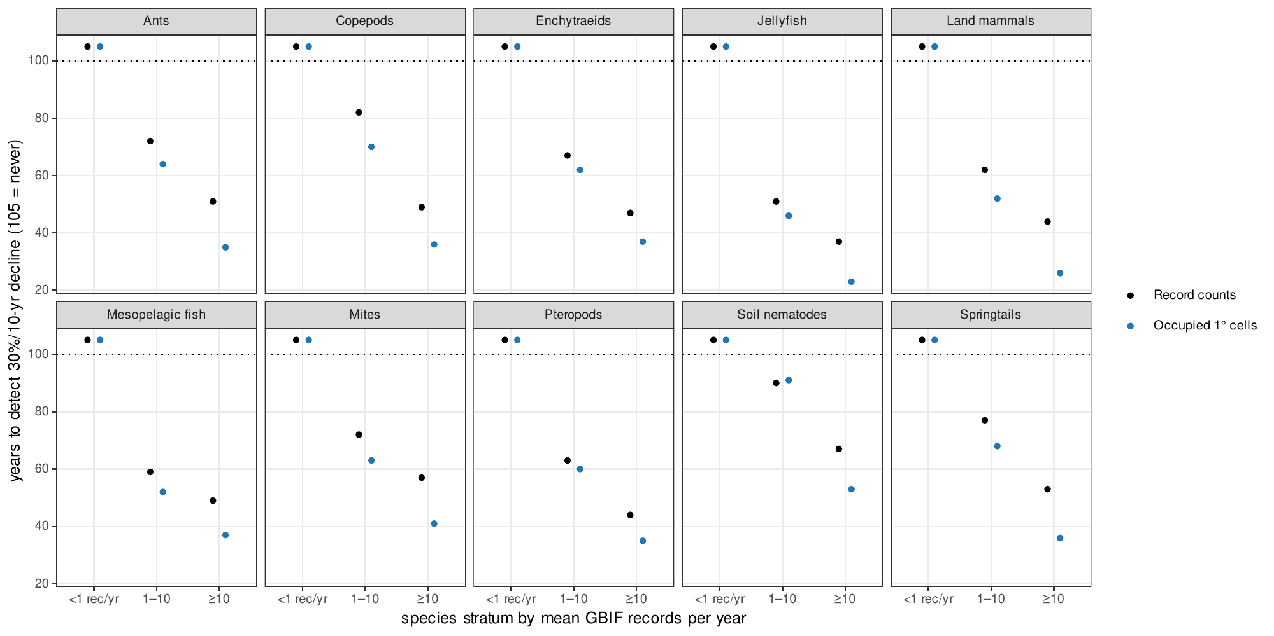
Fig. S3. Record counts versus occupied grid cells. Years needed to detect a 30% decline per decade using annual record counts (black) or the annual number of occupied 1° grid cells (blue), by group and stratum of mean records per species and year. Overdispersion was estimated separately for each index, and the occupancy index was assumed to decline in proportion to abundance, which is optimistic. A value of 105 denotes no detection within 100 years.
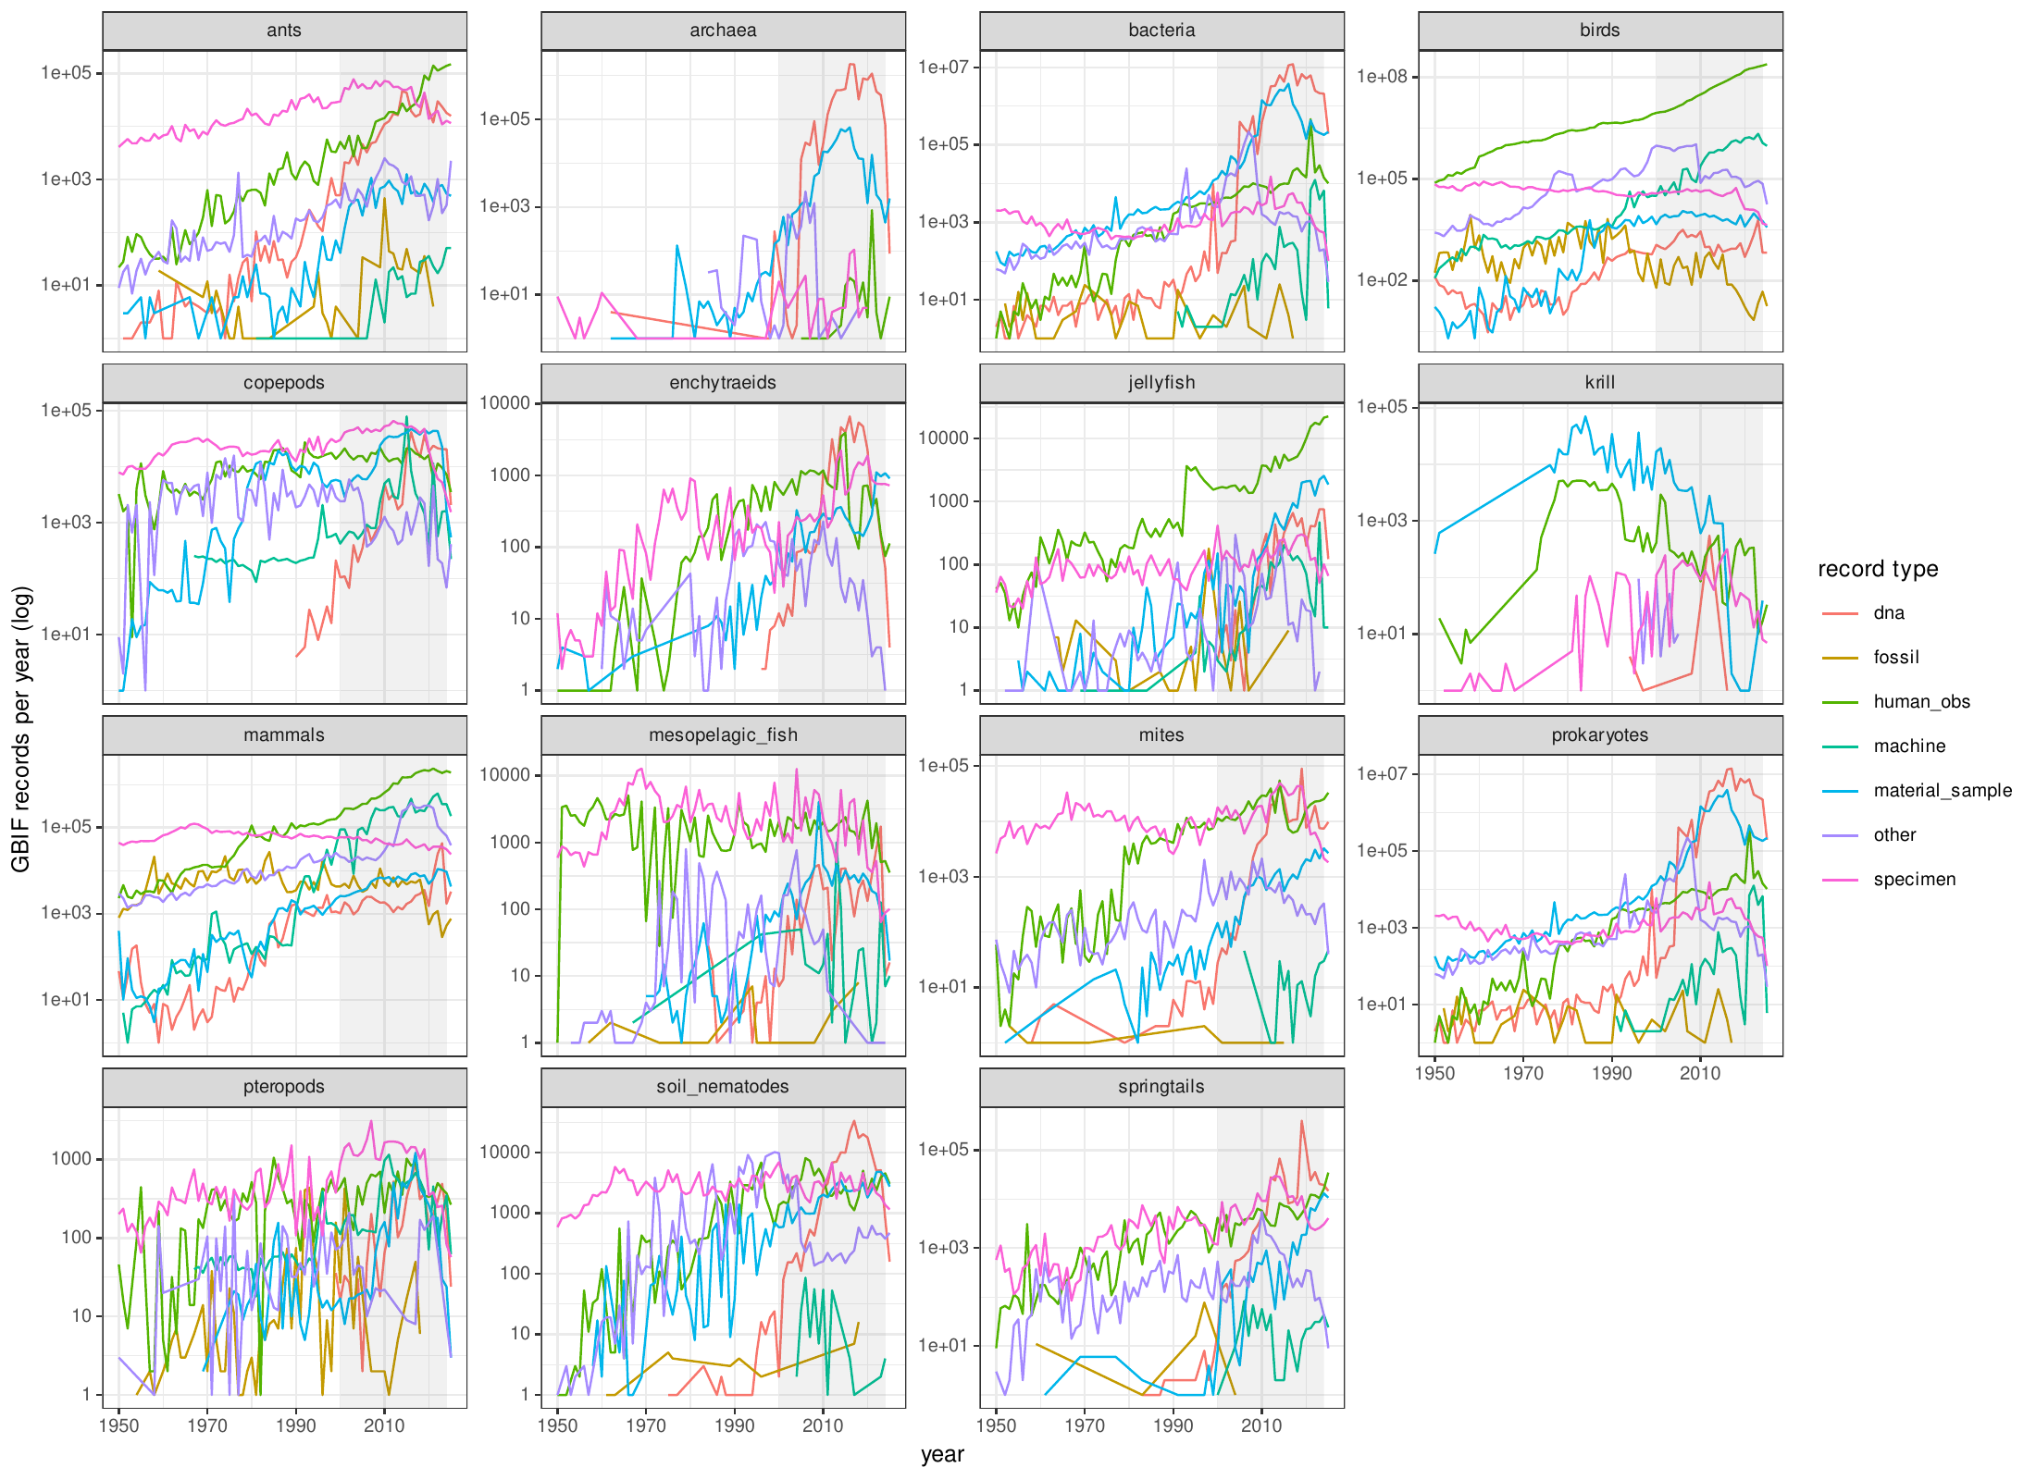
Fig. S4. Annual GBIF records by group and record type. Records per year from 1950 to 2025 (log scale) for each group, by record type (DNA-derived, human observation, specimen, machine observation, material sample and other). The shaded period (2000–2024) is the window analysed.
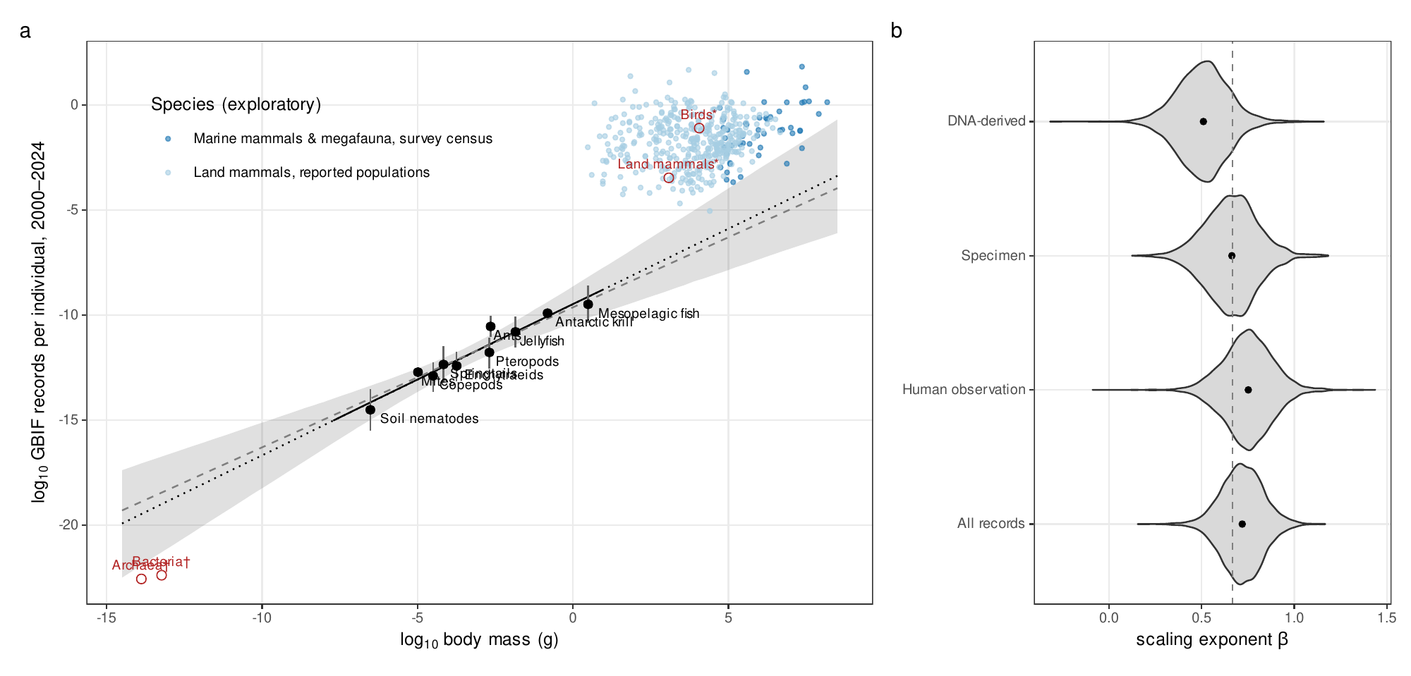
Fig. S5. Initial analysis of records per individual. (A) Records per individual against body mass for the ten groups with independent censuses (black; fitted relationship with 95% credible band, and the slope of 2/3 as a dashed line), groups with occurrence- or allometry-derived censuses or DNA-only records (red open symbols, not fitted), and mammal species with census abundances (blue). (B) Posterior distributions of the exponent by record type. Records per individual largely mirror abundance (main text, Fig. 2).

