**Coding exercise for Momenton**

* Developed using ASP.NET MVC5 in Visual Studio 2015.
* The data is sourced from json file ("~/Models/EmployeeList.json").
* The emphasis is on transforming the data and displaying the hierarchy
* Negative test cases not considered such as json file (EmployeeList.json) with invalid data

**Application Details**

Screenshot of landing page below:

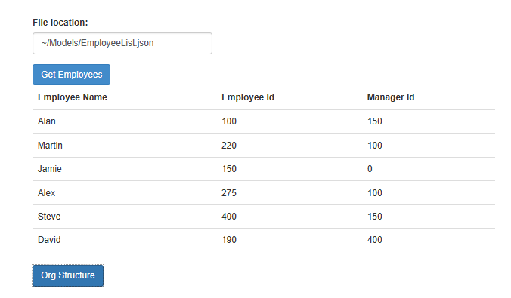

3

1

2

The page displays the sample list ("~/Models/EmployeeList.json") of employees.

A different list can be specified in the text box(1) and clicking on GetEmployees(2) will display the list on screen

Clicking on OrgStructure(3) will display the the processed tree structure of the employees as below:

