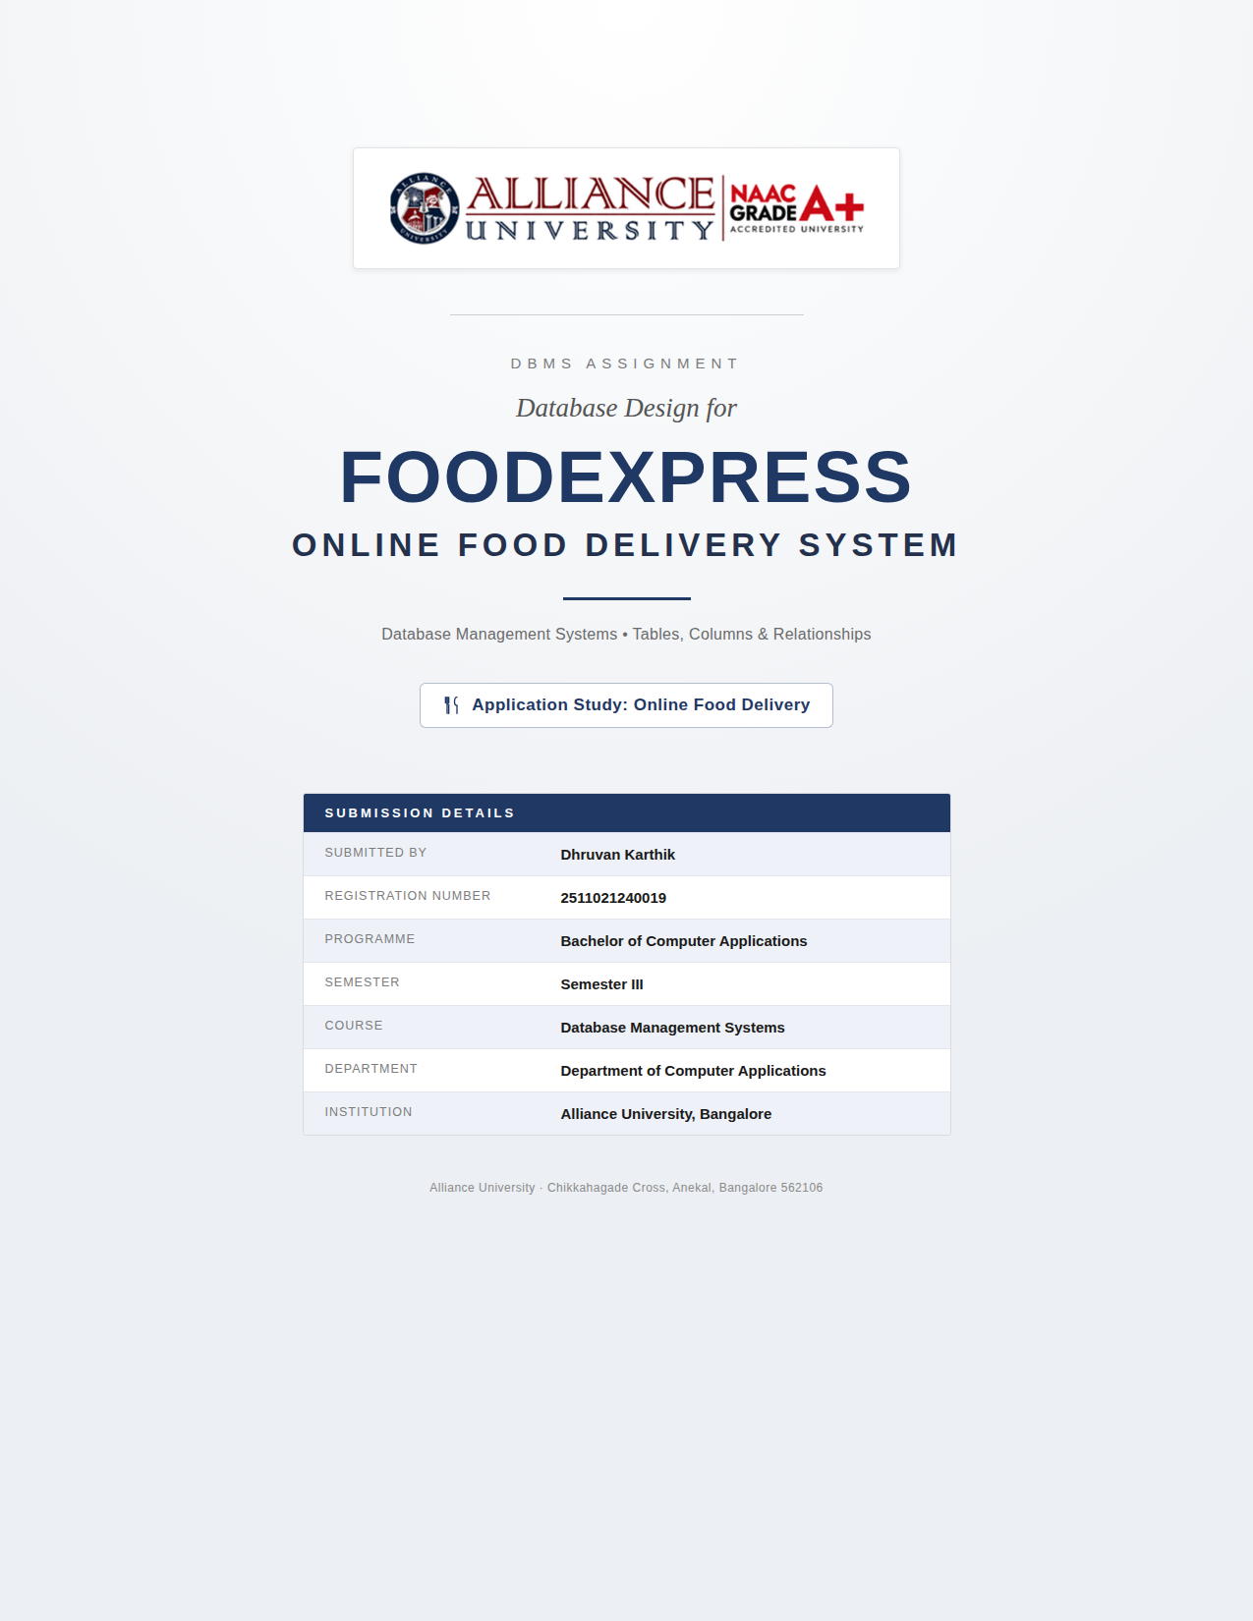

DBMS ASSIGNMENT
Database Design for an Online Food Delivery System
Identifying the tables required to manage a real-world food ordering and delivery application

1. Application Chosen and Purpose
Application: FoodExpress – Online Food Delivery System
Purpose: FoodExpress is a platform that connects customers, restaurants, and delivery agents. Customers browse restaurant menus, place orders, and pay online; restaurants prepare the ordered items; and delivery agents pick up and deliver the food to the customer's address. The underlying database must reliably track customers and their saved addresses, restaurants and their menus, the orders placed and the items within each order, delivery assignment, payment status, and post-delivery reviews. Each table below was chosen because it represents a distinct real-world entity or relationship in this workflow — no table exists merely to pad the design.

2. List of Required Tables
The system is represented using nine tables. Together they cover the four sides of the platform — customers, restaurants, orders, and delivery/payment/feedback — without duplicating information.
- Customers – Stores registration and login details of people who order food.
- Addresses – Stores one or more delivery addresses saved by each customer.
- Restaurants – Stores details of restaurants registered on the platform.
- MenuItems – Stores the food items offered by each restaurant, with price and availability.
- DeliveryAgents – Stores details of delivery personnel who deliver orders to customers.
- Orders – Stores the core record of every order placed, linking customer, restaurant, address and agent.
- OrderItems – Stores the individual food items and quantities that make up each order.
- Payments – Stores payment details and status for each order.
- Reviews – Stores customer ratings and feedback for completed orders.

3. Table Definitions (Columns, Keys, and Purpose)

3.1 Customers
Stores the personal and login details of every registered customer. This is the anchor table for identifying who placed an order and who saved which delivery addresses.
Column Name | Data Type | Key / Constraint | Description
customer_id | INT | Primary Key | Unique identifier for each customer.
full_name | VARCHAR(100) | NOT NULL | Customer's full name.
email | VARCHAR(100) | UNIQUE, NOT NULL | Customer's email address, used for login.
phone | VARCHAR(15) | UNIQUE, NOT NULL | Customer's contact phone number.
password_hash | VARCHAR(255) | NOT NULL | Encrypted password used for authentication.
registration_date | DATETIME | DEFAULT CURRENT_TIMESTAMP | Date and time the customer account was created.

3.2 Addresses
Stores one or more delivery addresses associated with a customer, since a customer may order to home, work, or other locations. Separating addresses from Customers avoids repeating address data and allows a customer to reuse a saved address across many orders.
Column Name | Data Type | Key / Constraint | Description
address_id | INT | Primary Key | Unique identifier for each address.
customer_id | INT | Foreign Key → Customers | The customer this address belongs to.
address_line | VARCHAR(255) | NOT NULL | House/street/locality details.
city | VARCHAR(50) | NOT NULL | City of the address.
state | VARCHAR(50) | NOT NULL | State of the address.
pincode | VARCHAR(10) | NOT NULL | Postal code used for delivery routing.
is_default | BOOLEAN | DEFAULT FALSE | Marks the address used by default for new orders.

3.3 Restaurants
Stores details of every restaurant partnered with the platform. This is the anchor table on the supply side, referenced by the menu items each restaurant sells and the orders placed to it.
Column Name | Data Type | Key / Constraint | Description
restaurant_id | INT | Primary Key | Unique identifier for each restaurant.
restaurant_name | VARCHAR(100) | NOT NULL | Name of the restaurant.
cuisine_type | VARCHAR(50) | NOT NULL | Primary cuisine offered (e.g., Chinese, Italian).
address | VARCHAR(255) | NOT NULL | Physical location of the restaurant.
contact_phone | VARCHAR(15) | NOT NULL | Restaurant's contact number.
avg_rating | DECIMAL(2,1) | DEFAULT 0.0 | Average customer rating, derived from Reviews.
is_active | BOOLEAN | DEFAULT TRUE | Whether the restaurant is currently accepting orders.

3.4 MenuItems
Stores the individual food items each restaurant offers, along with price and availability. Kept separate from Restaurants because one restaurant offers many items, and each item's price can change independently of the restaurant's own details.
Column Name | Data Type | Key / Constraint | Description
item_id | INT | Primary Key | Unique identifier for each menu item.
restaurant_id | INT | Foreign Key → Restaurants | The restaurant that offers this item.
item_name | VARCHAR(100) | NOT NULL | Name of the food item.
description | VARCHAR(255) | NULL | Short description of the item.
price | DECIMAL(8,2) | NOT NULL | Current selling price of the item.
category | VARCHAR(50) | NOT NULL | Menu category, e.g., Starter, Main Course, Dessert.
is_available | BOOLEAN | DEFAULT TRUE | Whether the item can currently be ordered.

3.5 DeliveryAgents
Stores details of delivery personnel who transport orders from restaurants to customers. Kept separate from Orders so an agent's profile persists across every delivery they are assigned.
Column Name | Data Type | Key / Constraint | Description
agent_id | INT | Primary Key | Unique identifier for each delivery agent.
agent_name | VARCHAR(100) | NOT NULL | Delivery agent's name.
phone | VARCHAR(15) | UNIQUE, NOT NULL | Agent's contact phone number.
vehicle_number | VARCHAR(20) | NOT NULL | Registration number of the agent's vehicle.
is_available | BOOLEAN | DEFAULT TRUE | Whether the agent is currently free for a new delivery.
avg_rating | DECIMAL(2,1) | DEFAULT 0.0 | Average delivery rating given by customers.

3.6 Orders
The central transaction table. Each row represents one order placed by a customer, linking together the customer, the restaurant, the delivery address used, and the delivery agent assigned, along with its current status and total value.
Column Name | Data Type | Key / Constraint | Description
order_id | INT | Primary Key | Unique identifier for each order.
customer_id | INT | Foreign Key → Customers | The customer who placed the order.
restaurant_id | INT | Foreign Key → Restaurants | The restaurant the order was placed with.
address_id | INT | Foreign Key → Addresses | The delivery address used for this order.
agent_id | INT | Foreign Key → DeliveryAgents, NULL | The agent assigned to deliver the order (set once assigned).
order_date | DATETIME | DEFAULT CURRENT_TIMESTAMP | Date and time the order was placed.
order_status | ENUM | Placed / Preparing / Out for Delivery / Delivered / Cancelled | Current stage of the order.
total_amount | DECIMAL(10,2) | NOT NULL | Final payable amount for the order.

3.7 OrderItems
A linking table that records which menu items, and how many of each, belong to a given order. This table is required because one order can contain many items, and one menu item can appear in many orders — a many-to-many relationship that cannot be represented inside the Orders table alone.
Column Name | Data Type | Key / Constraint | Description
order_item_id | INT | Primary Key | Unique identifier for each order line item.
order_id | INT | Foreign Key → Orders | The order this line item belongs to.
item_id | INT | Foreign Key → MenuItems | The menu item ordered.
quantity | INT | NOT NULL, > 0 | Number of units of this item ordered.
price_at_order | DECIMAL(8,2) | NOT NULL | Item price at the time of ordering (protects history if the menu price later changes).

3.8 Payments
Stores the payment made for each order, kept separate from Orders since a payment has its own lifecycle (pending, completed, failed, refunded) that is tracked independently of order preparation and delivery status.
Column Name | Data Type | Key / Constraint | Description
payment_id | INT | Primary Key | Unique identifier for each payment.
order_id | INT | Foreign Key → Orders, UNIQUE | The order this payment was made for (one payment per order).
amount | DECIMAL(10,2) | NOT NULL | Amount paid.
payment_method | ENUM | Cash / Card / UPI / Wallet | Mode of payment used.
payment_status | ENUM | Pending / Completed / Failed / Refunded | Current status of the payment.
payment_date | DATETIME | NOT NULL | Date and time the payment was made.

3.9 Reviews
Stores customer feedback and ratings submitted after an order is delivered, for both the restaurant and the overall experience. Kept separate from Orders because a review is optional and submitted after the fact, not part of placing the order itself.
Column Name | Data Type | Key / Constraint | Description
review_id | INT | Primary Key | Unique identifier for each review.
order_id | INT | Foreign Key → Orders, UNIQUE | The order being reviewed (one review per order).
customer_id | INT | Foreign Key → Customers | The customer who wrote the review.
restaurant_id | INT | Foreign Key → Restaurants | The restaurant being reviewed.
rating | INT | CHECK (1–5) | Star rating given by the customer, from 1 to 5.
comment | VARCHAR(500) | NULL | Optional written feedback.
review_date | DATETIME | DEFAULT CURRENT_TIMESTAMP | Date and time the review was submitted.

4. Relationships Between Tables
The tables are connected through primary key – foreign key relationships that mirror how the real application works: a customer can have many addresses and place many orders; a restaurant can list many menu items and receive many orders; and each order is broken down into line items so it can contain multiple dishes. The table below summarizes every relationship in the design.
Table A | Relationship | Table B | Description
Customers | 1 : M | Addresses | One customer can save many delivery addresses.
Customers | 1 : M | Orders | One customer can place many orders over time.
Restaurants | 1 : M | MenuItems | One restaurant offers many menu items.
Restaurants | 1 : M | Orders | One restaurant receives many orders.
Addresses | 1 : M | Orders | One saved address can be reused for many orders.
DeliveryAgents | 1 : M | Orders | One agent can be assigned to many orders (over time, not simultaneously).
Orders | 1 : M | OrderItems | One order consists of many order line items.
MenuItems | 1 : M | OrderItems | One menu item can appear as a line item in many orders.
Orders | 1 : 1 | Payments | Each order has exactly one payment record.
Orders | 1 : 1 | Reviews | Each order can receive at most one review.
Customers | 1 : M | Reviews | One customer can write many reviews (one per order).
Restaurants | 1 : M | Reviews | One restaurant can receive many reviews.
Note: Orders and MenuItems are also connected indirectly through OrderItems in a many-to-many relationship — one order can include many menu items, and one menu item can be part of many different orders. OrderItems resolves this by holding one row per (order, item) pair.

5. Conclusion
The nine tables above — Customers, Addresses, Restaurants, MenuItems, DeliveryAgents, Orders, OrderItems, Payments, and Reviews — together model the complete workflow of an online food delivery application: customer registration, restaurant and menu management, order placement, item-level order detail, delivery assignment, payment processing, and post-order feedback. Each table captures one clearly distinct real-world entity or relationship, primary and foreign keys enforce the connections between them, and no table was added purely to inflate the count. This design demonstrates how a normalized relational database can represent a real-world application end to end.

