Tutorial 1

- Differentiate the stack and heap memory in C++.
Stack Memory | Heap Memory
Auto | Manual
Managed | Unmanaged
Limited | Unlimited

- What is a pointer?
A variable that stores the memory address as its value.
- What is passing by reference and passing by value in function parameters?
- Passing by reference means to pass the reference of an argument in the calling function to the corresponding format parameter of the called function.
- Pass by value means make a copy in memory of the actual parameter’s value
- Describe the advantages of the Object Oriented Paradigm.
- Reusable- If you do correctly.
- Reliable
- What do the following stand for:
  - API – Application Programming Interface
  - IDE - Integrated Development Kit
  - SDK – Software Development Kit/ System Development Kit
- Describe a game engine.
-Game engine is a collection of tool to simplify the process of making a game. Game engine will turn into the game..
- List some examples of Multimedia APIs.
-Direct X
-OpenGL
-Oracle
- Sketch how DirectX is involved in the relationship between a Windows application and the graphics hardware (DirectX Architecture).
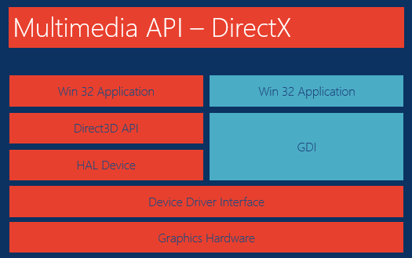
- Suggest some basic components required in a 2D game engine.
- System
- Initialize
- Input
- Physics
- Rendering
- Audio
- Cleanup
- Illustrate the typical game engine program structure.
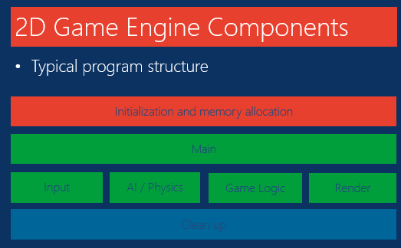

Tutorial 2
- Describe the relationship between using the Windows API and DirectX.
- What is the meaning of “pre-processors” and provide some examples.
Pre-processors is a way to communicate to the compiler.
enum
- Describe the WinMain structure.
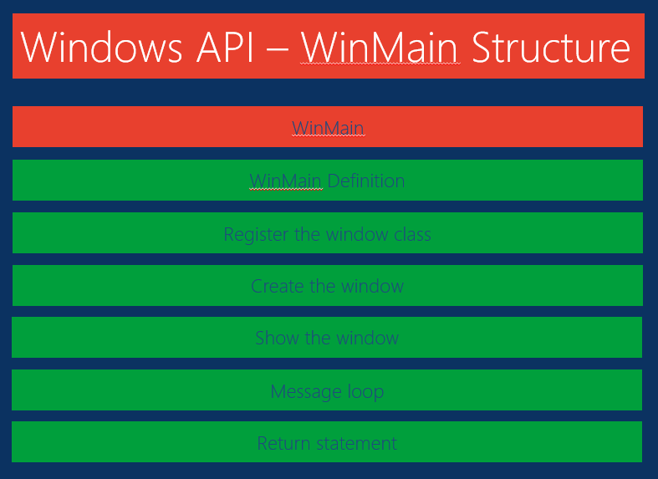
- What is the purpose of a Windows class?
To customize a window
- What is the Windows message loop?
It is an infinite loop that obtain messages
- Describe how the message loop works.
Window OS get message from the user and translate the message.
- Differentiate GetMessage from PeekMessage.

GetMessage() is a blocking function, it will return only when it receive the message.

PeekMessage() will return when get the message or not.

- Describe the difficulties in debugging Windows programs.
Windows programs sometime run in a infinite loop and it is hard to keep track of the bug.
Tutorial 3
- What are the 4 steps involved in setting up a DirectX application (ignoring the requisite windows code)?
-Create pointers to Direct3D object and device.
-Create the Direct3D object.
-Create the Direct3D device.
-Draw to the device.

- What is the purpose of hResult?
Use to check if the process is success or failed
- Describe the steps listed in Q1 above in detail.
- Describe the purpose of the DX presentation parameters.
- Describe the complete program structure of a DirectX Windows program.
Pre-processor
Global variable
Function prototype
WindowProcedure
Main
Create Window
Create DX
Message Loop
GetInput
…
CleanUp

- What are sprites within the computer gaming world?
-Brush
-Interface
- Describe the three ways sprites/2d textures can be presented on screen.
-Surfaces approach
-D3DXSprite approach
-Texturing a polygon approach
- List the three steps involved in drawing a sprite using the D3DXSprite Object/Interface
CreateSpriteBrush
CreateTexture
Draw
- There are multiple steps involved in the final drawing of the texture. List them.
GPU->Clear Buffer
GPU->Begin Scene
SpriteBrush->Begin
SpriteBrush->Draw
…
SpriteBrush->End
GPU->End Scene
GPU->Present
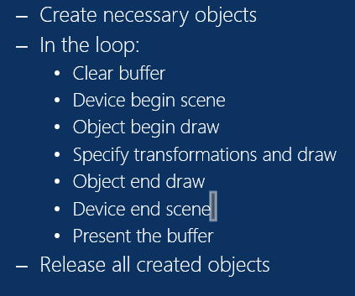
- Explain the steps in Q9 in detail.

Tutorial 4
- What is the purpose of Double buffering?
  - Ensures there is a complete picture in memory ready to draw to the screen when it time for the monitor

- List the steps involved in drawing lines in Direct3D9.
- Initialize the ID3DXLine interface
- Prepare the device for drawing lines
- Draw the lines
- End the drawing

- What is the main difference in drawing lines compared to drawing sprites?
- Need to know the arrays of vertices that make up the line
- Number of vertices in the vertex list

- List the steps involved in drawing font/text in Direct3D9.
- Initialize the font interface
- Draw the text
- What is the main difference in drawing font/text compared to drawing sprites?
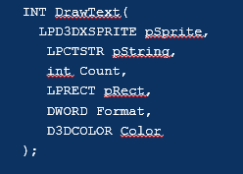

Fonr family – Visual style of text, includes ALL variants of te font, such as bold, italic, and from different size

Font face – Visual style of text

Tutorial 5
- How are inputs captured in a regular windows program?
- Windows message is captured in the message loop, whereby the program will ask the OS whether there is a message for it, and the it will translate and dispatch.
- Explain what is meant by wparam and lparam and identify how they are used for keyboard and mouse input.

Keyboard
- Character buffer (delay when you hold down a key)
- Design for single keypress at a time
- Sticky keys
- Input data limited by OS

Mouse
- Input data limited by OS(low resolution input)
- Does not support many mouse buttons
- Returns absolute position

- What is the weakness of using windows input? You should answer both in terms of keyboard and mouse input.
  - Keyboard
- Char buffer
- Frequency/high resolution
- Harder to detect multiple key press
- Windows key/sticky keys

  - Mouse
- Frequency/ high resolution
- Absolute position
- Mouse acceleration
- Describe the benefits of DirectInput over Windows Input.
- Directly retrieve input from hardware, instead of going through the windows OS
- High resolution
- Support gaming peripherals (joystick)
- Handle haptic feedback
- We can set cooperative level (exclusive control, background control, disable windows key)
- Mouse – Support extra mouse button
- Mouse – get relative position – give infinite movement in any axis
- Keyboard – unbuffered

- List the 5 steps involved in setting up DirectInput.
-Include Library
- Create pointer
-Create IputObject
-Use InputObject to make device
-Setting the data format
-Set Cooperative Level

- What is the special pre-processor needed for DirectInput and why?
- Does the DirectInput device have to be created for each and every hardware (keyboard + mouse)?
-Yes
- What is the reason for setting the cooperative level?
- Exclusive control?
- Disable windows key
- Background control (play for multiple instance at the same time)
- Describe how keyboard data is obtained for DirectInput.

KeyArray[0] = what alphabet??? What Key?
- Describe how mouse data is obtained for DirectInput.

Tutorial 6
- What is the problem with animations without timers?
- Explain the concept of how a timer can help with the problems in Q1 with the aid of an example.
- How are animations achieved in game programming?
- Describe what is meant by a spritesheet
- Describe what is meant by clipping
- Explain the logic for achieving simple rectangle collision

Tutorial 7

- In your own words, explain Newton’s first law of motion
- Explain how Newton’s first law of motion can impact your game mechanics
- In your own words, explain Newton’s second law of motion
-F=ma
- Explain how Newton’s second law or motion can be expressed in programming
- In your own words, explain Newton’s third law of motion
- Describe how the different laws of motion can be observed in a basketball that is thrown upwards.

Tutorial 8

- Write the pseudocode for the bounding box collision detection method
- Write the pseudocode for the quick collision detection method
- Discuss possible problems with the bounding box and quick collision method
- Suggest ways to overcome the problems discussed in question 3.
- Describe 5 uses for collision detection in an interactive program
- Why do we need to prioritize collision detection?
- How can the physics routine be optimized in a game?
- List some common physics effects observable in modern (less than 5 years old) games.
- Differentiate Physics modelling from physics simulation
- Identify the difference forces that will have to be modelled in order to recreate the natural effects of a rubber ball thrown upwards when on earth.
- List some areas of on-going game physics research

Tutorial 9

- List 5 ways sound can be used in a game.
- DirectSound utilizes multiple sound buffers. List and describe these buffers
- Describe the steps required to configure Visual Studio to work with FMOD Ex

Tutorial 10

- Describe parameters for the System::createSound()function.
- Differentiate the System::createSound() from System::createStream() functions
- Explain how sound can be manipulated using FMOD.
- What would happen if a channel’s frequency was set to a negative value?
- Provide 3 examples that use looping sound.
- Identify other methods for playing sound in a windows game.

Tutorial 11
- Describe the importance of the User Interface
- What are the two main types of UI controls?
- List 5 uses for labels
- List 5 uses for buttons
- How can tree views be useful in a OO user interface?
- Describe what is meant by
  - Z ordering
  - Notification
  - Focus

