**Home Page**

1. We need a description under each box with functionality to amend in CMS



1. Can we have a link to Team Page in this section



**Our Teams**

http://clientapp.narola.online/hd/cag/admin/pages/edit/13

In Our Teams page I amended the header as shown but it dues not change on website

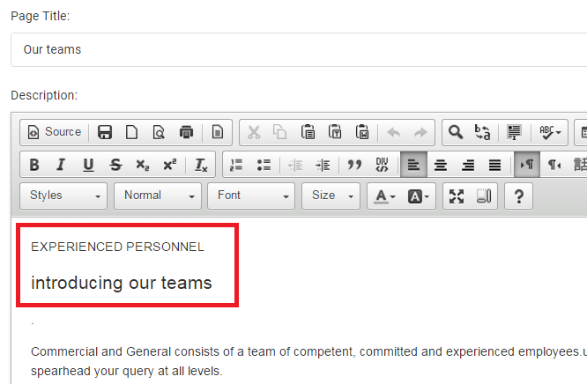

1. Also in http://clientapp.narola.online/hd/cag/admin/pages/edit/13

Because we now have a facility to create team members – should we delete employee details on this page??

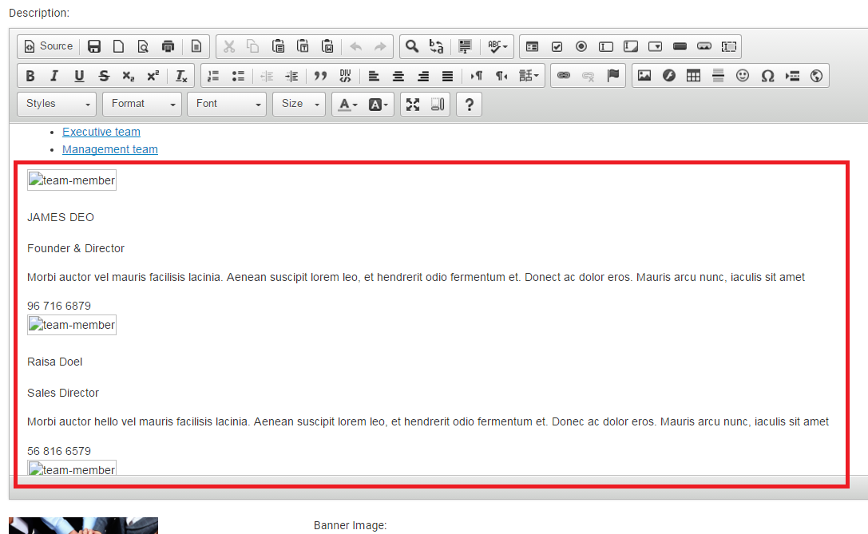

1. In Our Team section – can we add a column so we can see name as well as image please.

