VFit — Signup-to-Booking User Journeys
Provider and customer, from account creation to a confirmed appointment
How a provider (trainer) and a customer get from creating an account to a confirmed appointment, step by step, with a screenshot of every screen.
Italian version: signup-to-booking.it.md.
Recorded | 30 September 2026 (second recording, after the responsive pass), against the staging backend (vfit-app-staging), app built from main @ 9f9af27
Updated | 1 October 2026: the screens changed by the UI fixes were re-shot on the deployed staging app (main @ 9a2fcae), see Re-shoot on 1 October 2026
Device | Mobile viewport 390 × 844 (iPhone 12/13/14 size). Long screens are captured at full height
Theme | Dark
Language | English (the app also ships in Italian, Spanish, French and German)
Provider used | Davide Moretti, journey.en.provider@vitfitdemo.dev
Customer used | Elena Gallo, journey.en.customer@vitfitdemo.dev
Resulting booking | Dfi6vOZj7RoHLRkQkNn0: Personal Training, Fri 2 Oct 2026, 10:00–11:00, €50
Both accounts were created fresh for this walkthrough. Nothing in it was seeded or mocked.
About the 1 October re-shoot. By then the Fri 2 Oct request had already been confirmed, so the screens that need an open request (B10–B13, A14–A15) were re-taken with a second request from the same customer to the same trainer: Fri 9 Oct 2026, 10:00 (zMF09KunKbRCmuyyTxiQ), confirmed by the trainer and then cancelled by the customer. Those screenshots show Oct 9; the rest of the walkthrough is unchanged.

The two journeys at a glance
The two journeys meet at the booking request. The provider must be live, with at least one active and priced service, before a customer can book them.
# | Provider (trainer) | Customer
1 | Opens the landing page → Register as a provider | Opens the landing page → Register as a customer
2 | Fills in the signup form and ticks I also want to offer services as a professional, picking the services they offer | Chooses a signup method (email, Google, Apple, phone/SMS) and fills in the signup form
3 | Is approved on the spot: role provider, verified, default Mon–Fri 09:00–17:00 hours, one inactive draft service per chosen category | Lands on Home
4 | Sets a price on a draft service and activates it | Opens Book a service, finds the trainer (search, category or Near me)
5 | Checks their availability and sets a location so they appear in Near me searches | Opens the trainer’s page, picks a service, a date and a time slot
6 |  | Reviews the booking, accepts the terms and taps Confirm. The booking is created as a request
7 | Gets a New booking request notification and confirms the booking
8 | Sees the appointment under Upcoming Appointments | Gets a Booking accepted notification. The booking shows as Confirmed
Booking status lifecycle covered here: requested (“Awaiting confirmation”) → accepted (“Confirmed”). The later statuses (completed, cancelled, reviewed) are outside the scope of this document.
Payment: at this stage customers pay the trainer directly, in person or as agreed (cash, Satispay, bank transfer). Nothing is charged in the app. After the session the trainer records the payment.

Part A: Provider journey

A1. Landing page
The visitor opens the app. The hero offers two entry points: Register as a customer and Register as a provider. The provider taps Register as a provider.
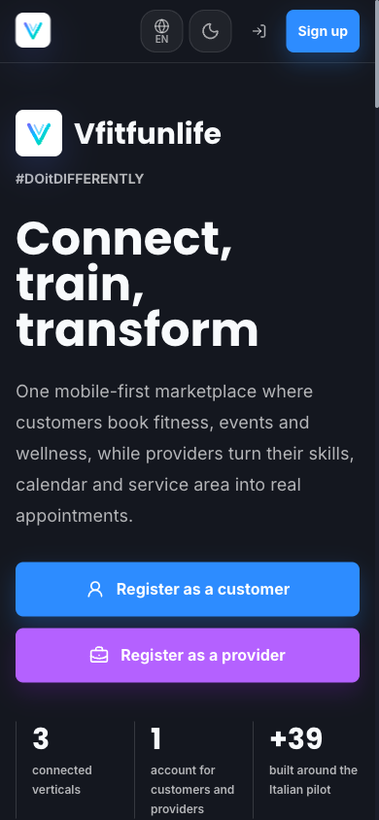
Landing page

A2. Signup form (provider mode)
Register as a provider opens /auth/register?as=provider. It goes straight to the email signup form, with the professional opt-in already ticked. A row at the top holds the language picker and the light / dark / system theme switch; the Back link sits below it.
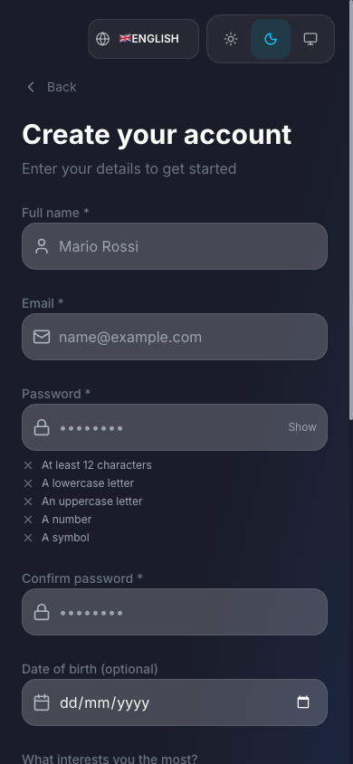
Empty provider signup form

A3. Personal details
The provider enters:
- Full name and Email (required)
- Password and Confirm password. The live checklist requires at least 12 characters, a lowercase letter, an uppercase letter, a number and a symbol.
- Date of birth (optional)
- What interests you the most?: VFit, VFun or VLife (here: VFit)
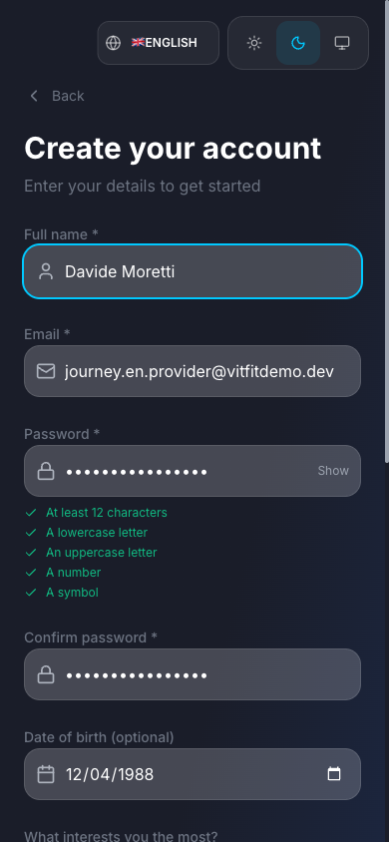
Provider details filled in

A4. Professional opt-in and services offered
With I also want to offer services as a professional ticked, the provider picks the services they offer from the platform catalogue. They choose a category (e.g. Strength & Conditioning) and then one or more services. Here: Personal Training and Functional Training. They tick the box to accept the Terms of Service and Privacy Policy (the ticked box is filled in the section colour, with the text right next to it) and tap Create account.
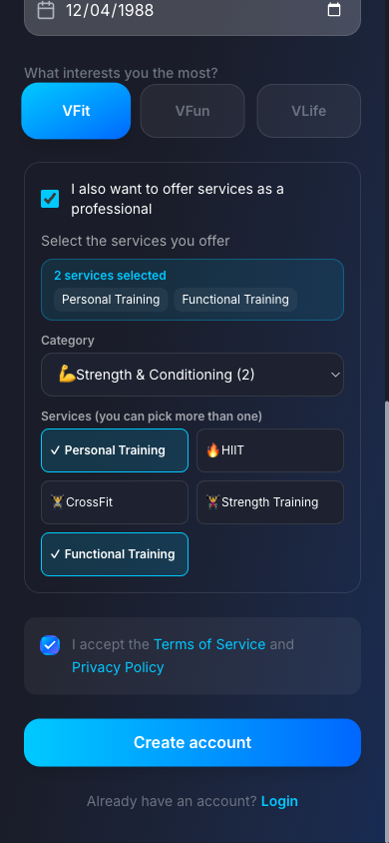
Professional opt-in with two services selected
What happens behind the scenes. Provider auto-approval is on by default (systemSettings/providerOnboarding.autoApprove, switchable on /admin/providers), so the applyAsProvider function approves the account immediately: role provider, verified provider profile, default Mon–Fri 09:00–17:00 availability, and one inactive, €0 draft service for each service picked. If an admin switches auto-approval off, the application goes to a pending queue instead.

A5. Permissions
After signup the app asks for Location (to find nearby gyms, events and services) and Notifications (booking updates). Both are optional. The provider can allow them or tap Skip for now.
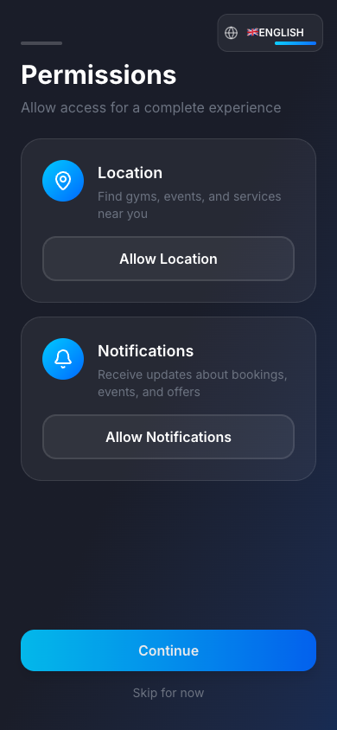
Permissions screen

A6. Provider dashboard
The provider lands directly in the Provider portal. The dashboard confirms they are already bookable (“You’re bookable Mon–Fri 9:00–17:00 — check your hours”) and suggests adding a location. A Confirm your email banner above the Provider portal bar asks them to click the verification link sent to their inbox. It does not block anything in this journey.
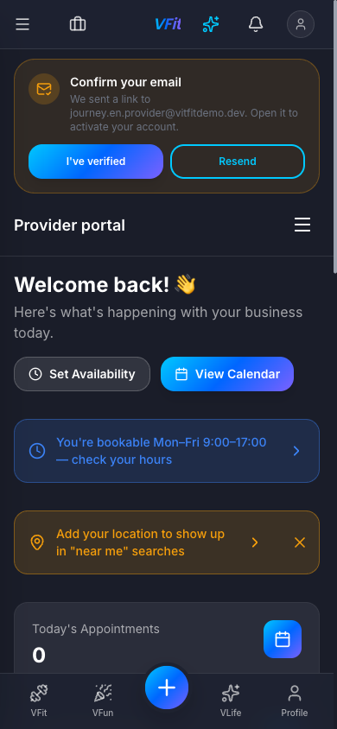
Provider dashboard on first login
This screenshot is from 30 September and still shows the old greeting. A new provider is now greeted with Welcome! (“Welcome back!” only once they have delivered a session); see A16.

A7. Services: the drafts created at signup
Provider portal → Services lists one draft per service chosen at signup. Drafts are Inactive at €0, so customers cannot book them until the provider sets a price.
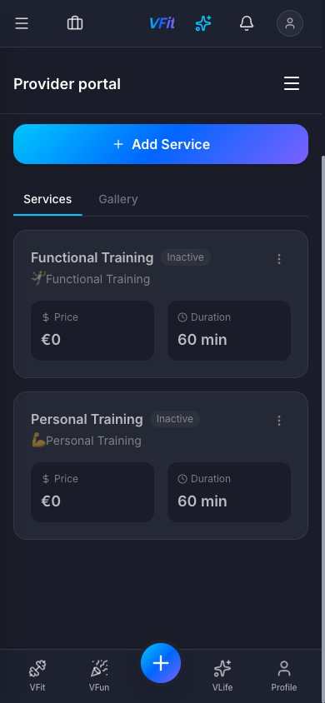
Services list with two inactive drafts
Screenshots A7 and A8 are from 30 September (the draft state can’t be recreated). Prices on the provider’s screens are now written out in full, e.g. €0.00 and €50.00 (see A10).

A8. Open the service actions
The ⋮ menu on a service card offers Edit, Duplicate, Activate and Delete. The provider opens it on Personal Training and taps Edit.
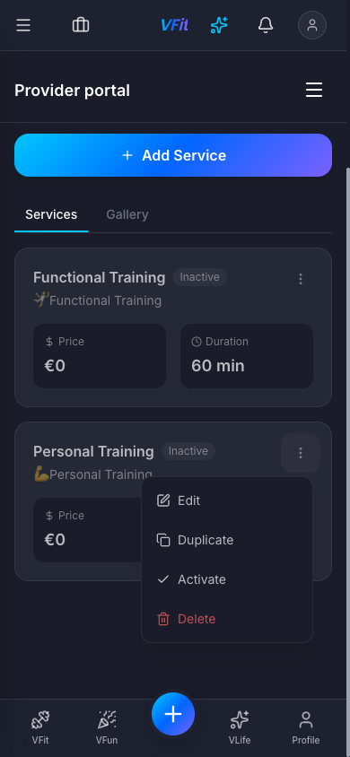
Service actions menu

A9. Price and activate the service
In Edit Service the provider adds a description, sets Price (€) to 50 and keeps Duration at 60 min. They tick Service is active and tap Save Changes. The dialog is centred on the phone; Esc or Cancel closes it without saving. (New services can also be added with Add Service, either from the catalogue or as a custom service.)
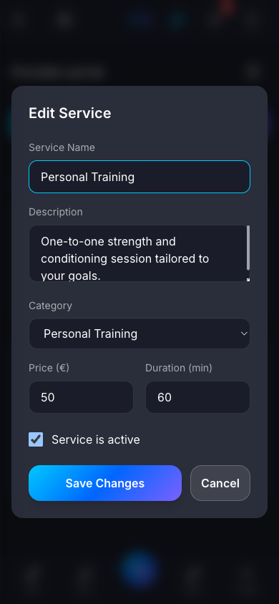
Edit Service dialog

A10. The service is live
Personal Training now shows €50.00 / 60 min and its description, with no Inactive badge. The provider appears in search results with From 50,00 €.
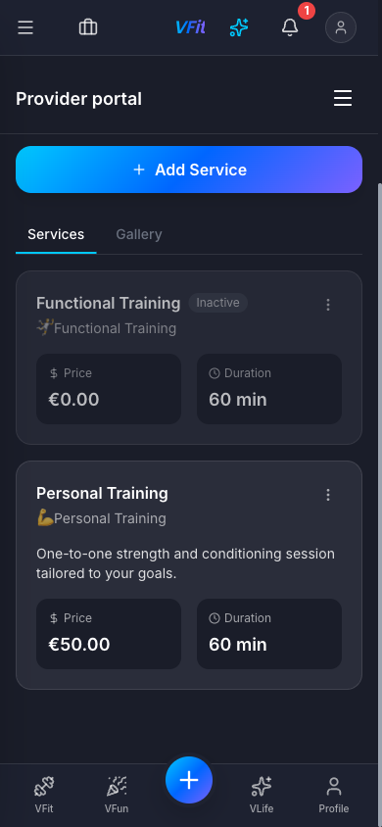
Personal Training active at €50

A11. Availability (optional check)
Provider portal → Availability shows the weekly schedule created at signup: Monday to Friday, one slot each (09:00–17:00), weekends off. It also has general settings:
- Buffer Time: 15 minutes
- Min. Advance Notice: 24 h
- Max Bookings per Day: 8
- Timezone: Europe/Rome
Date Overrides covers holidays and one-off changes.
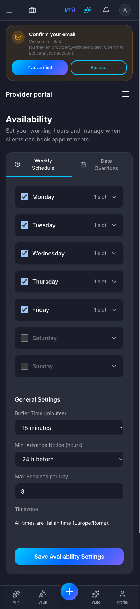
Availability settings

A12. Location (recommended)
Provider portal → Location sets where the provider works. They search an address (here Piazza Gae Aulenti, Milano), fine-tune the pin on the map, check the City and tap Save location. The confirmation reads “Location saved: you now show up in ‘near me’ searches.” Only an approximate position (~100 m) is stored. The map follows the app theme: dark here, light in the light theme.
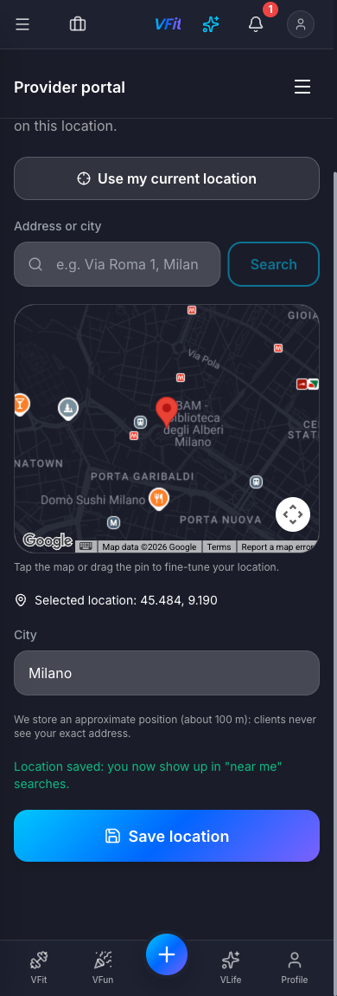
Location picker
Customers can find the provider by typing their name even without a location. The location adds them to Near me results and shows the distance.
The provider is now live. Part B shows the customer booking them. The provider’s side then resumes at A13.

A13. New booking request notification
When the customer books, the bell shows an unread badge. Notifications shows “New booking request — Elena Gallo requested Personal Training (Fri, Oct 2, 10:00 AM). Accept or decline it in the app.”
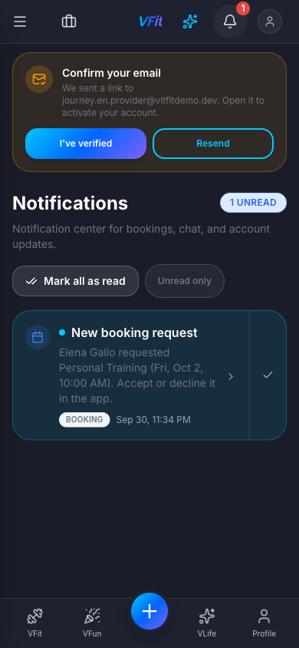
New booking request notification

A14. Bookings: the request awaiting confirmation
Provider portal → Bookings shows each booking as a card on a phone: client avatar, name and email, status AWAITING CONFIRMATION (under the name on a phone), service and duration, date, time and price, with the Confirm and Decline buttons always visible. The tabs filter by All, Pending, Confirmed, Completed and Cancelled; there is also a client-name search, Filters and Export.
(Re-shot with the Oct 9 request; the confirmed Oct 2 booking is the card below it.)
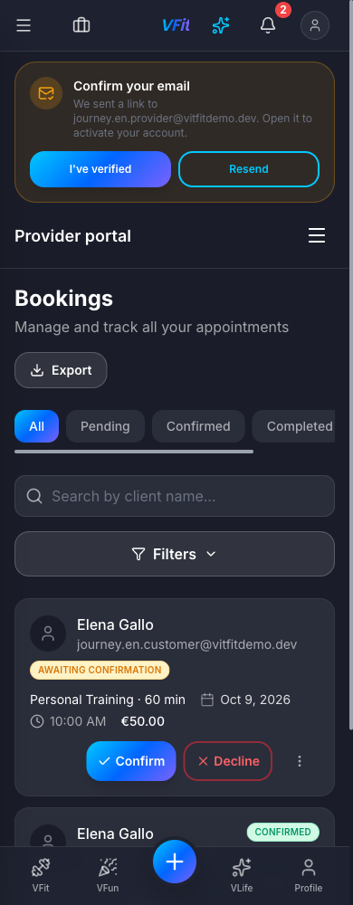
Provider bookings, request awaiting confirmation

A15. Confirm the booking
The provider taps Confirm. The button shows a spinner, then the card switches to CONFIRMED and a toast reads “Booking confirmed: the client will be notified.” The card action becomes Complete, which is used after the session.
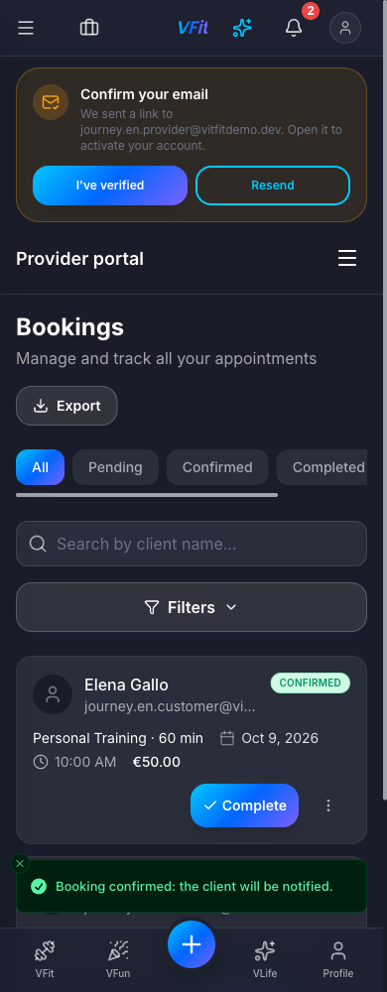
Booking confirmed

A16. Dashboard: upcoming appointment
The greeting reads Welcome!, since the provider has not delivered a session yet. The dashboard counts 1 under This Week’s Bookings. Upcoming Appointments lists Oct 2 · 10:00 AM · Elena Gallo · Personal Training · Confirmed, with a Details button. Recent Activity lists Booking confirmed and New booking request for Elena Gallo · Personal Training, newest first; each entry opens the booking.
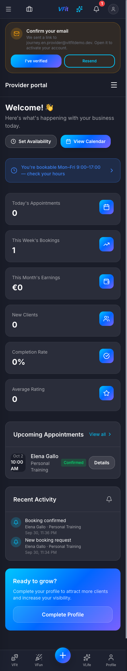
Dashboard with the upcoming appointment

Part B: Customer journey

B1. Landing page
The visitor taps Register as a customer.
Landing page

B2. Choose a signup method
Customers choose how to sign up: Email and Password, Google, Apple or Phone (SMS). This walkthrough uses email.
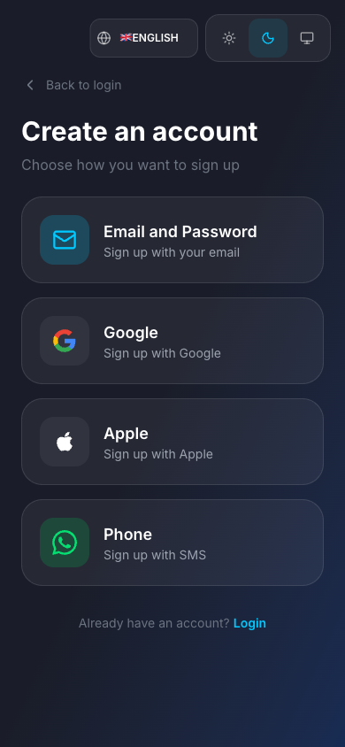
Signup method picker

B3. Signup form
This is the same form the provider used, but with the professional opt-in unticked.
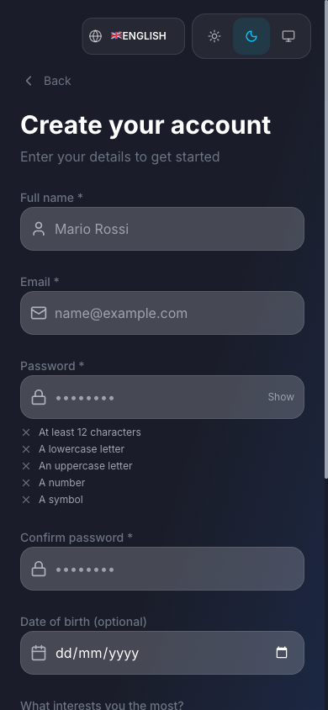
Empty customer signup form

B4. Fill in and create the account
The customer enters their name, email, a password that meets all five rules, an optional date of birth and their main interest (VFit). They accept the Terms of Service and Privacy Policy and tap Create account.
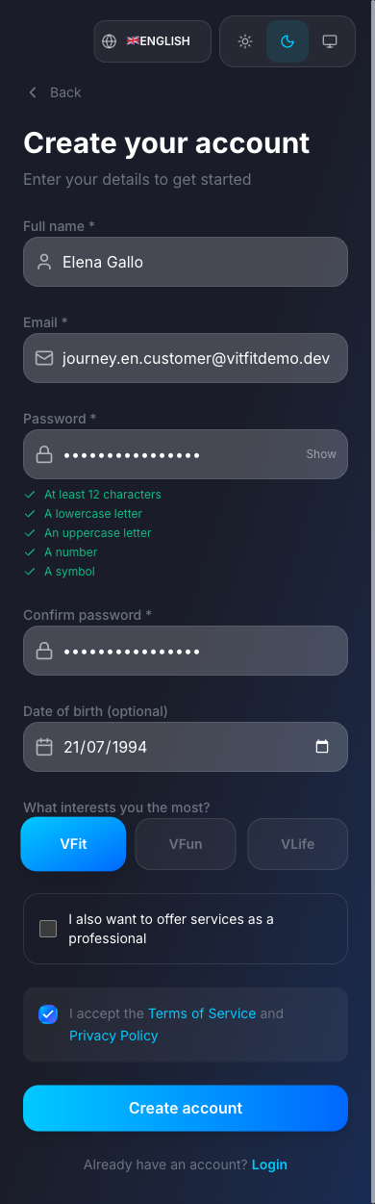
Customer signup form filled in

B5. Permissions
This is the same optional Location and Notifications step as the provider’s. The customer taps Skip for now. Allowing location here makes Near me one tap later.
Permissions screen

B6. Home
The customer lands on Home, which shows gyms and locations, active classes, the VFit map and Find your online coach. The same Confirm your email banner appears.
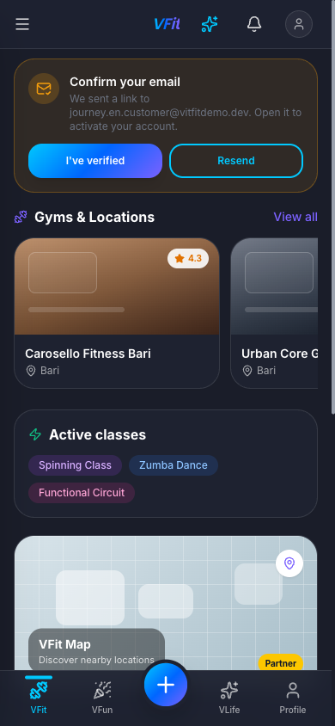
Customer home

B7. Book a service
The Book now button (centre of the bottom bar) or Search opens Book a service (/booking). The customer can:
- search by trainer or service name
- filter by category (Strength & Conditioning, Cardio & Endurance, Combat Sports, Mind & Body, Dance & Group, Therapy & Recovery, Nutrition & Lifestyle, Mental Wellness) and with Filters
- use Near me with a radius (5 / 10 / 25 / 50 km / All)
- switch between list and map view
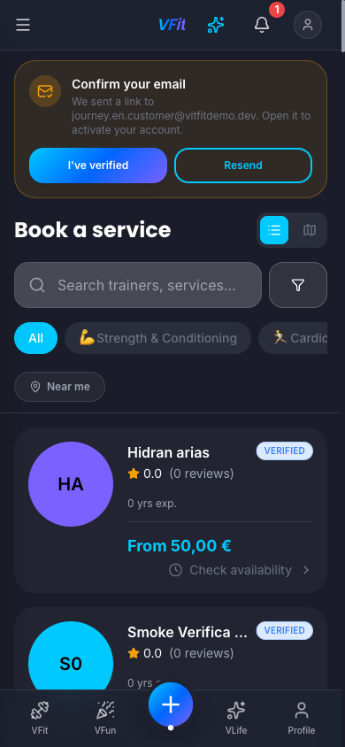
Book a service

B8. Find the trainer
The customer taps Near me, which uses the device location (here near Porta Nuova, Milan) with a default radius of 25 km, and types the trainer’s name. Davide Moretti appears first, marked VERIFIED, From 50,00 € with the distance (0.1 km) next to the price. (A seeded trainer with the same name shows up further down, 1.3 km away.) They tap Check availability.
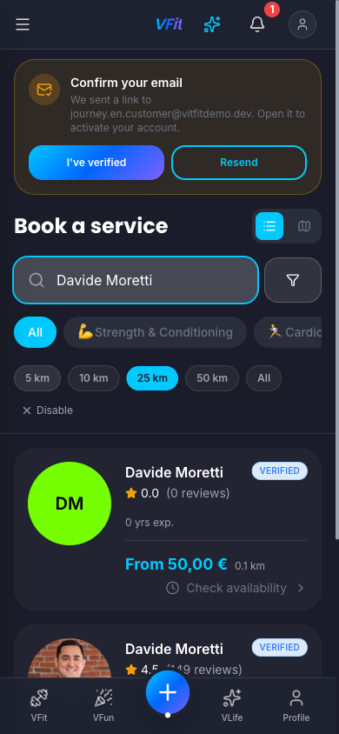
Near-me result for the trainer

B9. Trainer page: select a service
The trainer’s page (/book?providerId=…) has Services, Reviews and About tabs and the Message and Check availability buttons. Under Select a service the customer taps Select on Personal Training (1 h, 50,00 €).
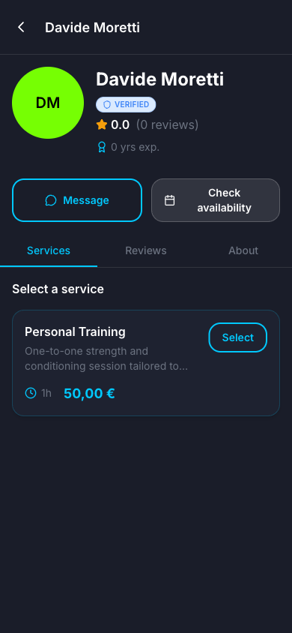
Trainer booking page

B10. Pick a date
The calendar opens on the current month and the customer taps Friday 2 (in the re-shot screenshot, Friday 9). Only days with at least one free slot can be tapped: weekends, days off and days inside the provider’s 24 h notice period (here today, Thu 1) are greyed out. They pulse briefly while the calendar checks the month.
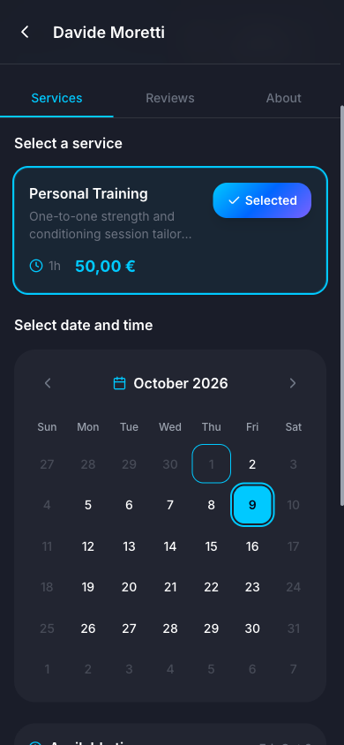
Date picker

B11. Pick a time
Available times lists the free 30-minute start times, grouped into Morning and Afternoon (Europe/Rome time). The customer picks 10:00. The footer summarises Personal Training · Fri, Oct 2 · 10:00 (Fri, Oct 9 in the screenshot), and they tap Continue.
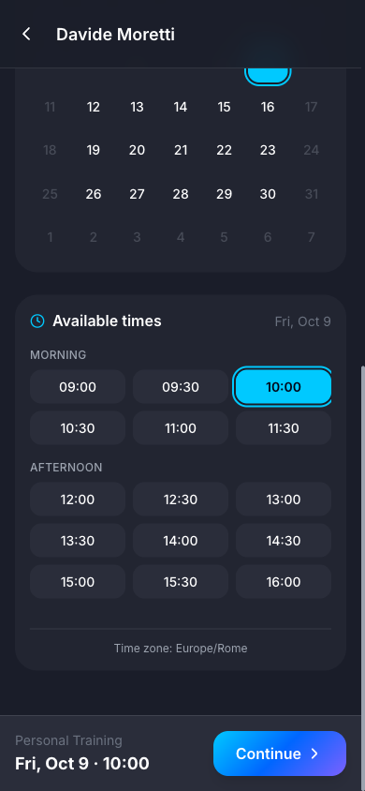
Time slot picker

B12. Confirm booking
The confirmation screen (/booking/confirm) shows:
- the trainer, service, date and time (Friday, October 2 · 10:00 · 60 min; October 9 in the screenshot) and city (Milano)
- Note for the trainer (optional), up to 500 characters
- Promotional code and Use my points (100 points = 1,00 €)
- Price summary: Service 50,00 €, Total 50,00 €
- Pay your trainer: nothing is paid in the app; the customer pays 50,00 € directly, and earns +50 XP once the trainer records the payment after the session
- the Terms of service and Cancellation policy checkbox (free cancellation within 24 hours), which is required
The customer writes a note, ticks the checkbox and taps Confirm.
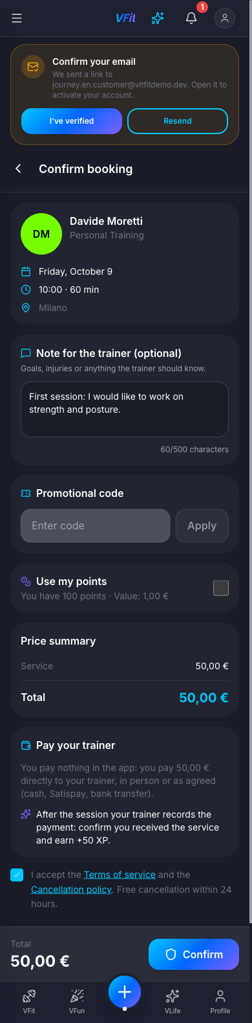
Confirm booking

B13. Request sent
The app opens the booking detail with a green banner: “Request sent, waiting for the trainer. We’ll let you know as soon as the trainer replies.”
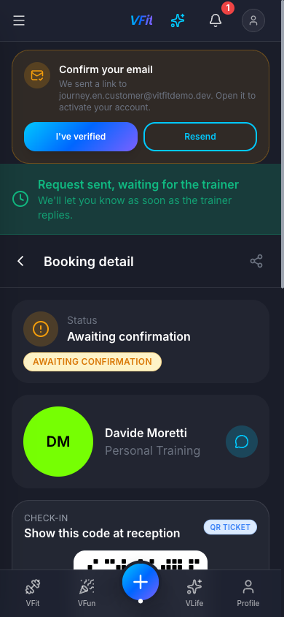
Request sent banner
The booking detail shows:
- status Awaiting confirmation, with the badge under the label
- the trainer’s name and service, with a chat button to message the trainer
- a check-in QR ticket to show at reception
- date and time, with Add to calendar
- the note left for the trainer
- payment status PENDING, total 50,00 €, Download receipt
- the booking ID and Cancel booking
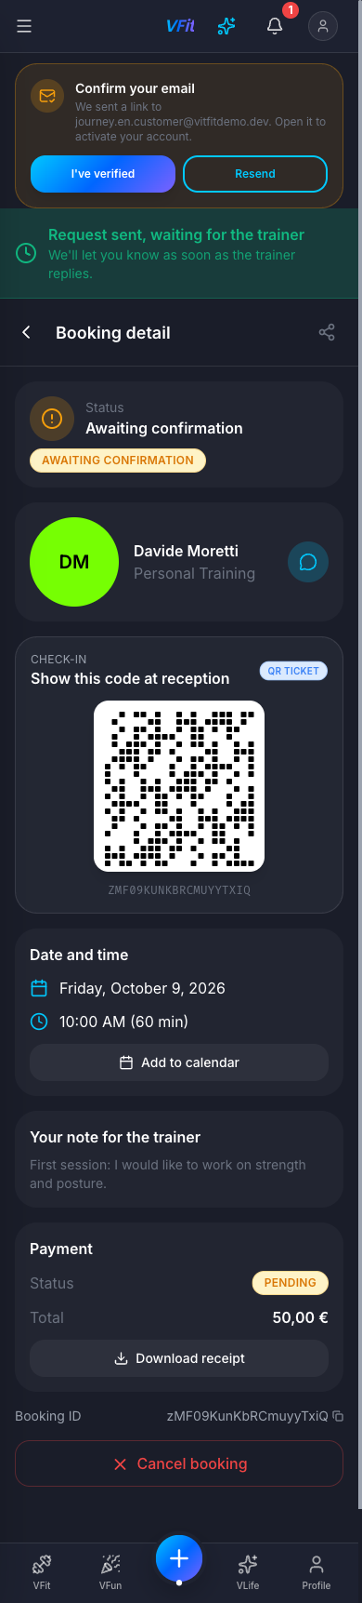
Booking detail, awaiting confirmation
The provider now accepts the request (steps A13–A15).

B14. Booking accepted notification
Once the trainer confirms, the customer gets “Booking accepted — Your trainer accepted your request for Personal Training.”
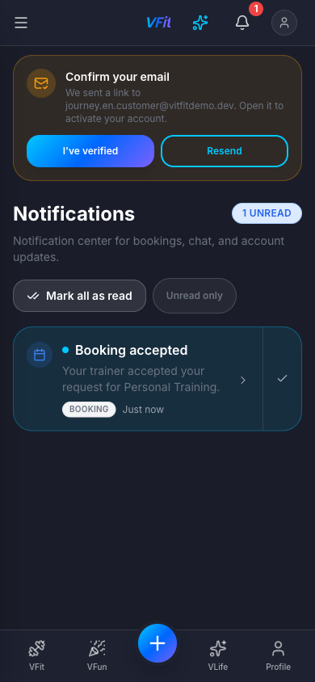
Booking accepted notification

B15. My bookings
My bookings (/bookings) has the tabs Upcoming, Past and Cancelled, plus a refresh button and + New. Under Upcoming it lists the session as VFIT · CONFIRMED · Personal Training · Davide Moretti · Oct 2, 10:00 AM, with the › chevron on the right of the card.
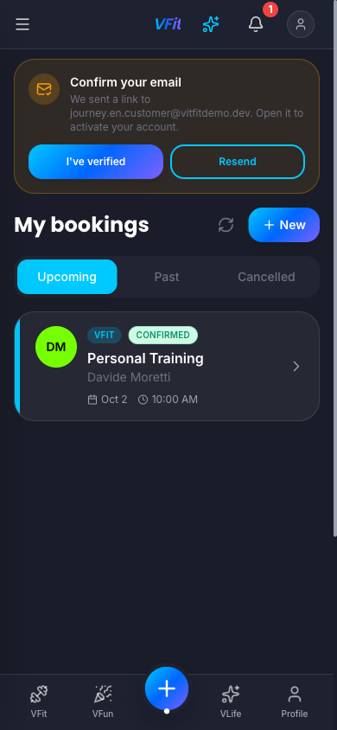
My bookings

B16. Booking detail: confirmed
The booking detail now shows status Confirmed. The QR check-in ticket, calendar export and receipt are still available, and the actions are now Reschedule and Cancel booking.
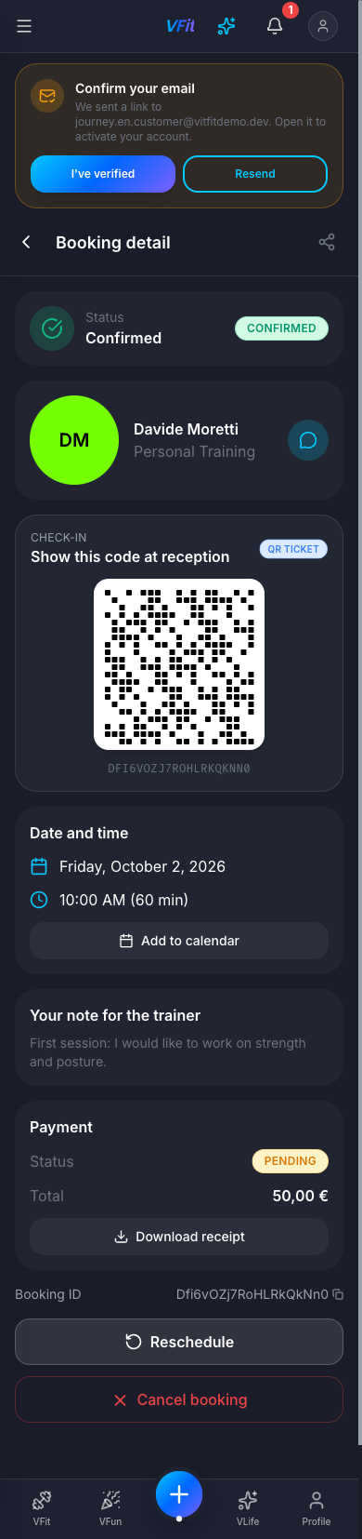
Booking detail, confirmed
The journey is complete: both accounts were created and the appointment is booked and confirmed on both sides.

What changed since the first recording
The first recording (earlier on 30 Sep 2026, light theme) found nine issues; issues 1–7 and 9 were fixed the same day (commit fa4ec61). This recording confirms the fixes that show up in the flow:
- Search by name finds a brand-new provider without a location (typing “Davide Moretti” with Near me off lists him).
- Provider bookings on a phone are cards with Confirm / Decline / Complete always visible, so A14–A16 are now shown at phone width instead of desktop width.
- Confirm feedback: the button shows a spinner, the card switches to Confirmed straight away and a toast confirms it.
- Trainer name appears on the customer’s booking card and booking detail (initials avatar instead of “?”).
- Email banner sits above the Provider portal bar instead of under it.
- Selected time slot uses dark text on the section colour.
Screens that differ from the first recording: the provider’s booking screens (A14–A16) are the mobile card layout; My bookings has three tabs (Upcoming, Past, Cancelled) plus + New instead of a New tab; the confirmed booking detail adds Reschedule; the booking detail has a chat button next to the trainer.

Re-shoot on 1 October 2026
The issues found in this recording were fixed on 1 October 2026 (plan docs/plans/2026-10-01-journey-ui-fixes-plan.md, tasks F1–F9) and deployed to staging and production. The screens they changed were re-shot on staging, dark theme, 390 × 844:
- Signup (A2–A4, B2–B4): the language and theme controls are a row above the Back / Back to login link instead of covering it; the terms checkbox sits right next to its text and is filled when ticked.
- Edit Service (A9): centred on the phone, labelled fields, a real dialog that closes with Esc.
- Provider prices (A10, A14, A15): written out in full (€50.00; 50,00 € in Italian).
- Location map (A12): dark in the dark theme.
- Provider bookings (A14, A15): the client avatar is a proper circle; the status badge moves under the name on a phone.
- Provider dashboard (A16): Welcome! for a provider who has not delivered a session yet, and Recent Activity now lists the booking events.
- Book a service (B7, B8): the VERIFIED badge stays whole and the distance sits next to the price.
- Booking calendar (B10, B11): only days with at least one free slot can be picked.
- Booking detail (B13): the AWAITING CONFIRMATION badge sits under the status label instead of sticking out of the card.
- My bookings (B15): the › chevron is on the right of the card.
B12, B13a and B16 were re-taken along with them. The trainer page (B9) looked the same in the dark theme, so it was kept. A6, A7 and A8 were kept because their first-login state can’t be recreated (see the notes under them).

Issues observed during this walkthrough
None of these stopped the booking from going through. Issues 1–12 and 14 from the 30 September list are fixed (see above) and have been removed. The remaining item is kept as #1; #2–#7 were seen during the 1 October re-shoot.
# | Severity | Where | What happened
1 | Info | Staging | No verification email arrives on staging (email secrets are placeholders by design), so the Confirm your email banner stays up. It does not block signup, service setup or booking.
2 | Low | Customer screens (B7–B13) | In English, customer-side prices still use the Italian format (From 50,00 €, Service 50,00 €, Value: 1,00 €), while the provider’s screens now show €50.00.
3 | Low | Provider dashboard (A16) | This Month’s Earnings is built by hand as €0 (provider/dashboard/page.tsx), so in Italian it reads €0 instead of 0 €.
4 | Low | Italian copy | The Notifications subtitle still says “Centro notifiche per booking, …” (notifications.subtitle).
5 | Low | Book a service, Italian (B8) | The distance uses a decimal point (0.1 km) instead of 0,1 km.
6 | Low | Book a service (B8) | Accessibility: neither the result card nor its Check availability text is a link or button, so a keyboard or screen-reader user cannot open a trainer from the results.
7 | Info | Booking detail, Cancel booking | Accessibility: the Keep / Cancel confirmation that opens from Cancel booking is not marked up as a dialog (no role="dialog").

Reproducing this walkthrough
- Staging only lets in allowlisted emails. A superadmin adds them first at Admin → Staging access (/admin/staging-access), or they are written to stagingAllowlist/{email} with the Admin SDK.
- Run the app locally against staging with npm run dev (.env.local points at vfit-app-staging). The staging gate is skipped on localhost, but sign-up is still checked against the allowlist on the server.
- Set dark theme with the theme switch (or localStorage['vfit.theme'] = 'dark') and English with the language picker (localStorage['vfit.locale'] = 'en').
- Follow Part A, then Part B, then A13–A16 and B14–B16.
- Regenerate the Word file (pandoc + Pillow; screenshots are sized like the first recording, 844 px = 14.1 cm, capped at 20 cm):
- cd docs/user-journeys
python3 build-docx.py signup-to-booking.md signup-to-booking.docx \
"VFit — Signup-to-Booking User Journeys" \
"Provider and customer, from account creation to a confirmed appointment" en-US

