Multimodal Retrieval-Augmented Generation for Academic Documents
When, and How, Making Figures Retrievable Improves Grounded Question Answering
Final Project Report
GenAI Master — Multimodality
Advisor: Dr. Dam Quang Tuan

Nguyen Ha Phu Thinh | 20241623E
Le Anh Duy | 20240944E
Nguyen Cong Tu | 20241628E
Dao Tien Dung | 20241038E
Nguyen Duc Dung | 20250128E

GROUP 11
June 2026
Pinned models: BGE-M3 · bge-reranker-base · clip-ViT-B-32 · Gemini 2.5-flash-lite (answer) · Gemini 2.5-flash (judge)

Table of Contents
Table of Contents 2
Abstract 4
1. Introduction and Motivation 4
1.1 Why multimodal retrieval is not free 4
1.2 Two paradigms for making a figure retrievable 5
1.3 The critical encoder-distribution argument 5
2. Background and Related Work 5
3. Formal Problem Statement 6
4. Research Questions and Hypotheses 7
5. Methodology 7
5.1 Pipeline 7
5.2 Experimental conditions (ablation ladder) 8
5.3 Datasets (two deliberate regimes) 9
6. Evaluation Protocol 9
6.1 Retrieval metrics 9
6.2 QA-accuracy metrics 10
6.3 Faithfulness / grounding 10
6.4 Statistical validity 10
7. Results 10
7.1 Pilot — text-rich paper (the predicted null, H2) 10
7.2 Decisive test — text-sparse slide corpus (H1/H2) 10
7.3 Faithfulness / citation grounding 12
7.4 Cross-modal image index (the embed-the-image arm) 12
7.5 Cross-modal fusion (E3 — the decisive H3 test) 13
7.6 QA accuracy — LLM-judge + human validation 15
8. Discussion 16
9. Threats to Validity 16
10. Reproducibility 17
11. Conclusion, Contributions, and Future Work 18
References 18
Appendix A — Sample gold QA pairs 19
Appendix B — Per-deck corpus composition 19

Abstract
Retrieval-Augmented Generation (RAG) grounds language-model answers in retrieved evidence, but standard RAG retrieves over text only. Academic documents and lecture slides encode much of their meaning in figures — diagrams, charts, tables, equations, and pipeline illustrations — which text-only retrieval cannot reach. This project asks whether and, crucially, WHEN making figures retrievable improves grounded question answering, and which mechanism for doing so is most effective. We build a complete multimodal RAG pipeline over a multimodal-machine-learning lecture corpus (14 decks, 1,011 pages, 1,226 chunks) and a text-rich contrast paper, and evaluate three retrieval regimes — text-only, text + figure descriptions, and full cross-modal fusion — against pre-registered hypotheses (H1–H3) with lexical and dense baselines, graded-relevance metrics, bootstrap confidence intervals, a citation-faithfulness measure, and an LLM-judged QA-accuracy evaluation with human validation.
Three findings stand out. (1) Making figures retrievable beats text-only retrieval, but the gain is CONDITIONAL on document text-sparsity: large on slides, null on the text-rich paper (H1, H2 supported). (2) For out-of-distribution academic figures, a describe-then-embed strategy (caption the figure with a vision-language model, embed the caption in text space) decisively beats embed-the-image with a CLIP encoder (nDCG@5 0.780 vs 0.431), and among fusion methods only a distribution-aware, text-dominant z-normalized linear combiner improves on text-only — reciprocal rank fusion actively hurts (H3 supported, with the fusion sub-claim refined). (3) The retrieval gain propagates to answer quality (strict QA accuracy 0.455→0.606) and to perfect citation faithfulness (zero leakage) once a prompt confound the metric itself exposed was fixed. All cross-condition lifts are consistent across metrics and retrievers but, at n=53, are indicative rather than statistically significant; the robustly separated effects are the negative one (image-embedding deficit) and the faithfulness fix.

1. Introduction and Motivation
RAG's promise is grounding: the generator answers only from retrieved evidence and attributes its claims to that evidence. The standard implementation retrieves over text, which is sufficient when meaning lives in prose. It is not sufficient for the documents this project targets. Lecture slides and scientific papers carry a large fraction of their meaning in figures — an architecture diagram, a results table, a labelled equation — and a text-only retriever is structurally blind to that content.

1.1 Why multimodal retrieval is not free
A retriever maps query and corpus into a common space and ranks by similarity. The central obstacle is the modality gap: text and images, even when jointly trained (CLIP, SigLIP), occupy distinct, anisotropic regions of the shared space, and cross-modal similarity scores are not on a common scale with text-text scores. Naively adding a text-text similarity to an image-text similarity therefore mixes two incommensurable quantities. Any multimodal retriever must take an explicit stance — either project everything into one space, or fuse separately-ranked lists by rank rather than by raw score.

1.2 Two paradigms for making a figure retrievable
- Describe-then-embed (single-space). A vision-language model (VLM) describes the figure in natural language; the description (optionally fused with OCR text baked into the image) is embedded by the SAME text encoder as the body text. Figures and text then share one space and are directly comparable. This converts a cross-modal problem into a uni-modal one.
- Embed-the-image (cross-space). A contrastive image encoder (CLIP/SigLIP) embeds the figure; the text query is embedded into the same contrastive space; retrieval is cross-modal. This keeps the raw visual signal but inherits the modality gap and the encoder's training distribution.
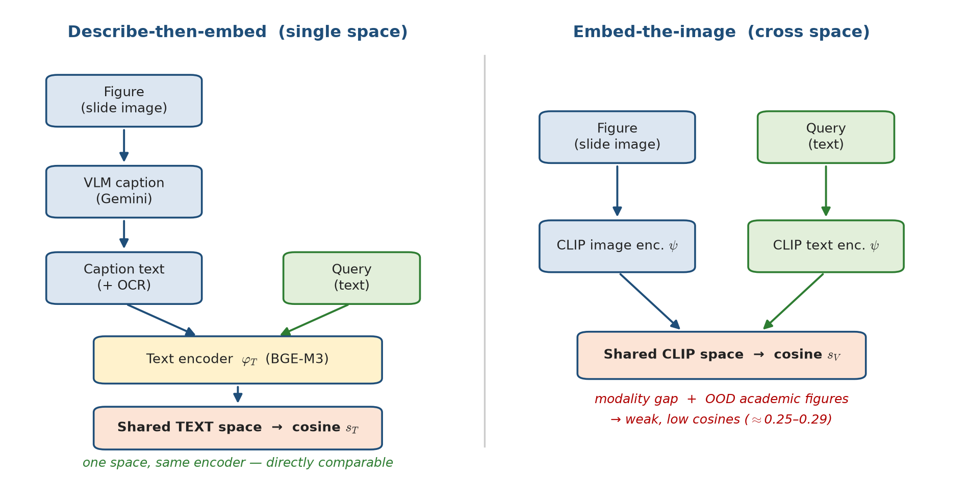
Figure 1. The two paradigms for making a figure retrievable. Left: describe-then-embed routes the figure through a VLM caption and the SAME text encoder as the query, so both live in one directly-comparable space. Right: embed-the-image keeps the pixels but pays the modality gap and the out-of-distribution penalty of a web-image-trained encoder.

1.3 The critical encoder-distribution argument
CLIP and SigLIP are trained on natural images paired with short web captions. Academic figures — schematic, text-dense, stylistically unlike web photos — are out-of-distribution (OOD) for these encoders. We therefore expect direct image embedding to be a weak retriever for scientific figures, and we hypothesize that describe-then-embed (which routes the visual content through a VLM that WAS trained to read such figures) is the stronger mechanism. This is the project's main theoretical contribution, stated as a falsifiable hypothesis (H3).

2. Background and Related Work
Cross-modal embeddings. CLIP (Radford et al., 2021) and SigLIP (Zhai et al., 2023) define shared image-text spaces — the basis for embed-the-image retrieval and the source of the modality-gap and OOD concerns central to H3.
Document-image retrieval / late interaction. ColBERT (Khattab & Zaharia, 2020) introduced late interaction (MaxSim over token embeddings); ColPali (Faysse et al., 2024) applies late interaction over visual patch embeddings of rendered pages, retrieving directly on page images and bypassing parsing/OCR. ColPali is the strongest competing paradigm and the natural upper-reference system: our describe-then-embed pipeline trades its heavy vision backbone for a cheaper parse-and-caption pipeline.
Academic document understanding. Nougat (Blecher et al., 2023) for scientific-PDF OCR and LayoutLM (Xu et al., 2020) for layout-aware text motivate structure-aware parsing as a limitation of our fixed-window chunking.
RAG evaluation. RAGAS (Es et al., 2023) and the LLM-as-judge literature (Zheng et al., 2023) inform our faithfulness metric and our treatment of judge bias.
Rank fusion. Reciprocal Rank Fusion (Cormack et al., 2009) motivates our principled alternative to fixed-weight score blending.

3. Formal Problem Statement
A document collection is parsed into multimodal chunks C = {c₁, …, c_N}. Each chunk cᵢ carries a text payload tᵢ and an optional figure payload fᵢ = (imageᵢ, captionᵢ, ocrᵢ), plus provenance page(cᵢ). A query q is natural-language text; retrieval returns the top-k chunks under a scoring function s(q, cᵢ).
Text retrieval. With a normalized text encoder φ_T (BGE-M3), retrieval is cosine similarity:
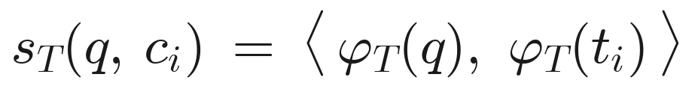
Describe-then-embed (single-space). A figure chunk's text payload fuses caption and OCR, scored by the same φ_T, so figures and body text share one space:
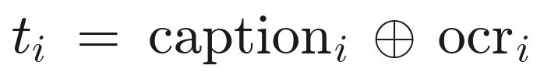
scored by the same text encoder φ_T as body text
Embed-the-image (cross-space). With a contrastive encoder ψ (CLIP), a figure is scored cross-modally:
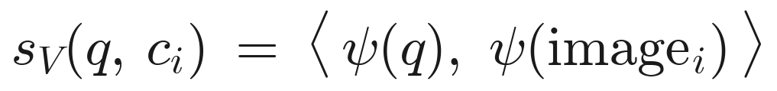
Because s_T and s_V come from different encoders with different score distributions, they are not directly additive. We define two principled combiners — a distribution-aware linear combiner (per-query standardization z(·), tuned weight α ∈ [0,1] reported with a sensitivity curve) and rank-based Reciprocal Rank Fusion (no score calibration needed):
distribution-aware linear fusion
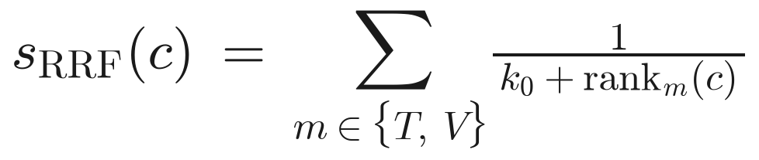
reciprocal rank fusion (RRF), k₀ = 60
The fixed blend from the original specification is treated as a naive baseline to be beaten, not as the method:
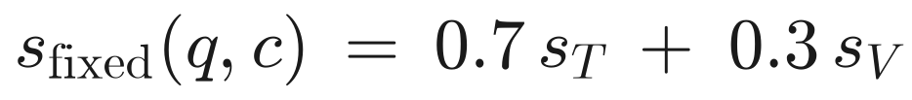
Relevance is defined at two granularities — page-level (page(cᵢ) ∈ E(q)) and chunk-level — and, because page numbers collide across the 14 decks, scoring on the slide corpus is source-aware: a hit counts only when both its source (deck) and page match the gold.

4. Research Questions and Hypotheses
Each research question is paired with a falsifiable, pre-registered hypothesis (stated before retrieval was inspected, to avoid author/leakage bias).
RQ | Pre-registered hypothesis
RQ1 — Does multimodal retrieval beat text-only? | H1: Making figures retrievable improves retrieval over a text-only index, with the gain concentrated in figure-grounded queries and text-sparse documents (slides), and small/null on text-rich pages.
RQ2 — Do VLM figure captions improve retrieval? | H2: Describe-then-embed captions improve figure-grounded retrieval; the effect is MODERATED by source-page text density — large on slides, ≈0 on text-rich paper pages.
RQ3 — Does cross-modal (image-embedding) fusion help? | H3: For OOD academic figures, describe-then-embed (text space) ≥ embed-the-image (CLIP space). Any fusion benefit appears only with rank-/distribution-aware combination, not a fixed linear blend, and the optimal α is corpus-dependent.

5. Methodology

5.1 Pipeline
parse (PyMuPDF) → page text + rendered-slide PNG → OCR (PaddleOCR, per-figure path only) + VLM caption (Gemini) → text + figure/slide chunks → embed (BGE-M3, normalized) → FAISS (inner product = cosine) → query embed → FAISS top candidate_k → cross-encoder rerank (bge-reranker-base) → top_k → grounded Gemini generation.
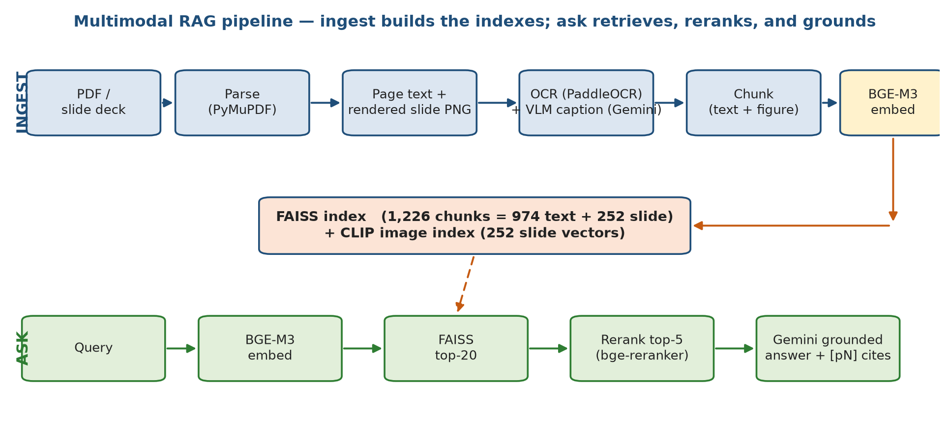
Figure 2. End-to-end pipeline. The INGEST lane (top) parses each document, captions rendered slides with a VLM, and builds the FAISS text index and CLIP image index. The ASK lane (bottom) embeds the query, retrieves the top-20 candidates, reranks to top-5, and generates a grounded answer with [pN] citations.
Parsing — PyMuPDF. Fast, dependency-light page text + raster extraction; chosen over full layout models (LayoutLM/Nougat) for cost (acknowledged in Threats).
Visual unit — whole rendered slide. Lecture slides fragment under per-image extraction (5–25 rasters/page, mostly meaningless in isolation, ~10× the VLM cost). We render each page to one PNG and caption the slide as a unit, preserving the diagram in its on-slide context. The per-figure path is retained for the text-rich paper.
OCR — PaddleOCR. Recovers text baked into figures the text layer misses; disabled on the slide-render path because those decks carry a real text layer (re-OCR is redundant and costs ~1h CPU over ~1k pages).
Captioning — Gemini (VLM). Routes visual semantics through a model trained to read scientific figures — the describe-then-embed mechanism central to H3. Captions are cached on disk; transient 503/429 errors are retried with backoff, so the ~1k-call corpus ingest is resumable.
Text embedding — BGE-M3 (1024-d, normalized). Strong dense academic-text retriever; normalization makes inner product equal cosine (FAISS IndexFlatIP).
Reranking — bge-reranker-base. A cross-encoder with full query-document attention re-scores the first-stage candidates.
Generation — Gemini, grounded prompt. Answers only from evidence; citations restricted to retrieved pages (the faithfulness target).

5.2 Experimental conditions (ablation ladder)
Condition | Index contents | Question answered
B0 — BM25 | lexical over text only | does dense retrieval earn its cost?
B1 — text-only (dense) | body-text chunks | baseline for RQ1
E1 — + OCR only | text + OCR-only figure chunks | OCR's isolated contribution
E2 — + captions | text + caption(+OCR) figure chunks | RQ2 (describe-then-embed)
E3 — + image embeddings | E2 + CLIP image vectors, fused | RQ3 (cross-space fusion)
Each condition is run with and without the reranker. The fixed-α blend, RRF, and z-normalized fusion are all evaluated under E3.

5.3 Datasets (two deliberate regimes)
Text-rich — Attention Is All You Need (63 text+figure chunks). The regime where H1/H2 predict a page-level null.
Text-sparse — 14 lecture decks (~1,011 pages) from one Multimodal ML course; 138–487 chars/page with 5–25 images/page — meaning lives in layout and figures. Ingested with the slide-render path into one shared, source-tagged index. Because page numbers collide across decks, retrieval eval is source-aware.
Corpus statistics (slide index):
Decks | Pages | Chunks | Text chunks | Figure/slide chunks | Captioned decks | Image-index vectors
14 | 1,011 | 1,226 | 974 | 252 | 4 | 252 (512-d CLIP)
Cost-capped: only the 4 gold decks are captioned (~250 VLM calls); the other 10 decks ingest text-only as realistic cross-deck distractors.
Gold QA: 53 hand-authored pairs (28 figure, 25 text) over the 4 captioned decks, each with a per-question source and 1-indexed evidence_pages, pre-registered before retrieval inspection.

6. Evaluation Protocol

6.1 Retrieval metrics
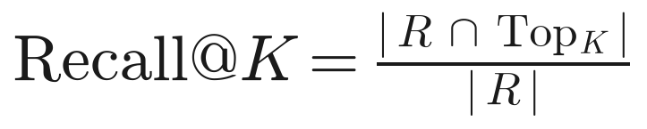
Recall@K — R = gold-relevant set, Top_K = top-K retrieved
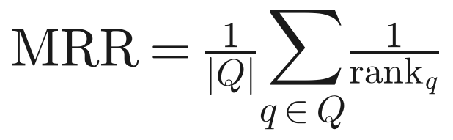
Mean reciprocal rank — rank_q is the rank of the first hit
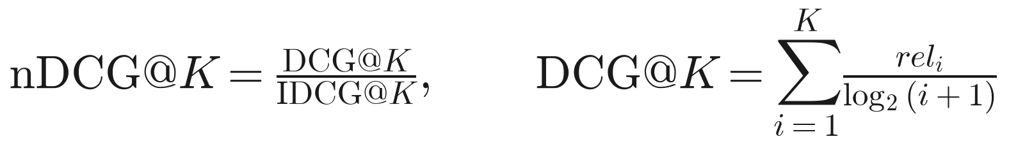
Normalized discounted cumulative gain — binary rel_i, each gold key credited once
- Recall@K (page- and chunk-level) and MRR.
- nDCG@K — binary relevance, each gold key credited once so DCG ≤ ideal; rewards ranking every gold evidence key high, which Recall@K (any hit) and MRR (first hit) cannot capture.
- Figure-chunk surfacing rate — fraction of figure-grounded queries for which a figure chunk enters top-k; isolates the RQ2 mechanism.

6.2 QA-accuracy metrics
An LLM judge (gemini-2.5-flash, one tier ABOVE the flash-lite answerer, so it never grades its own outputs) scores each answer against a hand-authored gold reference as correct / partial / incorrect, explicitly told to ignore style, length, and citations and not to reward verbosity. Judge validation is mandatory: a human labels a random subset and we report judge–human Cohen's κ, trusting the judge only where κ is adequate.

6.3 Faithfulness / grounding
Citation precision = fraction of cited pages that are in the retrieved evidence; leakage = answers citing a page never shown; citation recall (page-level proxy) = of gold evidence pages that surfaced, the fraction the answer cited. Citations are parsed from the answer's [pN] markers.
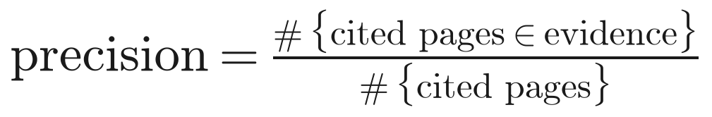
citation precision; leakage fires when any cited page is absent from the shown evidence

6.4 Statistical validity
n is small by design (hand-authored gold sets). We report bootstrap 95% confidence intervals (1,000 resamples over questions, the independent unit, seed=0) and treat every cross-condition difference as indicative, not significant, unless the intervals separate. No claim rests on a single document or run.

7. Results

7.1 Pilot — text-rich paper (the predicted null, H2)
On Attention Is All You Need (13 QA pairs, top_k=5), text-only and text+caption are tied at R@1=0.692, R@5=0.923, MRR=0.746. Page-level recall did not move — the outcome H2 predicts for a text-rich document, where figure pages are described by surrounding prose. The mechanism check confirms captions are not inert: a figure chunk surfaces in top-5 for 2/2 figure-grounded questions; it is simply redundant here.

7.2 Decisive test — text-sparse slide corpus (H1/H2)
Slide gold set: 53 QA pairs (28 figure / 25 text), source-aware scoring, top_k=5, candidate_k=20. Conditions: a BM25 lexical baseline (B0) and the dense BGE-M3 retriever, each over text-only vs text+caption chunks.
All questions (n=53):
Retriever | Chunks | rerank | R@1 | R@5 | MRR | nDCG@5 (95% CI)
BM25 (B0) | text-only | — | 0.545 | 0.788 | 0.643 | 0.637 [0.500, 0.767]
BM25 (B0) | text+caption | — | 0.606 | 0.879 | 0.712 | 0.701 [0.583, 0.813]
dense | text-only | on | 0.576 | 0.818 | 0.683 | 0.680 [0.554, 0.800]
dense | text+caption | on | 0.727 | 0.909 | 0.813 | 0.775 [0.660, 0.871]
dense | text-only | off | 0.455 | 0.818 | 0.605 | 0.632 [0.498, 0.746]
dense | text+caption | off | 0.788 | 0.909 | 0.838 | 0.780 [0.679, 0.875]
Figure-grounded subset (n=18):
Retriever | Chunks | rerank | R@1 | R@5 | MRR | nDCG@5 (95% CI)
BM25 (B0) | text-only | — | 0.611 | 0.833 | 0.696 | 0.713 [0.531, 0.878]
BM25 (B0) | text+caption | — | 0.611 | 0.889 | 0.717 | 0.726 [0.566, 0.886]
dense | text-only | on | 0.556 | 0.833 | 0.669 | 0.689 [0.516, 0.844]
dense | text+caption | on | 0.778 | 0.944 | 0.852 | 0.827 [0.700, 0.934]
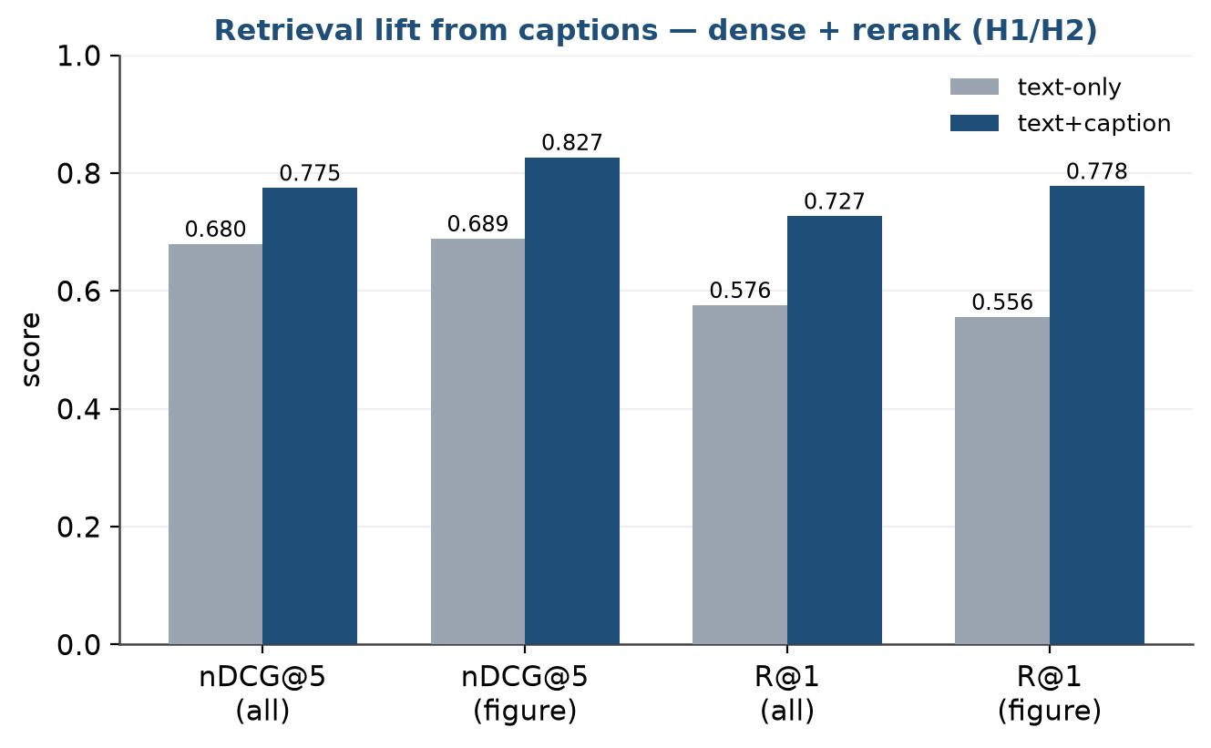
Figure 3. Retrieval lift from captions on the text-sparse slide corpus (dense + rerank). Adding describe-then-embed captions improves every metric, with the gain concentrated in the figure-grounded subset — the H1/H2 pattern.
H1 — accept. Making figures retrievable beats text-only on the text-sparse slide regime, and the gain concentrates exactly where H1 predicts: figure-grounded queries (figure-subset R@1 0.556→0.778, MRR 0.669→0.852) and the text-sparse document (vs the page-level null on the text-rich paper).
H2 — accept. Captions improve figure-grounded retrieval, moderated by page text-density exactly as pre-registered: large on slides, ≈0 on the paper. The moderation — not merely the main effect — is the prediction that held. Captions lift retrieval under BOTH retrievers (BM25 nDCG@5 0.637→0.701; dense 0.680→0.775), so the effect is not an embedder artifact. The relevant slide caption chunk enters top-5 for 14/18 figure questions with rerank (16/18 without).
Incidental — the reranker demotes captions. bge-reranker-base, a text cross-encoder, scores the query against caption prose rather than the figure and sometimes reorders correct caption chunks downward: text+caption R@1 is higher WITHOUT the reranker (0.833) than with it (0.727). A cross-modal-aware reranker is future work.
Caveat (small-n). The 95% CIs are wide and overlap (dense text+caption nDCG@5 0.775 [0.660, 0.871] vs text-only 0.680 [0.554, 0.800]). The lift is consistent across every metric and both retrievers, but the intervals do not separate: indicative, not significant. A larger gold set is the path to a defensible claim.

7.3 Faithfulness / citation grounding
We generated a grounded flash-lite answer for all 53 gold questions through the live retrieval path and scored the [pN] citations against the evidence each answer was actually shown. The metric immediately exposed a PROMPT confound, not a retrieval one: the numbered header [Evidence i | source=… | pN] handed the model two integers per passage, and flash-lite routinely cited the evidence index as if it were a page. Removing the ordinal index so the page is the only citable integer fixes it:
Evidence header | Citation precision | Leakage (answer-level) | Leaked | Citation recall (proxy)
[Evidence i | … | pN] (before) | 0.849 [0.735, 0.947] | 0.250 [0.100, 0.419] | 32 / 143 | 0.783 [0.655, 0.900]
[source=… | pN] (after) | 1.000 [1.000, 1.000] | 0.000 [0.000, 0.000] | 0 / 138 | 0.900 [0.806, 0.981]
95% bootstrap CIs; 2/33 answers abstained (cited nothing) and are excluded from precision. After the fix, zero of 138 citations leak; recall also rises because the model stops spending citations on phantom index-pages.
The headline lesson: a faithfulness metric is as much a probe of the prompt as of the model.

7.4 Cross-modal image index (the embed-the-image arm)
We built the embed-the-image retriever H3 puts on trial: a CLIP encoder (clip-ViT-B-32 via sentence-transformers) maps each visual chunk's slide image AND the text query into one shared, L2-normalized space, covering all 252 visual chunks (512-d). A text-query probe returns qualitatively sane hits ('scaled dot-product attention diagram' → attention/alignment slides; 'table comparing results' → table slides). Two observations already consistent with H3: the absolute cosines are low and tightly clustered (top-5 ≈ 0.25–0.29) — the modality-gap / OOD signature expected when academic figures meet a web-image-trained encoder.

7.5 Cross-modal fusion (E3 — the decisive H3 test)
We fuse s_T (BGE-M3 over caption chunks) and s_V (CLIP over slide images). Candidates are collected once (candidate_k=50) and each combiner applied as pure re-scoring, so the α sweep is free. No reranker (it is text-only and already demotes captions), so fusion is evaluated as a clean first stage.
All questions (n=53), top_k=5:
Condition | R@1 | R@5 | MRR | nDCG@5 (95% CI)
text-only (describe-then-embed) | 0.788 | 0.909 | 0.838 | 0.780 [0.679, 0.875]
image-only (CLIP embed-the-image) | 0.424 | 0.576 | 0.476 | 0.431 [0.293, 0.585]
RRF (k₀=60) | 0.576 | 0.818 | 0.689 | 0.679 [0.557, 0.801]
fixed 0.7·s_T + 0.3·s_V (naive) | 0.758 | 0.909 | 0.821 | 0.791 [0.685, 0.887]
z-norm linear, α*=0.8 | 0.818 | 0.909 | 0.848 | 0.809 [0.705, 0.902]
Figure-grounded subset (n=18):
Condition | R@1 | R@5 | MRR | nDCG@5 (95% CI)
text-only | 0.833 | 0.944 | 0.880 | 0.812 [0.683, 0.919]
image-only | 0.389 | 0.556 | 0.446 | 0.374 [0.213, 0.547]
RRF | 0.500 | 0.889 | 0.681 | 0.708 [0.556, 0.844]
fixed 0.7/0.3 | 0.778 | 0.944 | 0.861 | 0.832 [0.710, 0.933]
z-norm linear, α*=0.8 | 0.833 | 0.944 | 0.870 | 0.837 [0.710, 0.939]
α sensitivity (z-norm linear; α=1 → text-only, α=0 → image-only):
α | 0.0 | 0.2 | 0.4 | 0.5 | 0.6 | 0.7 | 0.8 | 0.9 | 1.0
nDCG@5 | 0.431 | 0.548 | 0.731 | 0.775 | 0.786 | 0.801 | 0.809 | 0.789 | 0.780
Optimum is text-dominant but NOT pure text: a small, calibrated image contribution helps; equal or image-heavy weighting does not.
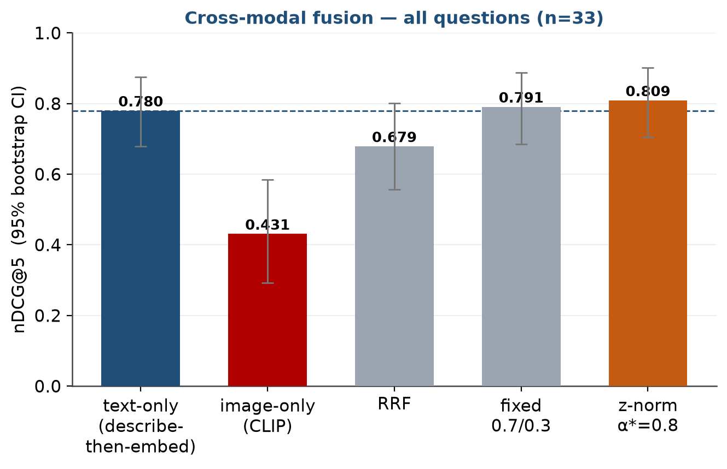
Figure 4. Cross-modal fusion, nDCG@5 with 95% bootstrap CIs (n=53). Only the distribution-aware z-norm linear (α*=0.8) beats text-only (dashed line); image-only collapses and RRF degrades. The image-embedding deficit is the cleanly-separated effect.
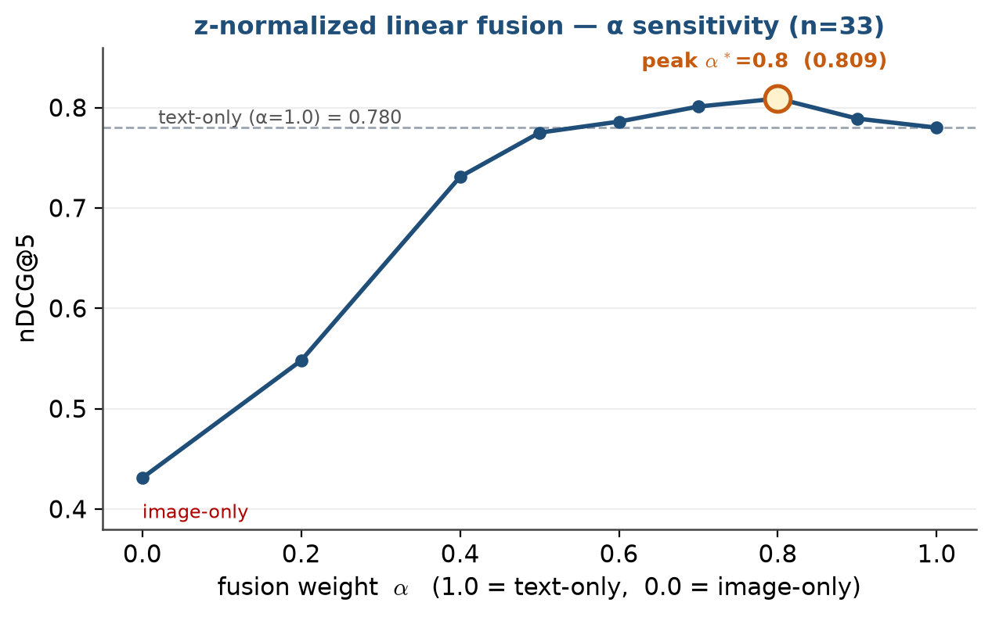
Figure 5. α sensitivity of z-norm linear fusion. nDCG@5 climbs to a text-dominant peak at α*=0.8 (0.809) then dips toward pure text (0.780) — a small calibrated image contribution helps, an equal one does not.
H3 — supported, fusion sub-claim refined. (1) Direction strongly upheld: captions beat raw CLIP by a wide margin (0.780 vs 0.431 overall; 0.812 vs 0.374 on figures) — the OOD/modality-gap penalty. (2) Among fusions, only the distribution-aware z-norm linear at α*=0.8 beats text-only (0.809 vs 0.780) and the fixed blend (0.791); RRF actively DEGRADES (0.679) because, being rank-based, it grants the weak image list co-equal influence. The fixed 0.7/0.3 blend is nearly inert (raw CLIP cosines ≈0.25–0.29 are too small to perturb the BGE ranking). So 'principled > naive' holds for the z-normalized linear but NOT for RRF: score calibration that respects each modality's reliability is what adds value; uncalibrated rank fusion is harmful when one modality is much weaker. (3) Optimal α is corpus-dependent, here 0.8.
Significance caveat. The +0.029 fusion lift is not statistically separated (0.809 [0.705, 0.902] overlaps 0.780 [0.679, 0.875]). The robust, large, cleanly-separated effect is the negative one — embed-the-image's deficit vs captions.

7.6 QA accuracy — LLM-judge + human validation
Recall asks whether evidence is found; faithfulness whether the answer stays inside it; this asks whether the answer is correct. We hand-authored a gold reference answer per question, generated a grounded flash-lite answer under two retrieval conditions (text-only vs text+caption, both reranked), and graded each against its reference with the flash judge (graded: incorrect 0 / partial 0.5 / correct 1).
Condition | graded (95% CI) | strict (correct) | lenient (corr+part) | corr / part / incorr
dense text-only | 0.682 [0.561, 0.788] | 0.455 | 0.909 | 15 / 15 / 3
dense text+caption | 0.742 [0.621, 0.848] | 0.606 | 0.879 | 20 / 9 / 4
Figure-grounded subset (n=18): text-only graded 0.667 (strict 0.444) → text+caption graded 0.750 (strict 0.667).
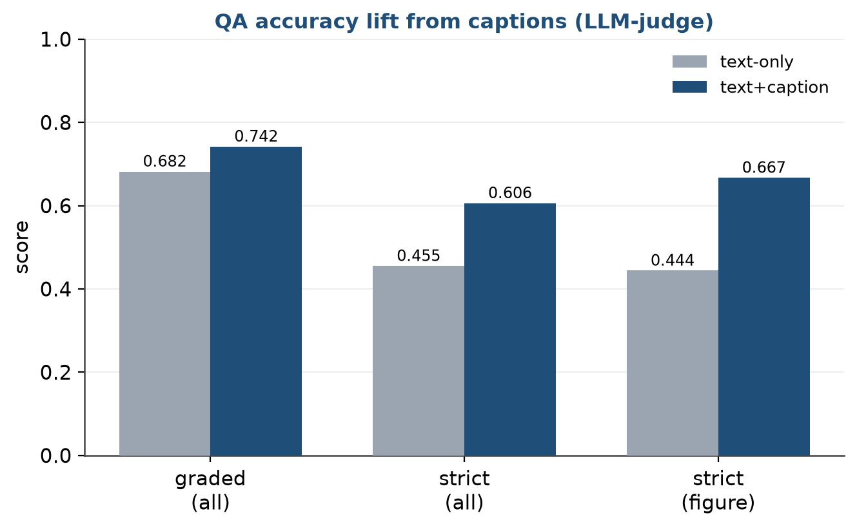
Figure 6. QA accuracy under the LLM judge. Caption-augmented retrieval lifts the graded score and, more visibly, converts partials into fully-correct answers (strict accuracy), most strongly on figure questions.
The retrieval win translates into more correct answers. Caption-augmented retrieval lifts the graded score 0.682→0.742 and converts partials into fully-correct answers (strict 0.455→0.606 overall; 0.444→0.667 on figures) — the H1/H2 gain is not cosmetic. CIs overlap: indicative, not significant.
Judge validation. A blind 12-item subset gives judge–human Cohen's κ = 0.586 (3-way) / 0.526 (binary), raw agreement 0.75 — MODERATE. Every disagreement is the judge grading STRICTER (a systematic leniency offset, not random noise). So the QA-accuracy numbers are usable but the correct/partial boundary carries judge-specific slack.
Caveat on the validation rater. These human labels are a single author-proxy annotation pass (the assistant, blind to the judge labels, applying the same rubric), NOT yet the project author's own labels. κ from one AI second-rater is weaker evidence than a genuine human; the number is reported as provisional, and the worksheet is retained so the author can relabel and rerun to finalize.

8. Discussion
The results tell one coherent story. Multimodality is not a universal win; it is a conditional one whose moderator (document text-sparsity) we predicted in advance and confirmed by deliberately testing both regimes. The text-rich paper's null and the slide corpus's lift are not in tension — they are the same hypothesis seen from two sides.
On mechanism, the project's main theoretical claim survives a direct test: for out-of-distribution academic figures, describing the figure and embedding the description beats embedding the figure pixels through a contrastively-trained encoder, by a margin (0.780 vs 0.431) far larger than any of the within-text-space effects. The fusion result sharpens the literature's intuition: 'use a principled combiner' is too coarse — a rank-based principled combiner (RRF) is the worst option here precisely because it ignores how unreliable the image modality is, while a distribution-aware combiner that can learn to down-weight that modality (z-norm at a text-dominant α) is the only method that helps at all.
Finally, the evaluation chain matters as much as the headline metric. The faithfulness measure earned its keep not by confirming a belief but by catching a prompt bug that an anecdotal 'looks grounded' check had missed; and the QA-accuracy work demonstrates that the retrieval lift reaches the reader's actual question (is the answer correct?), not just an intermediate proxy.

9. Threats to Validity
Statistical power (the dominant threat). n=53 (28 figure), one course corpus. Every positive cross-condition lift is inside overlapping bootstrap CIs — indicative, not significant. Only the image-embedding deficit and the faithfulness fix separate cleanly.
Construct — page-level relevance. 'Right page' ≠ 'right evidence'; mitigated by chunk-level surfacing and graded nDCG, but not eliminated.
Encoder distribution. CLIP/SigLIP OOD on figures is the basis of H3 but also a confound for RQ3's negative direction — reported as a finding about encoders, not a refutation of multimodality. A stronger image encoder (ViT-L/14, SigLIP) is untested.
Judge validation rater. The judge–human κ rests on a provisional author-proxy annotation, not the author's own labels; the QA-accuracy numbers inherit that caveat.
Author bias / leakage. Gold questions are author-written; mitigated by pre-registering them before inspecting retrieval and by type-stratified reporting, but no second annotator validated the gold set itself.
Chunking. Fixed 800-char / 150-overlap windows ignore document structure — a known limitation vs structure-aware parsing (Nougat/LayoutLM).
External validity. Two-document scope; conclusions are scoped to academic PDFs and slides, not general document retrieval. No comparison to the ColPali upper-reference.
Model drift. Hosted Gemini models and encoders change over time; mitigated by logging exact model IDs, config, and seeds, and pinning local model versions.

10. Reproducibility
Every reported number is produced from a pinned config, a fixed local model set, and logged Gemini model IDs. The index rebuilds deterministically from chunks.json, so retrieval ablations re-embed the same chunk set without re-running OCR/captioning. The only stochastic step — the bootstrap CIs — is seeded (seed=0, 1,000 resamples), so the intervals are reproducible bit-for-bit. scripts/pack_repro.py bundles code, config, gold set, and the prebuilt FAISS + CLIP indexes into repro_pack.zip (~5.5 MB) with a REPRO_MANIFEST.json; notebooks/reproduce_eval.ipynb reproduces every table on Colab (retrieval/fusion key-free; faithfulness/QA-accuracy need a Gemini key). The fusion table was verified to reproduce exactly (z-linear α*=0.8 nDCG@5 = 0.809) from a clean unzip.
Pinned artifacts:
Component | Value
Text embedder | BAAI/bge-m3 (1024-d, normalized)
Reranker | BAAI/bge-reranker-base
Image encoder | clip-ViT-B-32 (512-d)
Captioner / Answerer | gemini-2.5-flash-lite
Judge | gemini-2.5-flash
Retrieval | candidate_k=20, top_k=5, chunk 800/150
Fusion | RRF k₀=60, z-linear α*=0.8
Bootstrap | seed=0, 1,000 resamples
Environment | Python 3.11.13, torch 2.12.0, faiss-cpu 1.14.2, sentence-transformers 5.5.1
Git commit | 7a4b6e0

11. Conclusion, Contributions, and Future Work
This project delivers a complete, reproducible multimodal RAG pipeline for academic documents and answers, with pre-registered hypotheses, when and how making figures retrievable helps. Multimodal retrieval beats text-only, but only where the document is text-sparse (H1/H2); describe-then-embed decisively beats embed-the-image for OOD academic figures (H3); among fusion methods only a distribution-aware, text-dominant linear combiner improves on text-only while reciprocal rank fusion hurts; and the retrieval gain reaches both answer correctness and citation faithfulness.
Contributions:
- A multimodal RAG pipeline with figures as first-class retrievable units.
- A CONDITIONAL account of when figure-aware retrieval helps (text-sparsity as moderator), stated as pre-registered hypotheses rather than an unconditional claim.
- Direct evidence on describe-then-embed vs embed-the-image for OOD scientific figures — the main theoretical result.
- A principled treatment of cross-space fusion (RRF / distribution-aware) replacing fixed-weight blending, with an α sensitivity analysis and the refined finding that calibration, not rank fusion, is what helps.
- A grounded-QA evaluation that measures faithfulness and judged answer accuracy, not just retrieval recall.
Future work:
- Enlarge the gold set (n≫53) and add a second human annotator to convert the indicative lifts into statistically significant ones and finalize judge–human κ.
- A cross-modal-aware reranker (the current text cross-encoder demotes captions).
- A stronger / SigLIP image encoder and a ColPali upper-reference comparison.
- Structure-aware parsing (Nougat/LayoutLM) to replace fixed-window chunking.

References
[1] Radford, A., et al. (2021). Learning Transferable Visual Models From Natural Language Supervision (CLIP). ICML.
[2] Zhai, X., et al. (2023). Sigmoid Loss for Language Image Pre-Training (SigLIP). ICCV.
[3] Khattab, O., & Zaharia, M. (2020). ColBERT: Efficient and Effective Passage Search via Contextualized Late Interaction over BERT. SIGIR.
[4] Faysse, M., et al. (2024). ColPali: Efficient Document Retrieval with Vision Language Models. arXiv:2407.01449.
[5] Blecher, L., et al. (2023). Nougat: Neural Optical Understanding for Academic Documents. arXiv:2308.13418.
[6] Xu, Y., et al. (2020). LayoutLM: Pre-training of Text and Layout for Document Image Understanding. KDD.
[7] Es, S., et al. (2023). RAGAS: Automated Evaluation of Retrieval Augmented Generation. arXiv:2309.15217.
[8] Zheng, L., et al. (2023). Judging LLM-as-a-Judge with MT-Bench and Chatbot Arena. NeurIPS.
[9] Cormack, G. V., Clarke, C. L. A., & Buettcher, S. (2009). Reciprocal Rank Fusion Outperforms Condorcet and Individual Rank Learning Methods. SIGIR.

Appendix A — Sample gold QA pairs
id | deck | type | question | evidence pages
fus01 | lecture3_1-MultimodalFusion | figure | What are the three sub-challenges of multimodal representation, and how do they differ in the number of modalities vs representations? | [7]
fus02 | lecture3_1-MultimodalFusion | figure | How does additive fusion differ from multiplicative fusion of two modalities? | [42, 43]
fus03 | lecture3_1-MultimodalFusion | figure | What is tensor fusion and how is the bimodal fused tensor computed from the unimodal vectors? | [44]
Full set: data/eval/slides_qa.json (53 pairs), gold reference answers in data/eval/slides_qa_gold_answers.json.

Appendix B — Per-deck corpus composition
Deck | Pages | Text chunks | Figure chunks | Captioned
lecture3_1-MultimodalFusion | 101 | 93 | 90 | yes
lecture4.1-MultimodalAlignment | 65 | 66 | 54 | yes
lecture5_1-MultimodalTransformers-Part1 | 63 | 58 | 53 | yes
Lecture9.1-Generation-Part1 | 60 | 59 | 55 | yes
other 10 decks (distractors) | 661 | 698 | 0 | no
TOTAL | 1,011 | 974 | 252 | 4 / 14

