**Machine Learning : Perceptron**

**Perceptron**

* Supervised learning algorithm.
* Regression or classification.
* Allows us to weight features.

**Biological inspiration**

* Perceptron is like a brain.

**Perceptron**

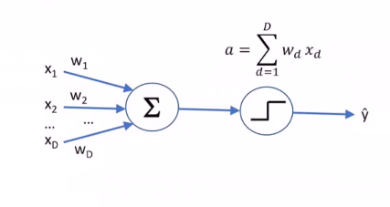

X = feature value

W = feature’s weight

Neuron : sums the weighted inputs and decides what to fire

The two circles represent one neuron.

“a” from the picture above is calledan **activation function,** it is a rule for firing neurons.

* Positive weights have positive influence and negative weights have negative influence.
  + If a > 0 then output 1 (positive example)
  + Else output -1 (negative example)
  + Use non-zero threshold
 $if a>θ \left(any constant\right) output 1, else output-1$

   - Can accomplish the same thing through bias term.

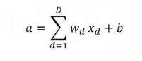

**Class Labels**

* Binary classifier
* Classes are + and –
* Denote by y = +1 and y = -1
* Once activation is computed, output is a sign of a

**Training a Perceptron**

* **Intuition**
  + If output -1 but should have output +1, need to increase weights. (False Negative)
  + If output +1 but should have output -1, need to decrease weights. (False Positive)
  + If $y*a≤0$ means it’s wrong
    - Y is either +1 or -1; if y * a = 0 then a = 0
    - If wrong correct a by nudging it in the direction of sign(y)

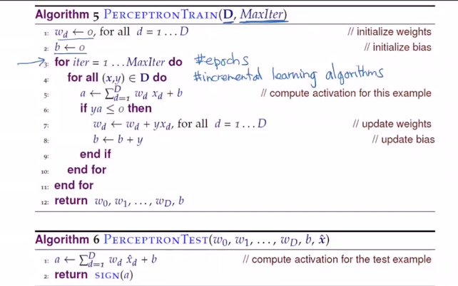

**D = Set of training data**

**MaxIter = Maximum number of iterations (hyper parameter)**

**w = weights (hyper parameter)**

**b = bias (hyper parameter)**

**Ordering is important (hyper parameter)**

**Amount to change weights (hyper parameter)**

**First Epoch (Iteration)**

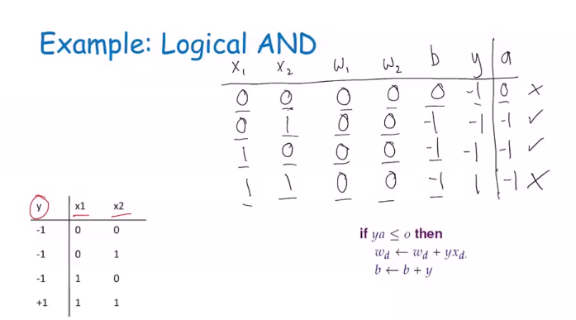

**Final Epoch (she skipped ahead)**

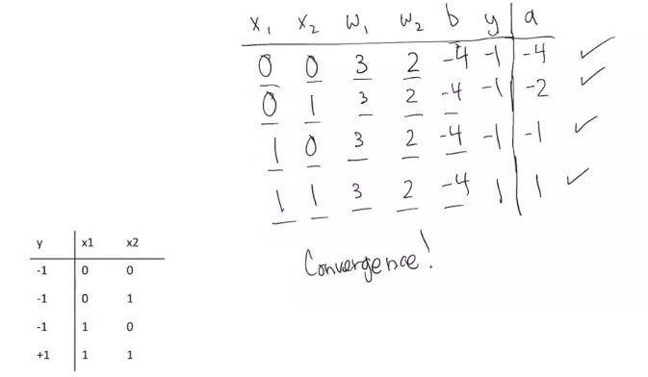

**Notice that $y*a is>0 that^{'}why it is correct$**

**Convergence is a good time to stop**