**Machine Learning : Perceptron 2**

$$If \left(x,y=1\right) is wrong that means that a≤0 so we update w,b→w^{'},b^{'}$$

$(w=weight, b=bias)$

$$w_{d}=w_{d}+yx_{d}$$

$$b=b+y$$

$$a^{'}=a+\sum_{d=1}^{D}{x_{d}^{2}+1>a}$$

$$a^{'}≥a+1 always$$

$For (x,y= -1)$

$$a^{'}= \sum_{d=1}^{D}{(w_{d}}-x_{d}{)x}_{d}+(b-1)$$

$$a^{'}=a-\sum_{d=1}^{D}{x_{d}^{2}+1}$$

$$a^{'}≤a-1$$

**Decision Boundary**

* Decision boundary is where sign(a) changes from -1 to +1
* Set of points x where a = 0
* Assume bias b = 0

$B=\{ x= \sum_{d}{w_{d}x_{d}}=0 \}$

**Dot products**

$u*v= \sum_{d}{u_{d}v_{d}}$

**Linearly Separable**

* If the classes can be separated by a hyperplane, then they are linearly separable.
* Perceptron can learn any linearly separable function.
* If the problem is not linearly separable the perceptron will never converge.

**Margin**

* Margin = distance between decision boundary specifically the hyperplane and the nearest point
* Large margin -> easy
* Small margin -> hard

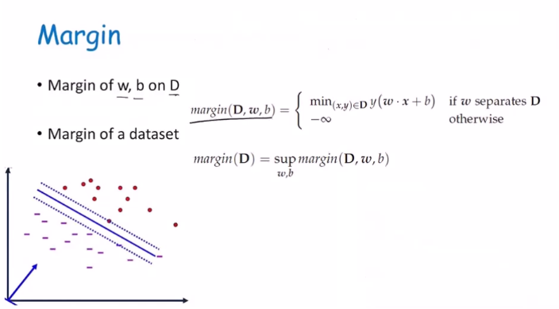

* sup = max but handles negative infinity differently

**Perceptron Pros and Cons**

* **Pros**
  + Simple
  + Classification & regression
  + Can handle numeric data.
* **Cons**
  + Can **only** handle numeric data.
  + Linearly separable only
  + May not converge quickly.