**Machine Learning : Clustering and Python ML Libraries**

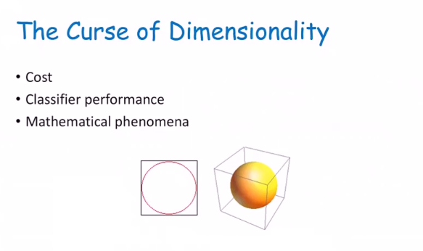

1.Computation cost : As you have more features the longer it’ll take and the more memory it’ll take up.

2.Effectiveness of learning : As you have more features the more complex it will be to learn.

3.Math phenomena : When your dimensionality becomes bigger there is less meaning to distance.

